**Instructions**

**RGxE**: Program for analysis of genotype stability and location value

1. Define input file information.

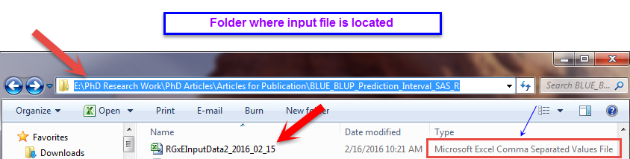



1. For Windows user
   1. Option 1

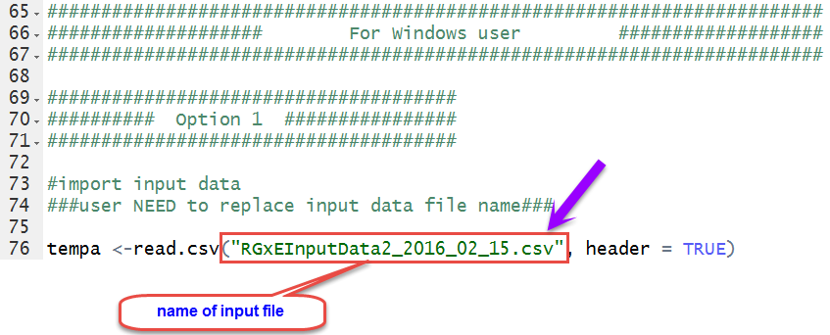

* 1. Option 2

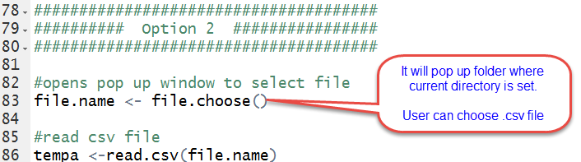

1. For Ois or Mac user

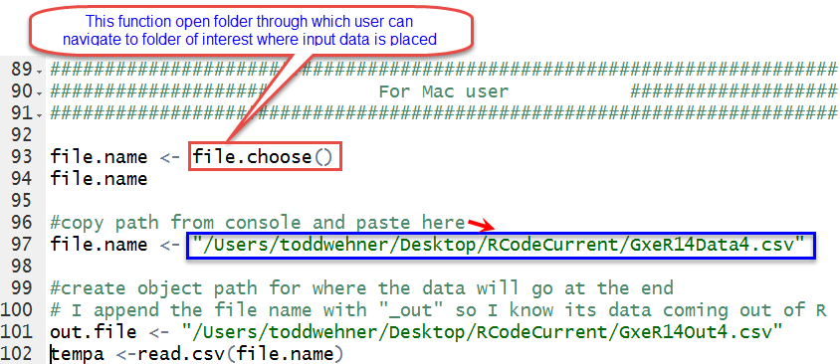

1. Define trait name that needs to be analyzed.

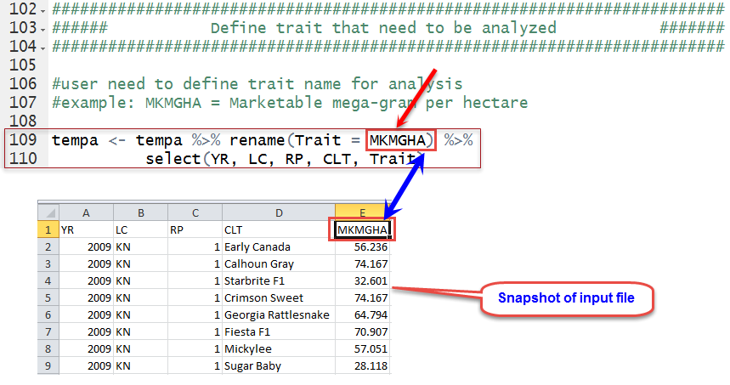

1. Define output file information.

