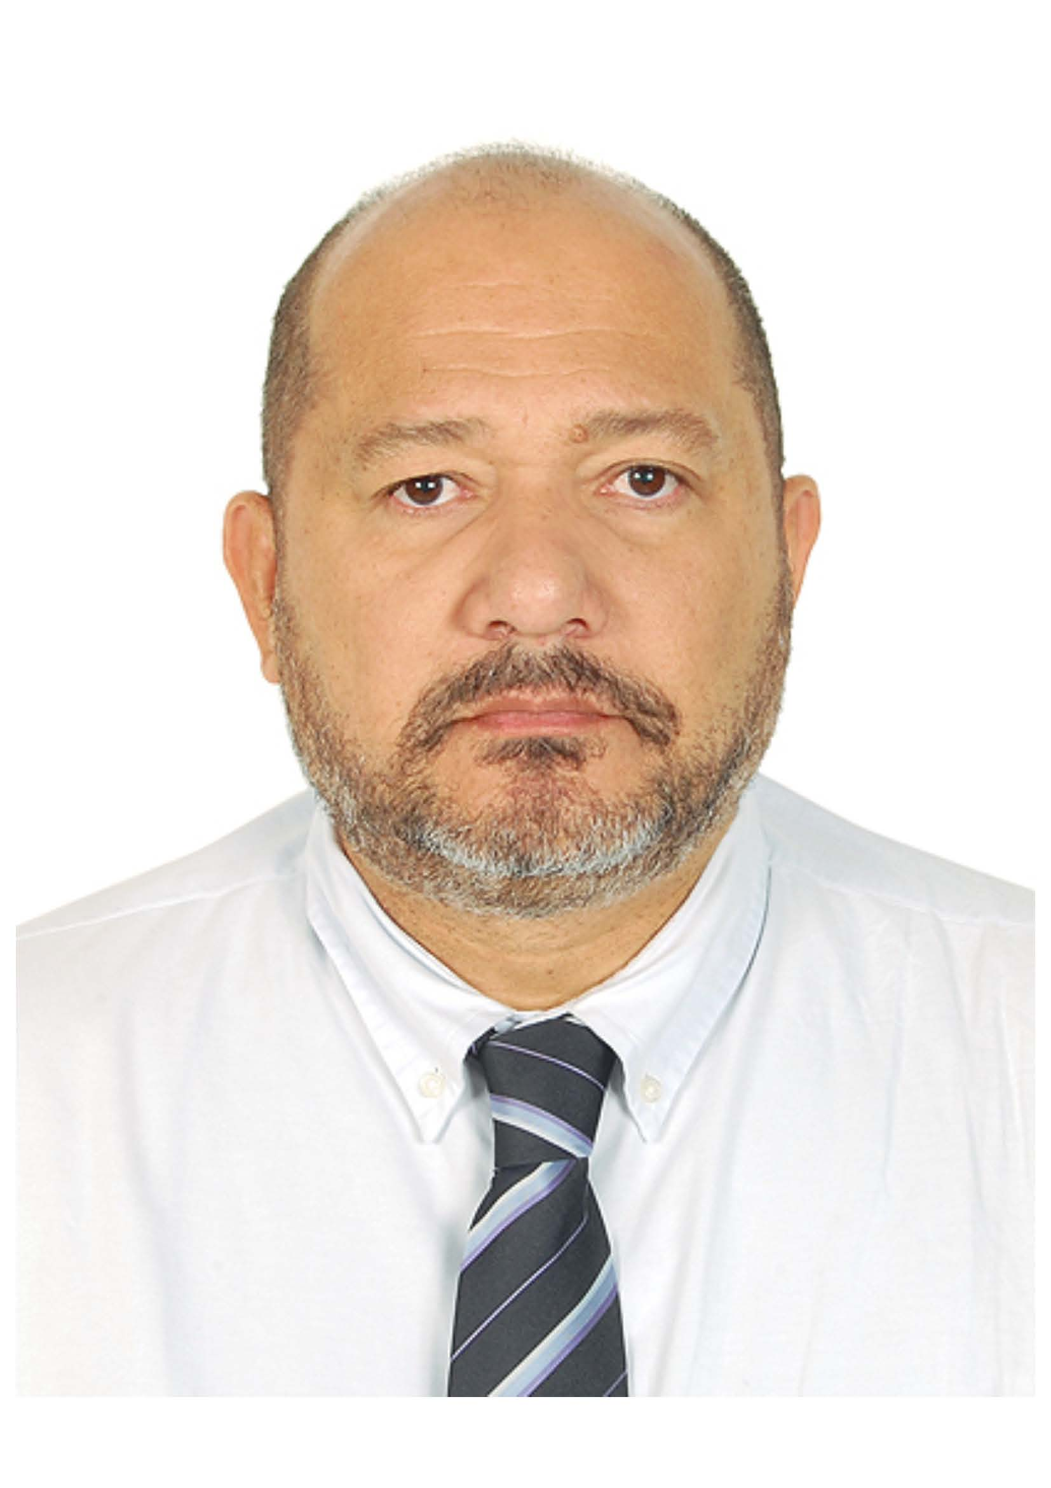**Personal Information:**

Name João Alberto Ferreira Pessoa

Naturallity São Paulo – SP – Date: 22/10/1965

Nationality Brazilian

Profession: Mechanical Technician / Production Engineer

Address: Twelve Street , 256, Geny Villa – Itaguaí City , Rio de Janeiro , Brazil

E-mail: [albertopess@hotmail.com](mailto:albertopess@hotmail.com) , joaoafpessoa@gmail.com

Zip Code: 23825-703

Tel: Home (55*21) 36316636

Cel: **(55) 21 9803 747804** (Wife, Brazil) **, (971) 055 2407046** (UAE)

RG: 06996890-7 IFP/RJ ( Registration Number )

CPF: 837.545.397-87 (Brazilian ID)

Passport: **YB559979** Expiration Date 26th, January, 2020

Driving License Brazil 00121647850 Expiration Date 27th, July, 2017

Driving License UAE 740321 Expiration Date 31th, July, 2023

Emirates ID 784-1965-9308524-2 Expiration Date 15th, February, 2017

Emirates VISA Residence Visa 33393734 Expiration Date 15th, February, 2017

Prof. Registration CREA – 891047434 / AP (Architecture & Engineering Registration Council)

**Desired Position :**

QA/QC Manager, QC Project Manager, Construction Manager, Client Representative, Third Part Inspection Leader/Manager, Operations Manager, General Manager.

**Professional Qualifications:**

* Quality Manager - **ACQI** – Register **6029436 ,** Ongoing CL5 Certification, upgrade to CQI Diploma,
* Welding Inspector L1 – FBTS/SEQUI - SNQC IS 0167 (1993) – Petrobras System,
* Welding Inspector L2 - ANSI B31.3 – FBTS – SEQUI – Ongoing - Petrobras System,
* Lead Auditor - ISO 9001/2015 – Register **6029436,** Ongoing, an upgrade to IRCA Recognition.

**Academic Background :**

* Technical Degree - EES – Metallurgical College (Technical School) – RJ (1986 – Dip. Available),
* Production Engineer – UNIGRANRIO – Production Engineer - RJ (2012 – Diploma To be Issued).

**Complementary Certifications:**

* Internal Auditor - ISO 9001/2000 – BVQI – 2007 - Certified,
* Internal Auditor - ISO 9001, 14001 and OSHAS 18001 – BVQI - 2011 - Certified.
* TBOSIET – Tropical Basic Offshore Safety Induction & Emergency Training – 2012.

**Languages:**

* English VIP - Conversation – Wizard – SP/RJ – 2011 - Fluent,
* Portuguese – Native.

**Informatics:**

* Windows, Apple OSX , Office Pack ( Word, Excel, PowerPoint, Project ), Internet – ( User’s Level ) .

**Professional Experience:**

* **TUV-Nord /Borouge 3 Expansion Project / Borouge – Polyolefin Plant - PO & LDPE Units - Ruwais – Abu Dhabi - UAE : 2013/14/15**

**Contract** - Third Part Services

**Position** - TPI Team Leader (PO/LDPE Package) – Client’s Third Part Inspection & PMC ProjectQuality Coordinator

**Main Activities** - Responsible for Inspection Teams (about 35 Engineers) , QA Audits Assessment, All NDT & Tech Labs Surveillance, Civil, Static & Rotating Inspections, I&E Test Inspection ,Painting and Insulation, Welding and Heat Treatment, Documentation Control (Review and Approval of ITP, Procedures, MC Dossiers), Control and Inspection of Pressure Tests, during Construction and Support to Precomissioning , Commissioning and Start Up, Handover of Project Documentation, Management of PO Package Site Inspection Resources and Day-to-Day Quality Issues and Responsibilities, from Construction to Core Group, up to SPM Level.

* **Bureau Veritas /Takreer Expansion Project – Ruwais – Abu Dhabi - UAE : 2011/2012**

**Contract** - Third Part Services

**Position** - QA/QC Team Leader (for EPC4 Package Services) – Client’s Third Part Inspection - **TPI**

**Main Activities** - Responsible for all Inspection Teams ( about 15 Engineers ) , NDT ( RT & UT , Tech Labs ) ,Civil and I&E Test Teams ,Painting , Insulation and Refractory Inspections , Welding and Heat Treatment Inspection, Documentation Control, Review and Approval , Teams and Contractors Surveillance, Materials Receiving Inspection , Control and Inspection of Pressure Tests on Tanks , Spheres , Pipelines , and Liaising with Team Administrative Aspects.

* **ThyssenKrupp – Siemens-VAI / ENESA : Brazil : 2009/2010/2011 – Steelmaking , Continuous Casting and Coke Plant Construction**

**Contract** – Main Equipment Erection & Installation, Pipelines, BOP Media Piping, Electrical & Instrumentation

**Position** - Quality General Manager (for All Contracts and Disciplines)

**Main Activities** – FEED Studies, Site Responsible for all Inspection Teams (about 100 people) , Source Inspections, NDT Subcontractors (RT & UT , Tech Labs) ,Civil and I&E Test Teams and Subcontractors , Painting , Insulation and Refractory Inspection Teams and Subcontractors, Welding and Heat Treatment Inspection Teams and Subcontractors , Materials Receiving Inspection , Control and Expedition , All Erection and Test Procedures Elaboration, except NDT, conventional NDT’s, as Visual, Penetrant or Magnetic , Manual UT and /or Automated UT (Phased Array) and/or SafetyRad (SpeedRad), QC Plans and Inspection Routine Elaboration , Reports , Manuals , and Data Books, delivery and Approval , All Management Meetings, Standards and Clients Specifications interpretation , NDT Results and Final Approval before Clients evaluations , Internal/External Audits upon ISO 9001/14.001/OHSAS 18.001, Team Administrative Aspects (Budget, Contracts, Costs Control, Manpower and Budget Control and Planning.

* **ENGECAMPO/TERMORIO/REDUC/TRANSPETRO: 2004 to 2009 – Brazil : EPC at Petrobras on Refineries , Terminals and Bases , Oil & Gas Units**

**Position Held** : QA/QC Manager

**Contract** – Erection and Maintenance in Various Petrobras Refineries and Petrochemicals Units

**Main Activities** – FEED, Site Responsible for all Inspection Teams (about 100 people), on Projects throughout Refineries REDUC , REFAP , REPLAN , REPAR , since FEED up to Erection Phase, Pipelines Spooling , Structures Assembly and Erection , Equipment Installation , Civil Services , I&E Installation Services , Project Details , Inspection and Commissioning into Water Cooling Units and Water Supply , Hydrocracking , Desulphurization Trains , Pipelines Maintenance , Units Maintenance, Pipelines fabrication and erection at TEBAR , TECAM, TEBIG , TECAB, TEDUC , TEAG , TEVOL, Including all storage and transportation facilities for Oil & Gas Products.

* **ANDRADE GUTIERREZ/ KAWASAKI – HI : 2003 - Brazil : Thermoelectric Fortaleza – TFOR**

**Contract** - EPC Contract for Power Plant Construction – Combined Cycle - TFOR

**Position** Held – QA/QC Manager & Construction Consultant in Eletromechanic Assembly and NDT Examinations,

**Main Activities** - Supervision over Contractor Inspection Teams , NDT Subcontractors (RT & UT , Tech Labs) , Civil and I&E Test Teams and Subcontractors ,Painting , Insulation and Refractory Inspection Subcontractors , Welding and Heat Treatment Inspection Teams and Subcontractors, Materials Receiving Inspection , Control and Expedition , Inspection of Pressure Tests , All Erection and Test Procedures Elaboration , except NDT, QC Plans and Inspection Routine Elaboration , Reports , Manuals , and Data Books elaboration , delivery and Approval , All Meetings Held , Standards and Clients Specifications interpretation , NDT Results and Final Approval before Clients evaluation, Team Administrative Aspects (Budget, Contracts, Costs Control, Planning).

* **TERMOCEARA – MPX :2002 – Brazil : MPX – CEGAS/PETROBRAS/MPX – TermoCeara Construction Site**

**Contract** - EPC Contract for Power Plant Construction – Open Cycle - TermoCeara,

**Position** – QA/QC Manager & Construction Consultant in Eletromechanic Assembly and NDT Examinations,

**Main Activities** - Responsible for all Inspection Teams (about 30 people) , NDT Subcontractors (RT & UT , Tech Labs) , Civil and I&E Test Teams and Subcontractors , Painting , Insulation and Refractory Inspection Teams and Subcontractors, Welding and Heat Treatment Inspection Teams and Subcontractors , Materials Receiving Inspection , Control and Expedition , Inspection of Pressure Tests , All Erection and Test Procedures Elaboration , except NDT (only revision / approval) ,QC Plans and Inspection , Routine Elaboration , Reports , Manuals , and Data Books elaboration , delivery and Approval , All Meetings Held , Standards and Clients Specifications interpretation , NDT Results and Final Approval before Clients evaluations, Administrative Aspects (Budget, Contracts, Costs Control, Planning).

* **ANDRADE GUTIERREZ : 2000 to 2002 – Brazil : Pecém Port Complex – SG Amarante - CE**

**Contract** - EPC Contract for Port and Oil &Gas Facilities Construction – Port of Pecém, including Large Pipelines, LNG and Gasoline Piers, Structures, Equipment Erection and Installation

**Position** – QA/QC Coordinator & Construction Consultant

**Main Activities** – FEED, Eletromechanic Assembly and NDT Examinations, Responsible for all Inspection Teams (about 20 people) , NDT Subcontractors (RT & UT , Tech Labs) ,Civil and I&E Test Teams and Subcontractors , Painting , Insulation and Refractory Inspection Teams and Subcontractors, Welding and Heat Treatment Inspection Teams and Subcontractors , Materials Receiving Inspection , Control and Expedition , Inspection of Pressure Tests , All Erection and Test Procedures Elaboration , except NDT (only revision / approval) , QC Plans and Inspection Routine Elaboration , Reports , Manuals , and Data Books elaboration , delivery and Approval , All Meetings Held , Standards and Clients Specifications interpretation , NDT Results and Final Approval before Clients evaluations, Team Administrative Aspects (Budget, Contracts, Costs Control, Planning).

* **CAMARGO CORREA: : 1999 to 2000 – Gas Pipeline Bolivia-Brazil – GASBOL – Section III and IV –** Welding Inspector, Pipeline Inspector, Supervisor
* **TECHINT Engineering : 1998 – Offshore Campos Overseas , Santos and Pelotas – Production Platforms -** Welding & NDE Inspection / Supervision
* **EISA Shipyard / Synesis : 1997 – Onshore Mounting of PLEM’s , Buoy , Mooring , Top Sides , Hull Deck s and many others Marine Parts –** Welding & NDE Inspection / Supervision
* **CBV /FMC-Brazilian Marine Valves Company : 1997 – Onshore Fabrication of Completion Risers , PLEM`s and Wet Trees – Welding and Hydro Tests -** Welding & NDE Inspection / Supervision
* **NUCLEP – Nuclebras Heavy Industries (Federal Government) : 1981 to 1997 – Nuclear Power Plants and Material Storage Facilities**

**Contracts** - EPC Contract for **Nuclear Power Plants** Construction and Nuclear Materials Facilities Production and Storage at Nuclear Power Station Angra I/ II , Heavy Equip. Assembly (Angra /RJ) Nuclear Industries – INB - Enrichment Shop (Resende/RJ) , AMRJ – Brazilian Navy – IKL209 Submarine Construction (Itaguaí/RJ),

**Position** - Apprentice, Welding Inspector, Supervisor

**Main Activities** - Client Representative, Responsible for all Inspection Teams at Site, acting Construction or Project Manager, elaboration and approval for Execution, Inspection Procedures and Plans, Erection of Heavy Equipment , as Reactor Heavy Parts, Pressurizer, Heavy Pumps and Exchangers, Heavy Piping, Installation of Heavy Items, as Condensers and Associated Items, for Primary, Secondary and Tertiary Systems at a PWR Power Plant (KWU Model) Angra I and II. Complete Domain over all construction Nuclear Cycle, since Mining, Cake Production, Enrichment, Plant Erection and Start up ! Follow up during Heavy Equipment Fabrication, tests and deliverables.

**Personal / Professional References:**

* Azhar Iqbal – TUV-Nord - Operations Manager - [azharvains@hotmail.com](mailto:azharvains@hotmail.com) - (971) 0505217721
* M. Tony Griggs – Bechtel - PMC QA/QC Manager - mohdtony36@gmail.com - (971) 0566887093
* Odd Mosbergvik – Borealis/Borouge – S P Manager - omosbergvik@gmail.com - (971) 0504464304

**General Information:**

* Management Years’ Experience : 15
* Inspection Years’ Experience : 16
* Current Salary (per Month) : USD 9.500,00
* Expected Salary (per Month) : USD ……(TBA )
* Notice period/Joining Time : Immediate
* Current Location : Al Ain, UAE
* Contacts : (971) 055 2407046 / albertopess@hotmail.com / joaoafpessoa@gmail.com

‘’ I guarantee that everything informed in this document is an expression of true and I’m completely responsible herein.’’

Signed By

**João Alberto Ferreira Pessoa**