NPS Exploratory Data Analysis
Data Overview
The dataset was sourced from HubSpot and contains NPS survey responses. All data has been cleaned prior to this analysis.
Attribute | Value
Source | HubSpot
Total Records | 11400
Number of Features | 7
Date Range | 1/1/25 – 2/4/26
Data Status | Cleaned

Score Distribution
Respondents are grouped into Detractors (0–6), Passives (7–8), and Promoters (9–10).
Category | Count | Percentage
Promoters (9–10) | 4882 | 42.7%
Passives (7–8) | 2023 | 17.7%
Detractors (0–6) | 4535 | 39.6%
Overall NPS: +3 – 42.7% - 39.6% (Promoters% – Detractors%)

Descriptive Statistics
Statistic | Value
Mean | 6.58
Median | 8.00
Std. Deviation | 3.57
Min / Max | 0/10

Chart 1: NPS Over Time
- NPS peaked at +11 in June 2025
- Steady decline from July onward, dropping below zero by August
- Hit the lowest point of -10 in December 2025
- Early signs of recovery in 2026, reaching +6 in February
- ~17 point drop from peak to lowest point

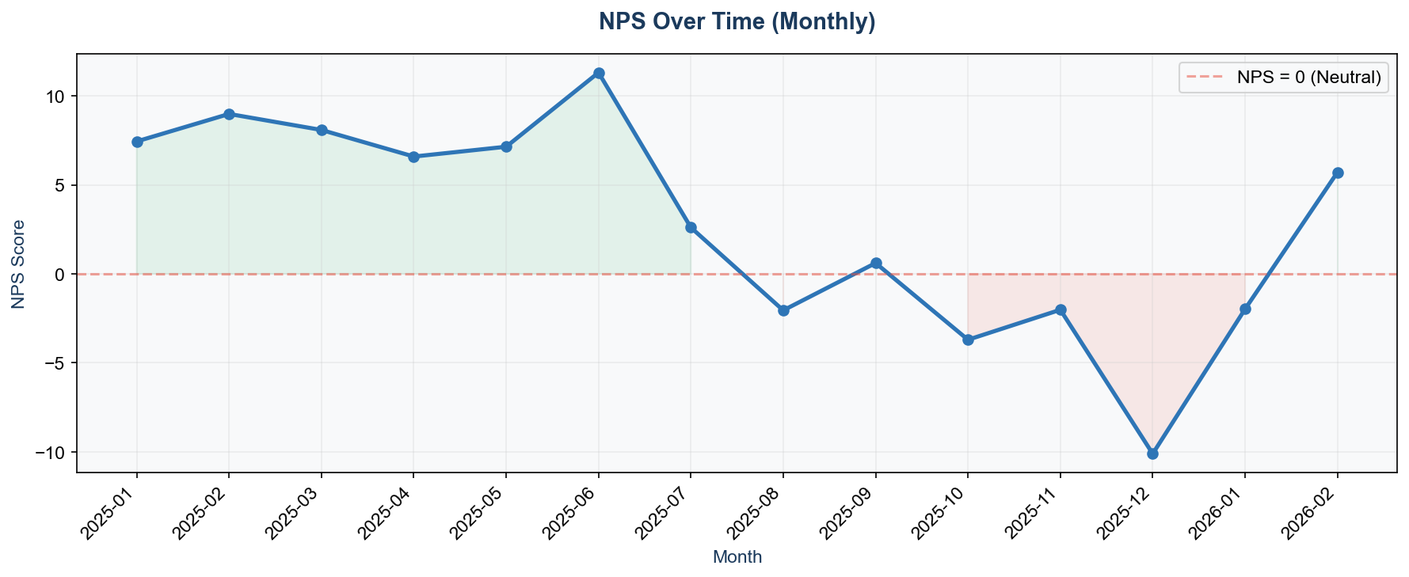

Chart 2: NPS by Taxonomy Type
- General (+30) and Usability (+13) are the strongest areas
- Functionality (-18) is moderately negative
- Performance (-69), Reliability (-65), and Expectation Gap (-63) are critical problem areas
- Customers like the product's ease of use but are frustrated by speed, stability, and unmet expectations
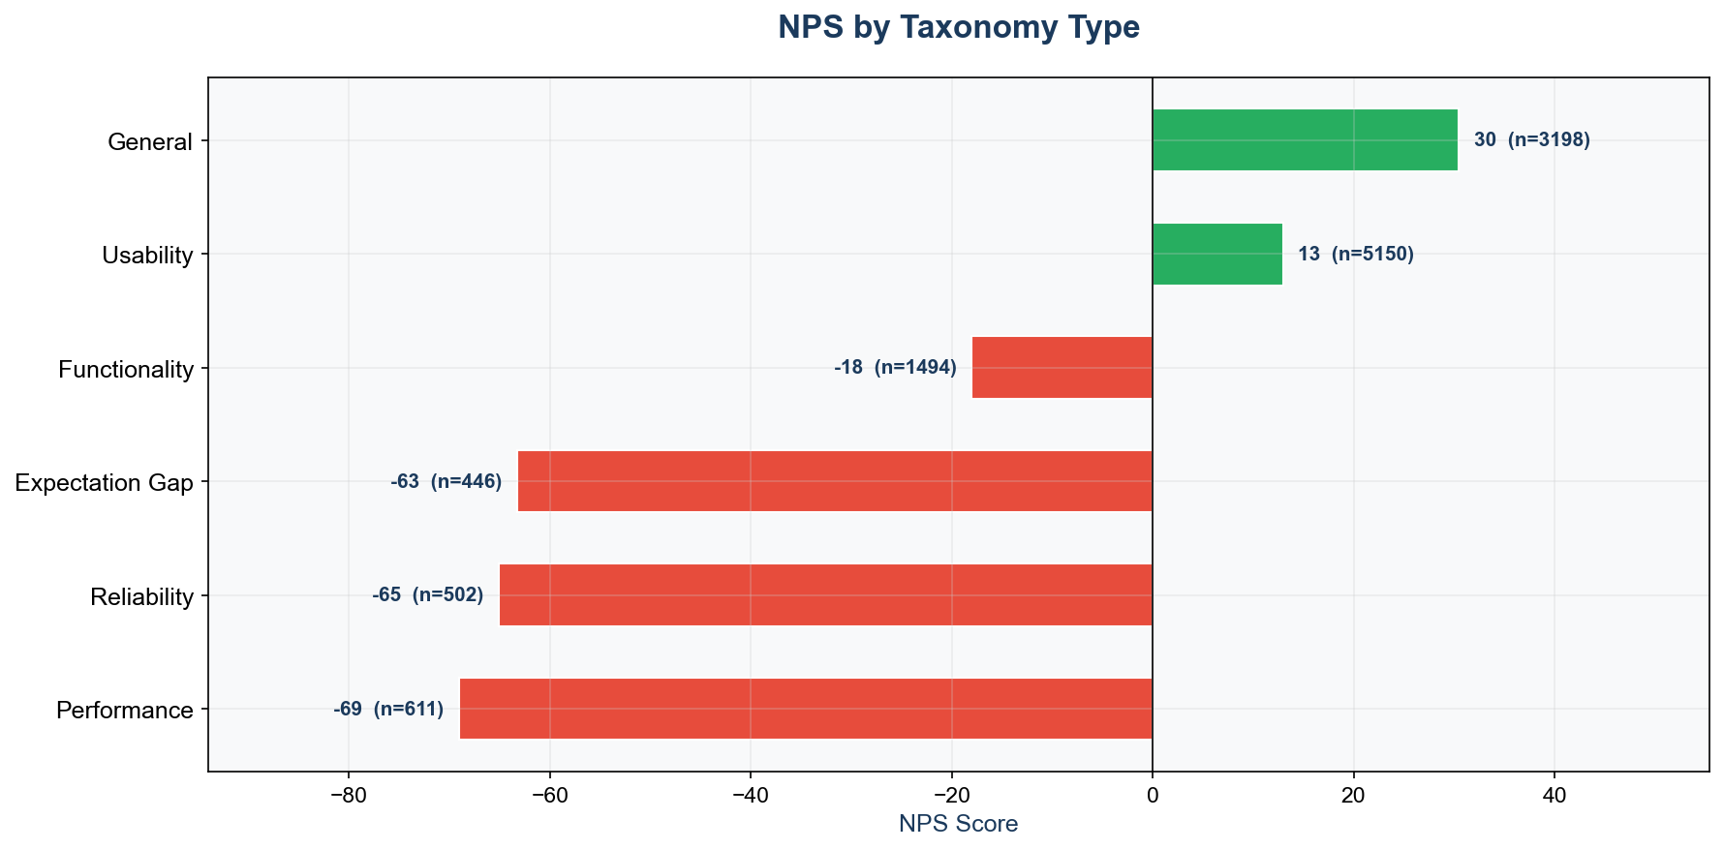

Chart 3: Response Volume
- Consistent volume of 800–1,000 responses per month through most of 2025
- December 2025 dip (554) likely due to holidays
- February 2026 only has 105 responses — month is likely incomplete
- No signs of survey fatigue overall

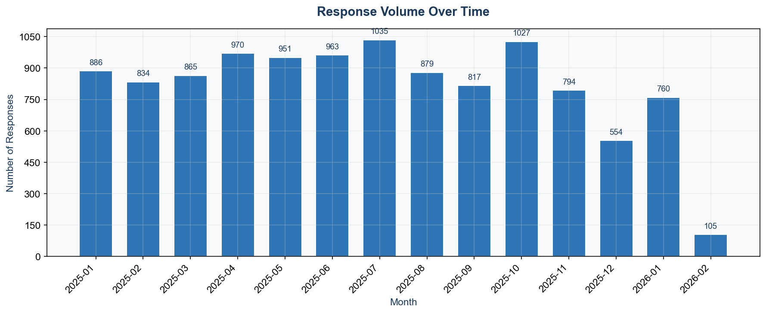

Key Findings
- NPS was positive (+7 to +11) from January to June 2025
- Sharp decline began in July 2025
- Went negative from August through January 2026
- Lowest point was -10 in December 2025
- Recovery began in February 2026 (+6), but based on limited data
- Main drivers of decline: Performance, Reliability, and Expectation Gap scores
Next Steps
- Analyze open-ended responses (response text) to understand what customers are saying about Performance, Reliability, and Expectation Gap
- Break down NPS by taxonomy type over time to identify which categories drove the mid-2025 decline
- Investigate what changed around July 2025 that may have triggered the downward trend
- Continue monitoring NPS monthly to confirm whether the early 2026 recovery holds

