|  |  |  |  |  |
| --- | --- | --- | --- | --- |
| WRITE-UP | | | | |
|  |  | | |  |
| Booking Demand | | | | |
|  | | Team Members:  Carlos Mendoza, Daniel Romero, Leobardo Preciado y Marcelo Flores |  | |

TABLE OF CONTENTS

Overview 3

1. Data and model 4

2. Results 5

3. Conclusion 17

# Overview

The objective is to analyze the Dataset of Hotel Booking Demand to determine if there are correlations between the information and get insights of when or how it is better to book a hotel.

This data set contains booking information for a city hotel and a resort hotel, and includes information such as when the booking was made, length of stay, the number of adults, children, and/or babies, and the number of available parking spaces, among other things

# Data and model

The data came from Kaggel (<https://www.kaggle.com/jessemostipak/hotel-booking-demand>). This is data retrieved from two hotels in Portugal, one in Lisbon and the other a resort it Algarve. The information came for the data bases that contained reservation from July 2015 to August 2017.

This data is very valuable and had been used In several academic exercises since is very rare to have this amount of good quality clean data.

# Results

Our findings area the following.

* Where do the guests come from? To answer this question the data was filtered by a registered country and a confirmed reservation.  
   For presentation reasons up to 1000 guest per country were considered for the second pie plot and Map.  
  After the analysis the mayor percentage (28%) of guests came from Portugal, which make sense as the data provides information from that specific country.  
  An interesting fact is that the second country with the highest percentage of guests (13%) is Great Britain despite the distance.  
  Another interesting fact is that although Spain is very close, it is the country with the fourth percentage of guests (9%)

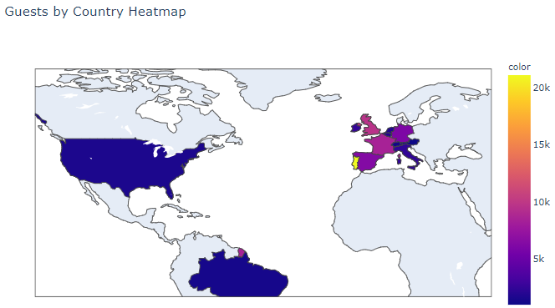

* **How much do guests pay for a room per night?** Most of the reservations (76.79%) came through Travel agents and Tour operators followed by Direct reservation to the Hotels.  
  On average the Cost of the Daily rate is higher when reservations area made using a Global Distribution System (GDS) and we have the lower rates for Corporate clients. -Travel Agencies have the second lowest rate.
* 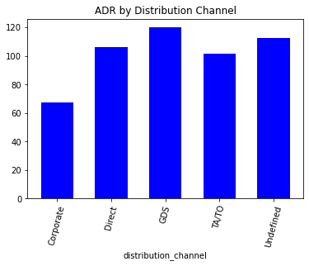
* **How does the price per night vary over the year?** The summer months are the most expensive and the winter months are the most affordable.
* Chart, bar chart

  Description automatically generated
* **Which is the busiest month?** The busiest month for both Hotels is August and we can consider November-January being low season where demand drops considerable to the rest of the year.

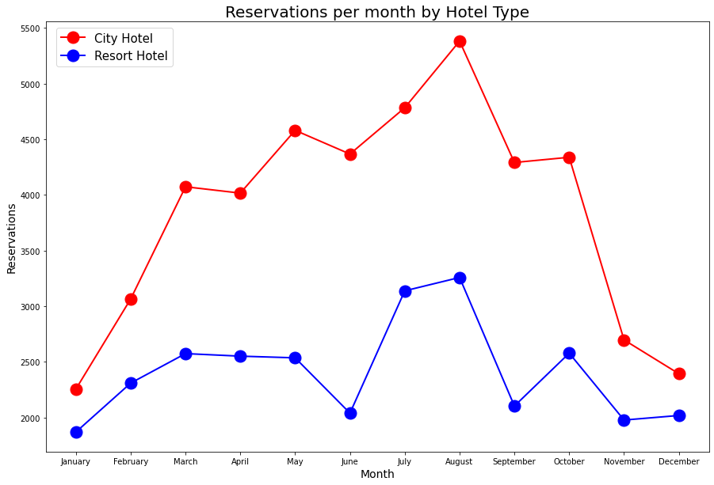

* **What is the average price by room type?**The room types represent the size and meal arrangements, even though they may not be the same for each Hotel and price varies depending on demand. Rooms A and B had the lowest average price per room while rooms G and H had the highest average price. This plot was filtered by Guest with the following criteria Who did not cancel reservation That has a registered country More than 1000 per country.

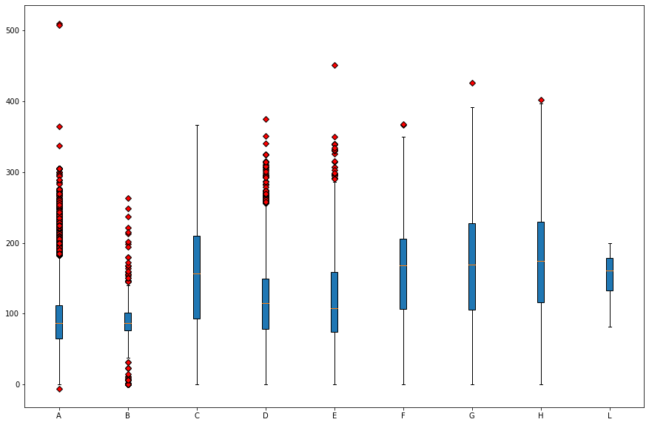

* **Which is the busiest month?** The busiest month for both Hotels is August.  
  We can consider November-January being low season where demand drops considerable to the rest of the year.   
  This plot was filtered by number of reservations per Month Only not canceled reservations were included.



* **How long do people stay at the hotels?** Filtered by City Hotel, Resort Hotel, and a confirmed reservation.   
  From analysis, average nights that a guest stays in a City Hotel is 2.92 nights and 52 is the maximum number of nights that a guest has stayed in the City Hotel.   
  At the Resort Hotel is 4.142892 and 69 is the maximum number of nights a guest has stayed in the Resort Hotel   
  The 25.73 % of guests stayed 3 nights at a City Hotel, which is considered the biggest percentage   
  The 22.73 % of guests stayed 1 night at a Resort Hotel, which is considered the biggest percentage.

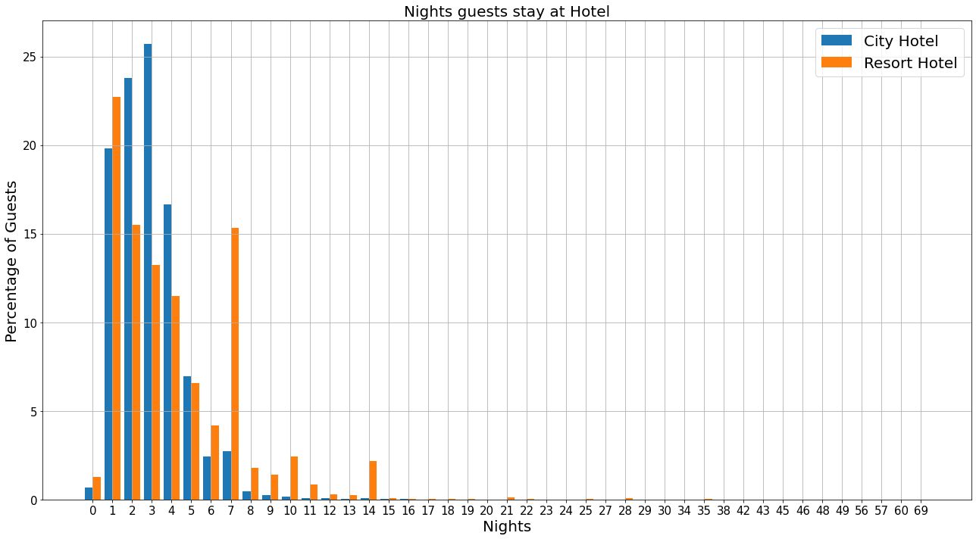

* **How many bookings were canceled?** City Hotels has the highest cancelation rate 37,04% of the total bookings were canceled.

* **Which month have the highest number of cancelations?**August is the month with more cancelations (11.85%) and January is the month with less cancelations (4.09%).  
  For city hotels there is not much variance between months For the Resort hotel it is highest cancelations in the summer and lowest during the winter

* **Bookings by market segment** Adults without children = 110,054 Adults with 1 child = 5446 Adults with 2 children = 3772 Adults with 3 children = 111. From the above table we can deduce that of the 119 thousand reservations, 110,054 were reservations for without children, most of them couples, followed by people traveling alone. When there are more bookings with children, two adults travel, we can deduce that they are couples and their children   
  47.30% of bookings were made online, 20.29% offline.   
  The rest were made by groups, corporations, directly at the hotel or by airline packages.

* **Is there a correlation between Cancelations and Lead time?** After analyzing the data, we decided to separate it in two groups, the first one takes into account the lead time for reservations under or equal to 50 days and the second one over 50 days.   
  For the lead time under or equal to 50 we found that the average of cancellation was 28.45% and the r-value was 0.6482313461494058   
  For the lead time over 50 we found that the average of cancellation was 56.28% and the r-value was 0.3919649481639411   
  We can observe that reservations with lead time over 50 days are twice as likely to be cancelled.
* 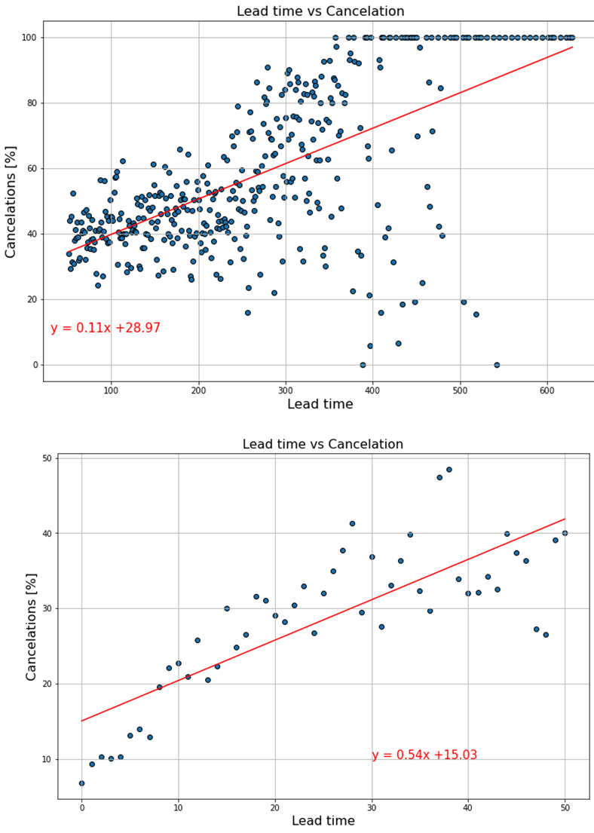

# Conclusion

This project gave us the opportunity to get insight of a new business.

By finding correlations we were able to get a big picture of the hotel business in this particular hotel.

Is important to be mindful of the limitations of this analysis and no over generalize the findings. The results are only for these two Portuguese hotels.

nd EDA an

* Opportunity: Describe the current market for the business’ offered service. At a high level, what is the market and who are its participants; is it business customers or consumers; what is the specific geography, etc.? More details on the market will be provided in the next section of the plan. Next, describe the current state of available services and how the business will offer better. Also discuss any additional services the company plans to offer in the future.
* Product overview: Describe the service offerings of the business in as much detail as possible. If it is effective to include pictures, this would be a good place to place them.
* Key participants: Identify any strategic partners in the business, such as critical suppliers, distributors, referral partners, or any others. In some businesses, products are custom-made and any break in their supply will impact the business. There may be key contributors to the services offered, so it is important to identify them.
* Pricing: Provide pricing of the service, gross margin projects, and upgrade paths. Describe why the company’s pricing will be attractive to the target market. Have a gauge on the competitor’s pricing and explain how the business’ service is unique to justify its pricing structure.
* Note the difference between working hours and billable hours. All working hours are not billable. If the business has employees with differing skill levels (for example, in a law practice, there are associates, paralegals, lawyers, partners, etc.), indicate the various billing rates.
* Communicate rates clearly to clients and customers. If there are potential additional fees which will be passed on to clients or customers, define and establish them up front.