CLT · TID · VSP · CEB
CLT Distribution Proposal
Hybrid textile printing (screen + digital) — Mexico and Latin America
For: Dongguan Changlian New Material Technology Co., Ltd. (CLT)
Prepared by: TID México · VSP Printing, Inc. · CEB
October 2026
Contact: Carlos Moreno — TID México · carlos.moreno@tidmexico.com.mx · +52 446 479 4420
Note: figures marked as “estimate” are our own calculations based on public sources and must be confirmed with CLT’s quotation and commercial terms.
CONFIDENTIAL DOCUMENT

1. Executive summary
TID México, VSP Printing, Inc. and its subsidiary CEB propose to become the distributor of CLT (Dongguan Changlian New Material Technology Co., Ltd., SZSE 301618) in Mexico, with expansion into the United States and Latin America. The goal is to introduce and locally support CLT’s hybrid printers (screen + digital) and its consumables: silicones, water-based pastes and inks.
- Opportunity: we found no distributor of Chinese hybrid printing with a formal presence in Mexico (local inventory, spare parts, technicians and chemicals).
- Market: ~102,500 textile businesses; ~1,400–1,900 reachable customers (medium/large companies and shops with automatic carousels); 30–90 potential hybrid lines in 5 years (estimate).
- Timing: Mexico’s 2026 tariffs (up to 35% on garments from non-FTA countries) favor domestic manufacturers, who need to differentiate through added value and fast response.
- Partner: 30+ years of combined industrial printing experience, a consumables-and-service business model, presence in Mexico (Querétaro) and the U.S. (Los Angeles), and an in-house importer incorporated in Mexico (CEB).
- Proposed initial investment (base case): ~US$262k, with estimated payback during year 3.

2. Scope and methodology
This study focuses on Mexico as the first stage; the United States and Latin America are presented as expansion stages. Sources: CLT’s international website (garmentprintingpro.com), its 2025 annual report, INEGI and CANAINTEX statistics, public tariff information and industry sources (FESPA México, manufacturers and distributors).
Parameter | Content
Market definition | Hybrid equipment, consumables (silicones, pastes, inks) and technical service; substitutes: traditional screen printing, DTG, DTF, sublimation
Segments | Export maquiladoras (IMMEX), domestic brands, medium/large screen-print shops, promotional, uniforms and sportswear
Sizing | Total, serviceable and obtainable market (TAM / SAM / SOM) with conservative, base and optimistic scenarios
Geography | Clusters: State of Mexico/Mexico City, Jalisco, Puebla/Tlaxcala, Guanajuato, Baja California, La Laguna, Aguascalientes, Nuevo León, Yucatán
Competition | DTG makers and distributors, automatic carousels, Chinese hybrids and consumables
Economics | Distributor investment, margins, break-even and payback
Regulation | 2026 tariffs, import through CEB, USMCA, electrical standards (NOM)

Figures marked as “estimate” are our own calculations and must be confirmed with CLT’s quotation and terms.

3. CLT: manufacturer profile
Dongguan Changlian New Material Technology Co., Ltd. (CLT) was founded in 2009 in Liaobu, Dongguan (Guangdong). It has been listed on the ChiNext board of the Shenzhen Stock Exchange since September 2024 (code 301618). It is recognized in China as a leader in water-based printing pastes and offers an integrated materials-and-equipment solution for textile printing.
2025 indicator | Value | Approx. USD
Total revenue | ¥568.1 million | ~US$80M
Water-based printing pastes | ¥304.4M (53.6%) | ~US$43M
Silicone materials | ¥117.7M (20.7%) | ~US$17M
Water-based resins | ¥45.9M (8.1%) | ~US$6M
Printing equipment | ¥37.0M (6.5%) | ~US$5M
Export sales | ¥103.5M (18.2%) | ~US$15M
Net profit attributable | ¥40.6 million | ~US$6M
Channel: traders / manufacturers | 49.5% / 50.5%

Source: CLT 2025 annual report (Shenzhen Stock Exchange). Reference exchange rate: ¥7.1 per US$.

Portfolio relevant to this proposal
- Hybrid printers: CLT-012R/015R/018R (Ricoh heads, up to 1800 dpi, 450 pcs/h), CLT-014B/016B/018B (Brother 680, 400 pcs/h), CLT-005S (Star Light white).
- Automatic oval presses: SM45-85, SM60-85, SM70-95 (up to 800 pcs/h, ±0.02 mm).
- 6-station DTG with inline pre-treatment and the CLT-6900 industrial DTF series.
- Effect silicones: high-density / 3D (S-1701), rounded-edge (S-1703), glossy glass-like (S-1704-1), special-purpose (S-1714-1); water-based pastes, puff pastes and DTG/DTF inks.
- Certifications: OEKO-TEX, GOTS, ISO 9001 and ISO 14001.

Hybrid technology
Digital stations are mounted on an oval screen-printing press. The white underbase is printed with (low-cost) screen paste and the color with digital heads, so screen effects (puff, foil, glitter, discharge, glass-like or embroidery-like silicone) can be combined in a single pass with photographic gradients. CLT reports ink savings of 40–70% versus pure DTG and profitability on runs of 500 to 5,000 pieces.

4. CLT’s commercial model
CLT uses equipment as the gateway to recurring chemical consumption, which makes up most of its revenue. Its 2026 plan is to consolidate Southeast Asia and expand in Europe, the Americas, the Middle East and Africa by building out its overseas agent network.
Element | How CLT applies it
Trade shows with live demos | Running production line, tests on the customer’s fabric and artwork, same-day written quote, show-only packages (PRINTING United, Stitch & Tex Egypt)
Turnkey package | Machine + matched chemistry + installation + training + freight and import paperwork, at one price
Phased investment | Start with the press and add digital stations; 2–3 season plans
ROI-based selling | Ink savings, fewer operators, less floor space; customized ROI calculation
Linked consumables | Warranty requires genuine CLT parts and chemistry
Application lab | Simulates the customer’s production and recommends the full process
Digital lead capture | Multilingual site, forms and WhatsApp with a response in under 2 hours

What is missing in Mexico today: local technical service, in-country spare parts and chemistry inventory, Spanish-language support and a demo showroom. These are exactly what our group brings.

5. Mexican market overview
Indicator | Data | Source
Textile & apparel GDP | MXN 91,165 million; 1.75% of manufacturing GDP | CANAINTEX, 2025
GDP composition | Apparel 56%, textile inputs & finishing 27%, textile products 17% | CANAINTEX
Businesses | 102,492 | INEGI 2023
Jobs | 519,313 (225k formal) | INEGI 2022 / CANAINTEX
Company size | Micro 95.6%, small 3.3%, medium 0.8%, large 0.3% | INEGI, 2019 Census
Exports | US$9.3 billion; 89% to the U.S. | INEGI 2023
Imports | US$13.3 billion; 35% from China | INEGI 2023
Trend | GDP -8.4% in 2023; ~20k jobs lost in 2024 | INEGI / FESPA

The industry is under pressure from low-cost imports and informality. Domestic manufacturers are responding by differentiating: customization, short runs with fast delivery and high-value effects. Hybrid printing directly addresses this need. The tariffs in force since January 2026 strengthen the position of those producing in Mexico.

6. Market size (estimate)
Level | Definition | Estimated size
Total market (TAM) | All textile and apparel businesses | ~102,500
Serviceable market (SAM) | Medium and large companies (~1,130) plus screen-print shops with automatic carousels (300–800) | ~1,400–1,900 customers
Obtainable market (SOM, 5 years) | 2–5% adoption of the serviceable market | ~30–90 hybrid lines

- Equipment: 30–90 lines × US$120–250k landed in Mexico = US$3.6–22 million over 5 years (estimate; to be confirmed with CLT’s quotation).
- Consumables: US$1,500–5,000 per line per month (hypothesis to validate with shops). With 50 lines: US$0.9–3 million per year, plus silicone and paste sales to shops without hybrid equipment.
- Competitor price reference: M&R Cobra automatic press, 10 stations / 8 colors, ~US$88k in the U.S.

7. Priority regions
Priority | Region | Rationale
1 | State of Mexico and Mexico City | Largest concentration of printers, brands, promotional and corporate buyers
1 | Jalisco (Guadalajara, Zapotlanejo) | Fashion, sportswear and domestic brands
1 | Baja California (Tijuana, Ensenada, Tecate) | Export screen printing for U.S. brands (Disney, Fanatics, Columbia); joint TID + VSP coverage from the border
2 | Puebla and Tlaxcala | Export maquila and knitwear
2 | Guanajuato (Moroleón, Uriangato, León) | Knitwear and wholesale; 1–2 hours from TID in Querétaro
3 | La Laguna, Aguascalientes, Nuevo León, Yucatán | Denim, IMMEX maquila and uniforms

Preliminary ranking by concentration of medium and large industry; to be validated with INEGI’s DENUE business directory.

Priority accounts: the 80/20 rule
Out of the 82 prospects identified in Mexico (47 printers and manufacturers, and 35 OEMs and contract manufacturers), we selected the top 20% by potential: production volume, in-house decoration, exports and fit with the hybrid line. These 17 accounts will receive 80% of the first-year sales effort (visits, demos and tests on their own fabric).

Priority prospects: printers and manufacturers (9 of 47)
Company | City | What they do | Subsector
ADN Serigrafía | Naucalpan, Edo. Méx. | Contract screen printing: 130,000+ pcs/week, up to 18 colors, production for the U.S. and Canada | Printing and screen printing
Serigrafía Textil Automatizada (KW) | Puebla, Pue. | Automated volume screen printing: campaigns, sportswear and promo; 30+ years | Printing and screen printing
Manufacturas Textiles RF (Reitex) | Guadalupe, N.L. | Integrated yarn-to-garment plant; high-volume campaign and promo T-shirts | Promotional
Diermi (Playeras Mindy) | Zapopan, Jal. | Sports and promo T-shirts in a 5,000 m² automated plant; exports to the U.S. | Sportswear
GOCA'S | Ciudad de México | Large-scale T-shirts and hoodies with in-house screen, sublimation and embroidery; 25+ years | Promotional
SerigrafiarteSP | Ciudad de México | Contract screen printing (plastisol, water-based, discharge), DTF and sublimation for factories and brands | Printing and screen printing
Grupo Martex | Naucalpan, Edo. Méx. | High-volume textile maker; uniforms (directory cites FIFA uniforms) | Uniforms and sportswear
Uniformes Carmen | Guadalajara, Jal. | Uniforms with screen, embroidery and transfer; volume print contracting; 30+ years | Uniforms
Charly (Grupo Charly) | León, Gto. | Sports brand: jerseys and licensed apparel for Liga MX clubs (León, Pachuca, Atlas, Santos) | Sportswear / licensing

Priority OEMs: export contract manufacturing (8 of 35)
Company | City | What they do | Brands and customers
Vertical Knits | Baca, Yuc. | Knitwear with in-house screen printing and embroidery; 16–25 million garments a year | Nike, Fanatics, Tommy Hilfiger, Patagonia
Ink Throwers de México | Tijuana, B.C. | Contract screen printing for retail and licensing: ~50,000 prints/day, ~538 workers | Disney, Levi's, Marvel
MD International Baja | Ensenada, B.C. | Mass printing and sewing; 1,200–1,300 workers | Fanatics, Hurley, REI
Fortune Fashions Baja (Mad Engine) | Ensenada, B.C. | Screen printing plant for licensed T-shirts for U.S. retail | Mad Engine Global, Disney
SOIR Textiles (TJ Factory Clothing) | Ensenada, B.C. | Garment printing, flatbed screen printing and dyeing in two plants | Columbia, Disney
Factory 1 (Factory1 Group) | Ensenada, B.C. | Full package with flatbed screen printing, dyeing and washing; 702 workers | Columbia, Disney
Codipsa (San Fernando ScreenPrinting) | Puebla, Pue. | Vertical knit (knitting, dyeing, finishing, printing) for fast fashion; 35+ years exporting | Puma, Gap, Hot Topic, Macy's, Disney
Industrias Manufactureras MYR | Irapuato, Gto. | Mexico national team, Liga MX and MLS jerseys; 1,658 workers; exports to the U.S. and South America | adidas, Puma

Next tier (OEM): Grumax / BEX Bordados y Estampados (Xalapa), California Cutting & Sewing (Puebla), Confecciones Clabeck / JHK (Tlalnepantla; audited by Inditex and C&A), Private Label Tehuacán (PVH, J.Crew, L.L.Bean), Augusta Sportswear de México (Fanatics), Zentrix (Nike, Lululemon) and Baja Skiva Screen Printing (Disney).
Sources: company websites, Open Supply Hub and industry directories. Brands and customers per public sources; to be confirmed at the first visit.

8. Competition
Type | Players | Observation
High-end DTG / digital | Kornit (via Sun Digital México) | DTG leader; high investment; established service
Automatic presses | M&R, ROQ, MHM, Anatol, Workhorse | Installed base in Mexico: natural customers for add-on digital stations
Chinese hybrids | Textalk, Hanglory and others | Sold mainly via social media and WhatsApp, with no visible local structure
Silicones and pastes | ScreenTec (Siltex), Avient (Wilflex, Rutland), Matsui and budget brands | Direct competition in consumables
Substitutes | DTF, sublimation, traditional screen printing | DTF is growing fast in short runs

Competitors in inks, pastes and silicones
Brand (origin) | Presence in Mexico | Reference price | Threat
Avient: Wilflex, Rutland, Union Ink, Printop (U.S.) | Casa Díaz and dealers; standard in export contract manufacturing | High: ~US$40–60/gallon for mixing colors; specialties US$90–310/gallon (U.S. stores) | High with OEMs
Grupo Sánchez / ScreenTec: Seritex, Aquatex, Siltex (Mexico) | Domestic manufacturer with a dealer network | Low: MXN 159–217/kg retail (Seritex) | High with shops
Matsui (Japan) | Casa Díaz; benchmark for water-based and discharge | Mid-high; bases from ~US$8–9/kg in Central America | Mid-high
International Coatings (U.S.) | Imported through U.S. dealers | Mid | Mid
Marabu (Germany) | Graficolor and others; strong in graphics, pad and digital printing | High | Low: limited textile range (nylon, synthetics)
RUCO / RUCOINX (Germany) | Tampomex (dealer) | High | Low: industrial inks for plastic, glass and metal
Tampoprint (Germany) | Mexican subsidiary; pad printing machines and inks | High | Low: tagless labels only
Low-cost Mexican brands: Dyssa, Celi Colors, Quitexa, De la Rana | Retail, Mercado Libre, screen printing stores | Very low: plastisol white ~MXN 790/gallon | Mid with small shops
Direct Chinese suppliers (Alibaba) | Online sales with no local service | Very low: silicone ~€3.5–5.2/kg | Mid: same origin as CLT

Comex does not make textile screen printing inks: it is an architectural paint brand. Public prices as of October 2026, for reference only; CLT’s price for Mexico is to be confirmed.

SWOT by competitor
Competitor | Strengths | Weaknesses | Opportunity for CLT | Threat to CLT
Avient (Wilflex, Rutland) | Global brand; certified inks approved by brands; full range | High price; imported; very expensive specialties | Silicones and special effects at a lower price; water-based | Export brands already have approved inks: switching is slow
Grupo Sánchez / ScreenTec | Domestic maker; low price; dealer network; Siltex silicones | No machines or hybrid line; focus on the domestic market | Turnkey package: machine + chemistry + service | Price war in consumables
Matsui | Benchmark in water-based, discharge and specialties | Imported; mid-high price | Water-based pastes are 54% of CLT’s sales | Already inside large contractors and shops
Marabu, RUCO, Tampoprint | German quality; strong in graphics, pad printing and industry | Little offer for garment printing | Not head-on competitors in apparel | Tagless label and synthetics niche
Low-cost Mexican brands | Very low price; sold in every store | Uneven quality; no certifications or technical support | Growing shops that need consistent quality | Price war in small shops
Direct Chinese suppliers | Lowest price | No service, no local stock, no warranty | Local service, stock and Spanish-speaking technicians | Same origin: customers compare price against CLT

SWOT of our position against the competition (CLT + TID · VSP · CEB)
Strengths | Weaknesses
• Only turnkey offer: hybrid machine + chemistry + service  • CLT chemistry priced below premium brands  • Service in Mexico and the U.S.; own importer (CEB) | • CLT brand little known in Mexico  • No export-brand ink approvals yet  • Textile team still to be built

Opportunities | Threats
• 2026 tariffs on Chinese apparel: more local production  • Export OEMs want high-value effects  • Few local suppliers of silicones and special effects | • Avient tied to brands’ approved-ink lists  • Low prices from ScreenTec and Mexican budget brands  • DTF in short runs  • Tariffs on Chinese inputs

Are they too expensive to compete? Premium brands (Avient, Matsui, Marabu, RUCO) cost more than Chinese chemistry: there CLT competes on price, but it must win brand approvals to get into contract manufacturing. The real price competition is Grupo Sánchez / ScreenTec, Mexican budget brands and direct Chinese suppliers; against them the argument is the package of machine, service and technical support.

9. Trade and regulation
- Importer: CEB, incorporated in Mexico, will act as importer of record for CLT equipment and consumables. Shipments will go directly China → Mexico to avoid U.S. tariffs (Section 301) on Chinese goods.
- 2026 tariffs: Mexico applies 5% to 50% on 1,463 tariff lines from non-FTA countries (including China); garments 35%, fabrics and yarns 15–35%. The rate for printing machinery (8443) and chemicals (3215, 3910), and possible PROSEC treatment, are to be confirmed with a customs broker.
- Import VAT (16%): creditable; it affects cash flow, not cost.
- Requirements: valid importer registry, applicable electrical standards (220 V equipment) and chemical safety data sheets.
- USMCA: 89% of textile exports go to the U.S.; maquiladoras demand certifications (OEKO-TEX) and fast response, which CLT can deliver.

10. The distributor group: TID México · VSP Printing · CEB
Company | Role in the project | Experience | Technicians
TID México (Querétaro) | Sales, installation and service in Mexico | 12 years in industrial decoration: pad printing, hot stamping and industrial screen printing; turnkey projects | 2
VSP Printing, Inc. (Sylmar, California) | Sales and service in the U.S.; technical backup for the group | 20+ years in pad printing, hot stamping, digital and screen printing; color matching and process development | 1
CEB (Mexico, VSP subsidiary) | Import of CLT equipment and supplies | Group importer incorporated in Mexico | —

Why we are the right partner
- Same business model: TID already sells turnkey projects combining machinery, consumables, training and service.
- Consumables-driven business: recurring sales of inks, foils and meshes are at the core of our operation.
- Local technical service in Spanish and preventive maintenance: what CLT cannot provide today from China.
- North America coverage with a single partner: Mexico (TID) and Los Angeles (VSP), one of the largest apparel-decoration hubs in the U.S.
- Strategic location: Querétaro is 1–2 hours from Guanajuato and 2–3 hours from Mexico City, State of Mexico and Puebla.
- In-house importer in Mexico (CEB) to control logistics, customs and inventory.

Gaps and how we close them
Gap | Action
Textile-sector experience | Create a textile division with 1–2 salespeople from the apparel-decoration industry
Textile chemistry (water-based, plastisol, silicone) | Technician certification at CLT’s plant and support from its application lab
Technical capacity (3 technicians) | Hire 1 textile technician in year 1 and another in year 2
Presence at textile events | Booth at FESPA México / Expo Producción and ties with CANAIVE
Demonstration | Showroom in Querétaro or Mexico City with a running hybrid line

11. Go-to-market strategy
Phase | Period | Key activities
1. Launch | Months 0–6 | Agreement signed, hiring of sales specialist, customer service and technician, training in China, initial inventory, silicone and paste sales to shops, launch at FESPA México
2. Demonstration | Months 6–18 | Showroom, customer trials, first 2–5 hybrid lines, service contracts
3. Scale | Months 18–36 | Coverage of priority clusters, second technician, spare-parts program, start of U.S. expansion (VSP)
4. Latin America | Year 3 onward | Central America, Colombia, Peru and Dominican Republic, subject to targets met

- Entry customers: shops that already own automatic presses (digital stations on their equipment) and uniform and sportswear makers (names and numbers on dark garments).
- Offer: turnkey package (equipment + chemistry + installation + training + service) with a customer-specific ROI calculation.
- Recurring revenue: consumables, spare parts and preventive-maintenance contracts.

Marketing plan (summary)
Goal: within 24 months, make CLT the reference brand for hybrid textile printing in Mexico and replicate the model in Latin America in year 3. Positioning: “Screen + digital in one pass, with chemistry and service in Mexico.” We do not sell a machine: we sell unlimited color at screen printing cost, effects DTF cannot achieve and a local technical partner.
Lever | What we will do
Account-based marketing | Sample with each of the 17 80/20 accounts’ own design, ROI calculator, demo and pilot on their fabric
Demo room | Querétaro as the sales engine: demos, effect workshops and the CLT Hybrid Academy (operator certification)
Content and digital | Effect reels (glass, embroidery, 3D), customer cases, LinkedIn for OEMs, WhatsApp for consumables
Events | FESPA México, demo room opening, “Hybrid Days” in 6 cities and PRINTING United with VSP
Offer | Starter, Pro and Full packages; “founding customers” program for the first 5 buyers; consumables as the entry point

Targets and budget | Year 1 | Year 2 | Year 3
Qualified leads | 300 | 600 | 900
Demos | 40 | 80 | 120
Shops buying CLT consumables | 30 | 70 | 120
Marketing budget | US$50k | US$65k | US$80k

Latin America: wave 1 in El Salvador, Honduras and Guatemala (years 2–3), wave 2 in Peru and Colombia (year 3), conditional on Mexico (5 lines and documented cases). We ask CLT for a co-op marketing fund of 3–5% of purchases, Spanish brand material and an engineer at the launch. Full plan with calendar, budget and KPI dashboard in the attached Excel workbook.
Targets and budget: estimate to be validated with CLT.

12. Team structure and training
The textile division will run with a dedicated team, backed by the existing structure of TID (2 technicians), VSP (1 technician) and CEB (import and logistics).
Role | Responsibilities | When | Approx. monthly cost
Textile sales specialist | Prospecting by region, visits and demos, turnkey quotes, customer ROI calculation and closing | Year 1 | ~MXN 40,000 + commission
Customer service | Consumables orders and replenishment, after-sales follow-up, warranties, scheduling of service and training, satisfaction surveys | Year 1 | ~MXN 20,000
Textile technician | Installation, commissioning, preventive and corrective maintenance, production-trial support | Year 1 (+1 in year 2) | ~MXN 30,000
Group support | TID (2) and VSP (1) technicians, import and logistics (CEB), administration | Existing | —

Machine and product training program
Training | Audience | Content
Initial, at CLT’s plant | Sales, technicians and customer service | Operation and maintenance of hybrids, presses and DTG; textile chemistry (silicones, pastes, inks); special effects; technical certification
Machine training for customers | Customer operators and supervisors | Installation, operation, calibration, head cleaning, preventive maintenance and troubleshooting; included in the turnkey package
Product (consumables) training | Customers and prospects | Use of silicones (3D, glass-like, embroidery-like), water-based pastes, curing, wash tests and effect recipes; workshops in the demo showroom
Ongoing updates | Internal team and customers | New CLT products and models, remote sessions with CLT engineers, annual refresher

Monthly salaries before benefits (~35%). Training can be offered for a fee to customers whose machines were not purchased through the group.

13. Initial investment (estimate)
Item | Light | Base (recommended) | Full
Demo equipment | US$0 (CLT consignment or anchor shop) | US$130k (press + hybrid station, 30–40% discount) | US$230k (press + hybrid + 6-station DTG)
Import (freight, insurance, broker, duty) | — | US$20k | US$40k
Showroom (220 V, compressor, curing, ventilation) | US$5k | US$25k | US$40k
Initial consumables inventory | US$20k | US$35k | US$60k
Spare parts (heads, boards) | US$10k | US$20k | US$35k
Training at CLT’s plant (2–3 people) | US$8k | US$12k | US$15k
Launch (FESPA, web, samples) | US$10k | US$20k | US$30k
Total initial investment | ~US$53k | ~US$262k | ~US$450k

Year-1 operating expenses (base case): ~US$131k, including a textile sales specialist (~MXN 40,000/month plus commission), customer service (~MXN 20,000/month), a textile technician (~MXN 30,000/month), benefits, ongoing training, trade shows, space and travel. Import VAT is creditable but affects cash flow.

14. Financial projection (base case, estimate)
Item | Year 1 | Year 2 | Year 3
Hybrid lines sold | 2 | 5 | 8
Equipment margin (20% on US$150k) | US$60k | US$150k | US$240k
Consumables margin (35%) | US$34k | US$99k | US$209k
Operating expenses | -US$131k | -US$160k | -US$180k
Annual result | -US$37k | +US$89k | +US$269k
Cumulative result | -US$37k | +US$52k | +US$321k

- Assumptions: line price US$150k; distributor margin 20% on equipment and 35% on consumables; ~US$36k annual consumption per installed line; additional silicone and paste sales to shops without hybrid lines.
- Base case: the ~US$262k investment is recovered during year 3.
- Conservative case (50% of base sales): positive results from year 3 and payback in 5+ years. CLT’s support on demo equipment and inventory is therefore decisive.

15. Proposed terms with CLT

What we request from CLT
- Exclusive distribution in Mexico; extension to Latin America (and U.S. coordination through VSP) subject to targets.
- Distributor pricing that allows ~20% margin on equipment and ~35% on consumables.
- Demo equipment on consignment or at a 30–50% discount.
- Initial consumables inventory on consignment or with 90-day credit.
- Free technician training and certification; access to CLT’s application lab.
- Shared support for trade shows (FESPA México) and samples.
- Referral to TID / CEB of all Mexican (and Latin American) leads generated by CLT’s website and trade shows.

What the group commits to
- Import, local inventory and logistics through CEB.
- Demo showroom, Spanish-language technical service and preventive maintenance.
- A dedicated textile team: sales specialist, customer service and technician.
- A machine and product training program for customers.
- Proposed minimum sales targets: 2 lines in year 1, 5 in year 2 and 8 in year 3, plus consumables volume to be agreed.
- Quarterly reports on market, pipeline and customer satisfaction.

16. Risks and mitigation
Risk | Mitigation
Contracting textile industry and cash-strapped customers | Phased investment, digital stations on existing presses and financing
DTF competition in short runs | Focus on volume (500–5,000 pieces) and effects DTF cannot achieve
Tariffs and regulatory changes | Confirm tariff lines with a customs broker; evaluate PROSEC; direct import through CEB
Group’s textile learning curve | Certification at CLT, hiring industry staff and CLT remote support
Equipment lead time (~1 month) | Spare parts and consumables inventory in Mexico
Exchange rate | Pricing in U.S. dollars and hedging where applicable

17. Expansion: United States and Latin America
- United States (VSP Printing, Los Angeles): CLT already exhibits at PRINTING United; VSP can provide local service and lead follow-up. The impact of U.S. tariffs on Chinese goods must be assessed.
- Latin America (year 3 onward): preliminary priority on Central America (export maquila), Colombia, Peru and the Dominican Republic; a detailed analysis will be delivered in the next stage of the study.

18. Next steps
- Receive CLT’s formal quotation (CLT-016B, CLT-012R, SM60-85 press and consumables) to replace the estimates.
- Meeting with CLT’s owners to review distribution terms.
- Confirm with a customs broker the tariff lines and duties for import through CEB.
- Validate consumption and pricing with 10–15 Mexican shops and manufacturers.
- Sign a letter of intent and define the 6-month launch plan.

Appendix: CLT samples
Photos of CLT’s PRINTING United 2026 booth (Las Vegas), taken by VSP Printing during its meeting with CLT, and of CLT production samples.
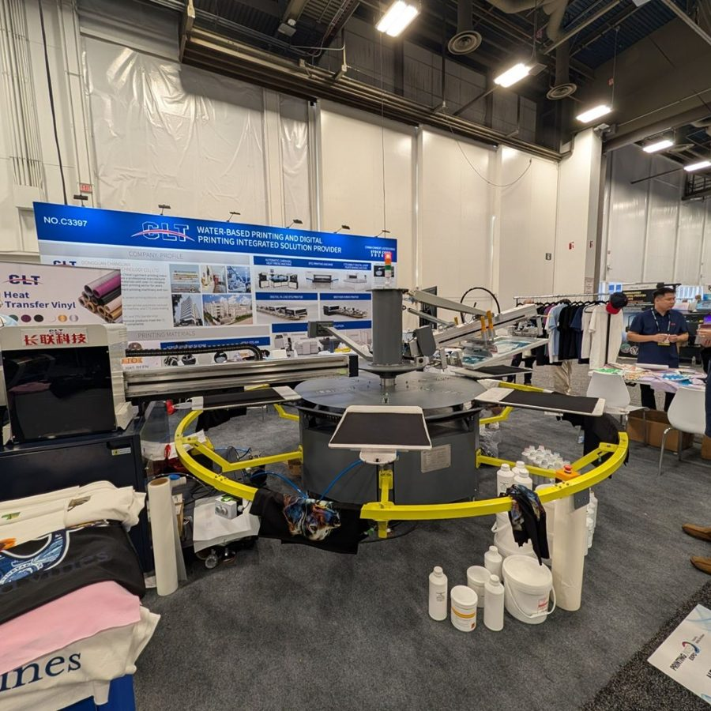  Booth C3397: automatic carousel with a digital station running | 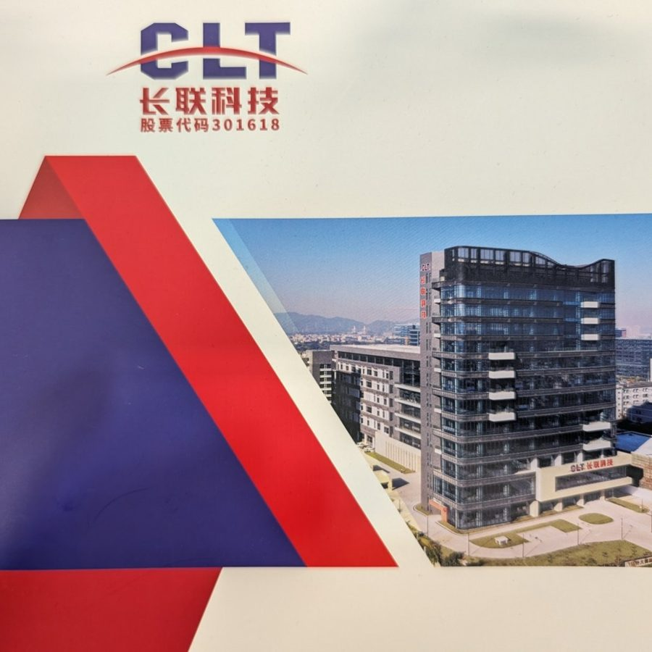  CLT corporate brochure (code 301618)
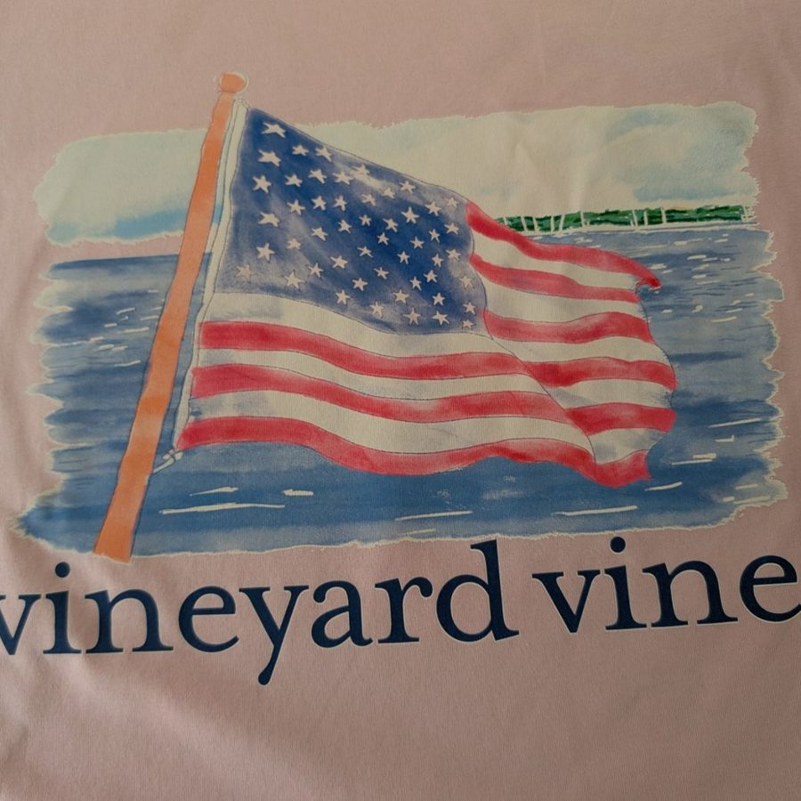  Digital watercolor over white base on a colored garment | 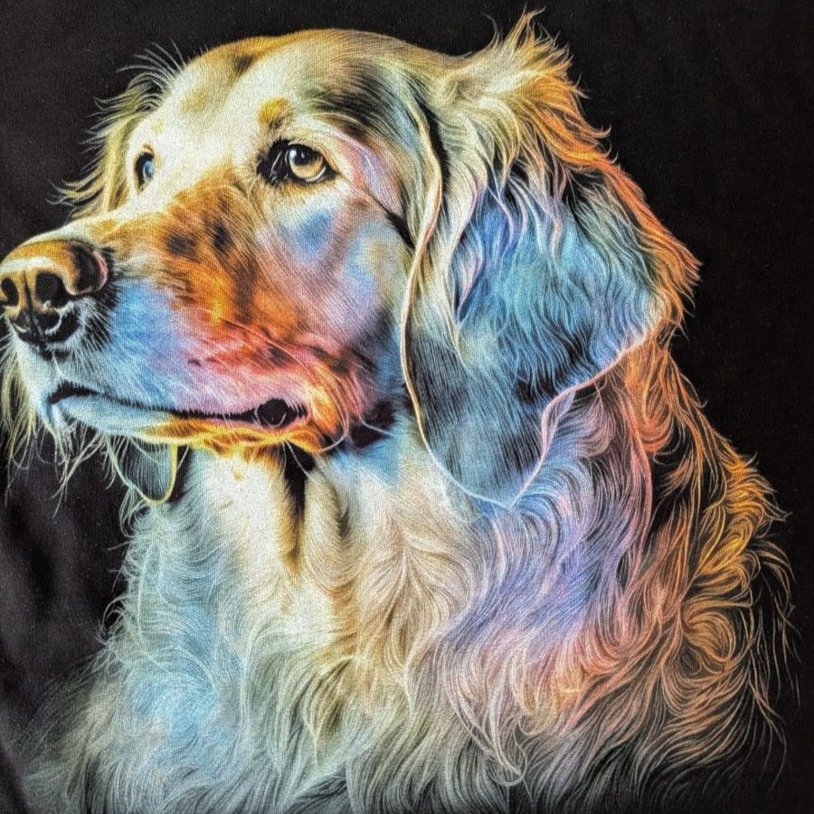  Digital photorealism on a dark garment
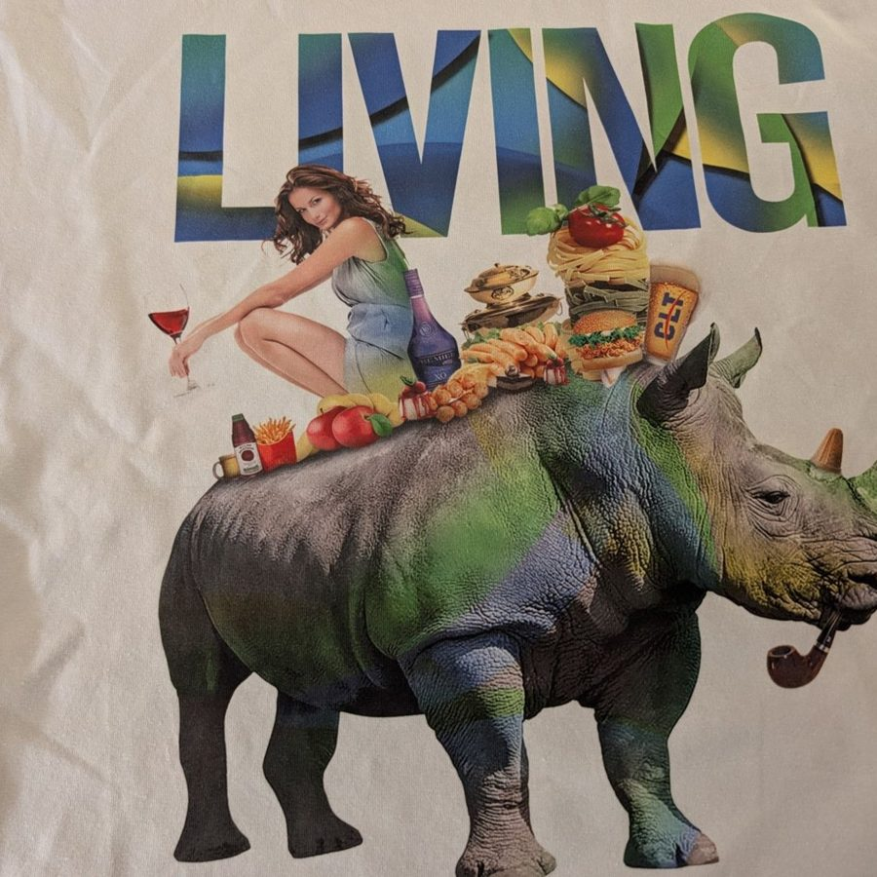  Full-color photographic collage | 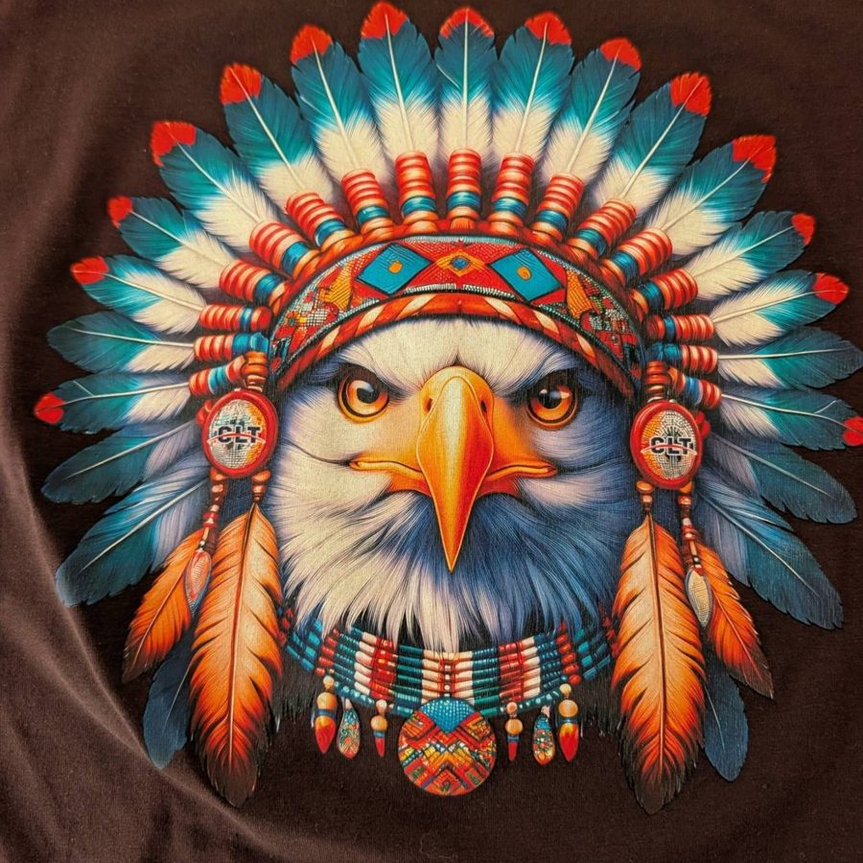  Breathable digital print on a dark garment
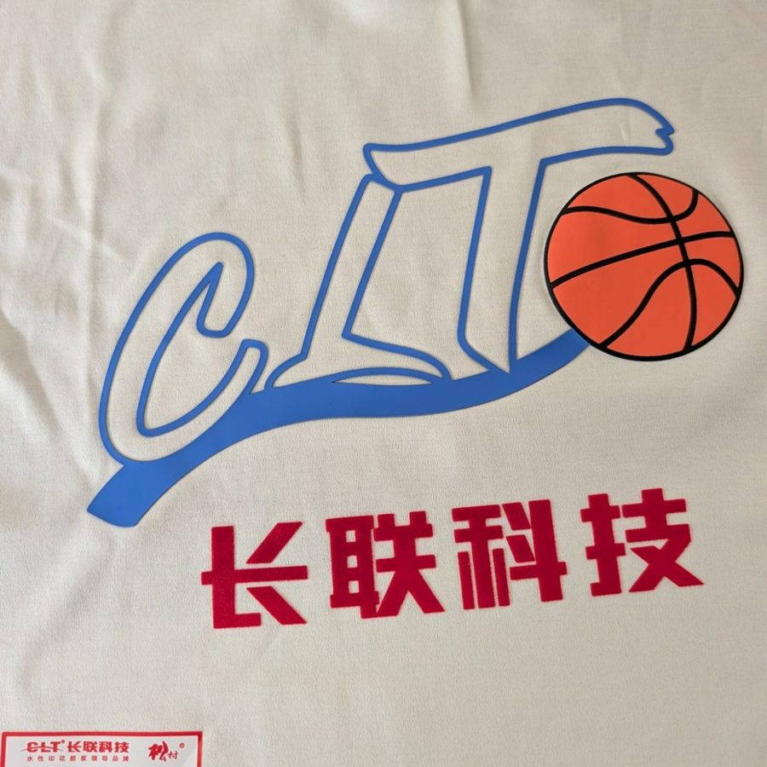  CLT pastes: high build 511-1, puff MP399, cold foil 105-3 |   Sports crest with relief and shimmer on polyester
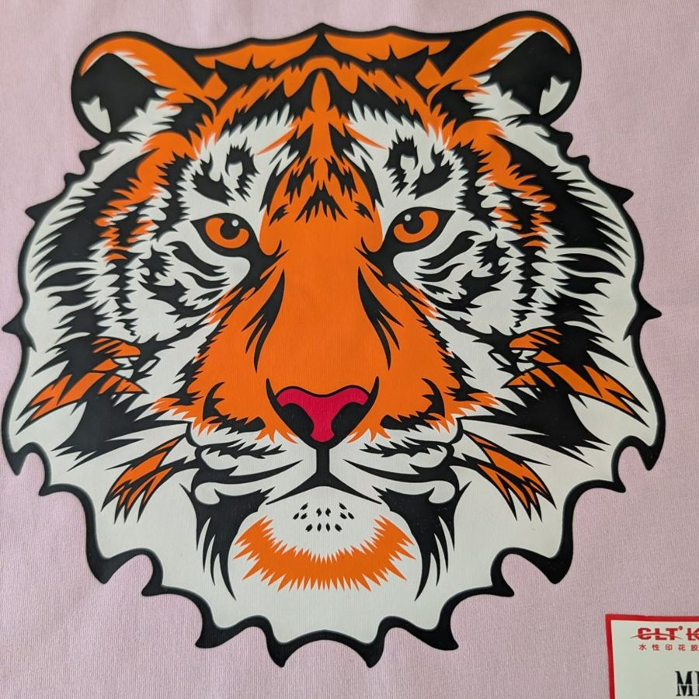  Spot-color screen print on a colored garment | 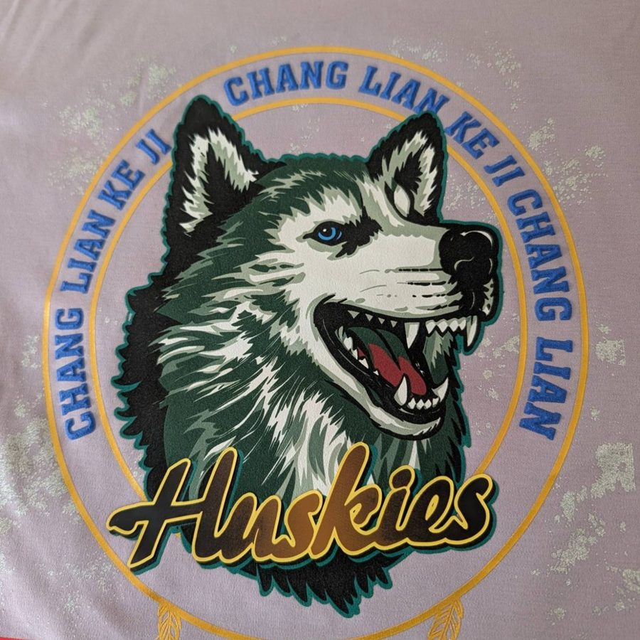  Relief, gold foil and metallic sparkle combined
Techniques were identified visually and should be confirmed with CLT.

Appendix: sources
- CLT — garmentprintingpro.com (international site) and dgclt.com (corporate).
- CLT — 2025 annual report, Shenzhen Stock Exchange (code 301618).
- INEGI — Conociendo la industria textil y de la confección 2024.
- CANAINTEX — Statistical information, May 2026 (2025 close).
- FESPA México — Overview and challenges of the Mexican textile industry 2025.
- Decree on tariffs for non-FTA countries (in force since January 1, 2026); El País, El Economista, Expansión.
- Equipment price references: public U.S. distributors (Texsource / M&R).
- Inks: avientspecialtyinks.com, screentec.com.mx, sanchez.com.mx, casadiaz.com.mx (Matsui), marabu-tintas.es, ruco-druckfarben.de (distributors), tampoprint.com; prices from screenprinting.com, spsi.com, graficosleo.com.mx, Mercado Libre and Alibaba (October 2026).

