**Enhancing Forms**

A major part of web development is to deal with user input. Through JavaScript we can use events to handle the user input and provide the user with a much better experience when they visit our websites.

One example of this can be seen when a user is creating a username and a password. In your final project, if your website does not contain a username and password, create the fields for them. If your website does not contain a feedback page. Create a new page with a form which will contain a multiline text field where a person can enter their feedback. That page should also allow the user to enter their email (so you can contact them back).

Using JavaScript, create an event that will handle the username and password. For the username, the username must be at least 5 characters long. The password must be at least 8 characters long.

The feedback message should not exceed 500 characters.

**JavaScript**

You must use the addEventListener method. If the user is using IE8 or earlier you should use the attachEvent method instead.

For both the username and password fields, once the user selects one of the fields (the field is focused), a little notification should appear beneath it. The notification should state: “The password should be at least 5 characters long”, in red letters if the condition is not met, and should appear in green letters if the username has at least 5 characters. The same should be done to the password field. Once the user clicks out of the field (on blur), this message should disappear. For this form, there should be a submit button, upon being clicked, this button should prevent the default behavior. (This should be valid for both newer browsers and for IE). Instead of submitting the form, the button should display a message at the bottom of the form that says: “The form data is valid” if both the password and the username are valid, or “The data is invalid, please double check or username and/or password”.

For the feedback form, you should have a counter below it that tells you how many characters the user can still write. For example at first it will display: “500 characters”. Every time the user releases a key, the counter will be updated to display the new amount of characters. Modify the “submit” button to prevent its default behavior (both in newer browsers and IE). Instead, clicking submit should display the message that was typed into the feedback box at the bottom of the page.

**Grading**

|  |  |
| --- | --- |
| **Task** | **Points** |
| Display username requirements on focus | 10 points |
| Display password requirements on focus | 10 points |
| Validates username and displays green/red text accordingly | 10 points |
| Validates username and displays green/red text accordingly | 10 points |
| Pressing Submit displays a message about username/password validation | 20 points |
| Feedback form counts the number of characters left | 20 points |
| Pressing submit displays the message at the bottom of the page. | 20 points |
| Total | 100 Points |

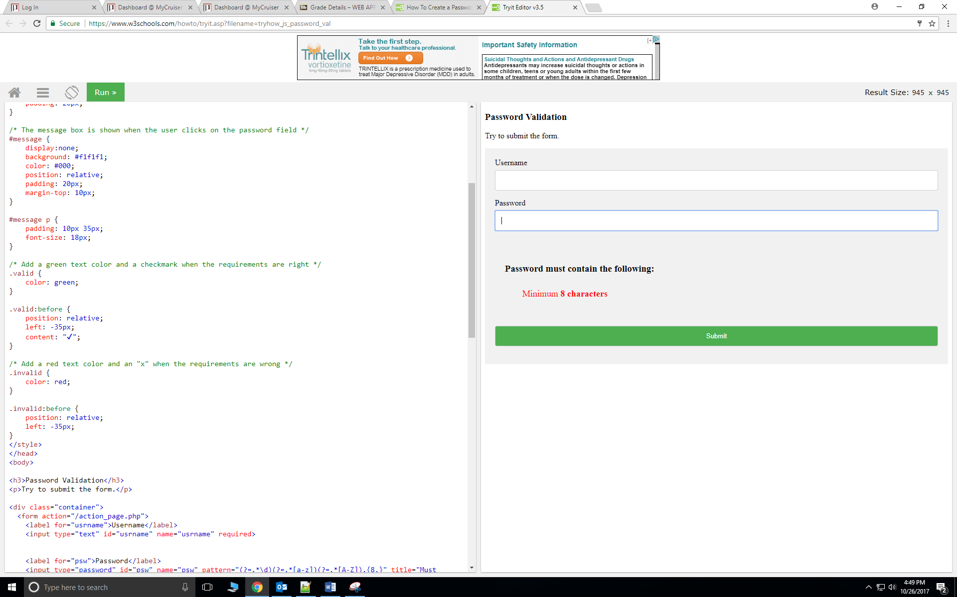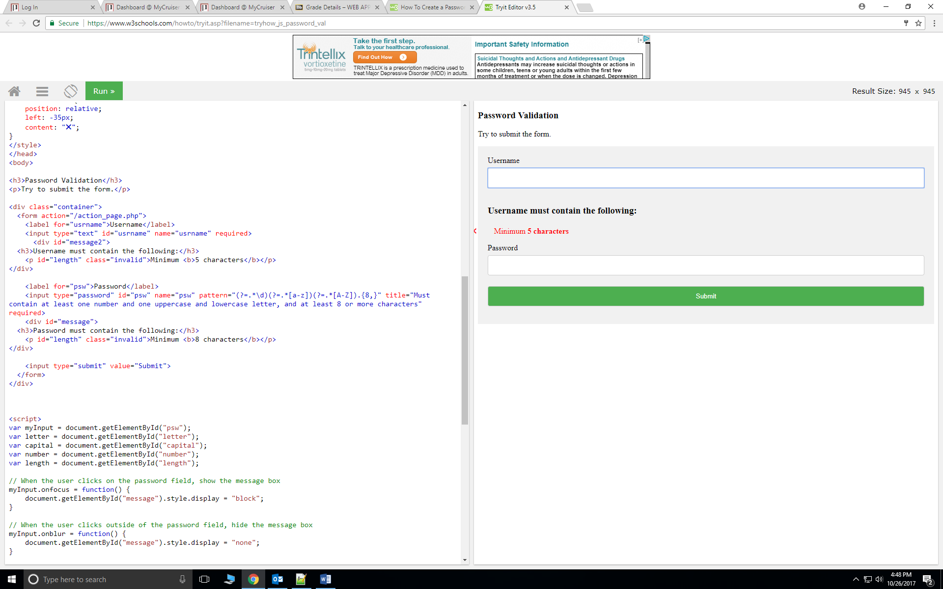**Example:**

