Supplementary Table 1: Mean χ², LD-score regression intercept and SNP-based heritability (h²) from lipedema phenotype GWAS with adjustment for hip circumference.
 | Mean Chi² | Intercept | h²
Hip Circ. adjusted | 1.210 | 1.0164 (0.0072) | 0.0513 (0.0038)

Supplementary Table 2: Associations of 18 significant SNPs for lipedema phenotype with each relevant phenotype among all UK Biobank women (European ancestry). Linear regression models included age, center, chip, and 10 genetic principal components as covariates.
 |  |  | Height |  |  | BMI |  |  | WC |  |  | HC |  |  | WHR |  |  | Leg Fat %
SNP | Effect allele | Nearest gene(s) | beta | se | p | beta | se | p | beta | se | p | beta | se | p | beta | se | p | beta | se | p
rs72959041 | G | RSPO3 | -0.26 | 0.04 | 6.5E-11 | 0.15 | 0.03 | 1.2E-05 | -0.61 | 0.08 | 2.4E-13 | 0.76 | 0.07 | 2.2E-28 | -0.0119 | 0.0005 | 2.7E-148 | 0.15 | 0.04 | 4.7E-05
rs1128249 | G | GRB14-COBLL1 | -0.01 | 0.02 | 0.46 | -0.08 | 0.01 | 1.8E-08 | 0.08 | 0.04 | 0.03 | -0.34 | 0.03 | 6.5E-30 | 0.0035 | 0.0002 | 2.0E-68 | -0.10 | 0.02 | 8.6E-10
rs11057418 | G | ZNF664-FAM101A | 0.01 | 0.02 | 0.55 | 0.07 | 0.02 | 3.6E-04 | -0.12 | 0.05 | 0.01 | 0.24 | 0.04 | 1.4E-10 | -0.0031 | 0.0003 | 4.5E-35 | 0.08 | 0.02 | 1.4E-04
rs6905288 | G | VEGFA | 0.00 | 0.02 | 0.92 | 0.05 | 0.01 | 8.0E-04 | -0.25 | 0.04 | 2.5E-12 | 0.17 | 0.03 | 1.9E-08 | -0.0037 | 0.0002 | 1.8E-79 | 0.002 | 0.02 | 0.88
rs6602994 | T | ADAMTSL3 | -0.30 | 0.02 | 3.1E-53 | -0.02 | 0.02 | 0.25 | -0.24 | 0.04 | 9.2E-10 | -0.25 | 0.03 | 1.9E-14 | -0.0003 | 0.0002 | 0.15 | -0.14 | 0.02 | 9.9E-17
rs10649697 | T | SLC12A2 | 0.07 | 0.02 | 1.8E-04 | 0.00 | 0.02 | 0.94 | -0.08 | 0.04 | 0.04 | 0.00 | 0.03 | 0.90 | -0.0008 | 0.0002 | 2.9E-04 | -0.17 | 0.02 | 8.6E-22
rs4616635 | C | ADAMTS9 | -0.03 | 0.02 | 0.09 | -0.04 | 0.02 | 8.2E-03 | 0.20 | 0.04 | 5.5E-07 | -0.22 | 0.03 | 7.4E-12 | 0.0036 | 0.0002 | 1.4E-61 | -0.05 | 0.02 | 8.2E-03
rs749853052 | TG | LYPLAL1 | -0.09 | 0.02 | 4.0E-06 | -0.06 | 0.02 | 9.0E-05 | 0.04 | 0.04 | 0.28 | -0.38 | 0.03 | 5.2E-33 | 0.0034 | 0.0002 | 2.6E-58 | -0.08 | 0.02 | 2.1E-06
rs536569640 | TAATA | PITPNM2 | 0.05 | 0.02 | 0.01 | 0.06 | 0.02 | 9.0E-04 | -0.03 | 0.04 | 0.53 | 0.20 | 0.04 | 2.6E-08 | -0.0019 | 0.0002 | 3.1E-15 | 0.07 | 0.02 | 1.1E-04
rs28394864 | G | ZNF652 | 0.11 | 0.02 | 9.6E-10 | -0.03 | 0.01 | 0.03 | -0.08 | 0.04 | 0.03 | 0.01 | 0.03 | 0.72 | -0.0008 | 0.0002 | 1.8E-05 | 0.03 | 0.02 | 0.06
rs543302184 | T | PLCE1 | 0.00 | 0.02 | 0.89 | -0.01 | 0.02 | 0.39 | 0.04 | 0.04 | 0.27 | 0.06 | 0.03 | 0.05 | -0.0001 | 0.0002 | 0.68 | 0.08 | 0.02 | 2.9E-07
rs11772918 | A | intergenic | 0.03 | 0.02 | 0.13 | 0.01 | 0.01 | 0.42 | 0.01 | 0.04 | 0.89 | 0.00 | 0.03 | 0.97 | 0.0000 | 0.0002 | 0.81 | -0.06 | 0.02 | 1.4E-04
rs62492368 | G | ABP1/AOC1 | -0.13 | 0.02 | 1.6E-12 | -0.01 | 0.02 | 0.54 | -0.12 | 0.04 | 0.00 | -0.04 | 0.03 | 0.19 | -0.0008 | 0.0002 | 1.8E-04 | 0.05 | 0.02 | 2.5E-03
rs5868014 | GC | ANKRD55-MAP3K1 | 0.02 | 0.02 | 0.31 | 0.02 | 0.02 | 0.36 | -0.29 | 0.05 | 1.7E-10 | 0.03 | 0.04 | 0.41 | -0.0030 | 0.0002 | 1.8E-32 | -0.004 | 0.02 | 0.84
rs71490394 | G | EML3 | 0.02 | 0.02 | 0.23 | 0.01 | 0.02 | 0.53 | -0.14 | 0.04 | 1.6E-04 | 0.07 | 0.03 | 0.02 | -0.0019 | 0.0002 | 2.2E-21 | 0.02 | 0.02 | 0.18
rs28849840 | G | LIMA1-FAM186A | -0.11 | 0.02 | 2.4E-10 | 0.03 | 0.02 | 0.08 | 0.03 | 0.04 | 0.36 | -0.05 | 0.03 | 0.08 | 0.0007 | 0.0002 | 2.6E-04 | -0.04 | 0.02 | 0.01
rs565113908 | T | intergenic | -0.46 | 0.26 | 0.08 | -0.35 | 0.22 | 0.12 | -0.32 | 0.54 | 0.56 | -1.08 | 0.45 | 0.02 | 0.0051 | 0.0030 | 0.09 | -0.44 | 0.24 | 0.06
rs4680338 | C | LEKR1-CCNL1 | -0.01 | 0.02 | 0.69 | 0.01 | 0.01 | 0.63 | 0.26 | 0.04 | 1.1E-12 | 0.05 | 0.03 | 0.07 | 0.0020 | 0.0002 | 7.4E-24 | 0.01 | 0.02 | 0.61

Supplementary Table 3: Loci showing significant association with lipedema phenotype (hip circumference (HC) adjusted and not adjusted), ordered by ascending p-value.
 |  |  |  |  |  |  |  |  | Not HC adjusted
SNP | Chr | BP | Nearest gene | A1 | A0 | A1 Freq | OR | p-value | OR | p-value
rs72959041 | 6 | 127,454,893 | RSPO3 | G | A | 0.950 | 1.24 | 2.7E-19 | 1.13 | 1.5E-08
rs1128249 | 2 | 165,528,624 | GRB14-COBLL1 | G | T | 0.610 | 0.92 | 3.0E-16 | 0.93 | 2.0E-12
rs11057418 | 12 | 124,508,976 | ZNF664-FAM101A | G | C | 0.798 | 1.10 | 5.6E-14 | 1.08 | 3.0E-09
rs6905288 | 6 | 43,758,873 | VEGFA | G | A | 0.429 | 1.07 | 1.8E-13 | 1.06 | 5.7E-09
rs6602994 | 15 | 84,490,757 | ADAMTSL3 | T | C | 0.276 | 0.92 | 6.9E-13 | 0.94 | 7.3E-07
rs10649697 | 5 | 127,432,908 | SLC12A2 | T | TAGA | 0.246 | 0.92 | 1.3E-12 | 0.92 | 9.1E-12
rs4616635 | 3 | 64,702,275 | ADAMTS9 | C | G | 0.723 | 0.93 | 4.9E-12 | 0.92 | 4.1E-13
rs749853052 | 1 | 219,747,226 | LYPLAL1 | TG | T | 0.702 | 0.93 | 1.5E-11 | 0.95 | 1.5E-06
rs536569640 | 12 | 123,553,002 | PITPNM2 | TAATA | T | 0.726 | 1.08 | 1.9E-11 | 1.05 | 4.1E-06
rs28394864 | 17 | 47,450,775 | ZNF652 | G | A | 0.538 | 1.07 | 1.9E-11 | 1.04 | 1.2E-05
rs543302184 | 10 | 96,009,182 | PLCE1 | T | TA | 0.580 | 1.07 | 3.0E-11 | 1.04 | 2.7E-05
rs11772918 | 7 | 46,609,344 | intergenic | A | G | 0.460 | 0.93 | 3.6E-11 | 0.96 | 5.7E-04
rs62492368 | 7 | 150,537,635 | ABP1/AOC1 | G | A | 0.694 | 1.07 | 4.0E-11 | 1.05 | 2.2E-05
rs5868014 | 5 | 55,860,907 | ANKRD55-MAP3K1 | GC | G | 0.814 | 1.08 | 2.7E-10 | 1.06 | 5.6E-07
rs71490394 | 11 | 62,370,155 | EML3 | G | A | 0.629 | 1.07 | 1.2E-09 | 1.04 | 5.2E-04
rs28849840 | 12 | 50,703,384 | LIMA1-FAM186A | G | A | 0.650 | 0.94 | 1.5E-09 | 0.96 | 5.6E-05
rs565113908 | 18 | 37,904,550 | intergenic | T | G | 0.999 | 0.52 | 1.6E-09 | 0.57 | 4.2E-06
rs4680338 | 3 | 156,794,425 | LEKR1-CCNL1 | C | G | 0.595 | 0.94 | 2.3E-09 | 0.96 | 2.1E-04

A1 refers to effect allele that OR (adds ratio) corresponds to; A1 Freq: effect allele frequency

Supplementary Table 4: Association of top SNPs identified in main model with lipedema phenotype incorporating leg pain in case definition (n=1,724 cases; 165,227 controls).
SNP | Chr | BP | Nearest gene | A1 | A0 | A1 Freq | Beta | SE | p-value
rs749853052 | 1 | 219,747,226 | LYPLAL1 | TG | T | 0.70 | -0.0017 | 0.0004 | 4.5E-06
rs11772918 | 7 | 46,609,344 | intergenic | A | G | 0.46 | -0.0014 | 0.0004 | 9.3E-05
rs62492368 | 7 | 150,537,635 | ABP1/AOC1 | G | A | 0.69 | 0.0011 | 0.0004 | 2.9E-03
rs11057418 | 12 | 124,508,976 | ZNF664-FAM101A | G | C | 0.80 | 0.0013 | 0.0004 | 4.4E-03
rs6905288 | 6 | 43,758,873 | VEGFA | G | A | 0.43 | 0.0009 | 0.0004 | 8.1E-03
rs72959041 | 6 | 127,454,893 | RSPO3 | G | A | 0.95 | 0.0020 | 0.0008 | 1.5E-02
rs28849840 | 12 | 50,703,384 | LIMA1-FAM186A | G | A | 0.65 | -0.0009 | 0.0004 | 1.8E-02
rs5868014 | 5 | 55,860,907 | ANKRD55-MAP3K1 | GC | G | 0.81 | 0.0010 | 0.0004 | 2.0E-02
rs71490394 | 11 | 62,370,155 | EML3 | G | A | 0.63 | 0.0007 | 0.0004 | 6.3E-02
rs536569640 | 12 | 123,553,002 | PITPNM2 | TAATA | T | 0.72 | 0.0007 | 0.0004 | 1.0E-01
rs1128249 | 2 | 165,528,624 | GRB14-COBLL1 | G | T | 0.61 | -0.0006 | 0.0004 | 1.1E-01
rs4616635 | 3 | 64,702,275 | ADAMTS9 | C | G | 0.72 | -0.0005 | 0.0004 | 1.7E-01
rs10649697 | 5 | 127,432,908 | SLC12A2 | T | TAGA | 0.25 | -0.0006 | 0.0004 | 1.7E-01
rs543302184 | 10 | 96,009,182 | PLCE1 | T | TA | 0.58 | 0.0005 | 0.0004 | 1.7E-01
rs6602994 | 15 | 84,490,757 | ADAMTSL3 | T | C | 0.28 | -0.0003 | 0.0004 | 3.7E-01
rs28394864 | 17 | 47,450,775 | ZNF652 | G | A | 0.54 | 0.0003 | 0.0003 | 4.0E-01
rs4680338 | 3 | 156,794,425 | LEKR1-CCNL1 | C | G | 0.60 | 0.0000 | 0.0004 | 9.4E-01
A1 refers to effect allele that OR (adds ratio) corresponds to; A1 Freq: effect allele frequency

Supplementary Table 5: List of statistically significant genes identified by MAGMA gene-based analysis.
SYMBOL | GENE | CHR | START | STOP | NSNPS | ZSTAT | P
ADAMTSL3 | ENSG00000156218 | 15 | 84312838 | 84718594 | 1182 | 8.1051 | 2.64E-16
FAM101A | ENSG00000178882 | 12 | 124447788 | 124810570 | 1182 | 7.5703 | 1.86E-14
ZNF664 | ENSG00000179195 | 12 | 124446392 | 124509986 | 152 | 7.5307 | 2.52E-14
COBLL1 | ENSG00000082438 | 2 | 165500134 | 165710189 | 722 | 7.2338 | 2.35E-13
CCDC92 | ENSG00000119242 | 12 | 124393207 | 124467378 | 211 | 6.9978 | 1.30E-12
EML3 | ENSG00000149499 | 11 | 62359690 | 62390237 | 49 | 6.4505 | 5.58E-11
MIR3654 | ENSG00000255508 | 11 | 62317075 | 62369003 | 90 | 6.4354 | 6.16E-11
EEF1G | ENSG00000254772 | 11 | 62317073 | 62352401 | 67 | 6.4096 | 7.29E-11
TUT1 | ENSG00000149016 | 11 | 62332517 | 62369649 | 61 | 6.3347 | 1.19E-10
DNAH10 | ENSG00000197653 | 12 | 124237042 | 124430753 | 671 | 6.2883 | 1.60E-10
MTA2 | ENSG00000149480 | 11 | 62350686 | 62379312 | 50 | 6.2354 | 2.25E-10
DNAH10OS | ENSG00000250091 | 12 | 124400971 | 124429531 | 96 | 6.2321 | 2.30E-10
HCAR1 | ENSG00000196917 | 12 | 123094824 | 123225390 | 341 | 6.2095 | 2.66E-10
RP11-81K2.1 | ENSG00000262039 | 17 | 47438102 | 47564350 | 387 | 6.1863 | 3.08E-10
B3GAT3 | ENSG00000149541 | 11 | 62372768 | 62399647 | 42 | 6.1822 | 3.16E-10
ROM1 | ENSG00000149489 | 11 | 62369194 | 62392592 | 36 | 6.1605 | 3.63E-10
ZNF652 | ENSG00000198740 | 17 | 47356568 | 47449835 | 231 | 6.1296 | 4.40E-10
HOXA10 | ENSG00000253293 | 7 | 27200210 | 27229880 | 62 | 5.9142 | 1.67E-09
RP11-1102P16.1 | ENSG00000253379 | 8 | 72305675 | 72514260 | 555 | 5.9107 | 1.70E-09
GANAB | ENSG00000089597 | 11 | 62382298 | 62424104 | 66 | 5.8639 | 2.26E-09
INTS5 | ENSG00000185085 | 11 | 62404320 | 62430774 | 53 | 5.8271 | 2.82E-09
PLXND1 | ENSG00000004399 | 3 | 129264018 | 129335661 | 264 | 5.769 | 3.99E-09
RP1-170O19.20 | ENSG00000257184 | 7 | 27193154 | 27229632 | 80 | 5.7509 | 4.44E-09
TMEM176A | ENSG00000002933 | 7 | 150487491 | 150512208 | 118 | 5.6638 | 7.40E-09
AOC1 | ENSG00000002726 | 7 | 150511715 | 150568592 | 301 | 5.5426 | 1.49E-08
RHO | ENSG00000163914 | 3 | 129237483 | 129264012 | 75 | 5.5378 | 1.53E-08
HOXA9 | ENSG00000078399 | 7 | 27192054 | 27220117 | 63 | 5.4871 | 2.04E-08
SHOX2 | ENSG00000168779 | 3 | 157804948 | 157834292 | 70 | 5.4604 | 2.38E-08
PTCH1 | ENSG00000185920 | 9 | 98195262 | 98289339 | 290 | 5.4283 | 2.85E-08
RP11-831H9.11 | ENSG00000255432 | 11 | 62407166 | 62442650 | 69 | 5.3922 | 3.48E-08
PHOSPHO1 | ENSG00000173868 | 17 | 47290724 | 47318128 | 79 | 5.3621 | 4.11E-08
C11orf83 | ENSG00000204922 | 11 | 62427745 | 62451159 | 50 | 5.3619 | 4.12E-08
H1FOO | ENSG00000178804 | 3 | 129252057 | 129280310 | 79 | 5.3404 | 4.64E-08
VEGFA | ENSG00000112715 | 6 | 43727921 | 43764224 | 89 | 5.2946 | 5.97E-08
C11orf48 | ENSG00000162194 | 11 | 62420287 | 62449727 | 66 | 5.288 | 6.18E-08
SMARCD1 | ENSG00000066117 | 12 | 50468755 | 50504495 | 46 | 5.282 | 6.39E-08
IFT122 | ENSG00000163913 | 3 | 129148968 | 129249198 | 331 | 5.1602 | 1.23E-07
UBXN1 | ENSG00000162191 | 11 | 62433970 | 62456567 | 41 | 5.1549 | 1.27E-07
MBD4 | ENSG00000129071 | 3 | 129139787 | 129168878 | 121 | 5.1508 | 1.30E-07
TMCC1 | ENSG00000172765 | 3 | 129356635 | 129622419 | 399 | 5.1126 | 1.59E-07
ATF1 | ENSG00000123268 | 12 | 51147493 | 51224905 | 137 | 5.1124 | 1.59E-07
STH | ENSG00000256762 | 17 | 44066616 | 44087060 | 118 | 5.1041 | 1.66E-07
METTL12 | ENSG00000214756 | 11 | 62422781 | 62445968 | 54 | 5.0879 | 1.81E-07
SOSTDC1 | ENSG00000171243 | 7 | 16491106 | 16580205 | 404 | 5.0718 | 1.97E-07
NSMCE2 | ENSG00000156831 | 8 | 126093921 | 126389362 | 750 | 5.0617 | 2.08E-07
GPD1 | ENSG00000167588 | 12 | 50487602 | 50515102 | 39 | 5.0608 | 2.09E-07
WNT3 | ENSG00000108379 | 17 | 44829872 | 44920520 | 148 | 5.0357 | 2.38E-07
MAPT | ENSG00000186868 | 17 | 43961748 | 44115700 | 789 | 5.0201 | 2.58E-07
HCAR2 | ENSG00000182782 | 12 | 123175840 | 123197890 | 60 | 5.0169 | 2.63E-07
SPPL2C | ENSG00000185294 | 17 | 43912256 | 43934438 | 138 | 5.005 | 2.79E-07
LRRC37A | ENSG00000176681 | 17 | 44360099 | 44425160 | 11 | 4.9343 | 4.02E-07
KANSL1 | ENSG00000120071 | 17 | 44097282 | 44312733 | 751 | 4.922 | 4.28E-07
COL5A2 | ENSG00000204262 | 2 | 189886622 | 190054605 | 484 | 4.9212 | 4.30E-07
ABI3 | ENSG00000108798 | 17 | 47277589 | 47310587 | 102 | 4.9182 | 4.37E-07
CRHR1 | ENSG00000120088 | 17 | 43689267 | 43923194 | 1024 | 4.8865 | 5.13E-07
SH3GL3 | ENSG00000140600 | 15 | 84105980 | 84297495 | 510 | 4.8503 | 6.16E-07
HOXA11 | ENSG00000005073 | 7 | 27211129 | 27234842 | 45 | 4.8215 | 7.12E-07
NUAK2 | ENSG00000163545 | 1 | 205261187 | 205300883 | 145 | 4.7535 | 1.00E-06
FAM118A | ENSG00000100376 | 22 | 45694849 | 45747836 | 181 | 4.7373 | 1.08E-06
DFNB31 | ENSG00000095397 | 9 | 117154360 | 117277730 | 448 | 4.7363 | 1.09E-06
LIMA1 | ENSG00000050405 | 12 | 50559571 | 50687329 | 165 | 4.7244 | 1.15E-06
SLC12A2 | ENSG00000064651 | 5 | 127409458 | 127535380 | 276 | 4.7092 | 1.24E-06
GOLGA6L4 | ENSG00000184206 | 15 | 84894525 | 84924120 | 56 | 4.666 | 1.54E-06
EFCAB12 | ENSG00000172771 | 3 | 129110164 | 129157494 | 205 | 4.665 | 1.54E-06
PHB | ENSG00000167085 | 17 | 47471414 | 47502246 | 87 | 4.6499 | 1.66E-06
ARL17B | ENSG00000228696 | 17 | 44342150 | 44449130 | 78 | 4.6242 | 1.88E-06
PXDNL | ENSG00000147485 | 8 | 52222138 | 52732005 | 1931 | 4.6082 | 2.03E-06
COX14 | ENSG00000178449 | 12 | 50495762 | 50524240 | 45 | 4.5988 | 2.12E-06
MANEA | ENSG00000172469 | 6 | 96015419 | 96067333 | 177 | 4.5984 | 2.13E-06
SIRT4 | ENSG00000089163 | 12 | 120730119 | 120761052 | 101 | 4.5875 | 2.24E-06
DIP2B | ENSG00000066084 | 12 | 50888768 | 51152450 | 442 | 4.5818 | 2.31E-06
CCDC71L | ENSG00000253276 | 7 | 106287211 | 106311442 | 76 | 4.5619 | 2.53E-06
NSNPS: the number of SNPs annotated to that gene that were found in the data and were not excluded based on internal SNP QC

Supplementary Table 6: All significant (FDR<0.05) eQTL of top SNPs in GTEx data

Supplementary Table 7: eQTL of all SNPs in LD (r²>0.6) with top SNPs, using data from GTEx v7. Only results with FDR<0.05 are shown. Chromosome and position are shown to indicate loci in general, but do not imply that the eQTL is for this particular variant.

Chr | Region (bp) | Gene | Tissue(s)
6 | 127454893 | RSPO3 | Adipose_Subcutaneous
2 | 165528624 | GRB14 | Esophagus_Muscularis
2 | 165528624 | SLC38A11 | Muscle_Skeletal, Thyroid
2 | 165528624 | SCN2A | Nerve_Tibial
2 | 165528624 | FIGN | Skin_Sun_Exposed_Lower_leg
2 | 165528624 | COBLL1 | Thyroid
12 | 124508976 | CCDC92 | Adipose_Subcutaneous, Adipose_Visceral_Omentum, Adrenal_Gland, Artery_Tibial, Breast_Mammary_Tissue, Esophagus_Mucosa, Heart_Atrial_Appendage, Heart_Left_Ventricle, Lung, Muscle_Skeletal, Nerve_Tibial, Prostate, Skin_Not_Sun_Exposed_Suprapubic, Skin_Sun_Exposed_Lower_leg, Spleen, Thyroid, Whole_Blood
12 | 124508976 | DNAH10OS | Adipose_Subcutaneous, Adipose_Visceral_Omentum, Artery_Aorta, Artery_Tibial, Brain_Anterior_cingulate_cortex_BA24, Brain_Cortex, Brain_Frontal_Cortex_BA9, Breast_Mammary_Tissue, Colon_Sigmoid, Colon_Transverse, Esophagus_Gastroesophageal_Junction, Esophagus_Mucosa, Esophagus_Muscularis, Heart_Atrial_Appendage, Heart_Left_Ventricle, Lung, Muscle_Skeletal, Nerve_Tibial, Prostate, Skin_Not_Sun_Exposed_Suprapubic, Skin_Sun_Exposed_Lower_leg, Testis, Thyroid
12 | 124508976 | DNAH10 | Adipose_Subcutaneous, Adipose_Visceral_Omentum, Artery_Tibial, Cells_Transformed_fibroblasts, Colon_Sigmoid, Esophagus_Gastroesophageal_Junction, Esophagus_Muscularis, Nerve_Tibial, Testis, Thyroid, Whole_Blood
12 | 124508976 | TCTN2 | Adipose_Subcutaneous, Muscle_Skeletal
12 | 124508976 | ZNF664 | Adipose_Subcutaneous, Adipose_Visceral_Omentum, Cells_Transformed_fibroblasts, Heart_Atrial_Appendage, Heart_Left_Ventricle, Nerve_Tibial, Thyroid, Whole_Blood
12 | 124508976 | FAM101A | Adrenal_Gland, Nerve_Tibial
12 | 124508976 | ATP6V0A2 | Nerve_Tibial
12 | 124508976 | TMED2 | Skin_Not_Sun_Exposed_Suprapubic
15 | 84490757 | GOLGA6L4 | Adipose_Subcutaneous, Adipose_Visceral_Omentum, Brain_Cortex, Breast_Mammary_Tissue, Colon_Sigmoid,Esophagus_Mucosa, Esophagus_Muscularis, Nerve_Tibial, Skin_Not_Sun_Exposed_Suprapubic, Skin_Sun_Exposed_Lower_leg, Thyroid
15 | 84490757 | UBE2Q2L | Adipose_Subcutaneous, Artery_Aorta, Artery_Tibial, Cells_Transformed_fibroblasts, Colon_Transverse, Esophagus_Mucosa, Esophagus_Muscularis, Heart_Atrial_Appendage, Lung, Muscle_Skeletal, Nerve_Tibial, Skin_Sun_Exposed_Lower_leg, Thyroid
15 | 84490757 | WDR73 | Adipose_Visceral_Omentum, Artery_Aorta, Artery_Tibial, Breast_Mammary_Tissue, Esophagus_Muscularis, Muscle_Skeletal, Nerve_Tibial, Pancreas, Thyroid
15 | 84490757 | ZSCAN2 | Adrenal_Gland, Lung, Whole_Blood
15 | 84490757 | ADAMTSL3 | Artery_Aorta, Artery_Tibial, Brain_Cerebellar_Hemisphere, Brain_Cerebellum, Cells_EBV-transformed_lymphocytes, Esophagus_Muscularis, Ovary, Thyroid
15 | 84490757 | NMB | Artery_Tibial, Cells_Transformed_fibroblasts, Colon_Sigmoid, Colon_Transverse, Esophagus_Mucosa, Esophagus_Muscularis, Nerve_Tibial, Pancreas, Skin_Not_Sun_Exposed_Suprapubic, Spleen, Stomach, Testis
15 | 84490757 | ALPK3 | Heart_Atrial_Appendage, Skin_Sun_Exposed_Lower_leg
15 | 84490757 | SH3GL3 | Small_Intestine_Terminal_Ileum
5 | 127432908 | SLC12A2 | Brain_Cerebellum
5 | 127432908 | FBN2 | Spleen, Thyroid
3 | 64702275 | ADAMTS9 | Artery_Aorta
1 | 219747226 | EPRS | Artery_Tibial
1 | 219747226 | SLC30A10 | Skin_Sun_Exposed_Lower_leg
17 | 47450775 | ZNF652 | Adipose_Subcutaneous, Artery_Tibial, Cells_Transformed_fibroblasts, Muscle_Skeletal
17 | 47450775 | GNGT2 | Thyroid, Whole_Blood
10 | 96009182 | C10orf129 | Adipose_Visceral_Omentum
10 | 96009182 | NOC3L | Adrenal_Gland, Artery_Aorta, Brain_Frontal_Cortex_BA9, Esophagus_Muscularis, Heart_Atrial_Appendage, Heart_Left_Ventricle, Lung, Muscle_Skeletal, Nerve_Tibial, Pancreas, Skin_Not_Sun_Exposed_Suprapubic, Skin_Sun_Exposed_Lower_leg, Spleen, Thyroid
10 | 96009182 | PLCE1 | Lung, Skin_Sun_Exposed_Lower_leg
7 | 150537635 | TMEM176B | Adipose_Subcutaneous, Adipose_Visceral_Omentum, Brain_Cerebellum, Heart_Atrial_Appendage, Heart_Left_Ventricle, Pancreas, Pituitary, Thyroid
7 | 150537635 | AOC1 | Adipose_Visceral_Omentum, Esophagus_Gastroesophageal_Junction, Esophagus_Muscularis, Heart_Atrial_Appendage, Heart_Left_Ventricle, Liver, Skin_Sun_Exposed_Lower_leg, Thyroid
7 | 150537635 | KCNH2 | Adrenal_Gland, Artery_Tibial, Nerve_Tibial
7 | 150537635 | TMEM176A | Brain_Hypothalamus, Heart_Atrial_Appendage, Heart_Left_Ventricle, Lung, Nerve_Tibial
7 | 150537635 | CHPF2 | Thyroid
7 | 150537635 | ASIC3 | Thyroid
11 | 62370155 | ROM1 | Adipose_Subcutaneous, Adipose_Visceral_Omentum, Artery_Aorta, Artery_Coronary, Artery_Tibial, Breast_Mammary_Tissue, Cells_Transformed_fibroblasts, Colon_Sigmoid, Esophagus_Muscularis, Heart_Left_Ventricle, Lung, Nerve_Tibial, Skin_Not_Sun_Exposed_Suprapubic, Skin_Sun_Exposed_Lower_leg, Thyroid
11 | 62370155 | EML3 | Adipose_Subcutaneous, Adipose_Visceral_Omentum, Adrenal_Gland, Artery_Aorta, Artery_Tibial, Brain_Caudate_basal_ganglia, Brain_Nucleus_accumbens_basal_ganglia, Brain_Putamen_basal_ganglia, Breast_Mammary_Tissue, Cells_EBV-transformed_lymphocytes, Cells_Transformed_fibroblasts, Colon_Sigmoid, Colon_Transverse, Esophagus_Gastroesophageal_Junction, Esophagus_Mucosa, Esophagus_Muscularis, Heart_Atrial_Appendage, Heart_Left_Ventricle, Lung, Minor_Salivary_Gland, Muscle_Skeletal, Nerve_Tibial, Pancreas, Skin_Not_Sun_Exposed_Suprapubic, Skin_Sun_Exposed_Lower_leg, Small_Intestine_Terminal_Ileum, Spleen, Stomach, Testis, Thyroid, Vagina, Whole_Blood
11 | 62370155 | EEF1G | Adipose_Subcutaneous, Artery_Aorta, Artery_Tibial, Esophagus_Mucosa, Esophagus_Muscularis, Lung, Nerve_Tibial, Skin_Not_Sun_Exposed_Suprapubic, Skin_Sun_Exposed_Lower_leg, Thyroid
11 | 62370155 | C11orf83 | Adipose_Visceral_Omentum, Artery_Tibial, Breast_Mammary_Tissue, Esophagus_Muscularis, Heart_Atrial_Appendage, Heart_Left_Ventricle, Muscle_Skeletal, Nerve_Tibial, Pituitary, Skin_Not_Sun_Exposed_Suprapubic, Skin_Sun_Exposed_Lower_leg, Thyroid
11 | 62370155 | B3GAT3 | Adrenal_Gland, Artery_Tibial, Brain_Amygdala, Brain_Caudate_basal_ganglia, Brain_Cerebellum, Brain_Frontal_Cortex_BA9, Brain_Hippocampus, Brain_Nucleus_accumbens_basal_ganglia, Brain_Spinal_cord_cervical_c-1, Brain_Substantia_nigra, Colon_Transverse, Esophagus_Gastroesophageal_Junction, Esophagus_Mucosa, Esophagus_Muscularis, Heart_Atrial_Appendage, Nerve_Tibial, Skin_Not_Sun_Exposed_Suprapubic, Skin_Sun_Exposed_Lower_leg, Testis, Thyroid
11 | 62370155 | MTA2 | Artery_Tibial, Brain_Cerebellar_Hemisphere, Cells_Transformed_fibroblasts, Colon_Transverse, Esophagus_Mucosa, Skin_Not_Sun_Exposed_Suprapubic, Skin_Sun_Exposed_Lower_leg, Spleen, Testis, Vagina
11 | 62370155 | C11orf48 | Brain_Cerebellar_Hemisphere, Brain_Cerebellum, Breast_Mammary_Tissue, Lung, Nerve_Tibial, Skin_Sun_Exposed_Lower_leg, Spleen, Thyroid, Whole_Blood
11 | 62370155 | TTC9C | Cells_Transformed_fibroblasts, Nerve_Tibial, Skin_Not_Sun_Exposed_Suprapubic, Skin_Sun_Exposed_Lower_leg
11 | 62370155 | METTL12 | Esophagus_Muscularis, Nerve_Tibial, Thyroid
11 | 62370155 | INTS5 | Lung, Skin_Not_Sun_Exposed_Suprapubic, Skin_Sun_Exposed_Lower_leg, Whole_Blood
11 | 62370155 | UBXN1 | Muscle_Skeletal
12 | 50703384 | RACGAP1 | Adipose_Subcutaneous
12 | 50703384 | COX14 | Adrenal_Gland, Cells_Transformed_fibroblasts, Lung, Muscle_Skeletal, Nerve_Tibial
12 | 50703384 | ATF1 | Artery_Aorta, Artery_Tibial, Colon_Sigmoid, Esophagus_Muscularis, Lung, Muscle_Skeletal, Whole_Blood
12 | 50703384 | CERS5 | Brain_Cerebellar_Hemisphere, Brain_Cerebellum, Lung, Nerve_Tibial, Spleen, Testis, Thyroid
12 | 50703384 | DIP2B | Brain_Putamen_basal_ganglia, Cells_Transformed_fibroblasts
12 | 50703384 | SMARCD1 | Cells_Transformed_fibroblasts, Skin_Sun_Exposed_Lower_leg
12 | 50703384 | LARP4 | Cells_Transformed_fibroblasts
12 | 50703384 | LETMD1 | Cells_Transformed_fibroblasts, Muscle_Skeletal
12 | 50703384 | LIMA1 | Esophagus_Gastroesophageal_Junction, Esophagus_Muscularis, Thyroid, Whole_Blood
3 | 156794425 | TIPARP | Adipose_Subcutaneous, Artery_Tibial

Supplementary Table 8: Lists of genes that are differentially expressed in relevant and highly represented tissues of interest, according to eQTL analysis.
Adipose_Subcutaneous | Adipose_Visceral_Omentum | Thyroid | Artery_Tibial | Artery_Aorta | Nerve_tibial
CCDC92 | CCDC92 | WDR73 | DNAH10OS | ATF1 | CCDC92
DNAH10OS | DNAH10OS | ZNF664 | WDR73 | DNAH10OS | WDR73
DNAH10 | EML3 | DNAH10OS | ATF1 | ROM1 | DNAH10OS
EEF1G | ROM1 | CCDC92 | CCDC92 | EML3 | CERS5
EML3 | DNAH10 | B3GAT3 | DNAH10 | UBE2Q2L | NMB
ROM1 | WDR73 | EML3 | ZNF652 | WDR73 | EML3
UBE2Q2L | C11orf83 | ROM1 | EEF1G | ADAMTSL3 | ROM1
EYA1 | GOLGA6L4 | METTL12 | ROM1 | ADAMTS9 | B3GAT3
WDR73 | TMEM176B | UBE2Q2L | NMB | EEF1G | C11orf83
HCAR3 | ZNF664 | LIMA1 | UBE2Q2L | NMB | GOLGA6L4
ZNF664 | AOC1 | GOLGA6L4 | EYA1 | NOC3L | UBE2Q2L
TIPARP | C10orf129 | C11orf48 | MTA2 |  | EEF1G
TMEM176B |  | EEF1G | ADAMTSL3 |  | EYA1
ZNF652 |  | NMB | EML3 |  | METTL12
RACGAP1 |  | DNAH10 | TIPARP |  | DNAH10
RSPO3 |  | C11orf83 | C11orf83 |  | ZNF664
GOLGA6L4 |  | SLC38A11 | B3GAT3 |  | FAM101A
TCTN2 |  | AOC1 | EPRS |  | SCN2A
 |  | FBN2 | KCNH2 |  | TTC9C
 |  | CERS5 |  |  | COX14
 |  | TMEM176B |  |  | ATP6V0A2
 |  | NOC3L |  |  | TMEM176A
 |  | GNGT2 |  |  | C11orf48
 |  | CHPF2 |  |  | HCAR2
 |  | COBLL1 |  |  | KCNH2
 |  | ADAMTSL3 |  |  | NOC3L
 |  | ASIC3
 |  | ZSCAN2

Supplementary Table 9: Pathway over-representation analysis using all genes obtained from eQTL analysis listed in Supplementary Table 5.
Pathway name/Gene ontology term | Set size | Candidates contained | p-value | q-value | Pathway source | Genes Contained
Dermatan sulfate biosynthesis | 17 | 2(11.8%) | 0.000898 | 0.0193 | HumanCyc | CHPF2, B3GAT3
EGFR1 | 455 | 6(1.3%) | 0.00107 | 0.0193 | NetPath | GRB14, SH3GL3, PLCE1, MTA2, RACGAP1, ATF1
Glycosaminoglycan biosynthesis – chondroitin sulfate / dermatan sulfate | 20 | 2(10.0%) | 0.00125 | 0.0193 | KEGG | CHPF2, B3GAT3
Proteoglycan biosynthesis | 30 | 2(6.7%) | 0.00281 | 0.0315 | EHMN | CHPF2, B3GAT3
GO:0032154 cleavage furrow | 55 | 3(5.5%) | 0.000444 | 0.0164 | GO CC 3 | WDR73, RACGAP1, LIMA1
GO:0032155 cell division site part | 65 | 3 (4.6%) | 0.000726 | 0.0271 | GO CC 2 | WDR73, RACGAP1, LIMA1
GO:0032153 cell division site | 82 | 3 (3.7%) | 0.00142 | 0.0271 | GO CC 2 | WDR73, RACGAP1, LIMA1
GO:0003785 actin monomer binding | 27 | 2 (7.4%) | 0.00241 | 0.0275 | GO MF 5 | COBLL1, LIMA1
GO:0015020 glucuronosyltransferase activity | 35 | 2 (5.7%) | 0.00404 | 0.0275 | GO MF 5 | CHPF2, B3GAT3
http://cpdb.molgen.mpg.de/download/CPDB.wsdl
Kamburov, A. et al. (2013) The ConsensusPathDB interaction database: 2013 update. Nucleic Acids Res.
Supplementary Figure 1: Scatter plot of residualized waist circumference and leg fat % measurements of females in the UK Biobank, indicating in green the lipedema phenotype cases, in yellow the ‘buffer’ individuals, and in blue, the controls. Independent variables used to generate residuals were height, hip circumference, age, and recruitment center.
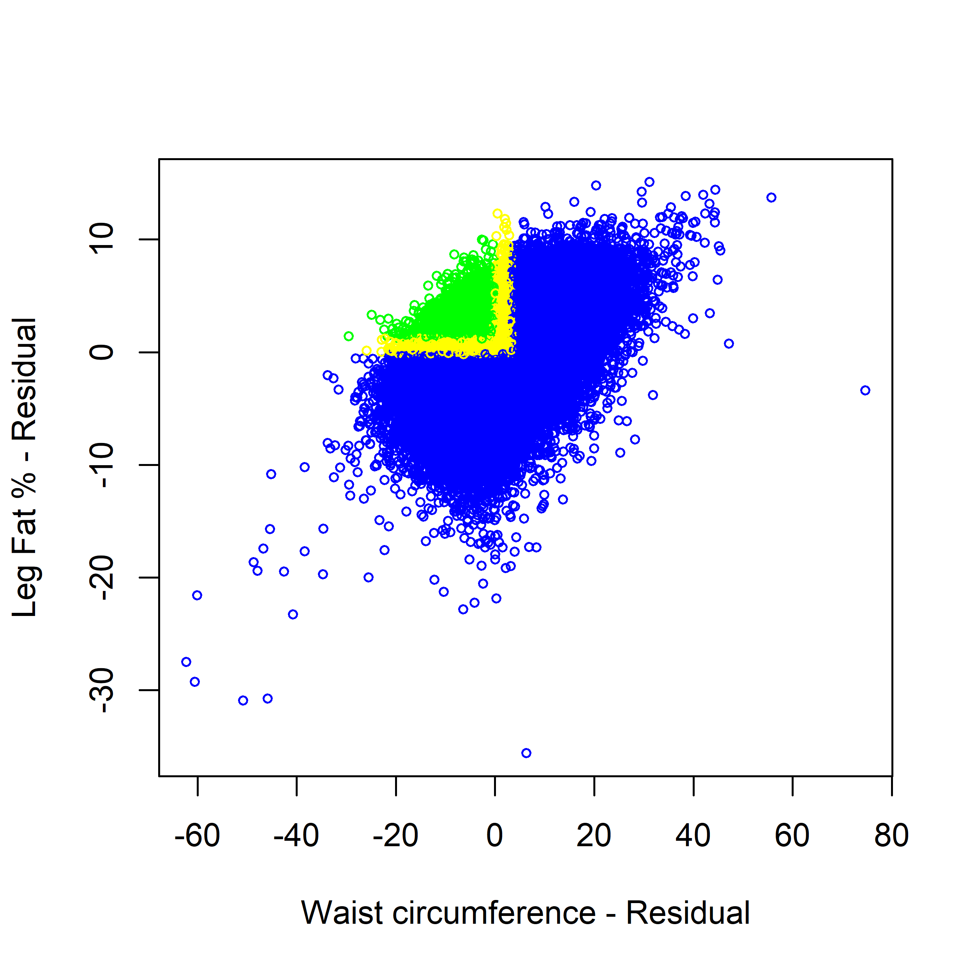
Supplementary Figure 2: Q-Q plot of GWAS of lipedema phenotype at 10% prevalence, with adjustment for hip circumference.
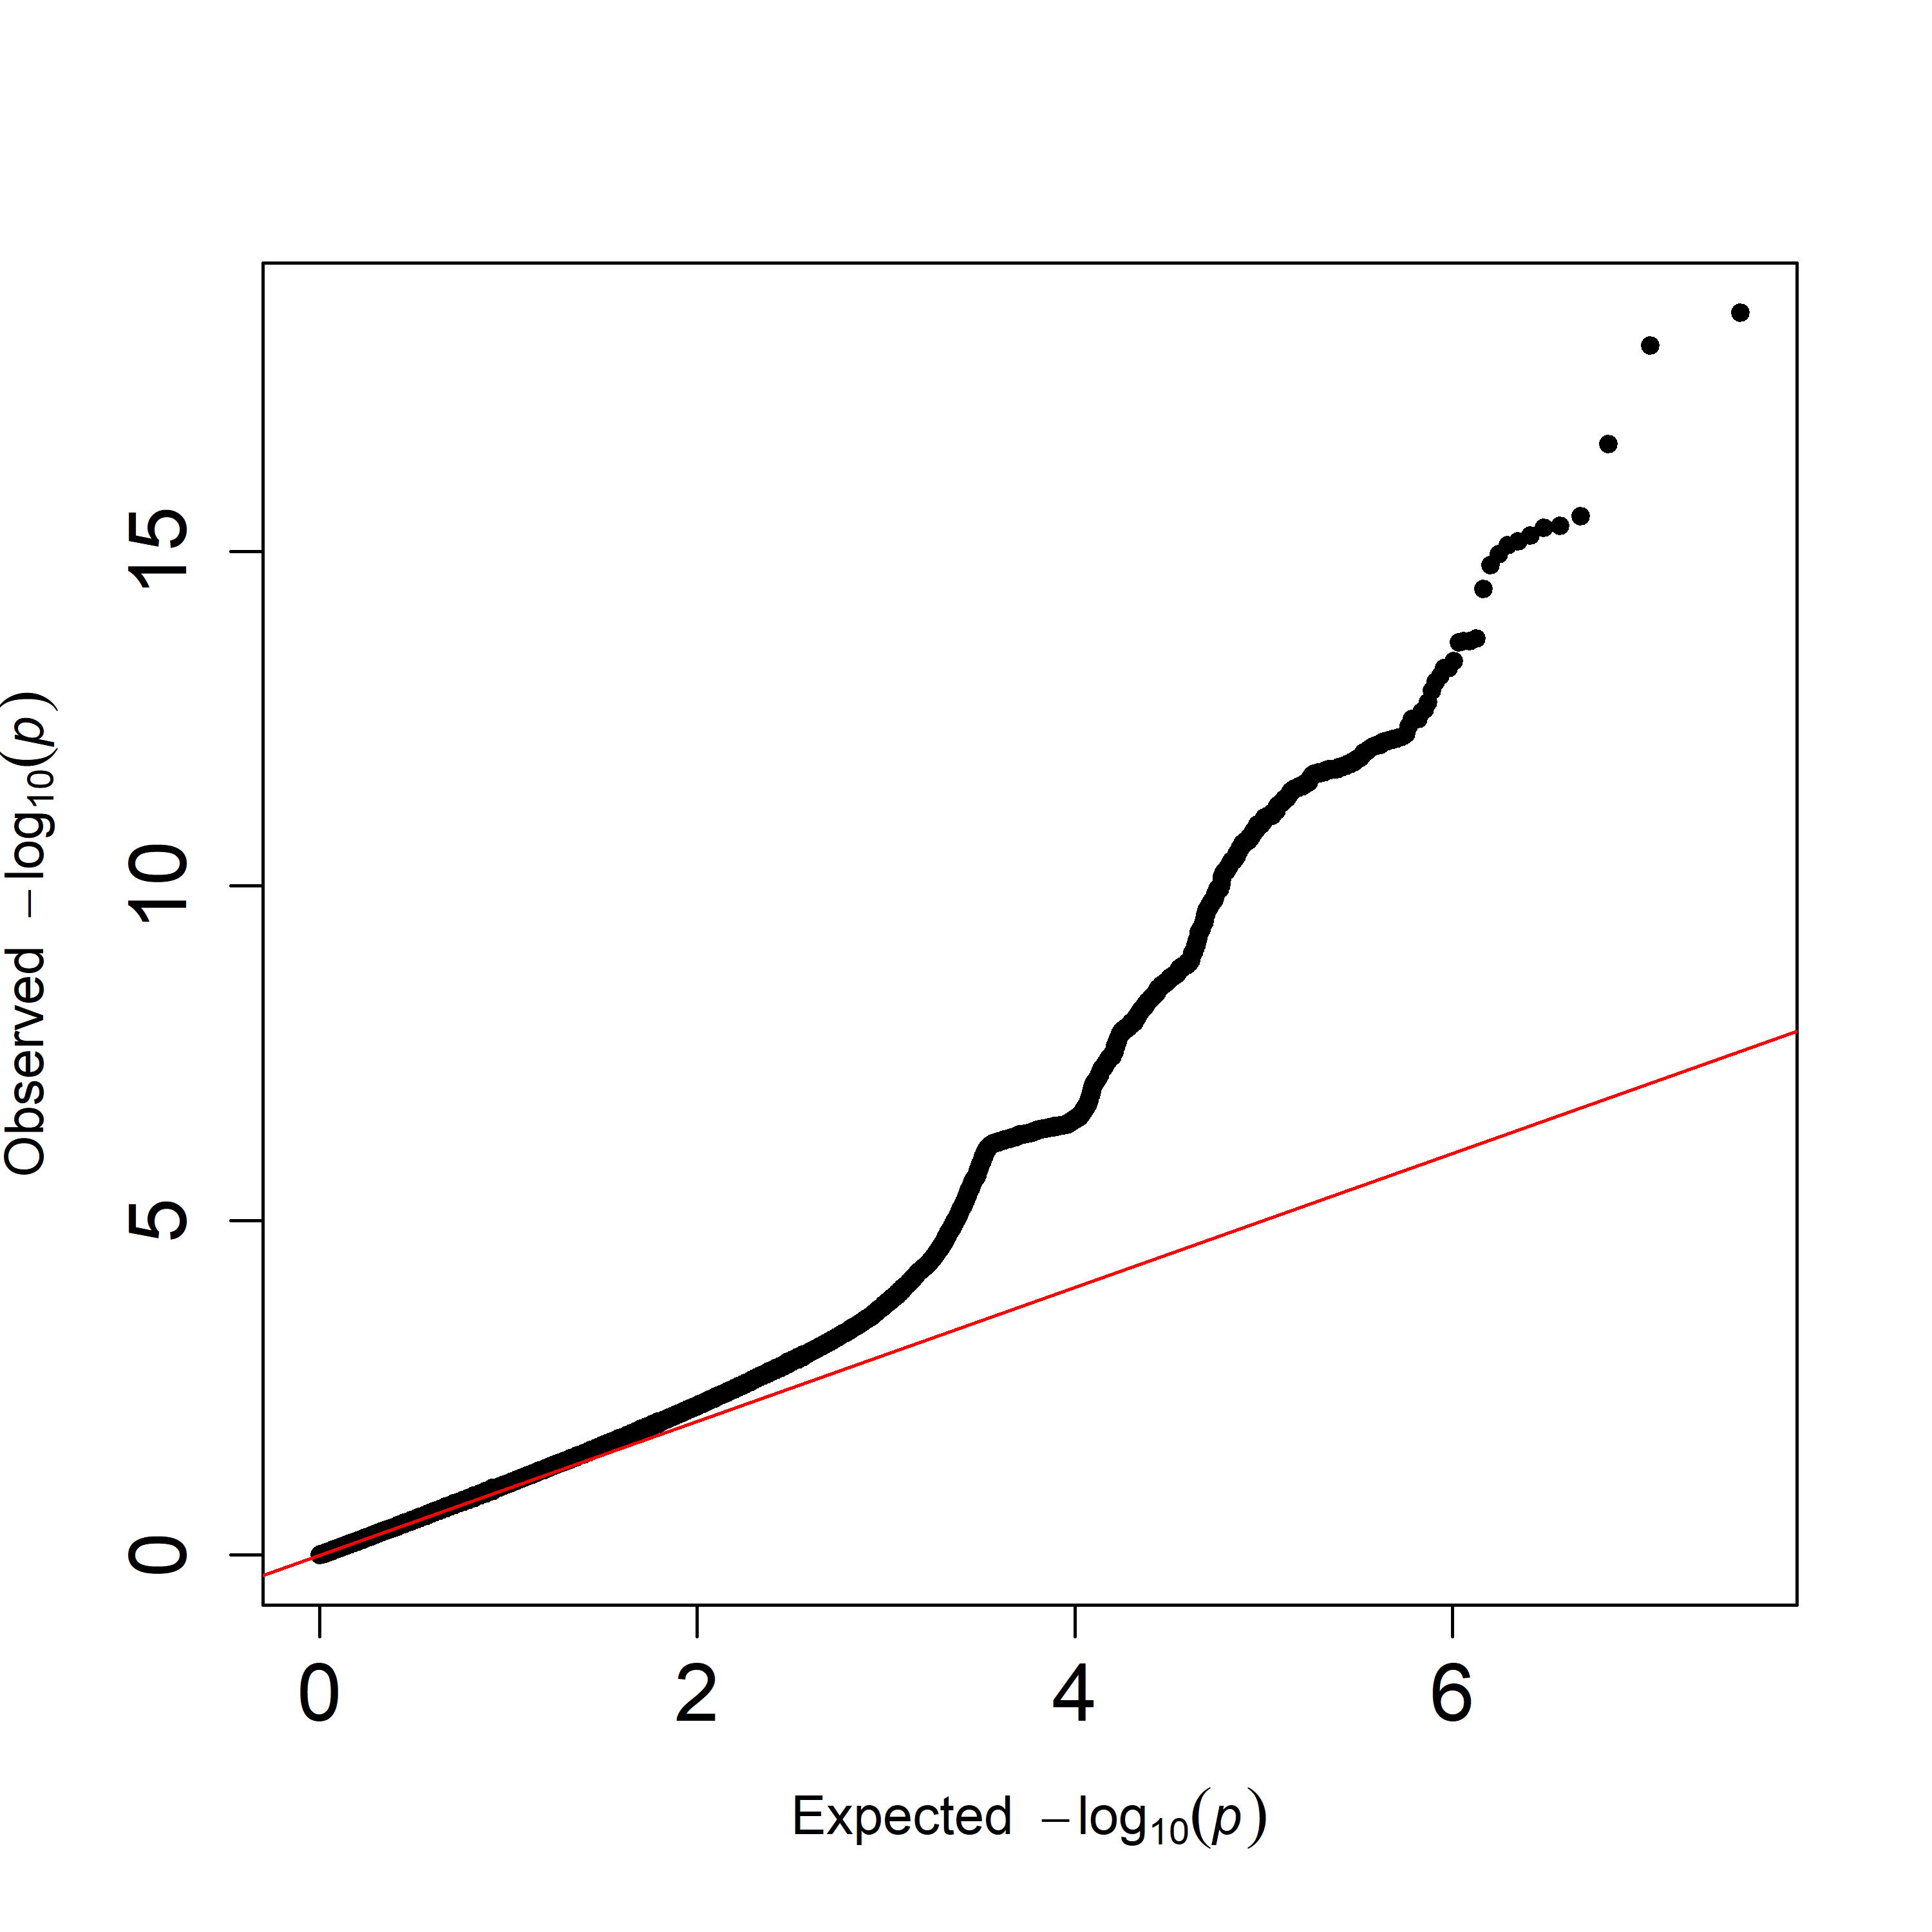

Supplementary Figure 3: Manhattan plot of lipedema phenotype at 10% prevalence with no adjustment for hip circumference.
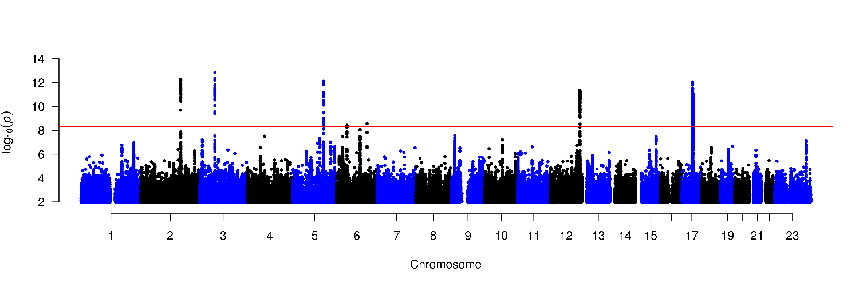

Supplementary Figure 4: Manhattan plots of lipedema phenotype at 10% prevalence among women with BMI <30
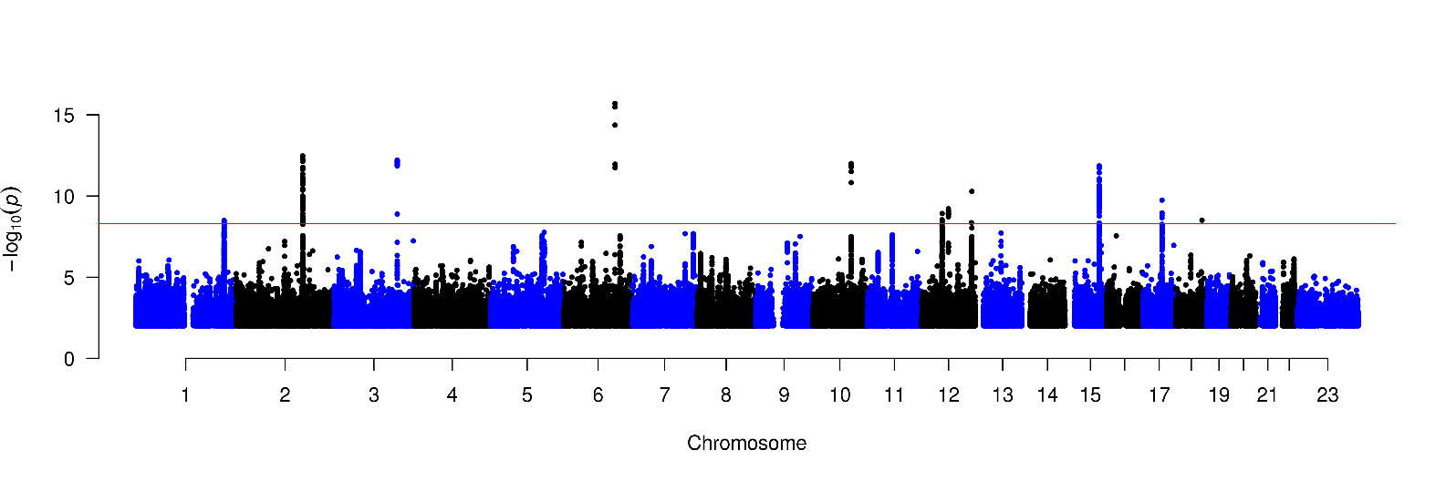
Supplementary Figure 5: Manhattan plots of lipedema phenotypes at 5% prevalence
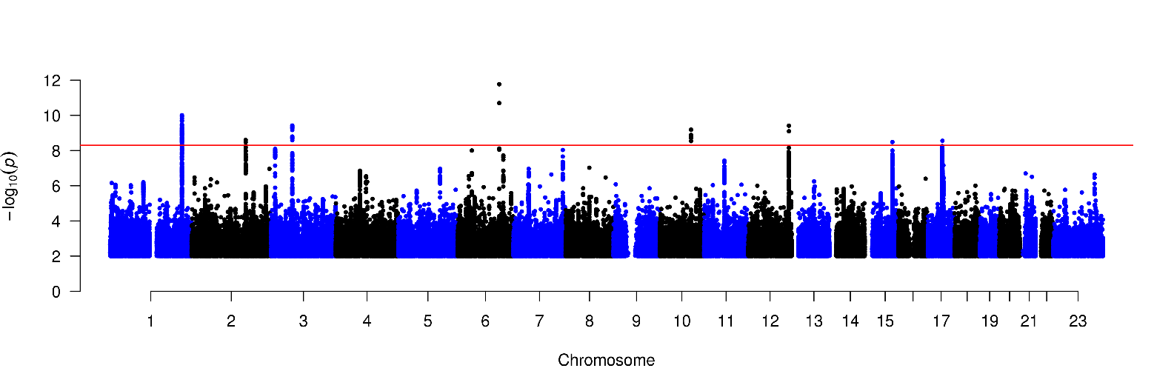

Supplementary Figure 6: Manhattan plot of lipedema phenotype at 10% prevalence including leg pain as criteria for cases, hip adjusted, excluding SNPs with MAF<0.01.
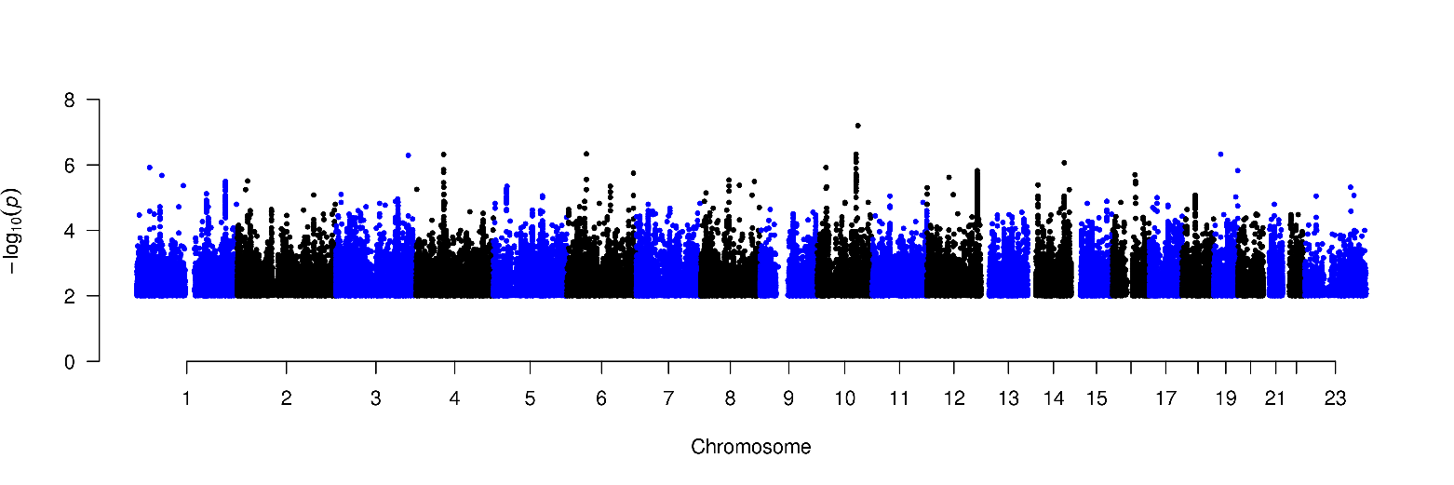

Supplementary Figure 7: Manhattan plot of gene-based test computed by MAGMA. The threshold for statistical significance is set at p=2.6 × 10⁻⁶.


Supplementary Figure 8: Genetic correlation of lipedema phenotype with other traits. Dark green color indicates p<2.5 x10⁻⁴, and light green color indicates p<0.05.

Supplementary Figure 9: Results of gene-based enrichment analysis for 53 tissue types, based on GTEx v7 integrated in FUMA-GWAS. Dashed line represents the Bonferroni-corrected significance threshold.


