NetKompetenz

SW System Design

|  |  |
| --- | --- |
| **Author:** | Carlos Raygoza |
|  | |
| **Revision:** | 1.1 |
| **Status:** | Released |
| **File:** |  |

# History

|  |  |  |  |
| --- | --- | --- | --- |
| Revision | Date | Author, Editor | Reason |
| 1.1 | 13/09/2017 | Carlos Raygoza | Initial revision |

# Table of Contents

3 Terms and abbreviations 347

4 Overview 348

5 Software structure 349

28 Annex 350

28.1 References 350

# Terms and Abbreviations

|  |  |
| --- | --- |
| **Term** | **Definition** |
| ER | Entity Relation Diagram |
| EER | Enhanced Entity Relation Diagram |
|  |  |
|  |  |
|  |  |
|  |  |
|  |  |
|  |  |
|  |  |
|  |  |

# Overview

This document describes the netKompetenz system. Definition of database, use cases, platform, general technic aspects and usability.

Eventhough, the netKompetenz system is built in php using Yii Framework, this document does not focus in detail on any of these.

# Software Structure

## ER Diagram

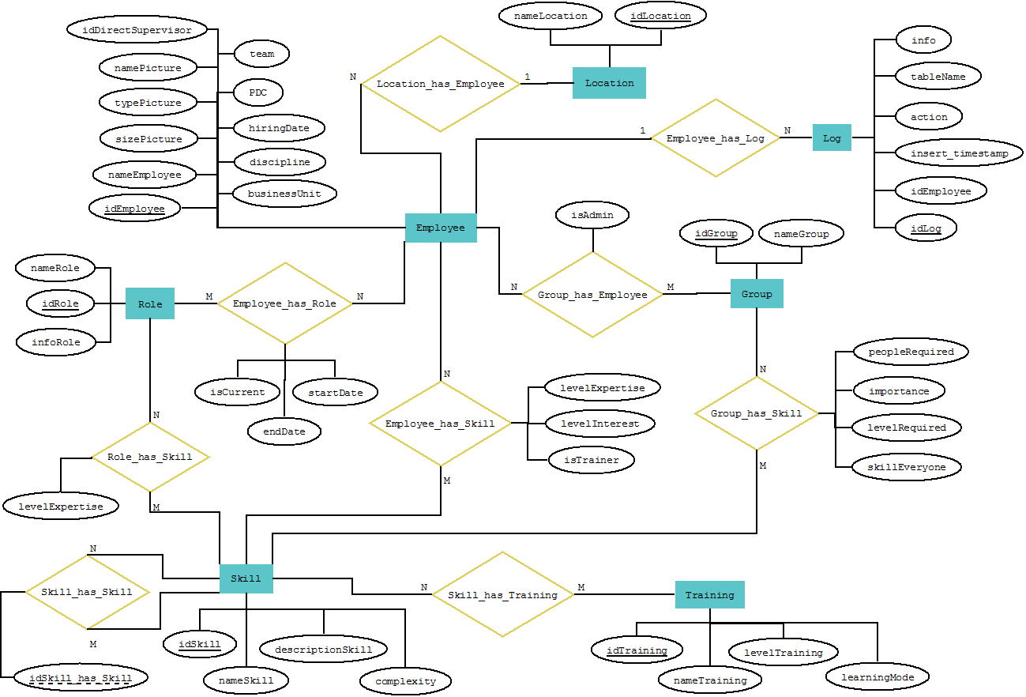

## EER Diagram

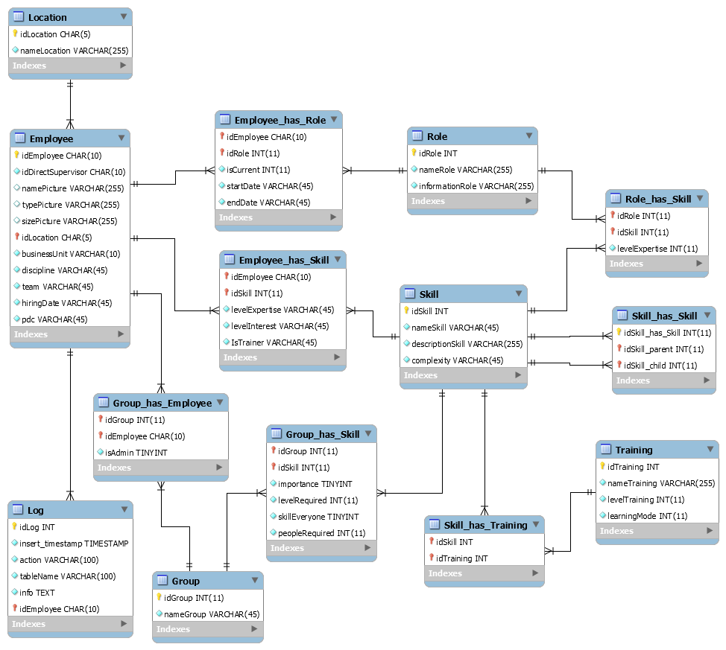

## Use cases

### New Employee in the system

To create a new user in the system, should be filled up all the attributes and upload his/her picture (or they are going to be taken from Continental data base). The ID is equal to the one in Windows.

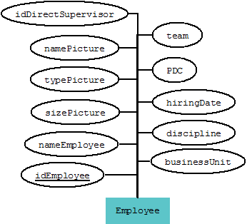

### Skills

Add skill A and skill B as parents of skill C. (Only applicable if there are 3 or more skills registered)

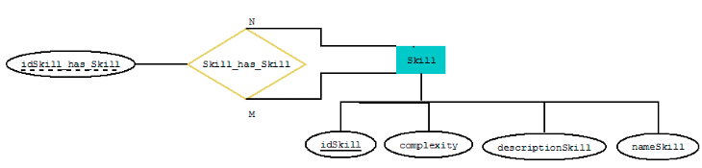

### Employee, trainer of a skill

An employee registers a skill as theirs. She / he fills their level of expertise and level of interest, also, want to be a trainer, check the box.

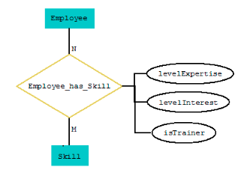

### Roles

1. To create a role, specify the name and the information about it.
2. An Employee is involved in a role at the moment. The attribute *isCurrent* needs to be checked.
3. An Employee has an old role. This should contain the end date. (The current one should be blank)

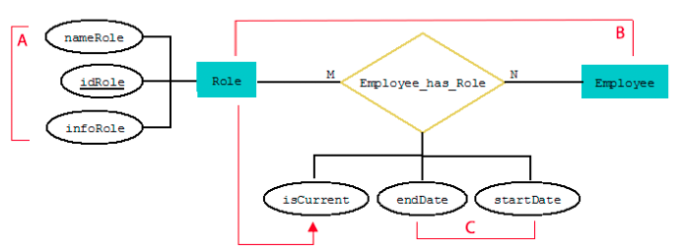

### Create a group

Employee creates a new group specifying a name. She/he is the admin of the group by default.

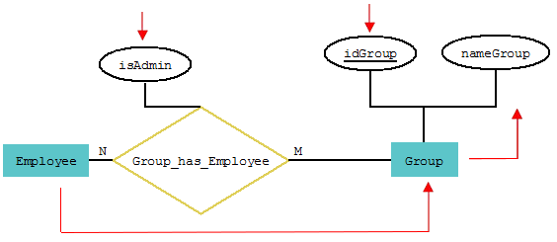

### Adding viewers to a group

Adding an Employee to a group as a participant (viewer), *isAdmin* should not be checked.

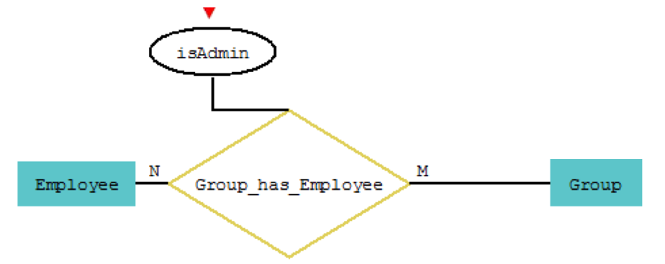

**Note**: Can be more than one admin in a group.

### Employees in a group

1. A group requires skill A with a certain level of expertise (*levelRequired)*. Employee B has that skill with the same or higher level (*levelExpertise)*. Then, it matches.
2. If *skillEveryone* shows that just 1 person should cover that level, Employee C with a lower level of expertise in the skill A can be part of the team. Could be a helper to Employee B.
3. If *peopleRequired* shows that 2 Employees should have skill A, this parameter is met with Employee B and C.

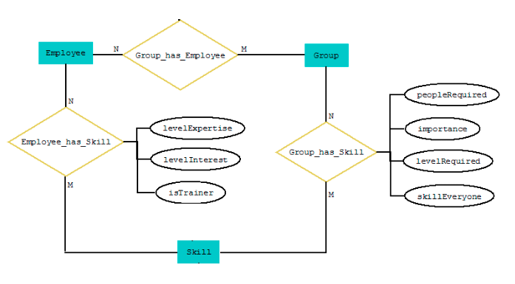

B

C

A

A

## Interfaces

### Header

The header includes the Continental official logo in the left corner. Name of the web platform in the midle. Down the name, it contains the main options as Home, Group Editor, Tree Editor, Search and Wiki. At the lower right corner, there is a welcome message alongside the first and last name of the actual user. The name provides a drop-down list with more options as View Profile and Log out.

This banner is going to be used in all interfaces (except the login interface)



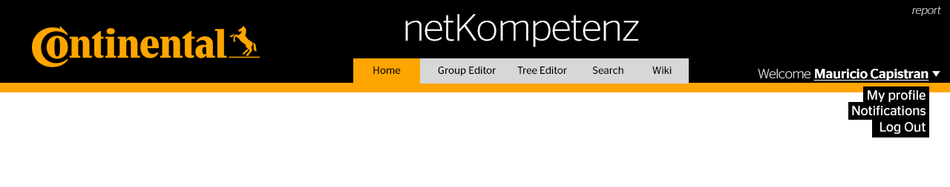

### Login

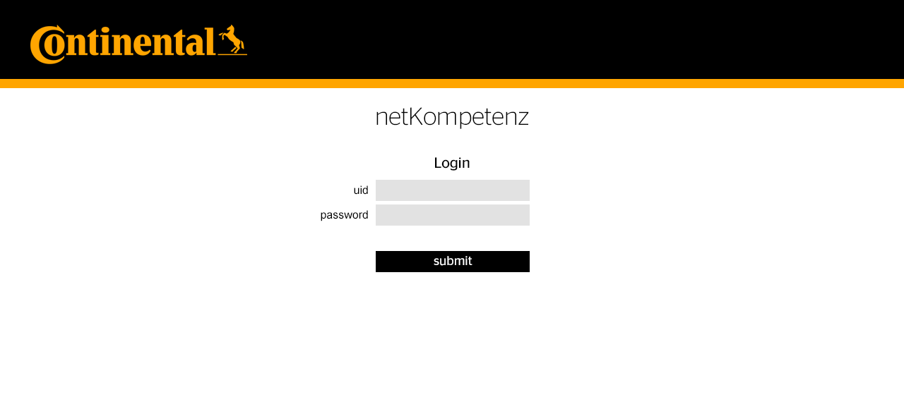

### View Profile

#### View “My profile”

All the following information would be showed when being in “My profile”. The same information is showed to other users that click your name.

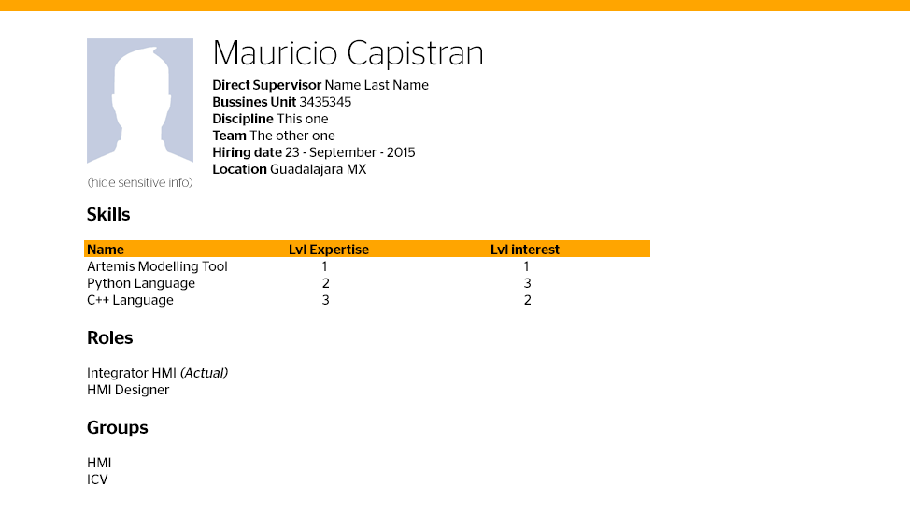

If this employee thinks there is sensitive information being showed, can ask to be restricted in the link below picture, “Show less info”. If exists any restriction of showing sensitive data, the content would change. Hiding the Employee’s name, picture, team and hiring date.

#### User viewing a restricted profile

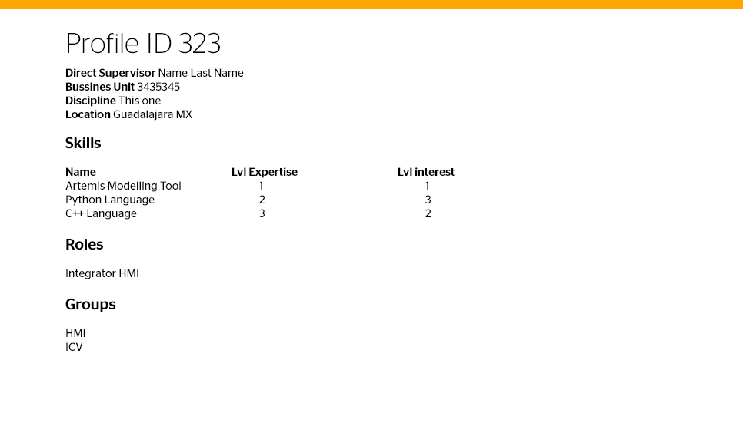

### Add new skill

When adding a new skill, should be compared with all the registered ones and check if it is not repeated. If not, the new skill would be submitted.

The new skill can have a parent skill added. The actual skills are going to be in the drop-down list.

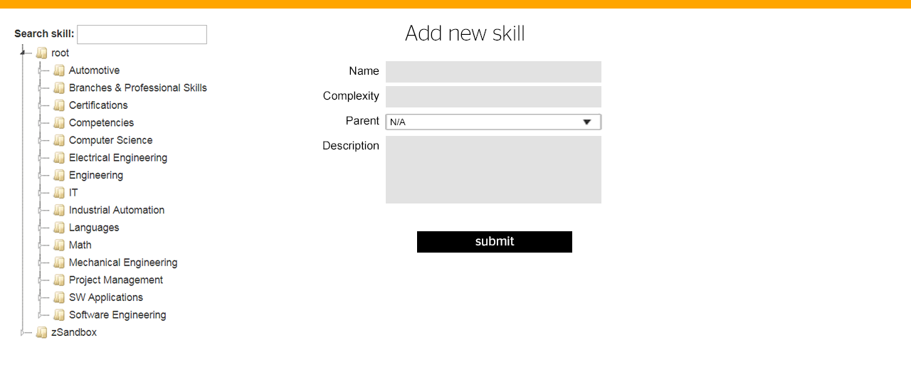

### Clic on a skill in the skill tree

Detailed description and skill parents are being shown when a skill is clicked. If this skill is not included in the profile, it appears the option to be added. If it has been added, it will appear the same drop down lists enabling the edition.

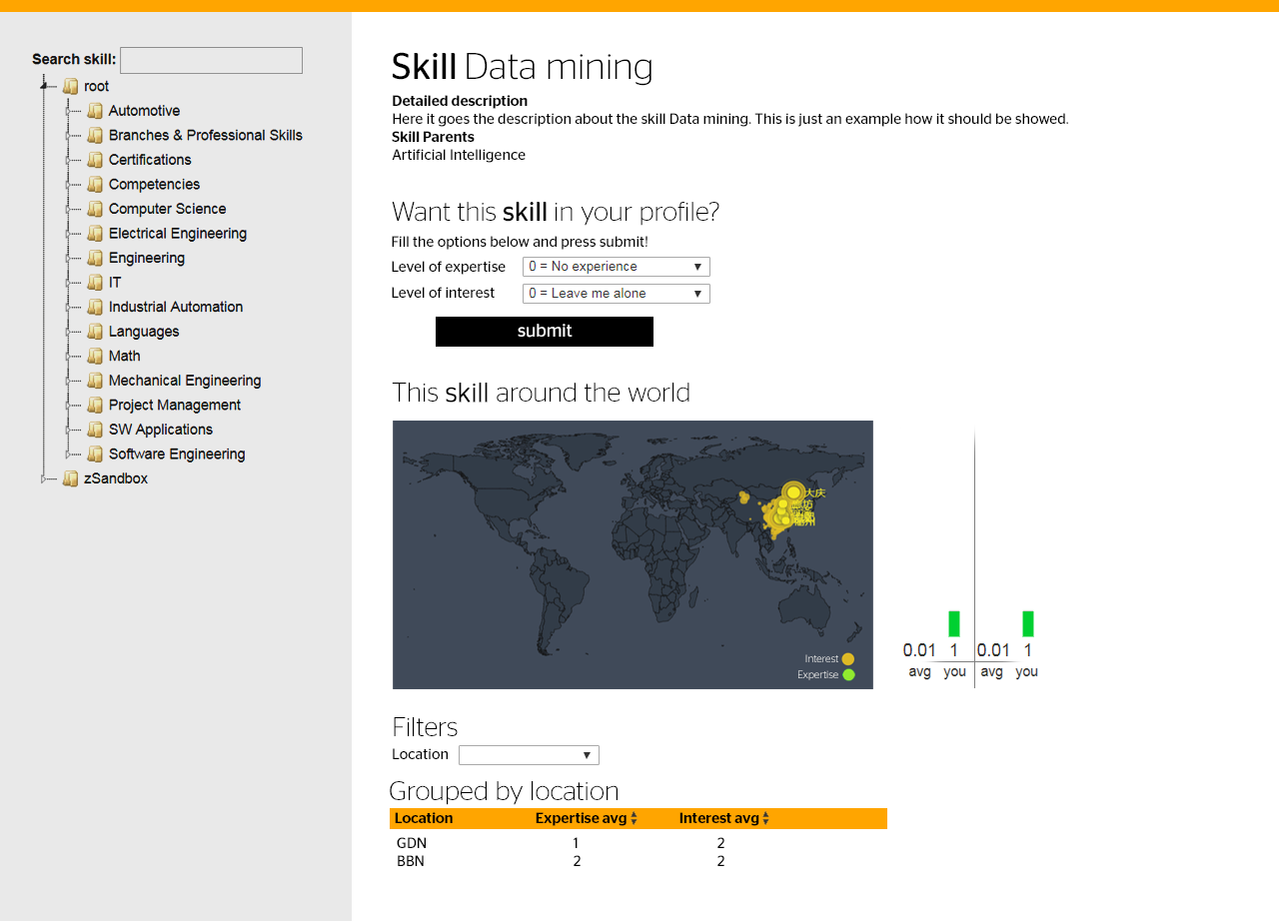

### Group editor

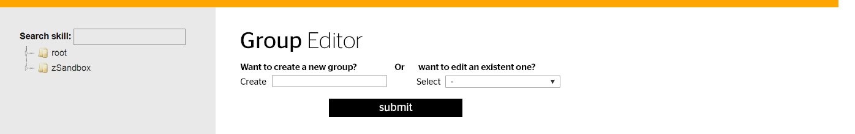

#### Group selected

### D:\Projects\NetKompetenz\GIT\netKompetenz\Design\interfaces\6_groupeditor.png

# SW-Update model

# Annex

## References

|  |  |  |
| --- | --- | --- |
| **Ref** | **Name of Document** | **Version or Release Date** |
| SD\_PF1 | Platform 1 for Ford Instrument Clusters (PF1-F-IC) SW System Design | <http://ims-id:7001/si/viewrevision?projectName=%23/id/ford_PF1/sw%23com/Design/~ford_PF1.sw.com.Design_genPF1&selection=SWSYS_D_PF1-F-IC.doc> |
| SD\_BSJCP2016 | JCP2016 Platform: SW System Design | \\cw01\root\Loc\bbuv\did35969\14\_SW\30\_SW\_System\02\_SW\_Systemdesign\JCP2016\_SW\_Platform.docx |
| MS\_WCS | Module Spec for Widget Communication Services | http://bhdjek0g.cw01.contiwan.com:54321/mediawiki/index.php?title=Widget\_Communication\_Services\_(WCS)\_High-Level\_Overview |
| MS\_WAS | Module Spec for Widget Administration Services | http://bhdjek0g.cw01.contiwan.com:54321/mediawiki/index.php?title=Widget\_Administration\_Services\_(WAS)\_High-Level\_Overview |
| Qt simulation | Loop X Qt simulation | Loop 8.3 |
| CIL | Configuration Item List | [CIL\_S-Family.xlsm](file:///\\cw01.contiwan.com\root\Loc\bbuv\did35969\14_SW\35_SW_Functions\PIFL_active_revision\CIL_S-Family.xlsm) |
| A69 | A69\_SHMI\_Languages\_and\_Markets\_\_ | See latest version in DOORS |
| Anim Model | FDS\_ANIM\_Ford\_S-Family\_S1-S2.docx | See MKS  <http://ims-id:7001/si/viewrevision?projectName=%23/id/ford_PF1/sw%23com/Functions/HMI/FDS/~ford_PF1.sw.com.FDS_SFamily&selection=FDS_ANIM_Ford_S-Family_S1-S2.docx> |
| MasterModel | Master Model FDS | <http://ims-id:7001/si/viewrevision?projectName=%23/id/ford_PF1/sw%23com/Functions/HMI/FDS/~ford_PF1.sw.com.FDS_SFamily&selection=FDS_Master_Model_Ford_S_Family_S1-S2.doc> |
| S Family Message Center with Quick Action Menu | S Family Message Center with Quick Action Menu – CGEA 1.3\_v2.0.doc | V3.1 |
| Interruptability\_Matrix | [Interruptibility\_Matrix.xlsx](#_References) | <http://ims-id:7001/si/viewrevision?projectName=%23/id/ford_PF1/sw%23com/Design/HMISys/~ford_PF1.sw.com.HMISys_gen_PF1&selection=Interruptibility_Matrix.xlsx> |
| ROOT\_SM | ROOT\_SM.xls | <http://ims-id:7001/si/viewrevision?projectName=%23/id/ford_PF1/sw%23com/Design/HMISys/~ford_PF1.sw.com.HMISys_gen_PF1&selection=ROOT_SM.xlsx> |
| General\_HMI\_TEMPLATE | HMI\_ATTACHMENT1a Global Template-v0 5.pdf | Doors Link:  /Ford\_S-Family/010\_Stakeholder Requirements/10\_CustomerRequirements/0\_SOW  v:\03\_Prod\_Dev\20\_Specifications\10\_CustomerRequirements\\_From\_Acquisition\_Phase\unzipped\_flat\HMI\_ATTACHMENT1a Global Template-v0 5.pdf |
|  |  | http://ims-id:7001/si/viewrevision?projectName=%23/id/ford\_PF1/sw%23com/Functions/HMI/SRSC/~ford\_PF1.sw.com.SRSC\_SFamily&selection=SRSC\_HMI\_S-Family.doc |
| AMT\_Help | AMT help file | Located in AMT installation folder |
| WRNDLR | FDS\_WarningHandler\_Ford\_S-Family.docm | http://ims-id:7001/si/viewrevision?projectName=%23/id/ford\_PF1/sw%23com/Functions/HMI/FDS/~ford\_PF1.sw.com.FDS\_SFamily&selection=FDS\_WarningHandler\_Ford\_S-Family.docm |
| FontRanges | Excel file containing the Unicode ranges for each font group | \\cw01\root\Loc\bbuv\did35969\14\_SW\100\_HMI\_GDL\30\_SW\_Subsystem\30\_Language\_Handling\FontSplit\Unicode Ranges\Loop7\_FontRanges.xlsx |