1. New Employee in the system

To create a new user in the system, should be filled up all the attributes and upload his/her picture (or they are going to be taken from Continental data base). The unique ID is equal to the one in Windows.

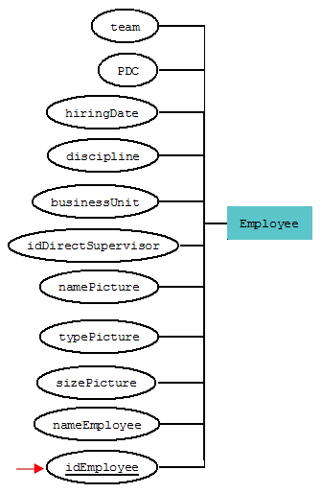

1. Skills

Add skill A and skill B as parents of skill C. (Only applicable if there are more than 3 skills registered)

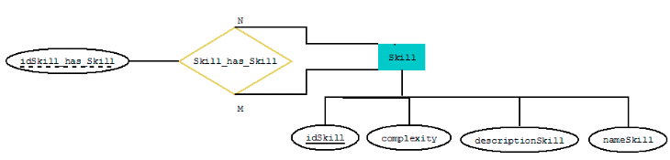

1. Employee, trainer of a skill

An employee register a skill as theirs. She / he fills their level of expertise and level of interest, also, want to be a trainer, they check the box.

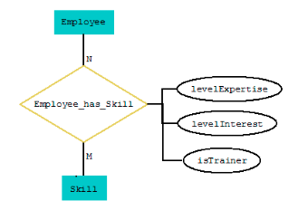

1. Roles
2. To create a role, specify the name and the information about it.
3. When an Employee is involved in a role at the moment, the attribute *isCurrent* needs to be checked.
4. When an Employee has an old role, this should contain the info of the end date. The current one should be blank.

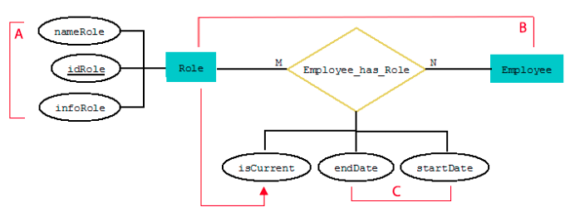

1. Create a group

Employee creates a new group specifying a name. She/he is the admin of the group by default. Each group has a unique ID.

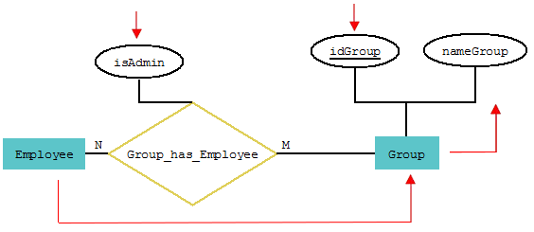

1. Adding Employees to a group

When adding Employee to a group, and want them to be just a viewer, *isAdmin* should not be checked.

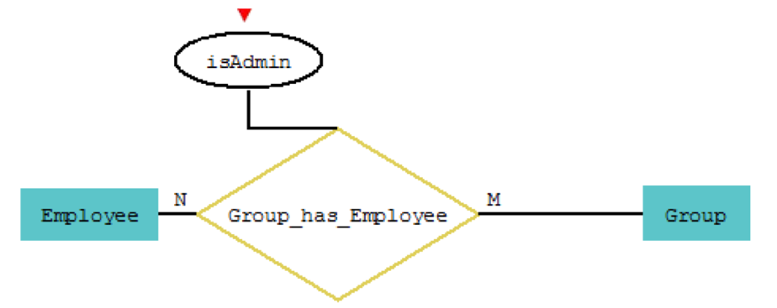

**Note**: Can be more than one admin in a group.

1. Employees in a group
2. A group requires skill A with a certain level of expertise (*levelRequired)*. Employee B has that skill with the same or higher level (*levelExpertise)*. Then, it matches.
3. If *skillEveryone* shows that just 1 person should cover that level, Employee C with a low level of expertise in the skill A can be a part of the team. Can be as a helper to Employee B.
4. If *peopleRequired* shows that 2 Employees should have skill A, this parameter is met with Employee B and C.

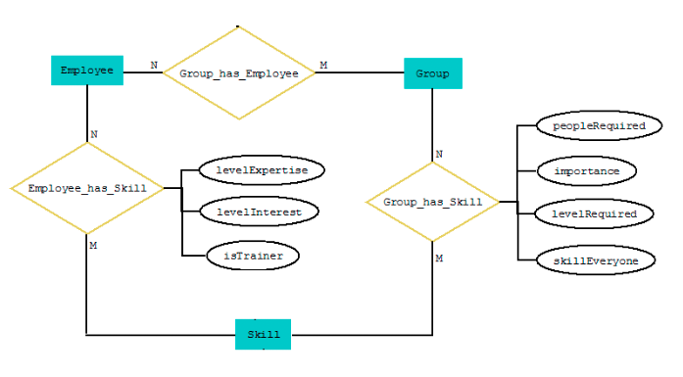

A

B

A

C