Spring Framework Udemy Course

# Patrón MVC

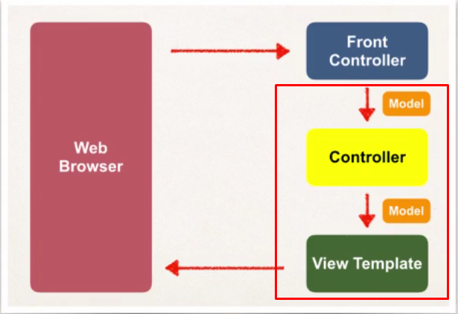

You will create:

* Object Models (data)
* Templates (views)
* Controller (Processing logic)

## Front Controller

The job of the Front Controller is to take de URI requests and find the right methods of Controller classes and load the view templates to show the info properly.

## Controller

Created by developer.

Contains Business logic:

* Handle requests
* Interacts with DB
* Place data in model

Send the info to appropriate view template.

## Model

Stores the info of the objects retrieved via backend services.

## View Template

Supports many view templates. Displays data.

# Configuration

Add configurations to file : *WEB-INF/web.xml*

1. Configure Spring MVC Dispatcher Servlet

Add servlet reference and use the dispatcherServlet provided by Spring:

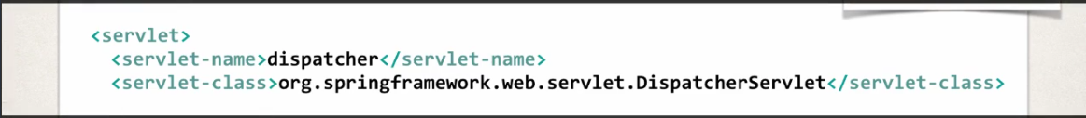

Config xml file location:

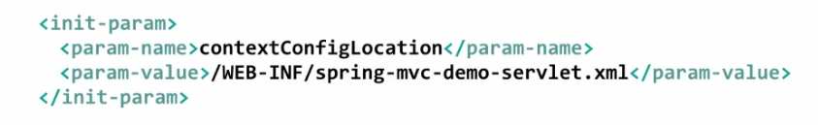

1. Set up mappings to Spring MVC Dispatcher Servlet

Write the pattern for a request url have to look for:

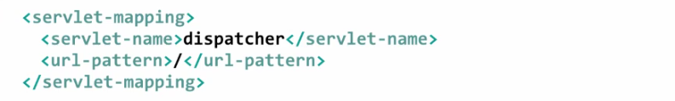

Add configurations to file: *WEB-INF/spring-mvc-demo-servlet.xml*

1. Add support for spring component scanning
2. Add support for conversion, formatting and validation

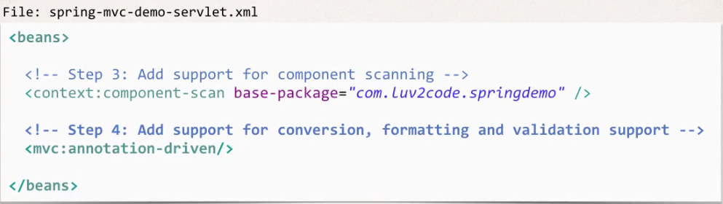

1. Configure Spring MVC View Resolver

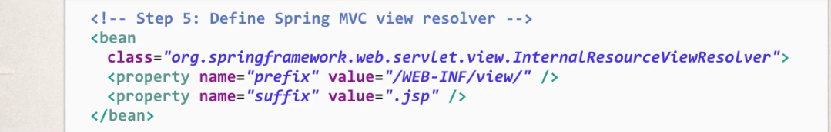

Spring will prepend the prefix and append the suffix to the name of the view.

Ex: /WEB-INF/view/[nombre del fichero].jsp