Chapter 12: Self-reproducing machines and manufacturing processes

Adrian Bowyer, University of Bath, UK

12.1 Introduction 1
12.2 A historical perspective 2
12.3 Scope, and some definitions of terms 3
12.4 Simulation and analysis 4
12.4.1 Cellular automata 5
12.4.2 Von Neumann reproduction 5
12.4.3 Moving from mathematics towards physics 7
12.5 Electro-mechanical self-reproduction………………………………………………………...8
12.5.1 Self-assembling kinematic machines…………………………………………………....8
12.5.2 Self-manufacturing kinematic machines……………………………………………….10
12.5.3 Self-assembling versus self-manufacturing kinematic machines………………………12
12.6 Physico-chemical self-assembly and reproduction…………………………………………..12
12.6.1 Meso-scale self-assembly……………………………………………………………....13
12.6.2 Synthetic biology……………………………………………………………………….14
12.7 Self-reproducing machines, economics, and society………………………………………...16
12.8 Self-reproducing machines, ethics and safety………………………………………………..17
12.9 References……………………………………………………………………………………18

12.1 Introduction

Anyone who has ever made a machine can see how it ought to be done: all they have to do is to look up from their workbench and out of the window. There they will see a riot of manufacturing excess that has created a knee-deep layer of machines covering the entire planet; indeed our very knees are made from those machines.
This chapter is about harnessing the planet-transforming power of self-reproduction to make products that are useful to people. Of course, in one sense, doing this is our oldest technology - we call it farming. But for farming we took naturally-evolved reproducers, genetically engineered them by selective breeding to make them more to our liking, and set them to work to feed and to clothe us. Farming is still our most important technology - we could live without engineering, but not without food; however, in this chapter I will look at attempts to create artificial reproducers to make the goods normally manufactured by industrial production.
The first question is obviously: why bother? Since the industrial revolution humanity has created a global system of production and distribution using conventional engineering that has given every nation that has adopted it wealth beyond the imaginings of our pre-industrial ancestors. Why would we alter that?
The answer lies in the difference between an arithmetic and a geometric progression. Suppose you run a factory that has an injection moulding machine making 200,000 door-handles a day. Tomorrow the machine will make another 200,000, and another 200,000 the day after. The number of door-handles made grows arithmetically, as – consequently - do your profits.
Now suppose that you had a self-reproducing machine that took a whole day to copy itself, and – in that day – it had just enough time left over to make one single pathetic door handle. That is 0.000005 times the production rate of the injection moulding machine. But the number of self-reproducing machines will grow geometrically (2, 4, 8, 16, 32, . . .), and so will the number of door-handles. In just eighteen days the self-reproducing machines will be making door-handles faster than the injection moulding machine. After a month there will be a self-reproducing machine (and a door-handle) for every man, woman, and child on Earth.
Of course, that apparently inexorable growth would be checked by resource limitations well before then. That is the same reason that we are not up to our knees in rabbits. But the ability of self-reproduction to produce goods geometrically, in contrast to the arithmetic production of conventional industrial processes, is what makes it so economically very attractive.

There is another, even better, reason why we should bother: because it would be interesting.

12.2 A historical perspective

How far back does the idea that a human-engineered machine might be made to reproduce itself go?

In their excellent book Kinematic Self-Replicating Machines, Bob Freitas and Ralph Merkle recount an anecdote: when Descartes told Queen Christina of Sweden his opinion that the human body was a machine, she asked, "How can machines reproduce themselves?" Descartes was visiting the queen in the winter of 1649, and that is the most probable date for the conversation, though they had previously corresponded (Freitas 2004).
In another version of the anecdote, the queen is reported to have pointed at her clock and said imperiously, “See to it that it reproduces offspring,” - a less perceptive response, and probably less likely; she was noted for her gifted and inquiring mind.
Moving forward two hundred years, in Chapter 23 of his simultaneously utopian and dystopian novel Erewhon, Samuel Butler's first-person narrator gives a translation of an Erewhonian "Book of the Machines". This recounts philosophical speculations on what we, today, would call artificial intelligence and artificial life. It contains the following passage:

"Surely if a machine is able to reproduce another machine systematically, we may say that it has a reproductive system. What is a reproductive system, if it be not a system for reproduction? And how few of the machines are there which have not been produced systematically by other
machines? But it is man that makes them do so. Yes; but is it not insects that make many of the plants reproductive, and would not whole families of plants die out if their fertilisation was not effected by a class of agents utterly foreign to themselves? Does any one say that the red clover has no reproductive system because the humble bee (and the humble bee only) must aid and abet it before it can reproduce? No one. The humble bee is a part of the reproductive system of the clover. Each one of ourselves has sprung from minute animalcules whose entity was entirely distinct from our own, and which acted after their kind with no thought or heed of what we might think about it. These little creatures are part of our own reproductive system; then why not we part of that of the machines?" (Butler 1872)

Erewhon was published in 1872, just thirteen years after The Origin of Species (Darwin 1859). Butler can reasonably be credited with the idea that self-reproducing machines would be useful for industrial production, and with the idea that they would be inescapably subject to Darwinian evolution. At the time, some though that he was attempting to disprove Darwin by reductio ad absurdum. To disabuse people of this opinion Butler later wrote, "I regret that reviewers have in some cases been inclined to treat the chapters on Machines as an attempt to reduce Mr. Darwin's theory to an absurdity. Nothing could be further from my intention, and few things would be more distasteful to me than any attempt to laugh at Mr. Darwin."
Moving forward another one hundred and forty years, our own age is more accommodating of the conceit that machines might both reproduce and evolve, in large part because we now make machines more subtle and fabulous than any seen in even the most opiate Victorian Limehouse pipe dream, and also because we are starting to achieve solid, reproducible (in every sense) research results in artificial machine reproduction.

12.3 Scope, and some definitions of terms

It is not possible in a single book chapter to do justice to the considerable research into artificial self-reproducing machines that has been carried out in the last fifty years. The reader wanting detail at a more profound level is guided to Freitas and Merkle's previously-mentioned book (Freitas 2004). Here I have attempted to use examples to adumbrate the breadth of the field, rather than to present parts of it in depth while (then necessarily) ignoring other areas completely.
Historically, the terminology used in the field of self-reproducing machines has sometimes been unclear, with different meanings being ascribed to the same words. In an attempt to bring some systematisation to this, I will define key terms for use in this chapter at least:

Kinematic machine - A physical machine that is composed of fixed and moveable parts. These parts may be such that you could hold them in your hand, or they may be microscopic, or even atomic. Kinematic machine makes a distinction between real machines and software models (which are frequently used for simulation). The words kinematic machine encompass both artificial mechanisms and evolved living organisms (including, of course, people).

Self-replication – To define this, let us start with the idea that self-replication could mean an imaginary Platonic process by which a kinematic machine was able to create an exact copy of itself. The Second Law of Thermodynamics and Shannon’s theorem (Shannon 1948) show that information cannot be copied without loss or error indefinitely, implying that the idea of an exact replicator is an impossibility. (It is the errors, of course, that drive Darwinian evolution.) Whilst it is philosophically and poetically useful to have words for impossible ideas, here the strength of the word replication is reduced to give it an engineering meaning: a copy within specified tolerances that will work as well as the original.

Self-reproduction - A process by which a kinematic machine is able to create an approximate copy of itself, perhaps with either insignificant or significant errors. All living organisms are self-reproducers. The specified-tolerances-and-works-as-well distinction between replication and reproduction follows through the definitions below, and the rest of this chapter. Replicators are a subset of reproducers.

Self-manufacturing – The ability of a kinematic machine to make some or all of its own parts from raw materials. This clearly prompts a requirement for a definition of “raw”: is an etched printed-circuit board a raw material? Or a uniform sheet of copper-clad fibreglass and a bottle of ferric chloride etchant? Or some copper, some glass, and some epoxy resin? Forensically, many Gordian Knots of this sort are cut by asking, “Would a reasonable person say it is so?” and leaving it at that. Here the same approach as the law is adopted.

Self-assembly - This refers to the ability of a kinematic machine to manipulate a series of parts into an assembled copy of itself.

Autotrophic self-reproduction or -replication - The ability of a system to make a direct copy of itself from raw materials without assistance. As yet, no artificial autotrophic self-reproducing kinematic machine has been made. However, examples exist in biology. For a kinematic machine to achieve autotrophic self-reproduction, it must contain a number of critical subsystems. One attempt to identify these subsystems was undertaken in Freitas and Merkle’s “Map of the Kinematic Replicator Design Space” in their book referred to above (Freitas 2004). This identified 137 design properties in order for autotrophic self-reproduction to be possible.

Assisted self-reproduction or -replication - A kinematic machine that includes at least one, but not all, of the critical subsystems required for autotrophic self-reproduction or replication and so needs human (or other) intervention to reproduce.

12.4 Simulation and analysis

When people can't make something they want, they often make a model of it instead. This is sometimes mere superstitious sympathetic magic. But othertimes a model is a step on the path to having the real object that the model represents. These days no one would build an aeroplane speculatively and then test-fly it to see if it would stay up. They would spend many hundreds of hours of computer time using finite-element models to find out if the wings were likely to fall off, and many more hundreds of hours using computational fluid dynamics models to find out if those wings were able to suspend the aeroplane in the air.
Before engineering had reached the point where kinematic artificial self-reproducing machines could even begin to be made, computers were powerful enough to model how they might, in the future, work. And before computers were that powerful, the theory of computation (another model) had progressed to the point where it was obvious that future computers would be able to process such models of self-reproducing-machines. Much of this early modelling of self-reproducers was done by John von Neumann towards the end of his life in the middle of the last century.

12.4.1 Cellular automata

Imagine that you have in front of you a sheet of graph paper, a pencil, and an eraser. Further imagine that someone has already shaded in a few squares on the graph paper, and has given you a set of rules. These rules say:

- If a shaded square has two or three shaded neighbours, it stays shaded;
- If a shaded square has less than two, or more than three, shaded neighbours rub it out; and
- If an unshaded square has three shaded neighbours, shade it in.

You could follow these rules, and the consequent patterns of squares would grow and shrink across your sheet of paper.
The graph paper squares (together the rules and you to execute them) are cellular automata. The moving patterns that such cellular automata can generate are extraordinarily rich. For example, it is possible to make a pattern that acts like a factory, producing smaller identical patterns that repeatedly split off and drift across the paper forever. Wikipedia has an animation of this happening that you can watch; it is rather hypnotic. (See reference (Wikipedia).) Stephen Wolfram has even maintained that cellular automata are the best (or maybe even the only) way to study very complicated systems in nature (Wolfram 2002).
Cellular automata were invented by Stanislaw Ulam, followed by his collaborator von Neumann, in the 1940s. Ulam wanted to use cellular automata to study crystal growth, and von Neumann wanted to use them to study self-reproducing machines.

12.4.2 Von Neumann reproduction

Von Neumann started with the idea that there was a strong similarity between the then-nascent digital computer and an animal's brain (von Neumann 1963) and went on to study the idea of a robot making another identical robot - a kinematic self-reproducing machine (von Neumann 1966) .
He very quickly ran up against two difficulties that can be summarized as size and containment.
Today, the size problem that he identified seems the less difficult of the two to surmount. He compared the size of a neuron to that of an electronic valve, arriving at a factor of a billion, and pointed out that their energy requirements differed by a similar factor. Following this through to build an artificial self-reproducing machine of a similar complexity to - say - a beetle one centimetre long would require the entire mass of the Earth. Once the researchers had finished building their earth-beetle, lack of further material would make demonstrating its reproductive ability difficult...
However, just the nucleus of a neuron is about ten microns across whereas we can now easily make transistors under one micron across. What we can't (yet) do is to connect a transistor to very many others. Typically a single transistor in a microprocessor might drive twenty more. One of the neurons in your brain, in contrast, might well act as input to 10,000 other neurons. But it is certainly the case that modern electronics is processing information at about the same length scales as natural biological systems, if not smaller.
(In passing, it is perhaps worth observing that von Neumann was concerned with the limits of computation in the context of reproducing machines and other things. But most self-reproducing entities in nature have no brain at all - they are microbes. However, they do all still process information. A bacterium dividing is, of course, copying the information in its DNA, and that information is then used to make the proteins that form the two new bacteria – see below.)
Von Neumann's second problem - containment - is at once both more obvious and more subtle. You can get together with someone else and have a baby; all you both need for that is food. You two parents and your baby form a closed reproduced system that requires nothing from outside itself except raw-materials to eat.
But it is extraordinarily difficult to have a robot driven by a computer make all the parts for another identical robot from a supply of raw materials such as steel and plastic. It is a little bit easier if the raw materials are steel gears and plastic pipe, and – revisiting the brief discourse on the meaning of the word “raw” in “raw materials” above - this is how you eat: you cannot eat carbon, hydrogen, nitrogen and oxygen, but you can eat amino acids made from those elements. However, going back to the robot, even if it could make itself from gears and pipe, it would not have copied the computer that is driving it - it is not a closed reproducing system like you, your partner and your baby. This requirement also to copy the computer adds another – and very daunting - layer of complexity to the artificial self-reproduction problem.

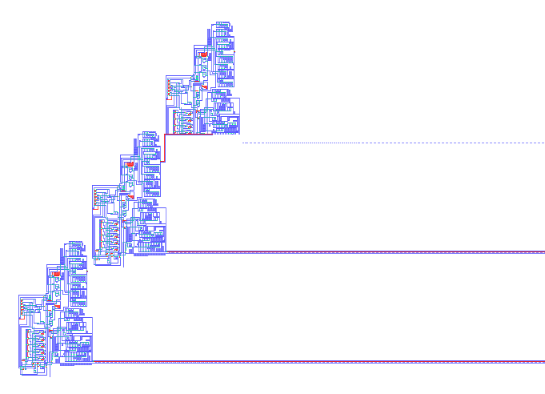

Figure 1: Pesavento's implementation of von Neumann's cellular automaton model of a reproducing machine (courtesy of Wikipedia). A parent (bottom) and its child (middle) are complete. The child is making a grandchild (top).

Stumped by these difficulties, von Neumann turned to his friend Ulam and, at Ulam's suggestion, decided to concentrate on simulating reproducing machines using their just-invented cellular automata to build a model. Von Neumann gave an existence proof that a particular pattern would make endless copies of itself within his cellular universe. His cells only considered their four orthogonal cells to be neighbours (that is, he used rook's - and ignored bishop's - moves). His cells had 29 possible different states (as opposed to the two - shaded and unshaded - in the example above).
Von Neumann did all this without the distraction of having access to an actual computer. In the 1940s they were too rudimentary for the task. He thus demonstrated the possibility of artificial mechanical replication (the digital copies really are identical) by making a model of a model of a reproducing machine.
It was not until 1995 that his work was implemented in a computer program and run. Figure 1 shows the program working. The implementation was done by Umberto Pesavento, and details can be found in (Pesavento 1995).
Pesavento's von Neumann implementation is, in its own cellular universe, an autotrophic self-reproducing kinematic machine by the definitions above. But it is not even a kinematic machine in our Universe; it is a simulation.

12.4.3 Moving from mathematics towards physics

In 2010 William Stevens published a PhD thesis in which he presented a three-dimensional simulation of a reproducing machine (Stevens 2010). This did not merely use three-dimensional cellular automata: given Pesavento's work that would be trivial (the two-dimensional automata could easily be made to work in a plane slice through a three-dimensional cellular universe, for example).

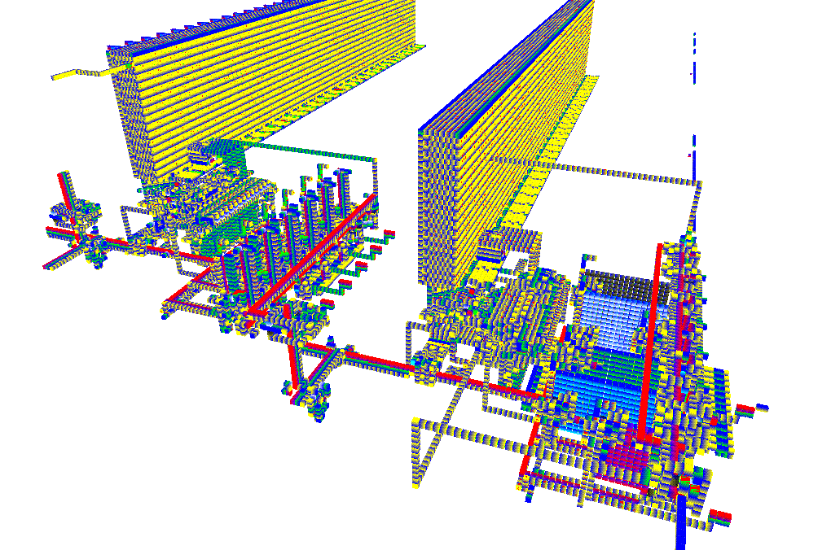

Figure 2. William Stevens's three-dimensional physical self-reproducer simulation. The parent is on the right; the child it is constructing is on the left. The big yellow blocks are the “computer memory” of each.

Stevens's universe consisted of an array of boxes that could be moved about by the actions of other boxes as if they were real material objects in a three-dimensional rectangular lattice. There was no friction and no gravity, but the boxes had different types such as logic gates, wires, and - necessarily - a type that caused any box next-door to it to move. He then designed a self-reproducing machine that would operate in the universe that he had defined. It is shown working in Figure 2. Interestingly, the first child produced by his designed parent was not identical to that parent, but the first grandchild - and all subsequent generations - were identical to the first child. The original machine had reproduced approximately, and then converged on exact replication.
12.5 Electro-mechanical self-reproduction

This simulation work is all very interesting, but obviously it's not going to make an aeroplane, or even a door handle, for us any time soon. If we are going to use self-reproducing machines to do industrial production, then we are going to have to move from simulation to the world of nuts and bolts or to the world of chemistry. This section is about making real kinematic self-reproducers as macroscopic machines – things that can initially be built with a screwdriver and a soldering iron.

12.5.1 Self-assembling kinematic machines

A self-assembling kinematic machine is a robot that can make a copy of itself when provided with a kit of parts. You are a self-assembling kinematic machine, and your kit of parts consists of those amino acids mentioned above, together with a lot of other complicated pre-manufactured kit-parts that are all in the soya beans, beef, lettuce, sea bass, walnuts and so on that you eat.
This brings us back to the definition of raw materials. A robot that can merely take another identical robot off a shelf and present it to you as its offspring cannot reasonably be said to have reproduced. But – as observed above - even you and a partner cannot make a baby from a collection of uncombined chemical elements. Most reasonable people would consider a machine working half-way between these extremes – say a robot made of Lego that could take a box of Lego bricks and make a copy of itself – to be legitimately capable of self-reproduction.
It is also legitimate to consider the manufacture of the kit to be something that assists the reproducer. That manufacture provides the reproducer with a competence that it itself does not have. Thus our notional Lego robot is an assisted self-assembling kinematic machines.
The first such kit-part kinematic self-reproducers were made by the father-and-son team of Lionel and Roger Penrose just a few years after von Neumann's work. They made a collection of cleverly-shaped wooden cut-outs that were placed on a one-dimensional slide (Penrose 1958). If the slide were randomly shaken (cf. Brownian motion), then the cut-outs would move about, but nothing special would happen. But if the cut-outs were first hooked together (as they were intended to be) in a pattern, then shaking the slide would recruit further cut-outs into copies of that original pattern. Figure 3 shows the device.

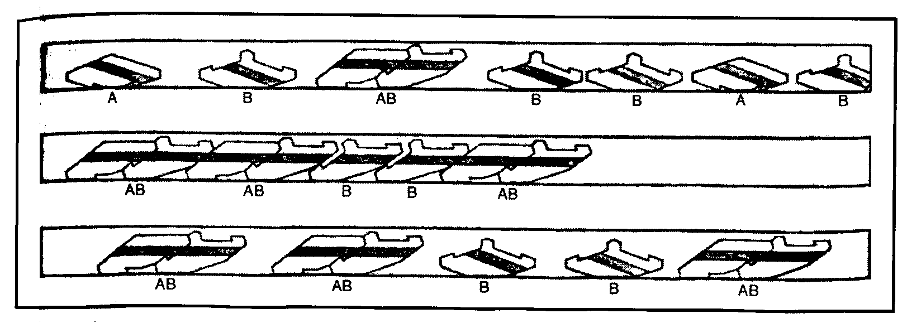

Figure 3. The Penroses' one-dimensional block reproducer. They also made a more complicated two-dimensional one.

In more recent times there have been other self-assembling kinematic self-reproducing machines that have taken advantage of microelectronics to allow kit-parts that exhibit more subtle behaviours. One of the most elegant is the machine designed by Victor Zykov and his colleagues at Cornell (Zykov 2005). Figure 4 shows it. It consists of a collection of identical cubes, each split by a diagonal plane. The two halves are motorized, and can thus rotate relative to each other about an axis at right-angles to the splitting plane. Each face of each cube is equipped with electromagnets that can be turned on or off, allowing one cube to pick up and to release another. An initial tower of cubes held together magnetically is constructed by hand. This tower can then automatically bend and flex like a robot arm, picking up extra cubes with its magnets and assembling them into an identical tower.

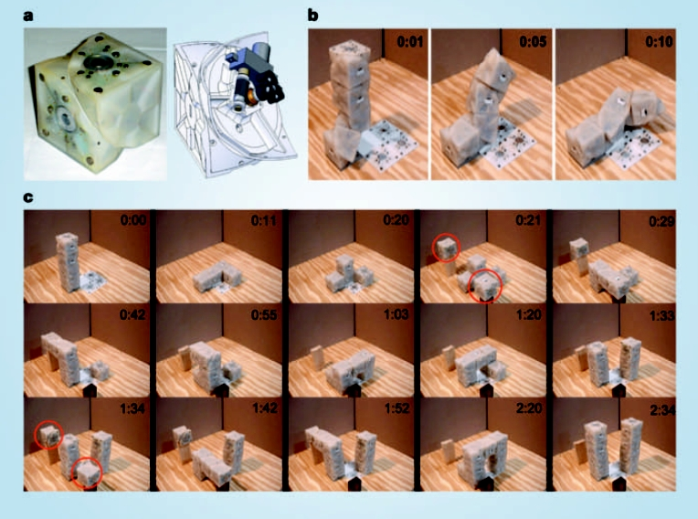

Figure 4. Zykov's self-reproducing tower of cubes, taken from (Zykov 2005). One cube is shown top-left (a). The sequence (c) shows the tower copying itself using a supply (red circles) of more identical cubes.

12.5.2 Self-manufacturing kinematic machines

A self-manufacturing kinematic machine is one that can make its own kit of parts from raw materials. If, in addition, it could also then assemble the kit into a copy of itself like the devices in the last section, it would be a fully autotrophic self-reproducing kinematic machine. So far no artificial fully autotrophic self-reproducing kinematic machines have been made, but most bacteria, archaea, protists, and plants are autotrophic self-reproducing kinematic machines.

As Butler, and then von Neumann, observed: any sufficiently well-equipped workshop could be considered to be an assisted self-manufacturing kinematic machine if it was capable of making the parts for all the tools it contained. People would have to assemble the tools, and then the workshop would have reproduced using the people as its assistants.
The problem lies in that “sufficiently well-equipped” phrase. Adding different equipment gives more manufacturing versatility and so gives more complete potential for reproduction, but it often also requires even more manufacturing versatility to make the new extra equipment. We end up chasing a receding target, though human engineering considered as a whole is obviously an assisted self-manufacturing kinematic machine.
Fab Lab, which was created by Neil Gershenfeld at MIT, is an example of a workshop that is currently one of those closest to being a reproducing workshop (Gershenfeld 2010). It is also extremely useful in its own right.
A Fab Lab (Figure 4) consists of a carefully-selected group of digitally-controlled manufacturing machines.

Photo from Neil (requested)

Figure 4. The Fab Lab in XXXXX

This group usually contains computers, a lasercutter, a small three-axis CNC mill, and a vinyl cutter. In addition Fab Labs have the materials and tools necessary for soft-tool-casting in a variety of substances such as polydimethyl siloxane, waxes and plasters. Finally they have hand-tools, especially those needed to make electronic circuits. The mill and the vinyl cutter are used for making printed circuit boards (conventional, and flexible, respectively) as opposed to making those traditionally by ferric-chloride etching. Some Fab Labs also have 3D printers (see below) and other more powerful tools.
That tool-group does not form a Butler/von-Neumann self-manufacturing kinematic machine. It cannot, for example, make the integrated circuits and the storage discs in its computers. But advances in such technologies as the printing of integrated circuits using ink-jet technology will move Fab Labs further along that road to becoming true reproducing workshops.
By the definitions above, a Fab Lab is an assisted self-manufacturing kinematic machine.
Another assisted self-manufacturing kinematic machine is RepRap (Sells 2009). RepRap is short for Replicating Rapid-prototyper. It is an attempt to get a single machine to make a kit of parts for a copy of itself. One is shown in Figure 5.
RepRap is a 3D printer that uses fused filament fabrication to build parts. Fused filament fabrication is rather like a computer-controlled glue gun: an extrusion head emitting a fine filament of molten plastic scribbles on a flat bed to form the bottom layer of a 3D part that is to be made. The head then moves upwards a small amount and scribbles the next layer. This, because it is molten, welds to the first. The process is repeated until the part is finished.
Not counting nuts and bolts, RepRap can print about 50% of its own parts. The remainder are deliberately chosen to be low-cost and very widely available worldwide. Because all the designs, software and documentation for RepRap are released free under the GNU General Public Licence, anyone who wants to make one can do so. They can then print another and give that RepRap to a friend...

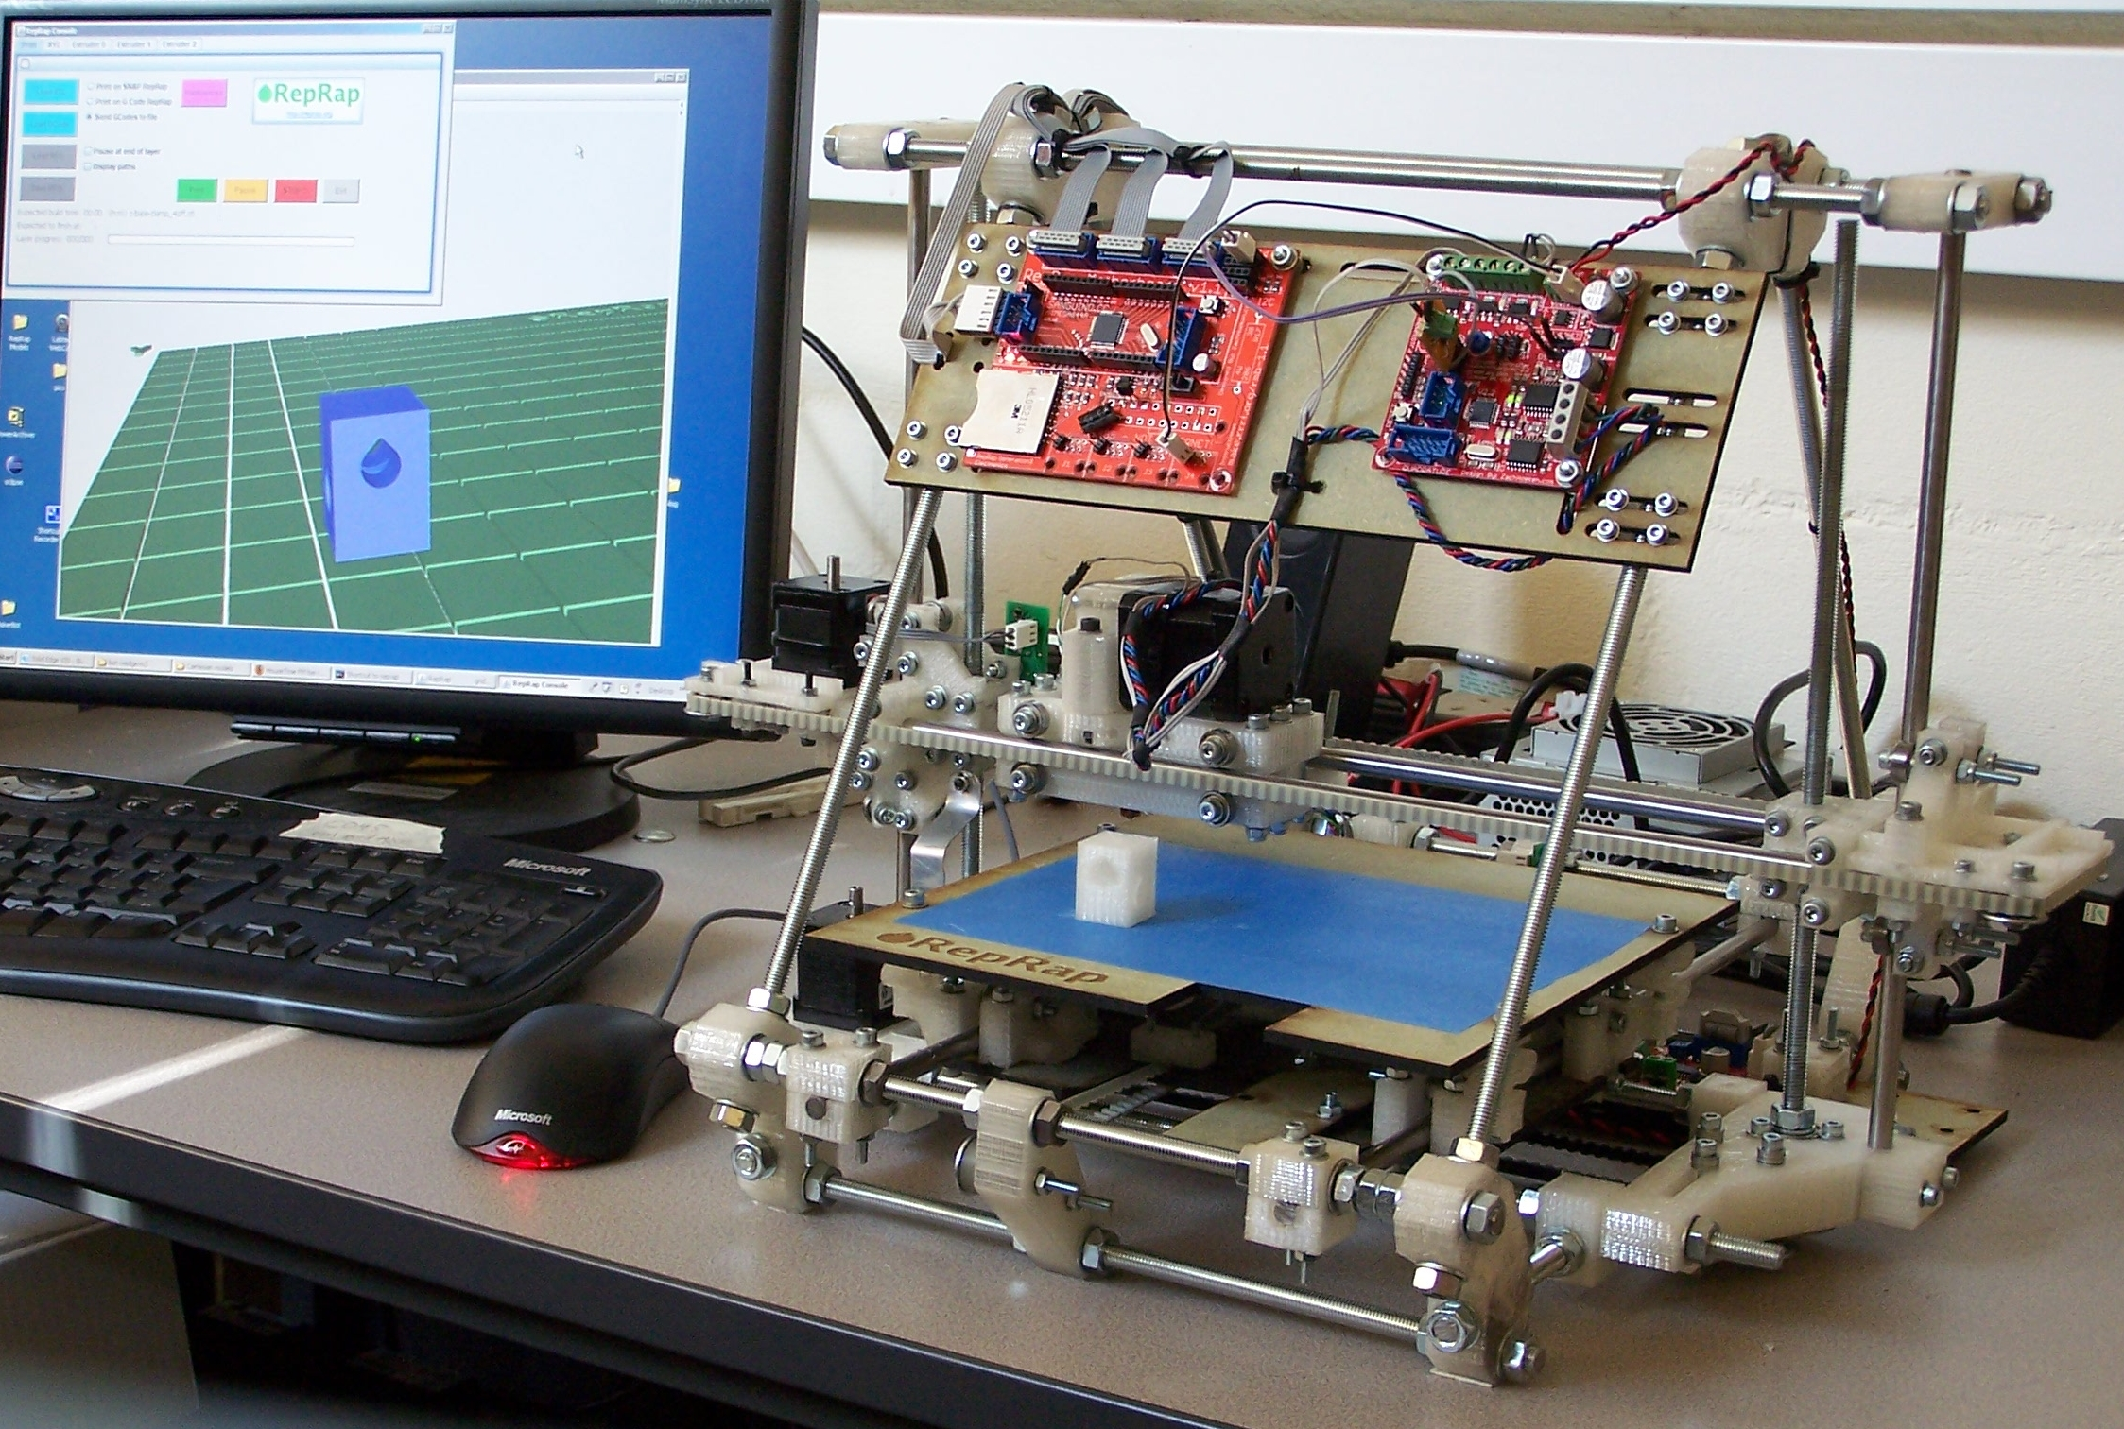

Figure 5. A RepRap machine. It has just made the white part that is on the blue build-base (the computer model of the part is also shown on the screen of the computer driving the RepRap machine). That part is a component of the RepRap machine itself.

12.5.3 Self-assembling versus self-manufacturing kinematic machines

As was mentioned at the start of the last section, an unassisted combination of self-assembling and self-manufacturing technologies would be a fully autotrophic self-reproducing kinematic machine. These have been extant on Earth for three and a half billion years, but have yet to be made artificially.
Assisted self-assembling kinematic machines tend to be more impressive to watch than assisted self-manufacturing kinematic machines, but the latter tend to be more useful.
Self-assembling kinematic machines are hard enough to make work on their own, without requiring from them the additional capacity to make useful goods from their kit-parts. Also, for most such machines that have been developed, the parts tend to be quite big (of the order of several centimetres across), optimized for operation in the self-assembling machine, and of more-or less uniform size, which again limits what can be made from them.
In contrast, an assisted self-manufacturing kinematic machine can make a wide variety of other goods in addition to the parts of itself because of the manufacturing versatility that it has to have anyway. Both Fab Lab and RepRap are intended to manufacture many other items that will be useful to people. In the case of RepRap this is a deliberate designed-in reproductive strategy: people getting goods from RepRap machines will have an incentive to help RepRaps to reproduce, just as the bee getting nectar from the clover has an incentive to help the clover to reproduce.

12.6 Physico-chemical self-assembly and reproduction

Life is chemistry, dancing.

Many people have made self-assembling systems using the toolbox provided by chemistry. Their early-days attempts are, perhaps, a mosh pit compared to the Ballets Russes of a clover or a bee, but living organisms give a clear existence proof that this approach can be made to work.

12.6.1 Meso-scale self-assembly

We know that self-assembled collections of atoms – molecules – make up everything in the world including everything that reproduces, but we can't take those collections apart by hand, or even forceps, to turn their parts about and see how they are shaped and how they work.
George Whitesides and his colleagues at Harvard have been modelling molecules with artificial atoms a millimetre or so across (Bowden 2001).
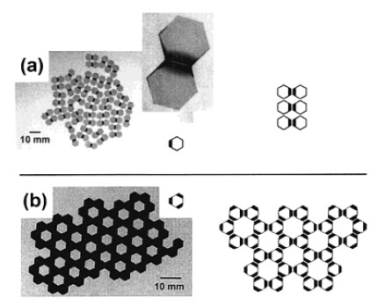

Figure 6. Two-dimensional self-assembling structures at a fluid interface, taken from (Bowden 2001). Picture (a) shows hexagonal tiles with one active edge forming “dimers”. Picture (b) shows hexagons with three active edges forming a reticulated pattern of larger hexagons. Left are photographs of the experiments; right are diagrams of what's going on.

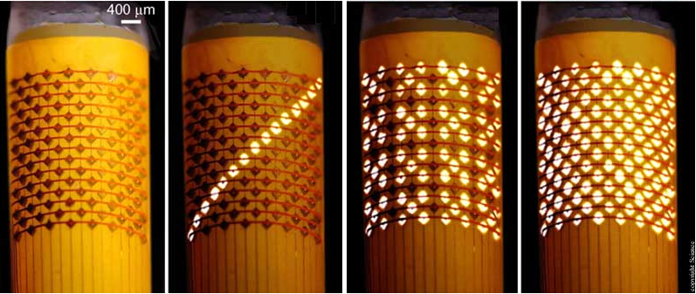
Figure 7. An array of LEDs self-assembled on the surface of a cylinder.

They make a set of very small plastic squares, hexagons or other polygons that will float at the interface between two immiscible fluids, usually perfluorodecalin and water (see Figure 6). They treat the edges of the shapes so that they have matching patterns of hydrophobic and hydrophilic sections. Capillary forces cause the tiles tend to stick together selectively depending on the patterns, allowing complicated structures to self-assemble.
This technique can be extended to tiles that are active. Figure 7 shows a pattern of LEDs that have self-assembled into an array on the surface of a cylinder using similar methods. It is straightforward to use conventional chip-manufacturing techniques to make a LED array on a flat surface, but those conventional techniques (which use image projection) do not extend well, or at all, to curved surfaces.

12.6.2 Synthetic biology

Moving back down among the molecules, we finally arrive at the research that is where all these other projects are heading: research that is trying to make a real living organism, or at least parts of one, from scratch. I, and all the others who did the work above, are synthetic-biologists manqué. Like the manufacturing engineer looking out of their window at the riot of life in the shrubbery, we know that that is the right way to do it, really.
The fundamental machine that is life is quite simple to describe and, superficially, quite easy to understand. A length of DNA is a list that describes the order of amino acids that needs to go together to make a protein. That length is copied to a length of RNA, which is then fed end-on into an assembly called a ribosome. The ribosome reads the RNA like an old-fashioned computer reading a punched paper tape and stitches together the right amino acids in the right sequence to make the protein.
Some of those proteins help to copy that DNA when the cell in which all this is happening reproduces. Other proteins (together with some RNA) make up more ribosomes. The rest build bones, give people food poisoning, put all the oxygen into the air, compose Chopin's Nocturne in B-flat minor Opus 9, turn a flower to face the sun, and write about all these things.
The RNA list consists of triples called codons, each one of which corresponds to an amino acid. There are sixty-four (= 4³) possible codons, and they are all used. But there are only twenty natural amino acids that codons define, so each amino acid has several different codons that can be employed to call it up. For example, the codons AUU, AUC and AUA all mean tack-an-isoleucine-onto-the-protein-being-made.
However, it is possible to make many artificial amino acids that don't occur in nature, and – if we could build those into proteins too – we could greatly expand the sorts of chemistry that could be carried out in living things. But all the sixty-four possible three-nucleotide codons are already used (if redundantly), and so there are no spare ones left to use to tell a ribosome to build the artificial amino acids into a protein.
Jason Chin and his colleagues in Cambridge have, in a piece of genetic engineering that is a tour de force, solved this problem (Bowden 2001). They redesigned the ribosome so that it works with codons consisting of four nucleotides as well as three. This gives 256 (= 4⁴) new codons. Together with the existing sixty-four natural codons that code for twenty amino acids, that means that 276 amino acids can be used in proteins. They inserted all their new bits of machinery into E. coli bacteria and got them to make a modified conventional protein that incorporated two new artificial amino acids. Those artificial amino acids were designed to hold the protein's folds together in a different, more stable, way to that used by all the natural amino acids. This could mean proteins that work at higher temperatures, in more acidic or alkali environments, or a host of other possible improvements over what has evolved biologically.
It is hard to overstate how important and revolutionary this is. All the exponential-growth advantages of self-reproducing manufacture that were described in the introduction to this chapter kick-in immediately you start to use bacteria (or any other living thing) to make products, just as they do with artificial reproducers. If we can use bacteria to make new materials that cannot exist in nature or in the output of our conventional chemical engineering industry, then truly extraordinary possibilities open up.
So. If we can re-engineer that core and fundamental part of all living things, can we build an entire living organism from scratch?
Not quite yet. Mycoplasma genitalium has the smallest genome of any organism that can be grown in pure culture. Craig Venter and his colleagues have identified which parts of its genetic material can be removed without affecting how it lives (all genomes contain DNA that does nothing useful and that just hitches a ride when the useful stuff copies itself). They have then built the resulting edited genome from scratch (Gibson 2008). They intend to go on to put that genome into a synthetic bacterium. Other people are assembling toolkits of genes for specific behaviours and characteristics that can then be included in synthetic organisms to give them those characteristics. The ultimate aim is to end up with a toolkit analogous to an electronic engineer’s catalogue of integrated circuits. People would decide what they want to make and, with assistance from a computer controlling a genetic engineering robot, take a minimal synthetic bacterium and add the appropriate tools from the kit to it. The bacteria would then start churning out exponentially-expanding amounts of conducting polymers for battery electrodes, drugs to break down the amyloid plaques in the brains of Alzheimer's sufferers, or diamond fibres for making aircraft wings. At least, that is the vision.

12.7 Self-reproducing machines, economics, and society

If that vision becomes the case (and it seems very likely that it will), the world will rapidly become as different from ours as ours is from the time before electricity.
Of course I have no better an idea of what will happen in the future than any of the seven billion of you. But we can identify trends.

One that is possibly very significant is the trend away from the traditional closed hierarchical industrial model that asserts “intellectual property” rights and garners profits to itself. This is starting to be replaced by flat open-source collaborations of volunteers to produce goods that are free. This has been facilitated by the Internet, of course; indeed it started as a way to develop the software such as Linux and the Apache web server that – to a first approximation – runs the Internet. But it is now moving into hardware too; there are open-source cars and open-source telephones.
The application of open-source to the technologies described in this chapter is particularly likely by the very nature of self-reproduction:

- Attempting to keep control of a self-reproducing product so that you can make money from it is intrinsically difficult, because all your customers immediately become potential producers. They can make your product for their friends. This does not lend itself to buying, selling, and profits using a conventional industrial model.
- Because self-reproduction, by definition, allows the product to copy itself, that product can get made and distributed in a manner far more like the copying of a computer file than like the manufacture of goods in factories and their sale in shops. This could destroy the idea of economies of scale in manufactured goods just as the ease of copying of music and motion-pictures has destroyed the idea of copyright in those items.
- Self-reproducing machines will become cheap because of the exponential rate at which their numbers grow and their resulting large numbers: an ear of wheat costs nothing compared to a Ferrari, even though it is an almost-unimaginably more complicated machine. Cheap machines are ones that everyone can own. This implies personal production of goods, rather than centralised industrial production.
- Darwin's Law of Evolution operates, as it must for all reproducers. But the extinction of less-fit species of artificial reproducers and their replacement by better human-designed ones is the prerogative of people. The process is much more like the selective breeding of the dog from the wolf, which we did about ten-thousand years ago, than the natural selection that gave rise to the original wolf. One result of that is that the artificial reproducers should become very robust and very efficient very quickly.
- Just as a person who grows their own food has – all other things being equal – less need for money than a person who doesn't, a person who makes their own goods and materials also has less need for money. The widespread take-up of self-reproducing machines (either macroscopic or microscopic) by individuals and small groups for the manufacture of materials and goods will free up money for use on other things and might make significant sections of industry go the way of newspapers, record companies and other now-surpassed producers.

Note that all this means both more wealth and a more even distribution of it, though possibly less money (or at least a lowering of the significance of money). It is, though, extremely unlikely to mean lower employment. Almost every technical advance since the industrial revolution has – at the time – been said to be the thing that will finally lead to an age of leisure. This has never happened, and it probably never will. It is rather interesting to read the predictions of mass unemployment that were made in the 1960s when people envisioned the widespread use of computers. This simply failed to materialise. Instead very large numbers of people gained employment in the digital economy.
What technical advances do is to change the jobs done, not to reduce their number. Almost every fully-employed person in the developed world is doing a job that would seem easy, part-time, effete, and self-indulgent to one of our ancestors working in a non-automated nineteenth-century factory; and their job would seem similarly easy to one of their hungry subsistence-farming ancestors.
Jobs do not create wealth. Wealth creates jobs. But the nature of those jobs becomes both easier and more interesting the more wealthy we get.

12.8 Self-reproducing machines, ethics and safety
One of the more endearing aspects of the human psyche is our modesty: we are always saying how badly-behaved and selfish we are, both individually and collectively. This is driven, in part, by the very biased selective reporting of only bad news (good news does not sell). Our modesty is becoming, but it is not objectively and statistically true. Human beings are about the kindest and best-behaved organisms on the planet. We are, for example, the only one that cares for all the others and looks out for their welfare as well as our own. And give people an internal combustion engine and they will make tanks. But they will make many many more ambulances.
However, it is obvious that a world in which thirteen-year-olds can genetically alter self-reproducing microbes in kitchens to make polymers that have never existed in nature or in commerce is a world containing the potential for new mischief. How are we to restrain that mischief, if at all?
There are two ways to control human behaviour: rules can be written, or incentives and disincentives can be imposed. There is a rule against murdering people; there are taxes on tobacco to reduce consumption. Murder is already about as heavily punished as possible, but the detection rate is not perfect. If the detection rate were raised, the murder rate would fall, though not to zero, as we all know that some crimes of passion are committed without thought of the consequences. If the tobacco tax went higher, more people would stop smoking. But others would start growing their own tobacco.
A rule with a sanction, or an incentive or disincentive, all shift the point of a Nash equilibrium in a social game. People's behaviour in the game will change when the rule changes, but no rule nor incentive will ever produce a perfect result. Murders would still happen if there was a 100% detection rate and guilt meant instant death for the murderer and all his or her children. Imposing the same punishment for possession of tobacco would not completely eliminate smoking (though it would cut it down...). It would virtually eliminate it in the long-term though (as it would murder); it is a perfect Darwinian selection against the behaviour. But murderer (and smoker) mutants would still occasionally pop up at random, even then.
The point of this extreme, though brief, excursion into over-the-top enforcement is that self-reproducing machines are uniquely immune to regulation. It is a sobering experience to pour antibiotic into a Petri dish containing a flourishing culture of bacteria. They all seem to die. But, after a while, two or three perfect circles of new bacterial growth start to spread. They come from the two or three bacteria from among the dead billions that were antibiotic-resistant.
For self-reproducing machines (whether actual bacteria or things you can pick up and put in a cupboard) the whole human race is the Petri dish's nutrient gel, and attempts at regulation (or incentives) are the antibiotic. If people find the machines useful (that is, if the gel nourishes the machines) then no rule will stamp them out completely. And, like the resistant strain, given exponential growth it only takes one to get through…
So our teenage genetic engineer will come to pass, sooner or later. And the lesson of history is that we will muddle along, producing rules and incentives to try to control what does and does not happen. Those rules and incentives that have been framed dispassionately and game-theoretically will probably work about as well as the game theory predicted. Those that are hastily cobbled together to respond to some emergency (whether real – or, given the biased press reporting mentioned above - more likely imaginary) will probably hardly work at all.
In other words, it will be just like what we do at the moment. Our technology and our built surroundings will change beyond recognition, but people (until we start using that technology to change our germ line) will stay much the same.

12.9 References
(Freitas 2004) Robert A. Freitas Jr., Ralph C. Merkle: Kinematic Self-Replicating Machines, Landes Bioscience, Georgetown, TX, 2004. (http://www.MolecularAssembler.com/KSRM.htm)
(Butler 1872) Samuel Butler: Erewhon: or, Over the Range, Jonathan Cape, 1872. (http://www.gutenberg.org/etext/19060)
(Darwin 1859) Charles Darwin: On the Origin of Species by Means of Natural Selection, or the Preservation of Favoured Races in the Struggle for Life, John Murray, 24 November 1859. (http://www.gutenberg.org/etext/21153)
(Shannon 1948) Claude Shannon: A Mathematical Theory of Communication, The Bell Systems Technical Journal, Vol. 27, pp. 379–423, 623–656, July - October, 1948. (http://tinyurl.com/f4two)
(Gardner 1970) Martin Gardner: Mathematical Games, Scientific American, October 1970.
(Wikipedia) Wikipedia: Conway's Game of Life, http://en.wikipedia.org/wiki/Conway's_Game_of_Life
(Wolfram 2002) Stephen Wolfram: A New Kind of Science, Wolfram Media, Inc., 2002. ISBN 1-57955-008-8.
(von Neumann 1963) John von Neumann: Collected Works, ed. A. H. Taub, Volume 5: Design of computers, theory of automata and numerical analysis, Pergamon Press, New York, 1963.
(von Neumann 1966) John von Neumann: Theory of Self-Reproducing Automata, ed. Arthur W. Burks, University of Illinois Press, 1966.
(Pesavento 1995) Umberto Pesavento: An implementation of von Neumann's self-reproducing machine, Artificial Life (MIT Press) 2 (4): 337–354, 1995. (http://tinyurl.com/ydtll5d)
(Stevens 2010) William Stevens: PhD thesis, Open University, 2010. http://www.srm.org.uk/home.html
(Penrose 1958) Lionel Penrose: Mechanics of self-reproduction. Ann. Human Genetics, 23, pp. 59-72, 1958. (http://vx.netlux.org/lib/mlp01.html)
(Zykov 2005) Victor Zykov et al.: Self-reproducing machines, Nature, v 435, p163, 2005 (http://tinyurl.com/ygozg37)
(Gershenfeld 2010) Neil Gershenfeld:
(Sells 2009) Ed Sells et al.: RepRap: The Replicating Rapid Prototyper, in Handbook of Research in Mass Customization and Personalization, Eds. Frank Piller and Mitchell Tseng, World Scientific, ISBN: 978-981-4280-25-9, 2009.
(Bowden 2001) Ned Bowden et al.: Molecule-Mimetic Chemistry and Mesoscale Self-Assembly, Acc. Chem. Res., 34 (3), pp 231–238, 2001.
(Neumann 2010) Heinz Neumann et al.: Encoding multiple unnatural amino acids via evolution of a quadruplet-decoding ribosome, Nature 464, 441-444, 2010.
(Gibson 2008) Daniel Gibson et al.: Complete Chemical Synthesis, Assembly, and Cloning of a Mycoplasma genitalium Genome, Science 319 (5867): 1215-1220, 2008.

Rather appropriately, I write these words while on holiday in Ironbridge in Shropshire, popularly - if naively - known as the birthplace of the Industrial Revolution.
The Swedish winter of 1649, incidentally, was what did for poor Descartes; he died of pneumonia on the 11th of February 1650. The queen was distraught - she had warned him against visiting in the winter, suggesting spring or summer instead.
Though see the work of the Penroses, père et fils, below.
This particular set of three cellular automaton rules were devised by John Conway, and are called "Life" (Gardner 1970).
So a whole neuron is bigger. It is hard to be specific because a neuron's dendrites can be very long - of the order of one meter.
http://en.wikipedia.org/wiki/Von_Neumann_universal_constructor
This is not strictly true. What I said above about the impossibility of true perfect replication still holds. A stray alpha particle can flip a bit in a computer's memory, for example. Such events are almost preternaturally rare, but – given long enough – they are inevitable.
Pre-manufactured, ultimately, by plants and microbes. In fact, you can also make some, though not all, amino acids for yourself.
Whether by photosynthesis in the leaf of a soya plant, or by injection moulding in a Lego factory.
Now Sir Roger Penrose, one of the world's most pre-eminent mathematical physicists. At the time of this research on self-reproduction he was a schoolboy.
“Rapid Prototyper” is engineer-speak for 3D printer. I invented RepRap. That is the reason that I was invited to write this...
Sometimes called “Fused Deposition Modelling”, though that phrase is trademarked (unlike Fused Filament Fabrication), and so is not in free use.
The nuts and bolts could be replaced by printed cylinders plus glue, and the machine would work just as well. But it would then be more difficult to experiment with and to modify.
http://reprap.org
There are two more, selenocysteine and pyrrolysine, that are incorporated by different mechanisms.
Nucleotides: A = Adenine: C5H5N5; C = Cytosine: C4H5N3O; G = Guanine: C5H5N5O; U = Uracil: C4H4N2O2
HO2CCH(NH2)CH(CH3)CH2CH3 - an essential amino acid, that is to say one of the ones that we can't make ourselves.
"Intellectual property is dead." said Eric von Hippel, Professor of Management at the MIT Sloan School of Management, in his keynote address to the World Conference on Mass Customization and Personalization, MIT, October 2007.

