

The 3D printer that prints itself

http://reprap.org

RepRap was the first of the low-cost 3D printers, and the RepRap Project started the open-source 3D printer revolution.

More significantly - and uniquely - RepRap is able to print out half its own parts. The other half are designed to be common items available from hardware stores or on-line. RepRap is the Replicating Rapid-prototyper. This means that anyone with a RepRap can make another RepRap for a friend, or can make RepRaps and sell them. Anyone using RepRaps for production of more RepRaps, or any other item, can double their capacity in a few days simply by taking their RepRaps out of service and having them copy themselves.

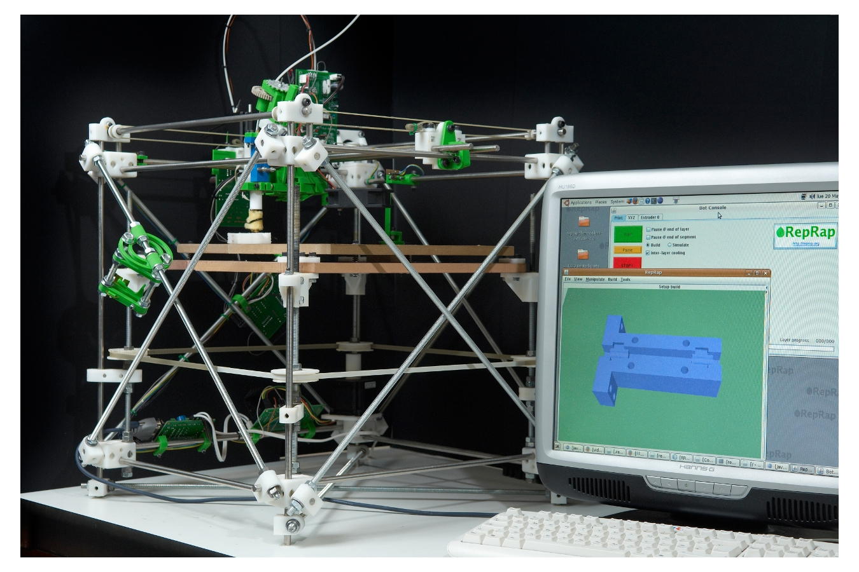 RepRap Version I "Darwin" (2007)

Because RepRap is free and open-source, any person or company anywhere in the world can do these things without any royalty payments or other licensing issues. The only obligation on users is openly to release any improvements they make to the design of the RepRap machine itself back to the community.
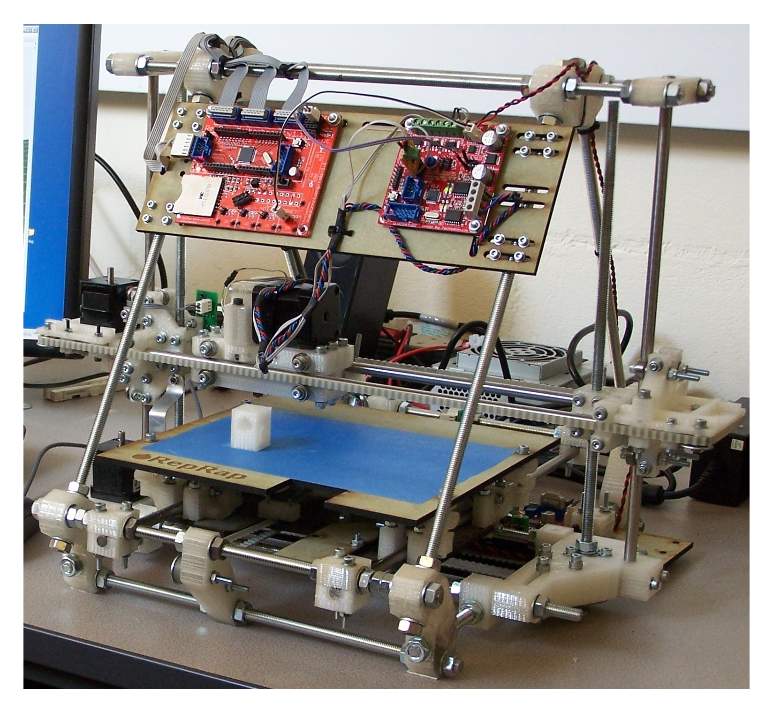 RepRap Version II "Mendel" (2009)

Of course, RepRap is not the only 3D printer that can make more RepRaps. Any 3D printer that can build mechanically-strong parts can do so. This means that people and companies starting with another 3D printer can expand their manufacturing capacity independently by having that printer print RepRaps.

What can RepRap make?
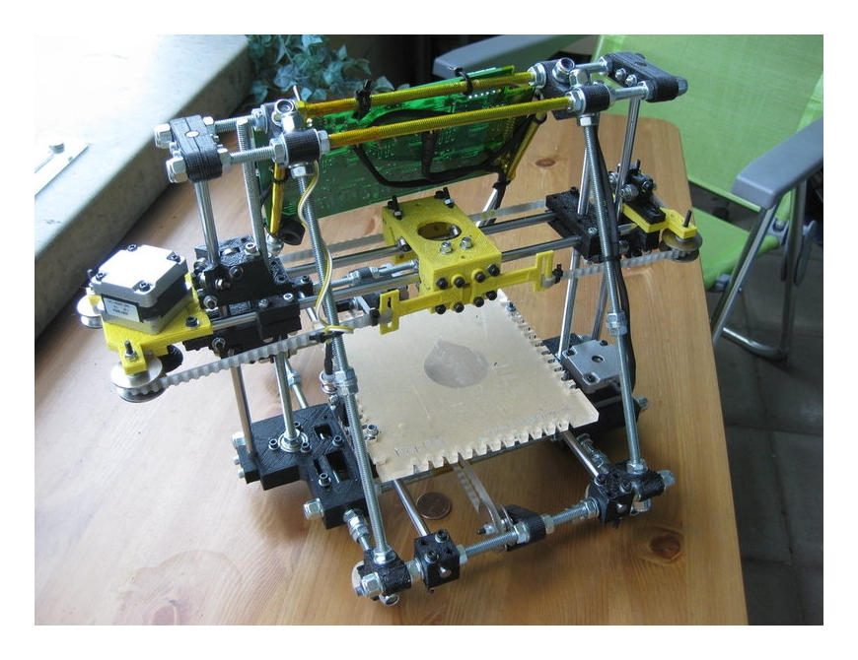 RepRap Version III "Huxley" (2011)
RepRap mainly works in plastic. But people have also used it to print in clay/ceramic and silicone rubber. Experiments on getting RepRap to print in low-melting-point metals are at an advanced stage.

All these materials can be combined into single complex objects, and - with metals in particular - 3D electrical circuitry becomes possible.

There are websites where people can upload designs of items so that others can print them too. For RepRap users, the electronic exchange of material objects is already as simple as exchanging pictures or music.

Here are a few things people have made in RepRap machines:
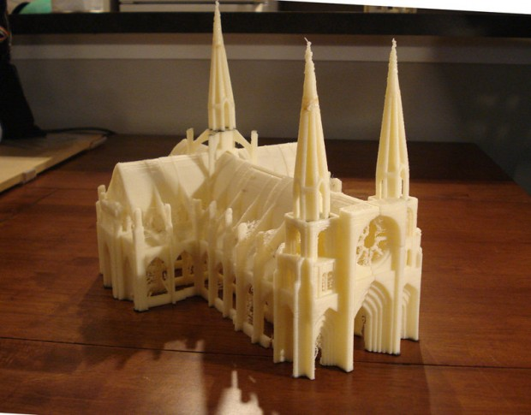Architectural models
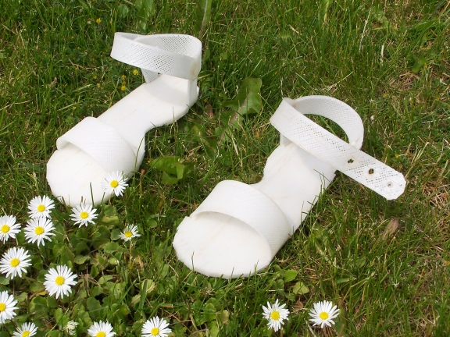Children's shoes

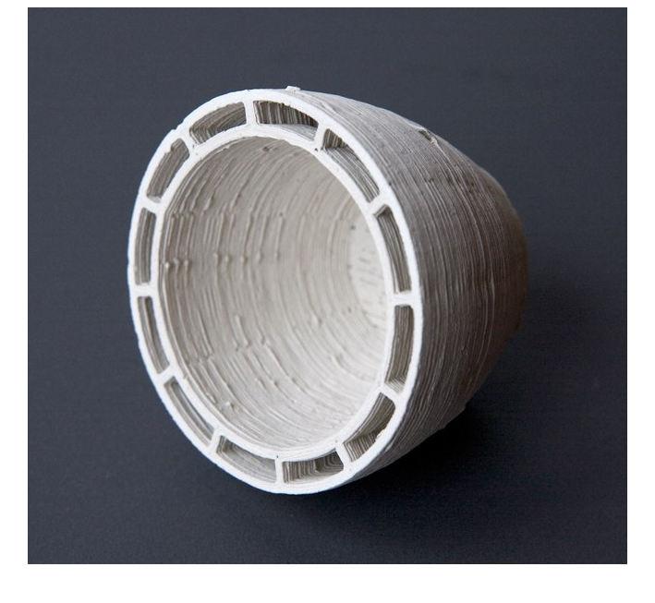Insulated clay cups (how else would you make that?)
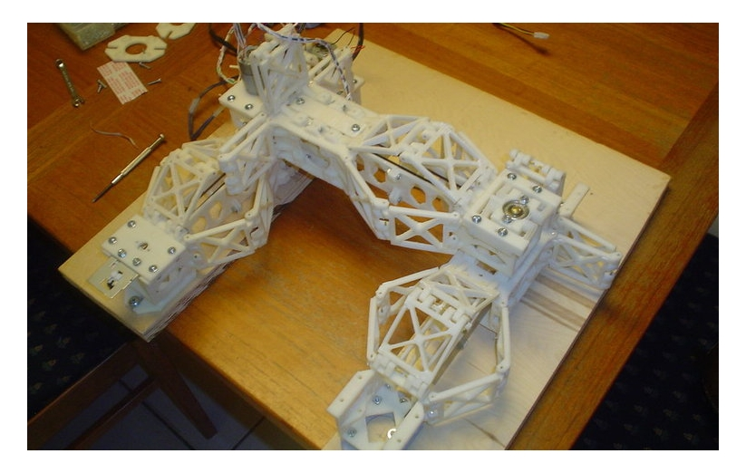 New types of RepRap...

