Chapter 12: Self-reproducing machines and manufacturing processes

Adrian Bowyer, University of Bath, UK

12.1 Introduction 1
12.2 A historical perspective 1
12.3 Some definitions of terms 2
12.4 Simulation and analysis 4
12.4.1 Cellular automata 4
12.4.2 von Neumann reproduction 4
12.4.3 Moving from mathematics to physics 6
12.10 References 7

12.1 Introduction
Anyone who has ever made anything can see how it ought to be done: all they have to do is to look up from their workbench and out of the window. Outside there will be a riot of manufacturing excess that has created a knee-deep layer of machines covering the entire planet; indeed our very knees are made from those machines.
This chapter is about harnessing the planet-transforming power of self-reproduction to make products useful to people. Of course, in one sense, doing this is our oldest technology - we call it farming. But for farming we took naturally-evolved reproducers, genetically engineered them by selective breeding to make them more to our liking, and set them to work to feed and to clothe us. Farming is still our most important technology - we could live without engineering, but not without food; however, in this chapter I will look at attempts to create artificial reproducers to make the goods normally manufactured by industrial production.

12.2 A historical perspective
How far back does the idea that a human-engineered machine might be designed to reproduce itself go?
In their excellent book Kinematic Self-Replicating Machines [1], Bob Freitas and Ralph Merkle recount the anecdote that, when Descartes told Queen Christina of Sweden his opinion that the human body was a machine, she asked, "How can machines reproduce themselves?" Descartes was visiting the queen in the winter of 1649, and that is the most probable date for the conversation, though they had previously corresponded.

In Chapter 23 of his simultaneously utopian and dystopian novel Erewhon [2], Samuel Butler's first-person narrator gives a translation of an Erewhonian "Book of the Machines". This recounts philosophical speculations on what we, today, would call artificial intelligence and artificial life. It contains the following passage:

"Surely if a machine is able to reproduce another machine systematically, we may say that it has a reproductive system. What is a reproductive system, if it be not a system for reproduction? And how few of the machines are there which have not been produced systematically by other
machines? But it is man that makes them do so. Yes; but is it not insects that make many of the plants reproductive, and would not whole families of plants die out if their fertilisation was not effected by a class of agents utterly foreign to themselves? Does any one say that the red clover has no reproductive system because the humble bee (and the humble bee only) must aid and abet it before it can reproduce? No one. The humble bee is a part of the reproductive system of the clover. Each one of ourselves has sprung from minute animalcules whose entity was entirely distinct from our own, and which acted after their kind with no thought or heed of what we might think about it. These little creatures are part of our own reproductive system; then why not we part of that of the machines?"

Erewhon was published in 1872, just thirteen years after The Origin of Species [3]. Butler can reasonably be credited with the idea that self-reproducing machines would be useful for industrial production, and with the idea that they would be inescapably subject to Darwinian evolution. At the time, some though that he was attempting to disprove Darwin by reductio ad absurdum. To disabuse people of this opinion he later wrote, "I regret that reviewers have in some cases been inclined to treat the chapters on Machines as an attempt to reduce Mr. Darwin's theory to an absurdity. Nothing could be further from my intention, and few things would be more distasteful to me than any attempt to laugh at Mr. Darwin...."
Our own age is more accommodating of the conceit that machines might both reproduce and evolve, in large part because we now make machines more subtle and fabulous than any seen in even the most opiate Victorian Limehouse pipe dream, and also because we are starting to achieve solid, reproducible (in every sense) research results in artificial machine reproduction.

12.3 Some definitions of terms
Historically, the terminology used in the field of self-reproducing machines has sometimes been unclear, with different meanings being ascribed to the same words. In an attempt to bring some systematisation to this, I will define key terms for use in this chapter at least:

Kinematic machine - A physical machine that is composed of fixed and moveable parts. This term makes a distinction between real machines and software models (which are frequently used for simulation). In what follows I take the words kinematic machine to include living organisms.

Self-replication – To define this, let us start with the idea that self-replication could mean an imaginary Platonic process by which a kinematic machine was able to create an exact copy of itself. The Second Law of Thermodynamics and Shannon’s theorem [4] show that information cannot be copied without loss or error indefinitely, implying that the idea of an exact replicator is an impossibility. (It is the errors, of course, that drive Darwinian evolution.) Whilst it is philosophically and poetically useful to have words for impossible ideas, here the strength of the word replication is reduced to give it an engineering meaning: a copy within specified tolerances that will work as well as the original.

Self-reproduction - A process by which a kinematic machine is able to create an approximate copy of itself, perhaps with either insignificant or significant errors. All living organisms are self-reproducers. The specified-tolerances-and-works-as-well distinction between replication and reproduction follows through the definitions below, and the rest of this chapter. Replicators are a subset of reproducers.

Self-manufacturing – The ability of a kinematic machine to make some or all of its own parts from raw materials. This clearly prompts a requirement for a definition of “raw”: is an etched PCB a raw material? Or a uniform copper-clad board? Or some copper, some glass, and some epoxy resin? Forensically, many Gordian Knots of this sort are cut by asking, “Would a reasonable person say it is so?” and leaving it at that. Here the same approach as the law is adopted.

Self-assembly - This refers to the ability of a kinematic machine to manipulate a series of parts into an assembled copy of itself.

Autotrophic self-reproduction or -replication - The ability of a system to make a direct copy of itself from raw materials without assistance. As yet, no artificial autotrophic self-reproducing kinematic machine has been made. However, examples exist in biology. For a kinematic machine to achieve autotrophic self-reproduction, it must contain a number of critical subsystems. One attempt to identify these subsystems was undertaken in Freitas and Merkle’s “Map of the Kinematic Replicator Design Space” in their book referred to above [1], which identified 137 design properties in order for autotrophic self-reproduction to be possible.

Assisted self-reproduction or -replication - A kinematic machine that includes at least one, but not all of the critical subsystems required for autotrophic self-reproduction or replication and so needs human (or other) intervention to reproduce.

12.4 Simulation and analysis
When people can't make something they want, they often make a model of it instead. This is sometimes mere superstitious sympathetic magic. But othertimes a model is a step on the path to the goal of having the real object that the model represents. These days no one would make an aeroplane speculatively and then test-fly it to see if it would stay up in the air; they would spend many hundreds of hours of computer time using finite-element models to find out if the wings were likely to fall off, and many hundreds of hours more using computational fluid dynamics models to find out if those wings were able to hold the aeroplane up.
Before engineering had reached the point where kinematic artificial self-reproducing machines could even begin to be made, computers were powerful enough to model how they might, in the future, work. And before computers were that powerful, the theory of computation (another model) had progressed to the point where it was obvious that future computers would be able to process such self-reproducing-machine models. Much of this early modelling of self-reproducing machines was done by John von Neumann towards the end of his life in the middle of the last century.

12.4.1 Cellular automata
Imagine that you have in front of you a sheet of graph paper, a pencil, and an eraser. Further imagine that someone has already shaded in a few squares on the graph paper, and has given you a set of rules. These rules say:

- If a shaded square has two or three black neighbours, it stays shaded;
- If a shaded square has less than two, or more than three, shaded neighbours rub it out; and
- If an unshaded square has three shaded neighbours, shade it in.

You could follow these rules, and the consequent patterns of squares would grow and shrink across your sheet of paper.
The graph paper (together with you and the rules) would be an example of cellular automata. Each square together with the rules is a cellular automaton. The moving patterns that such cellular automata can generate are extraordinarily rich. For example, it is possible to make a pattern that acts like a factory, producing smaller identical patterns that repeatedly split off and drift across the paper forever. Wikipedia has an animation of this happening that you can watch; it is rather hypnotic. (See reference [6].) Stephen Wolfram has even maintained that cellular automata are the best (or maybe even the only) way to study very complicated systems in nature [7].
Cellular automata were invented by Stanislaw Ulam and John von Neumann in the 1940s. Ulam wanted to use cellular automata to study crystal growth, and von Neumann wanted to use them to study self-replicating machines.

12.4.2 von Neumann reproduction
John von Neumann started with the idea that there is a strong similarity between a computer and an animal's brain [8] and went on to study the idea of a robot making another identical robot - a kinematic self-replicating machine [9]. He very quickly ran up against two difficulties that can be summarized as size and containment.
The size problem that he identified seems, today, the less difficult of the two to surmount. He compared the size of a neuron to that of an electronic valve, arriving at a factor of 10⁹, and pointed out that their energy requirements differed in a similar ratio. Following this through to build an artificial self-replicating machine of a similar complexity to - say - a beetle one centimetre long, would require the entire mass of the Earth. Once the researchers had finished, lack of further material would make demonstrating its reproductive ability difficult...
However, just the nucleus of a neuron is about ten microns across whereas we can now easily make transistors under one micron across. What we can't (yet) do is to connect a transistor to very many others. Typically a single transistor in a microprocessor might drive twenty more. One of the neurons in your brain, in contrast, might well act as input to 10,000 other neurons. But it is certainly the case that modern electronics is processing information at about the same length scales or smaller than natural biological systems.
In passing, it is perhaps worth observing that von Neumann was concerned with the limits of computation in the context of reproducing machines and other things. But most self-replicating entities in nature have no brain at all - they are microbes. However, they do all still process information. A bacterium dividing is, of course, copying the information in its DNA, and that information is then used to make the proteins that form the two new bacteria.
Von Neumann's containment problem is at once both more obvious and more subtle. You can get together with someone else and have a baby; all you all need for that is food. You two parents and your baby form a closed reproduced system that requires nothing from outside itself except raw-materials to eat.
But it is extraordinarily difficult to have a robot driven by a computer make all the parts for another identical robot from a supply of raw materials such as steel and plastic. It is a little bit easier if the raw materials are steel gears and plastic pipe, and this is how you eat: you cannot eat carbon, hydrogen, nitrogen and oxygen, but you can eat amino acids made from those elements. But the robot has not copied the computer that is driving it - it is not a closed reproducing system like you, your partner, and your baby. This requirement also to copy the computer adds another layer of complexity to the artificial self-replication problem.
Von Neumann realised this and, at Ulam's suggestion, decided to concentrate on simulating reproducing machines using their just-invented cellular automata to build a model. Von Neumann gave an existence proof that a particular pattern would make endless copies of itself within his cellular universe. His cells only considered the four orthogonal cells to be neighbours (that is, he used rook's, and ignored bishop's, moves). His cells had 29 possible different states (as opposed to the two - shaded and unshaded - in the example above).
Von Neumann did all this without the distractions of access to an actual computer. In the 1940s they were too rudimentary for the task. He thus demonstrated the possibility of artificial mechanical replication (the digital copies really are identical) by making a model of a model of a reproducing machine.
It was not until 1995 that his work was implemented in a computer program and run. Figure 1 shows the program working. The implementation was done by Umberto Pesavento, and details can be found in reference [10].
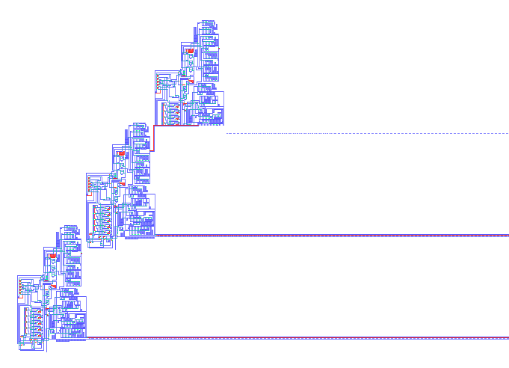
Figure 1: Pesavento's implementation of von Neumann's cellular automaton model of a reproducing machine (courtesy of Wikipedia). A parent (bottom) and its child (middle) are complete. The child is making a grandchild (top).

12.4.3 Moving from mathematics to physics
In 2010 William Stevens published a PhD thesis in which he presented a three-dimensional development from von Neumann's and Pesavento's work [11]. This was not merely a three-dimensional - as opposed to von Neumann's and Pesavento's two-dimensional - cellular automaton: that would be trivial (the two-dimensional one could easily be made to work in a plane slice through a three-dimensional universe, for example).

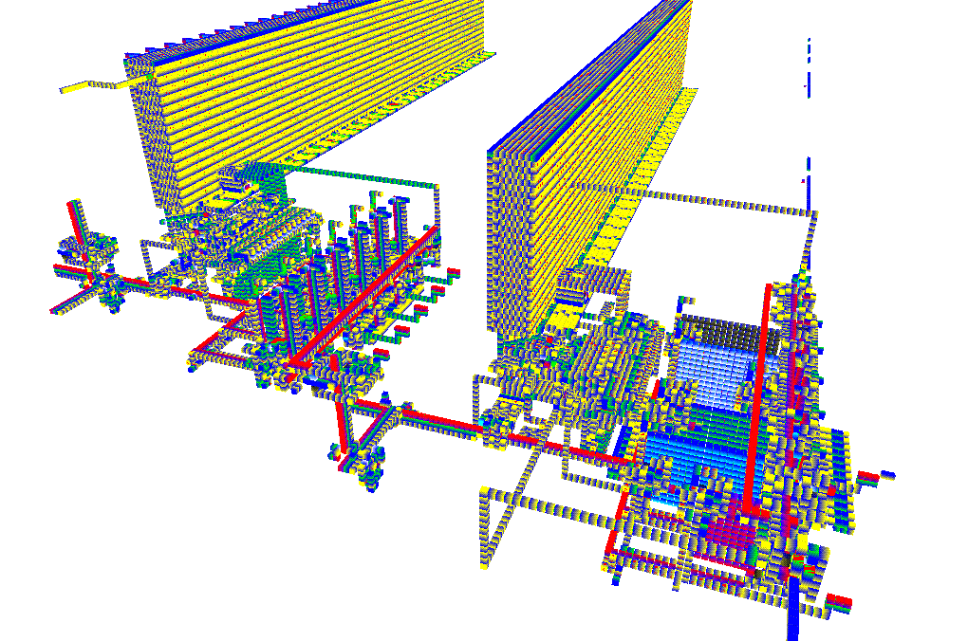

Figure 2: William Stevens's three-dimensional physical self-replicator simulation. The parent is on the right; the child it is constructing is on the left.

Steven's universe consisted of an array of boxes that could be moved about by the actions of other boxes in a three-dimensional rectangular lattice. There was no friction and no gravity, but the boxes had different types such as logic gates, wires, and - necessarily - a move-the-box-next-door type. He then designed a self-replicating machine that would operate in the universe that he had defined. It is shown working in Figure 2. Interestingly, the first child produced by his designed parent was not identical to that parent, but the first grandchild - and all subsequent generations - were identical to the child. The original machine had reproduced approximately, and then converged on exact replication.

12.5 Electro-mechanical self-reproduction
12.5.1 Kinematic self-reproducing machines
12.5.1.1 Self-assembly
12.5.1.2 Self-manufacture
12.6 Physico-chemical self-reproduction
12.6.1 Meso-scale self-assembly
12.6.2 Micro-scale self-assembly
12.7 Synthetic biology
12.8 Possible near-future developments
12.9 Ethics and safety

12.10 References
[1] Robert A. Freitas Jr., Ralph C. Merkle: Kinematic Self-Replicating Machines, Landes Bioscience, Georgetown, TX, 2004. (http://www.MolecularAssembler.com/KSRM.htm)
[2] Samuel Butler: Erewhon: or, Over the Range, Jonathan Cape, 1872. (http://www.gutenberg.org/etext/19060)
[3] Charles Darwin: On the Origin of Species by Means of Natural Selection, or the Preservation of Favoured Races in the Struggle for Life, John Murray, 24 November 1859. (http://www.gutenberg.org/etext/21153)
[4] Claude Shannon: A Mathematical Theory of Communication, The Bell Systems Technical Journal, Vol. 27, pp. 379–423, 623–656, July - October, 1948. (http://tinyurl.com/f4two)
[5] Martin Gardner: Mathematical Games, Scientific American, October 1970.
[6] Wikipedia: Conway's Game of Life, http://en.wikipedia.org/wiki/Conway's_Game_of_Life
[7] Stephen Wolfram: A New Kind of Science, Wolfram Media, Inc., 2002. ISBN 1-57955-008-8.
[8] John von Neumann: Collected Works, ed. A. H. Taub, Volume 5: Design of computers, theory of automata and numerical analysis, Pergamon Press, New York, 1963.
[9] John von Neumann: Theory of Self-Reproducing Automata, ed. Arthur W. Burks, University of Illinois Press, 1966.
[10] Umberto Pesavento: An implementation of von Neumann's self-reproducing machine, Artificial Life (MIT Press) 2 (4): 337–354, 1995. (http://tinyurl.com/ydtll5d)
[11] William Stevens: , PhD thesis, Open University, 2010. http://www.srm.org.uk/home.html

That version of the anecdote is the one kindest to the queen's intellect. In another, she is reported to have pointed at her clock and said imperiously, "“See to it that it reproduces offspring.” - a less perceptive response. The Swedish winter of 1649 was what did for poor Descartes; he died of pneumonia on the 11th of February 1650. The queen was distraught - she had warned him against visiting in the winter, suggesting spring or summer instead.
Though see the work of the Penroses (père et fils) below.
This particular set of three rules were devised by John Conway, and are called "Life" [5].
So a whole neuron is bigger. It is hard to be specific because a neuron's dendrites can be very long - of the order of one meter.
http://en.wikipedia.org/wiki/Von_Neumann_universal_constructor

