Sample Glossary

* **HTML:** Hypertext Markup Language is the standard markup language for documents designed to be displayed in a web browser.
* **Intranet:** An intranet is a computer network for sharing information, collaboration tools, operational systems, and other computing services only within an organization, and to the exclusion of access by outsiders to the organization.
* **Logout:** In computer security, logging in is the process by which an individual gains access to a computer system by identifying and authenticating themselves.
* **Newsgroup:** A Usenet newsgroup is a usually within the Usenet system, for messages posted from many users in different locations using Internet.
* **Phishing:** Phishing is the fraudulent attempt to obtain sensitive information such as usernames, passwords and credit card details by disguising oneself as a trustworthy entity in an electronic communication.

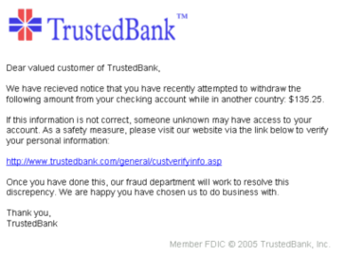

* **Shareware:** Shareware is a type of proprietary software which is initially provided free of charge to users, who are allowed and encouraged to make and share copies of the program.
* **SMTP:** The Simple Mail Transfer Protocol is a communication protocol for electronic mail transmission.
* **Spooler:** In computing, spooling is a specialized form of multi-programming for the purpose of copying data between different devices.



* **Spyware:** Spyware is a type of malware that aims to gather information about a person or organization, without their knowledge, and send such information to hack another entity without the consumer's consent.
* **Telnet:** Telnet is an application protocol used on the Internet or local area network to provide a bidirectional interactive text-oriented communication facility using a virtual terminal connection.