Assignment(s): Introduction to R

Lianne Ippel *(last version modified by C. Utrilla Guerrero)*

April 15, 2020

# Course: VSK1004 Applied Researcher



*Deadline assignment(s): 18h00*

## Introduction

The idea of this session is to provide an introduction to using the statistical computing package known as R. This first workshop includes how to read data into R, perform various calculation, obtain summary statistics for data and carry out simple visualisations. You should read and work through the given notes and seek clarification and help when required from one of the staff in the course.

## What is R?

The command language for R is a computer programming language but the syntax is fairly straightforward and it has many built-in statistical functions. The language can be easily extended with user-written functions. R also has very good graphing facilities.

Source: <https://en.wikipedia.org/wiki/R_(programming_language)>

## Obtaining and instaling R and Rstudio

R can be downloaded directly from CRAN: <https://cran.r-project.org/> afterwhich you can install Rstudio Desktop: <https://rstudio.com/products/rstudio/download/> (follow the instructions for installation).

Also find a more extensive R introduction here: <https://cran.r-project.org/doc/manuals/r-release/R-intro.pdf>

R studio is an interface of R and using these exercises you will learn how to work with the R language. R studio has 4 panels: Script, Console, Environment, and a help/plot/packages. The script is a log that allows you to do analysis. The output of the script is sent to the console. The environment shows what R `knows’ currently: it is an overview of what R has in memory. The final panel is more diverse: it can show you help documentation, or it can show you the graph you asked for, or it gives you plainly an overview of the files that are currently accessible to R.

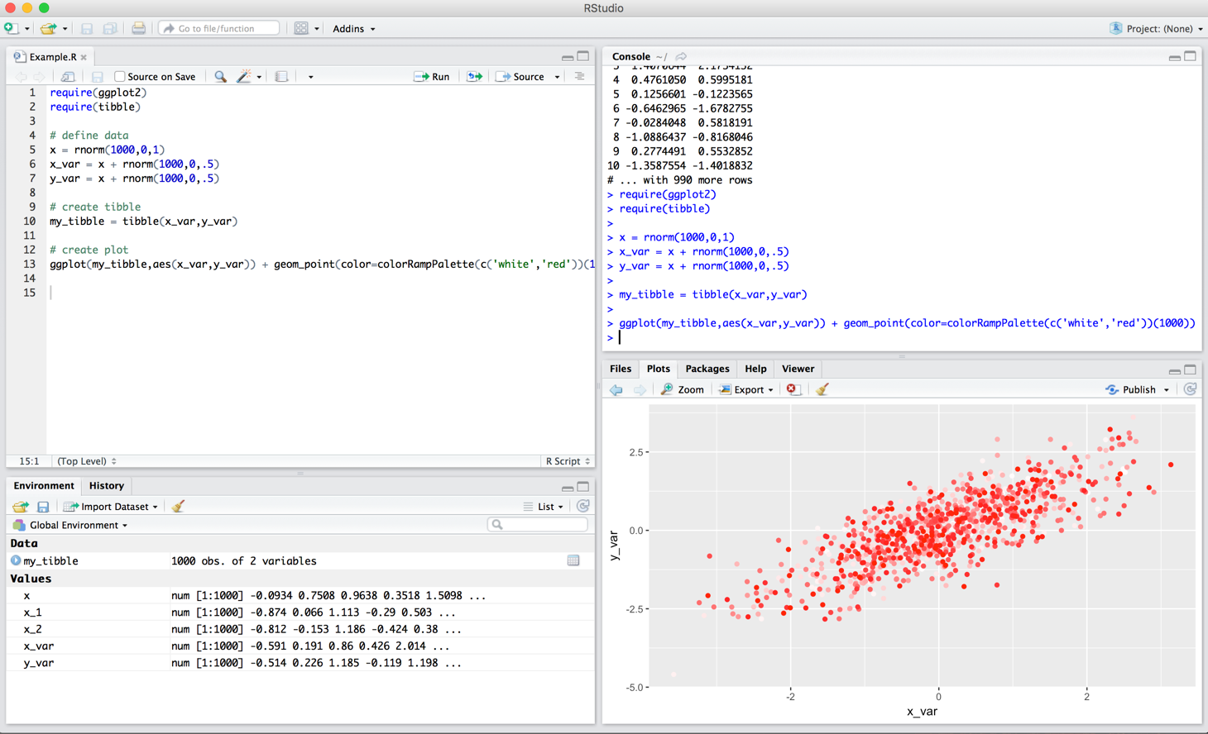

## Starting playing with R

First thing first, we need to make sure that we will remember the purpose of this script and when it was created. We do that using the `#’ symbol, as follows:

# Fill in with your name, date and file description  
# author:   
# date: 15th April, 2020  
# Description:

Now that we know what is this, see hello to everybody! To execute this code, select/highlight the piece of code you want to run and either press Ctrl Enter or click Run in the upper right corner of the script.

### 1. Open a new script and print ‘Hello World’.

print('Hello World')

## [1] "Hello World" # remember “##[1]” as the result of your run code

#### *Exercise 1*: Can you please use print() function to write *“I love you R, maybe”*?

# insert your code here #

Let’s practice the basics. We can start by using R as calculator.

### 2. Use R as a calculator

# examples of how R can be used as a calculator - THE BASICS  
1+1

## [1] 2

1+2^2

## [1] 5

exp(2)

## [1] 7.389056

log(2)

## [1] 0.6931472

sqrt(16)

## [1] 4

I provide some examples but you can of course try other things yourself. Simply write the equation, select the equation and run the code as before.

#### *Exercise 2*: Can you please say to R to return the square root of π number?

Hint: $π$ in r is pi.

# insert your code here #

Well, calculator is nice, but R can do many more things. Let go ahead!

### 3. Create an object - Variables

Now, we start with the creation of ‘objects’. Objects in R are containers that can hold numbers, words, large complex model results, any digital thing you can think of. You tell R to create an object with the assignment sign ‘<-’ .

# An object which holds a word  
wordObject <- 'word'  
# An object which holds a number  
numberObject <- 10 # variable "numberObject" allocate the value 2

Objects that contain numerical values, can also be used for calculation. But operation of objects should be only between numerical.

#### *Exercise 3*: Can you please multiply wordObject x 2, what happens?

# insert your code here #

#### *Exercise 4*: A right triangle has a side length (cm) of 6 ‘a’ and side length ‘b’ of 5. What is the hypotenuse ‘h’? Use pythagorean theorem to retun the result.

# insert your code here #

We already discussed different data types during the lecture, so now let’s try some of these data types.

### 4. Data types

#### 4.1. Vectors

There are many data types used in R: Vectors, *Matrix, Array, Data frames, and List*. Each of these data types can be stored in an object. Actually, the objects we just created are single ~~entree~~ vectors! Vectors can contain either number or strings (letters/words), but if you combine them, R will treat everything as string, meaning you can no longer use the ~~entrees~~ for calculation.

When you want to select an entry from a vector, you do that as follows.

# creating our first vector. Create a variable with 3 elements  
firstVector <- c(1,2,3)

How would you access the second *element* of *firstvector*?

To access an element of a vector use square brackets, *e.g* elements number 2:

firstVector[2]

## [1] 2

To access a series of elements, say from 1 to 3:

firstVector[c(1:3)]

## [1] 1 2 3

Say you want to change one particular entry, you do it as follows:

# creating our first vector   
  
firstVector[1] <- 7  
  
# or if you want to include more numbers  
firstVector <- c(firstVector, 8) # adding 8 to last element  
  
#maybe include a missing number,   
  
firstVector <- c(firstVector , NA) #NA means Not Available/applicable

##### Exercise 5: Can you please create a vector b with all prime number below 10, and another vector b that includes the last five letters of the latin alphabet?

(Hint: 2,3,5, [..])

# insert your code here #

##### Exercise 6: Given the ten first natural numbers, find out:

* 6th component *(Hint: To extract the sixth component of a vector we use square brackets)*.
* Components in between 2sd - 9th both inclusive.
* Components in between 2sd - 7th both inclusive, but highest to lowest
* Convert last component into number 4
* Calculate sum, mean, median and mode of these numbers

# insert your code here #

4.2. Matrix

The second data type, matrix, is very similar to a vector, with the only difference that a matrix has **rows and columns**

# creating our first matrix   
  
firstMatrix <- matrix(data = c(1,2,3), nrow = 6, ncol = 2)  
firstMatrix

## [,1] [,2]  
## [1,] 1 1  
## [2,] 2 2  
## [3,] 3 3  
## [4,] 1 1  
## [5,] 2 2  
## [6,] 3 3

#select a row:  
firstMatrix[1, ]

## [1] 1 1

#select a column  
firstMatrix[, 1]

## [1] 1 2 3 1 2 3

#select a cell  
firstMatrix[1,1]

## [1] 1

Let us define a variable

z <- c(1,2,3,4)

using the function c() that combines its argument into a vector. The variable z is still numeric but

z <- as.matrix(z)

Transform z to a matrix object and gives it new attributes such as dimensions

dim(z)

## [1] 4 1

We can also reshape z to square matrix

z <- matrix(z, ncol=2, nrow = 2)

which is the same as

z <- matrix(c(1,2,3,4), ncol = 2, nrow = 2)

To select the cell in row 1 and column 2 type

z[1,2]

## [1] 3

As you see right now, many vectors put in rows or column can make a matrix. The combination of the vector a and b that we previously created will generate a matrix. Use the following functions:

cbind(b,d)

## b d   
## [1,] "2" "V"  
## [2,] "3" "W"  
## [3,] "5" "X"  
## [4,] "7" "Y"  
## [5,] "11" "Z"  
## [6,] "13" "V"  
## [7,] "17" "W"  
## [8,] "19" "X"  
## [9,] "23" "Y"  
## [10,] "29" "Z"

rbind(b,d)

## [,1] [,2] [,3] [,4] [,5] [,6] [,7] [,8] [,9] [,10]  
## b "2" "3" "5" "7" "11" "13" "17" "19" "23" "29"   
## d "V" "W" "X" "Y" "Z" "V" "W" "X" "Y" "Z"

##### Exercise 7: What is the difference between cbind() and rbind()? Explore the operations between matrices or vector and a matrix.

# insert your code here #

##### Exercise 8: Given matrix 2X3 in which the rows are the first six odd numbers consecutively, we ask:

* Convert to zero the element (2,3)
* Convert the matrix into a new one with 1x6 format
* Multiply the matrix x 6

# insert your code here #

Please bare in mind that if you provided less data than there are spots available in the matrix (see example), that R will repeat the number, WITHOUT TELLING YOU! This is true for all data types, not just matrices.

#### 4.3. Data frames

For your current research project, the data frame will be most important. Data frame looks very similar to a matrix, however, data frames can have both numerical and string data, without R converting everyting to strings. Just to speed things up a little, I am throwing in some additional function of R, which will be explained below:

# creating our first data frame   
help("data.frame")

firstDF <- data.frame(id = 1:10, gender = rep(c('male','female'), times = 5),  
 income = rnorm(10, mean = 1500, sd = 50 ))  
firstDF

## id gender income  
## 1 1 male 1469.202  
## 2 2 female 1505.009  
## 3 3 male 1576.877  
## 4 4 female 1448.782  
## 5 5 male 1476.981  
## 6 6 female 1461.230  
## 7 7 male 1467.756  
## 8 8 female 1480.589  
## 9 9 male 1469.193  
## 10 10 female 1516.956

#select a row:  
firstDF[1, ]

## id gender income  
## 1 1 male 1469.202

#select a column  
firstDF[, 1]

## [1] 1 2 3 4 5 6 7 8 9 10

#or   
firstDF$gender

## [1] male female male female male female male female male female  
## Levels: female male

#select a cell  
firstDF[1, 1]

## [1] 1

#or  
firstDF$id[1]

## [1] 1

#want to add a variable?  
firstDF$discipline <- rep(1:5, each = 2)  
#need value labels?  
firstDF$discipline <- factor(firstDF$discipline, levels = 1:5,  
 labels = c("Medicine", "Agtech",  
 "Food", "Data science", NA))

##### Exercise 9: Delete the last column of the firstDF data frame.

# insert your code here #

### 5. R functions

Quick introduction to rep(). R has a lot of basic functions implemented. For instance if you want to repeat the same serie of numbers or strings. Not sure on what you have to fill out after a command? type in your console: ?rep This will activate the help window and give you information about how the rep command works. This works the same for every command in R.

# repeat a set with multiple entries, numerical or string using rep()   
# check out the difference between these two options  
  
rep(c(1,2), times = 5) # repeat the whole vector each ==5 times

## [1] 1 2 1 2 1 2 1 2 1 2

rep(c(1,2), each = 5) # each element is repeated each == 5 times

## [1] 1 1 1 1 1 2 2 2 2 2

#### *Exercise 10*: What is the difference between ‘each’ and ‘times’ parameters in ‘rep’?

# insert your code here #

### 6. Data Simulation

In need of practice data? You can create data yourself using rnorm()this command creates random data that follows a normal distribution with a mean and a stddev. Now because this is random data, you will not get the exact same result.

myData <- rnorm(n = 1000, mean = 5, sd = 1)

One way to force R to always give the same random sequence of numbers is by setting the seed:

set.seed(98743) # choose a nice funny number  
rnorm(n=5, mean = 0, sd = 1)

## [1] -0.04786583 -0.59425060 -0.09509987 0.54836361 0.77825508

We can also use R to visualize our data, for instance by using a histogram:

hist(myData)

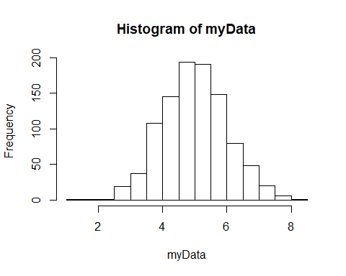

Write a function to compute the mean of 2 numbers, and add 1 to the mean. Below you see an example with default values, this is good practice but you have to be careful with defaults!

meanPlus1 <- function(x1, x2, add = 1){   
 average <- (x1 + x2) / 2  
 result <- average + add  
 return(result)}   
  
meanPlus1(1,2)

## [1] 2.5

#### *Bonus Exercise*: Challenge code: ‘Opposite number’

Very simple, given a number, find it’s opposite. Examples:

|  |  |
| --- | --- |
| Input | Output |
| 1 | -1 |
| 24 | -24 |
| 33 | 33 |

*Source*: <https://www.codewars.com/collections/learning-r>

opposite <- function(number){

# insert your code here #

return()  
}

### 8. R Packages

Sometimes, the integrated functions of R are not exactly what you are looking for. In that case, you can check whether someone else has written it for you and made the code available. To include such a chunk of code, we have to install a ‘package’. A google search will usually tell you which package you need. Say you want to read in Excel file, you can use the readxl package. If you want to read in an SPSS data file, use the foreign package.

# usually we install packages via the console and attach them using the script,   
# can you imagine why?  
# install.packages('readxl')  
library(readxl)  
# to read in a file use the following command   
# (but remove the #, and insert correct name of the file)  
# myExcelData <- read_excel('name_of_the_file.xls')

## Working with data

Lastly, R is only learned by doing it! Google is your friend –The most effcient avenue to help is to simply google whatever it is you want to do. I will finish this exercise by pointing you to some data that you can play with for the remaining time with some functions to learn the data a little better. You can select a dataset from the list that you get once you run the command: data(). For now let’s look at mtcars.

Try finding some information about this data set. (hint: ?how do you ask for help in R). You can look at the spreadsheet of the data by using View(mtcars). Please mind that View is with a capital. Try plotting some variables. You can use hist(), or plot(), even boxplot works or google for some other kind of plot. Select a variable (see previously for the data frame, selecting a column) and compute the mean. What do you see when you do table(mtcars$gear) , and what summary(mtcars$carb) do?

sessionInfo()

traindf <- mtcars # import dataset  
summary(mtcars)

## mpg cyl disp hp   
## Min. :10.40 Min. :4.000 Min. : 71.1 Min. : 52.0   
## 1st Qu.:15.43 1st Qu.:4.000 1st Qu.:120.8 1st Qu.: 96.5   
## Median :19.20 Median :6.000 Median :196.3 Median :123.0   
## Mean :20.09 Mean :6.188 Mean :230.7 Mean :146.7   
## 3rd Qu.:22.80 3rd Qu.:8.000 3rd Qu.:326.0 3rd Qu.:180.0   
## Max. :33.90 Max. :8.000 Max. :472.0 Max. :335.0   
## drat wt qsec vs   
## Min. :2.760 Min. :1.513 Min. :14.50 Min. :0.0000   
## 1st Qu.:3.080 1st Qu.:2.581 1st Qu.:16.89 1st Qu.:0.0000   
## Median :3.695 Median :3.325 Median :17.71 Median :0.0000   
## Mean :3.597 Mean :3.217 Mean :17.85 Mean :0.4375   
## 3rd Qu.:3.920 3rd Qu.:3.610 3rd Qu.:18.90 3rd Qu.:1.0000   
## Max. :4.930 Max. :5.424 Max. :22.90 Max. :1.0000   
## am gear carb   
## Min. :0.0000 Min. :3.000 Min. :1.000   
## 1st Qu.:0.0000 1st Qu.:3.000 1st Qu.:2.000   
## Median :0.0000 Median :4.000 Median :2.000   
## Mean :0.4062 Mean :3.688 Mean :2.812   
## 3rd Qu.:1.0000 3rd Qu.:4.000 3rd Qu.:4.000   
## Max. :1.0000 Max. :5.000 Max. :8.000

How many cases and variables are there?

dim(traindf)

## [1] 32 11

We can also get an editable spread-sheet version of the data using function ‘fix()’:

# fix(traindf)

#### *Exercise 11*: What summary measures can we give for the variable ‘gear’? We can calculate the absolute numbers per category:

# insert your code here #

Add new variable to give information about brand (‘brandA’, ‘brandB’):

traindf$brand <- rep(c('brandA','BrandB'))

To calculate the proportion of brands, we can take the mean of a Boolean that is equal to TRUE if a respondent is brandA

mean(traindf$brand=='brandA')

## [1] 0.5

The variable ‘brand’ is not numeric, so adding, substracting values for this variable does not make sense. To see what type of values a variable takes type:

mode(traindf$brand)

## [1] "character"

#### *Exercise 12*: What is the average units of ‘wt’?

(Hint: We can do it “manualy” using the definition of the arithmetic mean or using the build function ‘mean’. Firt manually, $x_{1}$ + $x_{2}$ + . + $x_{n}$ and divide the result by the number of *n*.)

# insert your code here #

#### *Exercise 13*: What about using the function as before?

# insert your code here #

#### *Exercise 14*: Is the median greater or smaller than the mean and does it mean that the distribution is skewed?

# insert your code here with explanation #

Now we continue with some other measures. To get a sense of the variation we calculate the minimun and maximun values and the variance

range(traindf$wt) # This will give same results as calculating min and max

## [1] 1.513 5.424

As for the mean we are going to calculate the variance manually first. The expression $σ^{2}$ = $\frac{∑((x-\overline{x})^{2})}{-1}$ written is R is:

sum((traindf$wt - mean(traindf$wt))^2)/(N-1)

## [1] 0.957379

and the built function is:

var(traindf$wt)

## [1] 0.957379

#### *Exercise 15*: To get a visual confirmation of your summary measures of ‘*wt’*, draw a histogram please.

# insert your code here #

#### *Exercise 16*: Visualise the distribution of *brand* in the data.

Note that neither ‘plot()’ nor ‘hist()’ works with *traindf$brand* as the values are nonnumerical.

We use ‘table()’ again, to provide the plotting function the frequencies.

# insert your code here #

### 9. Lastly some bivariate summaries

Plotting *wt* against *brand* is not particularly instructive. We can however make a histogram of *wt* only for brandA

hist(traindf$wt[traindf$brand=='brandA'])

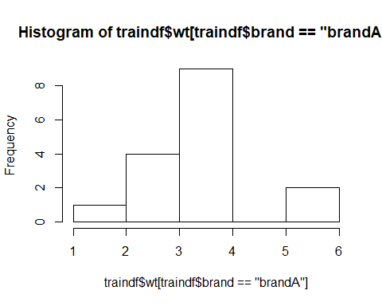

To investigate whether the ‘*wt’* differs between brands, you can calculate group-wise means as:

aggregate(traindf$wt, by = list(traindf$brand), mean)

## Group.1 x  
## 1 brandA 3.319062  
## 2 BrandB 3.115438

We can cross-tabulate choice of brands and wt easily using the function ‘table’ as above.We can get a grouped bar-chart by applying ‘barplot()’ to the table:

barplot(table(traindf$wt, traindf$brand))

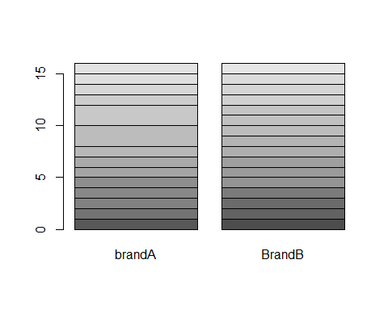

### 

### 10. Super Bonus: Descriptive Statistics Report

#### Given two different topics, can you perform a brief summary of descriptive statistics? *(Note: there is no right or wrong answer in the assignment. Limited to 1 page, inclusive graphs and tables)*

##### Option A: How contagious a disease is?

We study a well-know infectious diseases, for which WHO organization have quantified infectiousness (RO), and then project future incidence using the package projections. Simple estimation of infectiousness, as measured by the reproduction number (R), in the early stages of an outbreak.

***Please, do the following:***

***1: Create data frame with the official statistics given in the table 1.***

***2: Perform brief summary of descriptive statistics per group. What do you find it there?***

*Table 1: Values of R0 of well-known infectious diseases [1]*

|  |  |  |
| --- | --- | --- |
| **Id_dis** | **t_type** | **R0** |
| Measles | Airbone | 15.6 |
| Varicela | Airbone | 11.4 |
| Pertussis | Airbone dropet | 5.3 |
| Rubella | Airbone dropet | 6.2 |
| Mumps | Airbone dropet | 4.3 |
| Smallpox | Airbone dropet | 3.2 |
| SARS | Airbone dropet | 3.4 |
| Common Cold | Airbone dropet | 3.5 |
| COVID-19 | Airbone dropet | 2.3 |
| Influenza-1918 | Airbone dropet | 0.4 |
| HIV/AIDS | Body fluids | 3.1 |
| Ebola | Body fluids | 1.4 |
| Polio | Others | 6 |
| Diphtheria | Others | 3.4 |

*[1]: History and epidemiology of global smallpox eradication (*[*https://stacks.cdc.gov/view/cdc/27929*](https://stacks.cdc.gov/view/cdc/27929)*)*

|  |  |
| --- | --- |
| variable | description |
| id_dis | Official contagious infection name. |
| t_type | Transmission type. |
| RO | Basic Reproducible number (how contagious is a disease). |
|  |  |

##### Option B: Experiment on Plan Growth.

A research group compared yields (as measured by dried weight of plans) obtained under a control and two different treatment conditions.

***Please, do the following:***

***1: Import ‘PlantGrowth’ table.***

***2: Perform brief summary of descriptive statistics per group. What do you find it there?***

*Source: Dobson, A. J. (1983) An Introduction to Statistical Modelling. London: Chapman and Hall.*