

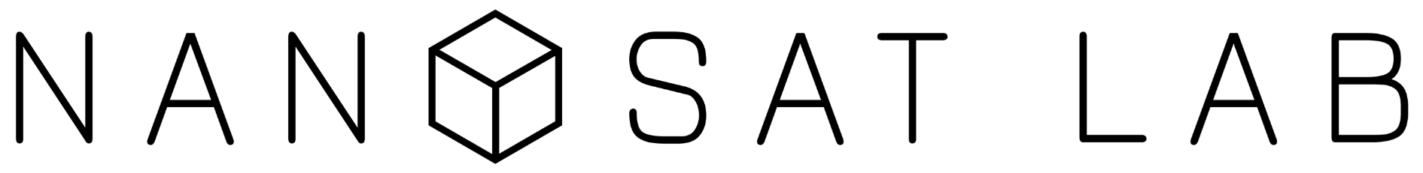

Technical-functional definition
Interpolation of pollution values

 | Module: | Version: | Broadcast date: | Total page number:
 | Data acquisition | 1.0 | 03/05/2020 | 6
 | Created by: | Carlos Vidal
 | Aproved by: | Anton Villalonga

INDEX
1. SIGNIFICANCE 3
2. DESCRIPTION OF THE PROCEDURES 3
2.1 GENERATING A GRID OF POSITIONS WITHIN THE DESIRED AREA 3
2.2 INTERPOLATION 4
3. ATTACHEMENTS - LINKS 5
4. CONTROL OF DOCUMENT CHANGES 5

SIGNIFICANCE
The objective of this document is to define the operating procedures necessary for the treatment and interpolation of pollution values.

DESCRIPTION OF THE PROCEDURES
In this section we will explain how the interpolation is achieved presenting the two main steps for generating a grid of pollution values.

GENERATING A GRID OF POSITIONS WITHIN THE DESIRED AREA
Our goal is to cover a certain area by interpolating point values that are measured by different sources. We only want to generate these new values in land areas and not on the seas for a couple of reasons: 1- there are not enough sensors to obtain a valid interpolation, and 2- we want to save storage space.
To achieve this, we have to generate a grid of positions in which we are going to generate the new pollution values and this grid must adapt to the coastline.
So first we need to define the coastline positions values and we can do this using google earth. We generate a line that follows the coastline with the desired resolution (in degrees). We can export the data from this line to a ‘.kml’ file. We obtain the latitude and longitude from the points of the line and read them using MATLAB.

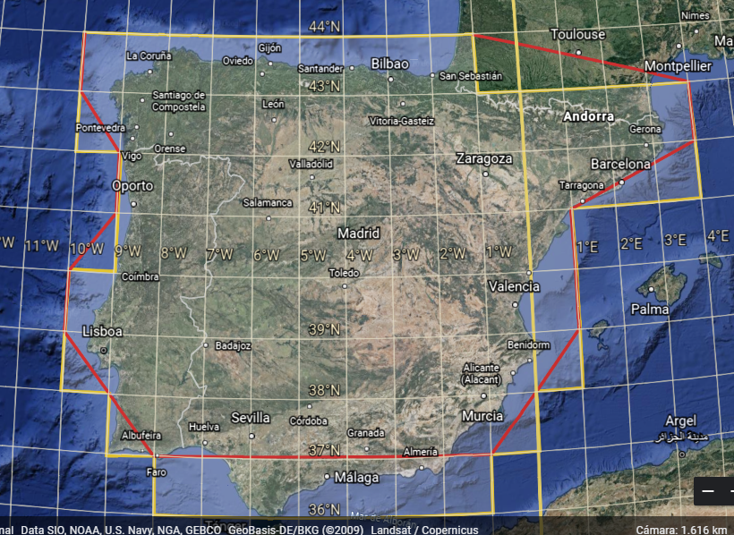

Considering the Iberian Peninsula, in the previous image, the area inside the yellow line is the desired area, and the red line is how we have to define the line that will generate that area. The example showed is a simplified version of a one-degree resolution, that’s why so much sea is wrapped inside the desired area.

In MATLAB we use two scripts to generate the grid from the ‘.kml’ file:

2.1.1) kml2format
We use this program to arrange the string of position values in the desired format to later parse the data to the next script which will generate the grid of position values.
The format is the following:
lat, long_min, long_max
This format defines, for each latitude, the maximum and minimum longitudes to generate positions values inside. The script is programed taking into account that for some latitudes there will be more than one pair of “long_min, long_max”, although this is not the case for the depicted example.

2.1.2) generate_positions(A)
With this function we can parse the line positions with the correct format and it outputs the grid of positions adapted to the limits of the input line.

Note: Both scripts have to be manually adjusted to the desired resolution. It only requires editing a line where a product/fraction is computed.

INTERPOLATION
The interpolation method is yet to be totally defined.
There will be 3 layers with different resolutions.
Spatial Resolution per layer (Square):
- L1: 10*10 km
- L2: 1*1 km
- L3: 100*100 m
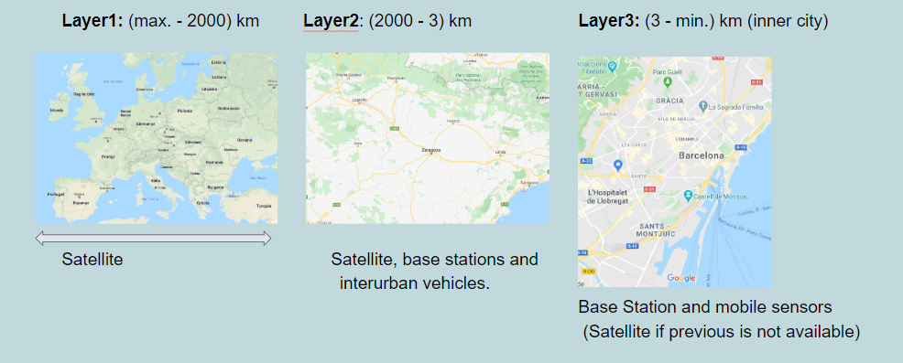

Since the first layer only uses sat. data wich covers all the map, there’s no need to interpolate here.
For the layer 2 areas, the studies show that differnces between interpolation methods are small, so we will use IDW, since we think it’s the most aproppiate in this case. For areas where no BS are available within a specified radius, satellite data will be the value. For the rest, IDW+satellite data is chosen.

In layer 3 the most probable way of interpolation is kriging (using covariances of previous measures) given the dynamic nature of the data.

ATTACHEMENTS - LINKS
Bibliography of studies that support our decisions

CONTROL OF DOCUMENT CHANGES

Ver. | Date | Changes description | Afected pages
1.0 | 03/05/2020 | Creation | All

