



Technical-functional definition

Data acquisition from Satellites and Base Stations

 | Module: | Version: | Broadcast date: | Total page number:
 | Data acquisition | 1.0 | 26/04/2020 | 6
 | Created by: | Andreu Soler
 | Aproved by: | Anton Villalonga

INDEX
1. SIGNIFICANCE 3
2. DESCRIPTION OF THE PROCEDURES 3
2.1 RECEIVING BASE SATION DATA WITH PYTHON 3
2.2 RECEIVING SATELLITE DATA WITH PYTHON 4
3. ATTACHEMENTS - LINKS 5
4. CONTROL OF DOCUMENT CHANGES 5

SIGNIFICANCE
The objective of this document is to define the operating procedures necessary for the acquisition and treatment of data from satellite and base stations.

DESCRIPTION OF THE PROCEDURES
This section will define the structure that this data collection will follow and how they are processed to make them available to the interpolation module.

RECEIVING BASE SATION DATA WITH PYTHON
To collect the data from the base stations we use a web page called AQICN, since we can make a request for data unlimitedly and free of charge. Furthermore, these data are collected from various sources, both local and continental, so they are contrasted data with official sources.
To make the code for this implementation and store it in the database table, a request to the API must be made from each list of the available base stations and any one of them will generate JSON data.
Next, we will filter the valid information and save it in the database with the attributes: name, time, latitude, longitude, CO, NO2, SO2, O3, PM10 and PM2.5.
Base stations that do not give any specific pollutant, we will leave your box empty.
At the moment the pollutants are defined with their AQI value, but we will convert it to CAQI.
The libraries used are shown in the following code image:
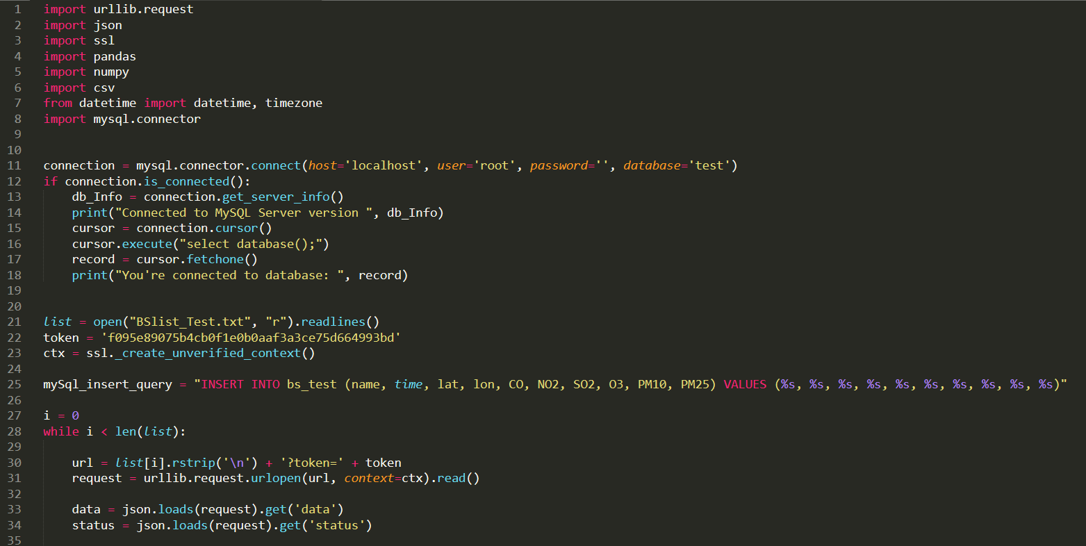
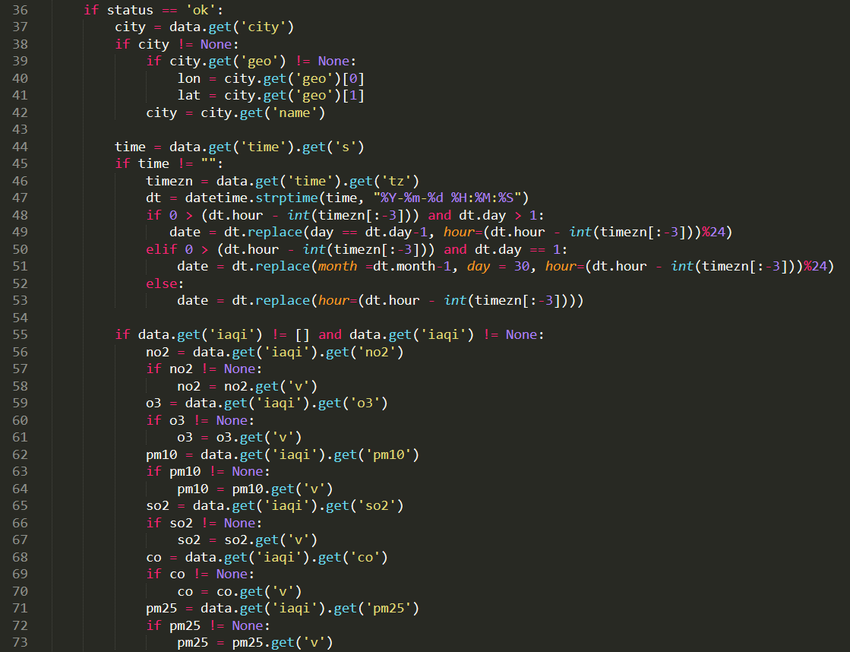
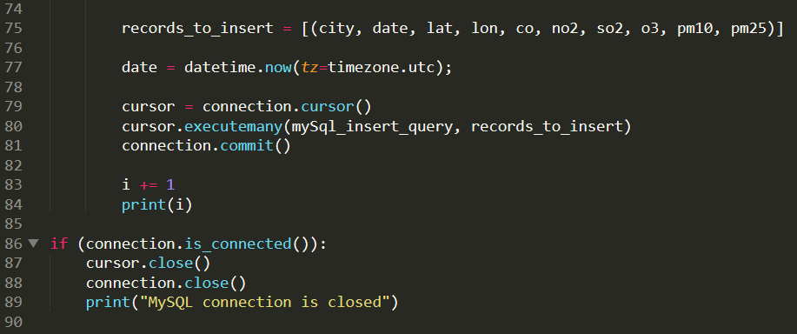

Obtaining this data to database for Portugal, Spain, Andorra and France, without the use of multithreading yet, is estimated at about 1 hour due to the multiple requests.

RECEIVING SATELLITE DATA WITH PYTHON
To collect satellite data, we use the Copernicus Atmosphere website, a website approved by the European Commission. With it, we can make a single request for prediction data of the required day and hourly, and indicating the pollutants and area of Europe necessary. This file is given in netCDF format, which we will deal with below to obtain database data and thus facilitate the reading of the data.
To make the code for this implementation and store it as a csv file, we will import the downloaded netCDF file and manipulate it by saving it the database with the attributes: time, lat, lon, CO, NO2, SO2, O3, PM10 and PM2.5.
The libraries used are shown in the following code image:
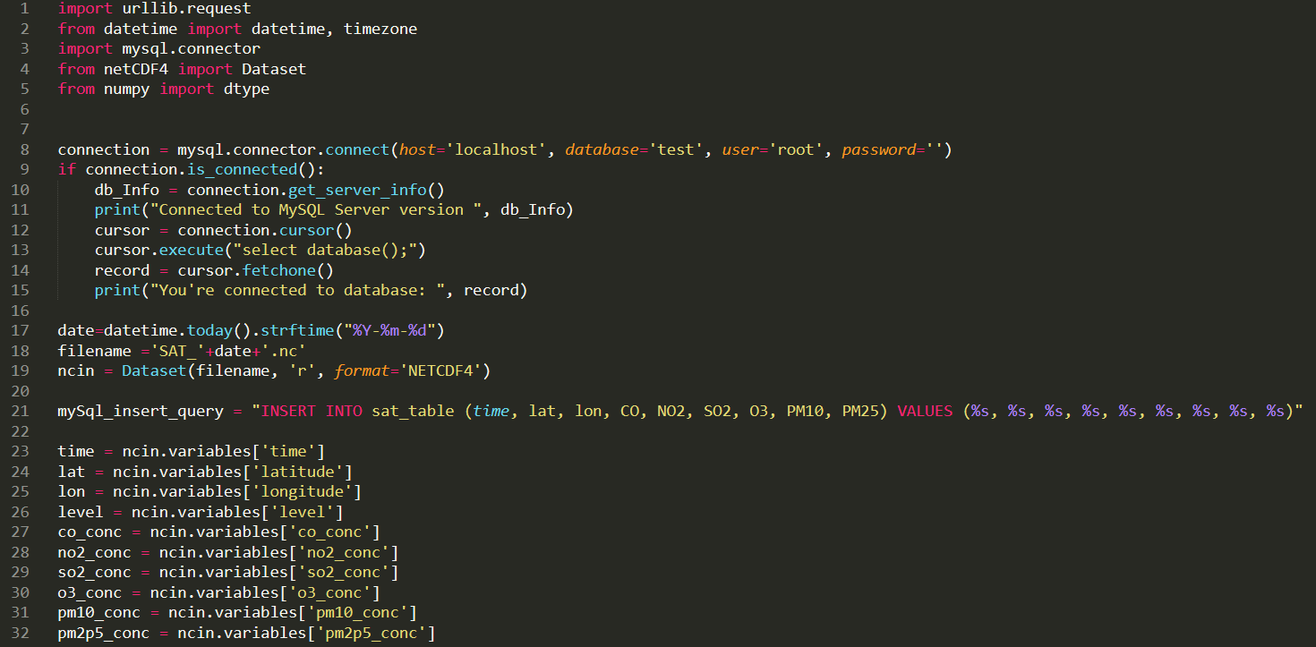
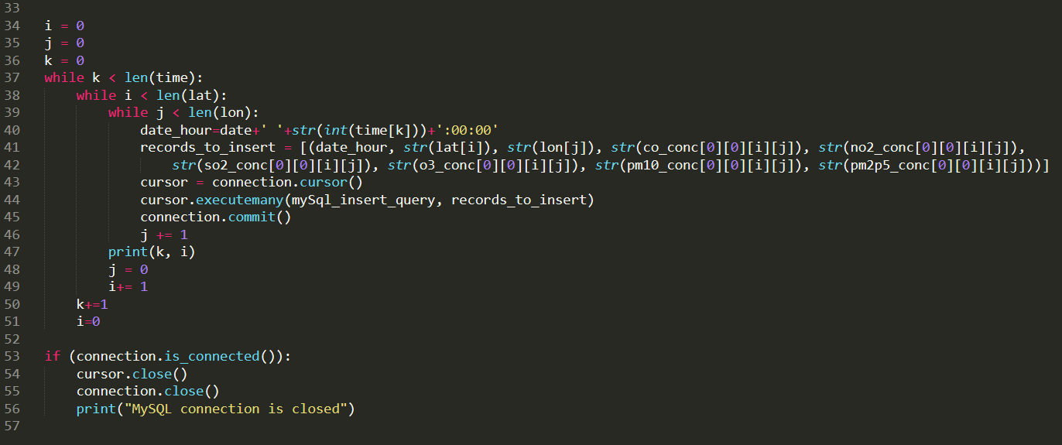

Obtaining these data format for the Iberian Peninsula to all the day, without the corresponding optimization carried out, is estimated to take around 21 minutes due to the large amount of data.

ATTACHEMENTS - LINKS
Python language: https://www.python.org/
AQICN: https://aqicn.org/
Copernicus Atmosphere Monitoring Service: https://ads.atmosphere.copernicus.eu/
Extra information in the Github Team Repository.

CONTROL OF DOCUMENT CHANGES

Ver. | Date | Changes description | Afected pages
1.0 | 26/04/2020 | 1st version | All
2.0 | 03/05/2020 | Insert data to database | All

