  
**Weather Report for Abbotsinch, and Heathrow**

# Disclaimer

This report has been created as an assignment for *STATS5078 - R Programming*, part of the MSc in Data Analytics (ODL) programme at the University of Glasgow.

The content of this file is only displayed for illustrative purposes. The author is not responsible for data accuracy.

# Seven Day Summary

| Site Name | Date | Avg. Air Temp | Avg. Rel Hum | Avg. Wind Speed | Avg Visibility |
| --- | --- | --- | --- | --- | --- |
| Heathrow | 2020-11-24 | 10.2 | 85 | 8.0 | 3,275 |
| 2020-11-25 | 9.6 | 89 | 6.0 | 2,292 |
| 2020-11-26 | 5.9 | 88 | 2.3 | 1,522 |
| 2020-11-27 | 3.0 | 92 | 3.0 | 636 |
| 2020-11-28 | 8.8 | 92 | 5.2 | 452 |
| 2020-11-29 | 7.8 | 92 | 3.6 | 408 |
| 2020-11-30 | 7.0 | 91 | 8.3 | 1,239 |
| Abbotsinch | 2020-11-24 | 10.0 | 89 | 11.6 | 902 |
| 2020-11-25 | 5.2 | 93 | 5.0 | 952 |
| 2020-11-26 | 2.3 | 98 | 2.2 | 451 |
| 2020-11-27 | 4.5 | 92 | 2.6 | 950 |
| 2020-11-28 | 4.3 | 90 | 3.3 | 868 |
| 2020-11-29 | 1.7 | 95 | 1.5 | 356 |
| 2020-11-30 | 7.3 | 84 | 12.2 | 929 |

# Air Temperature

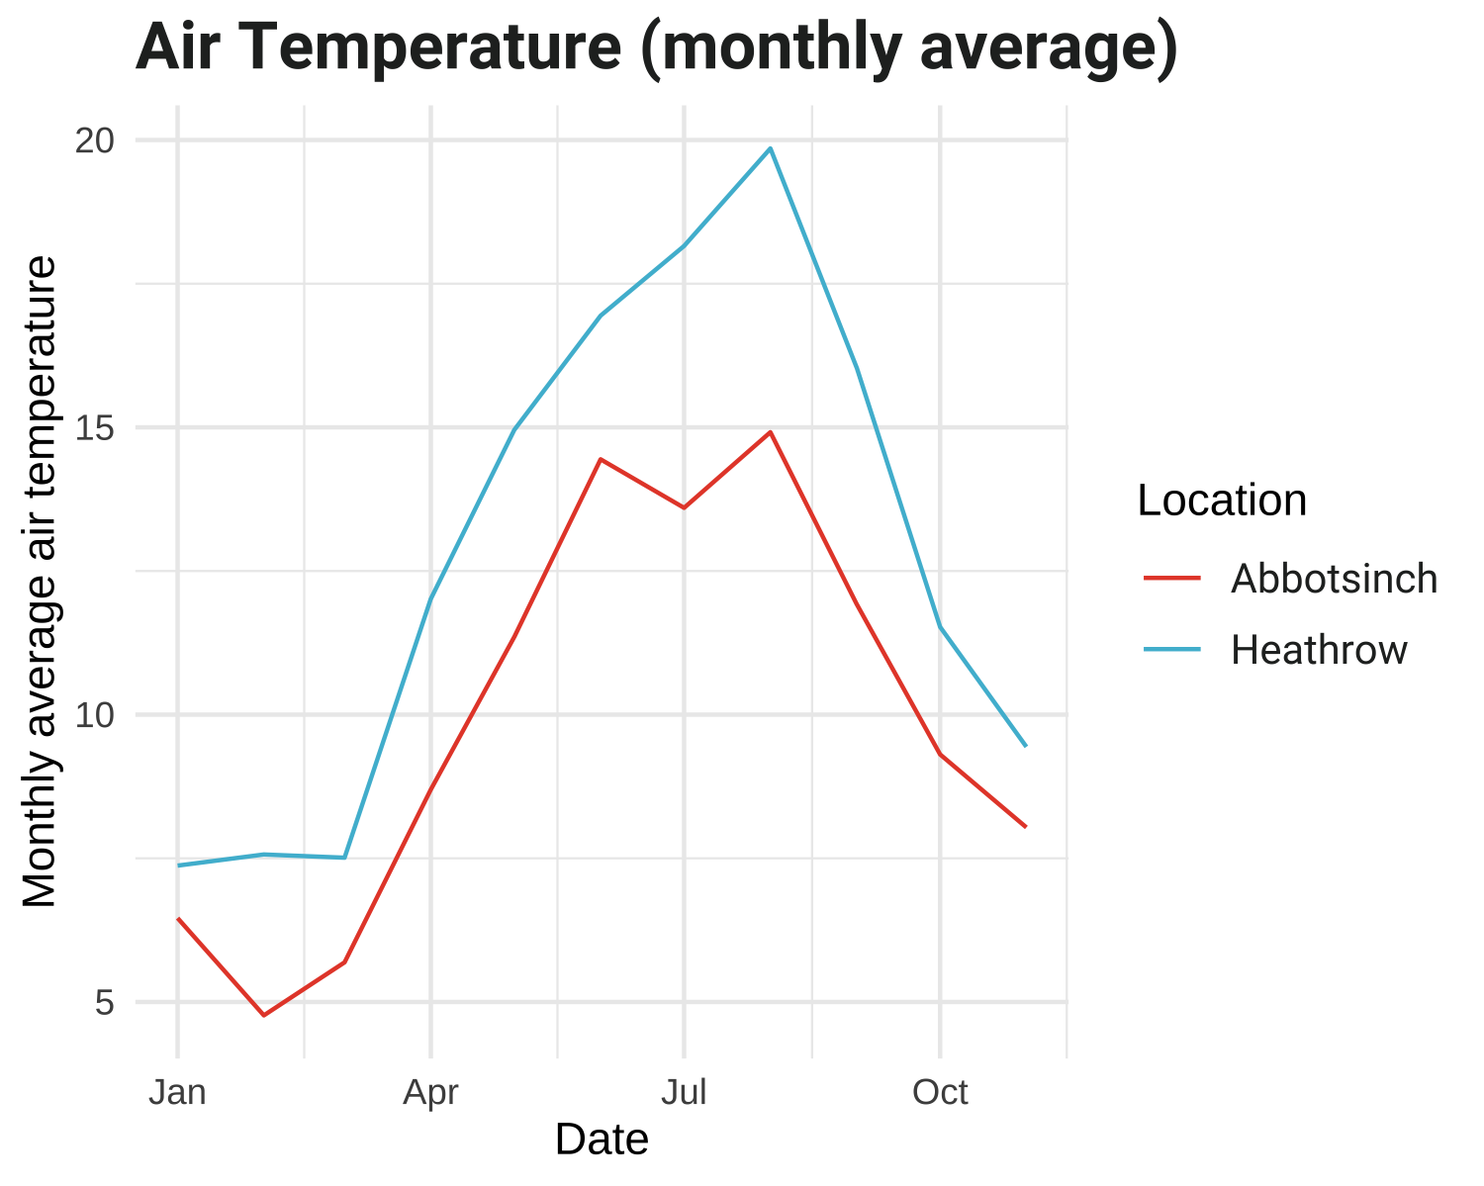 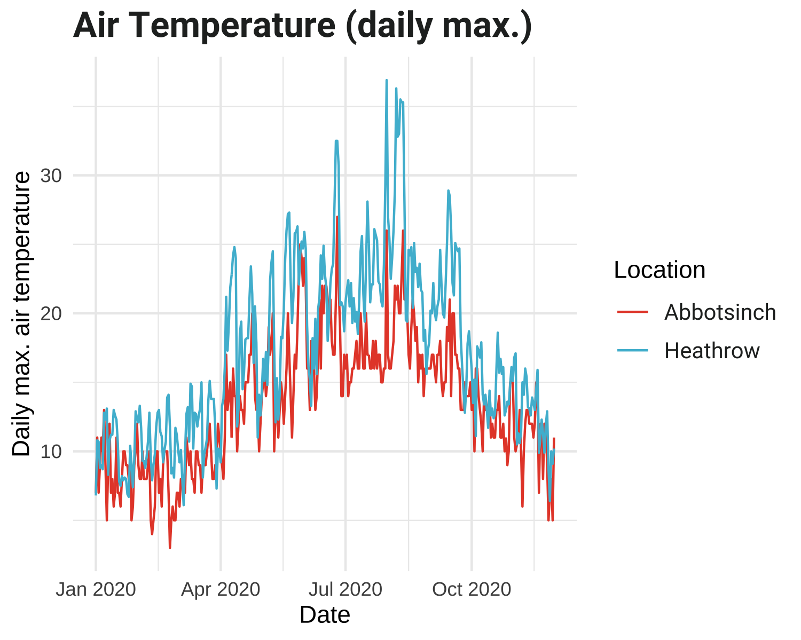 

# Relative Humidity

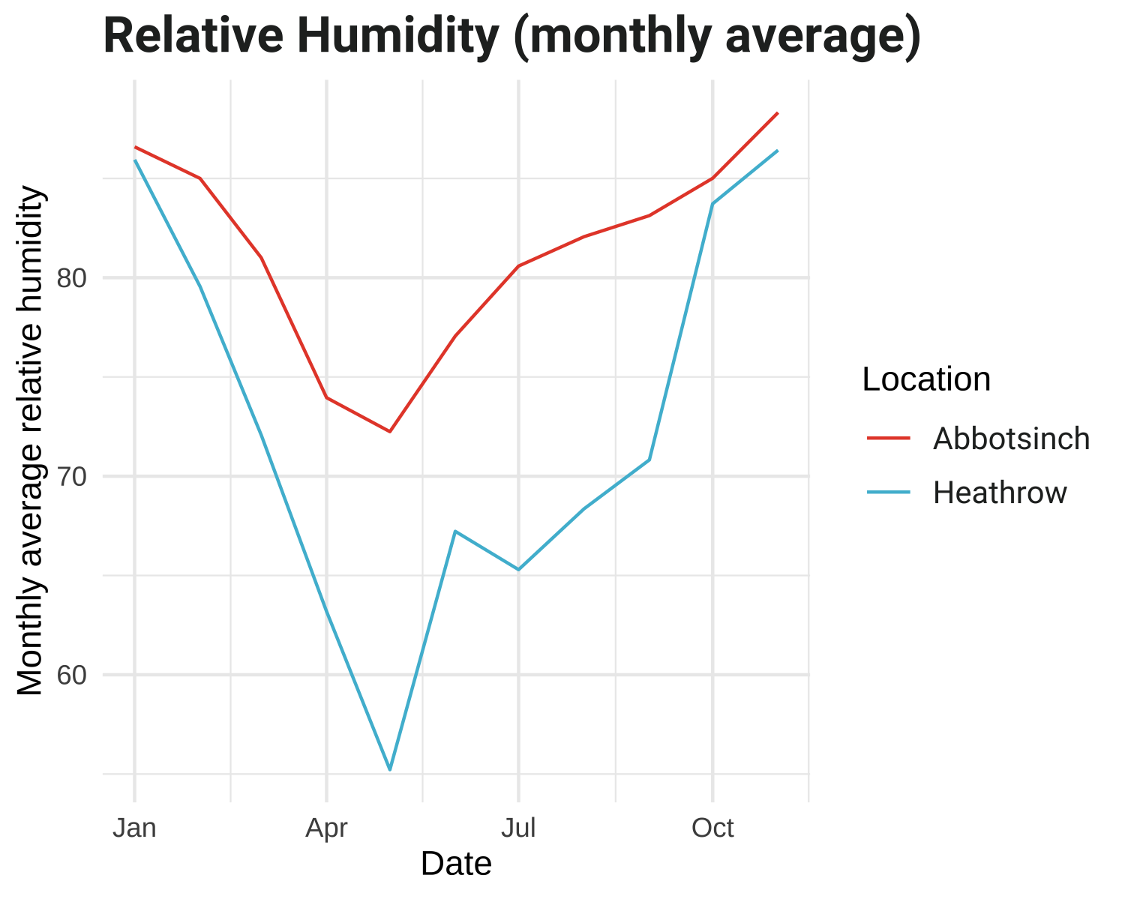 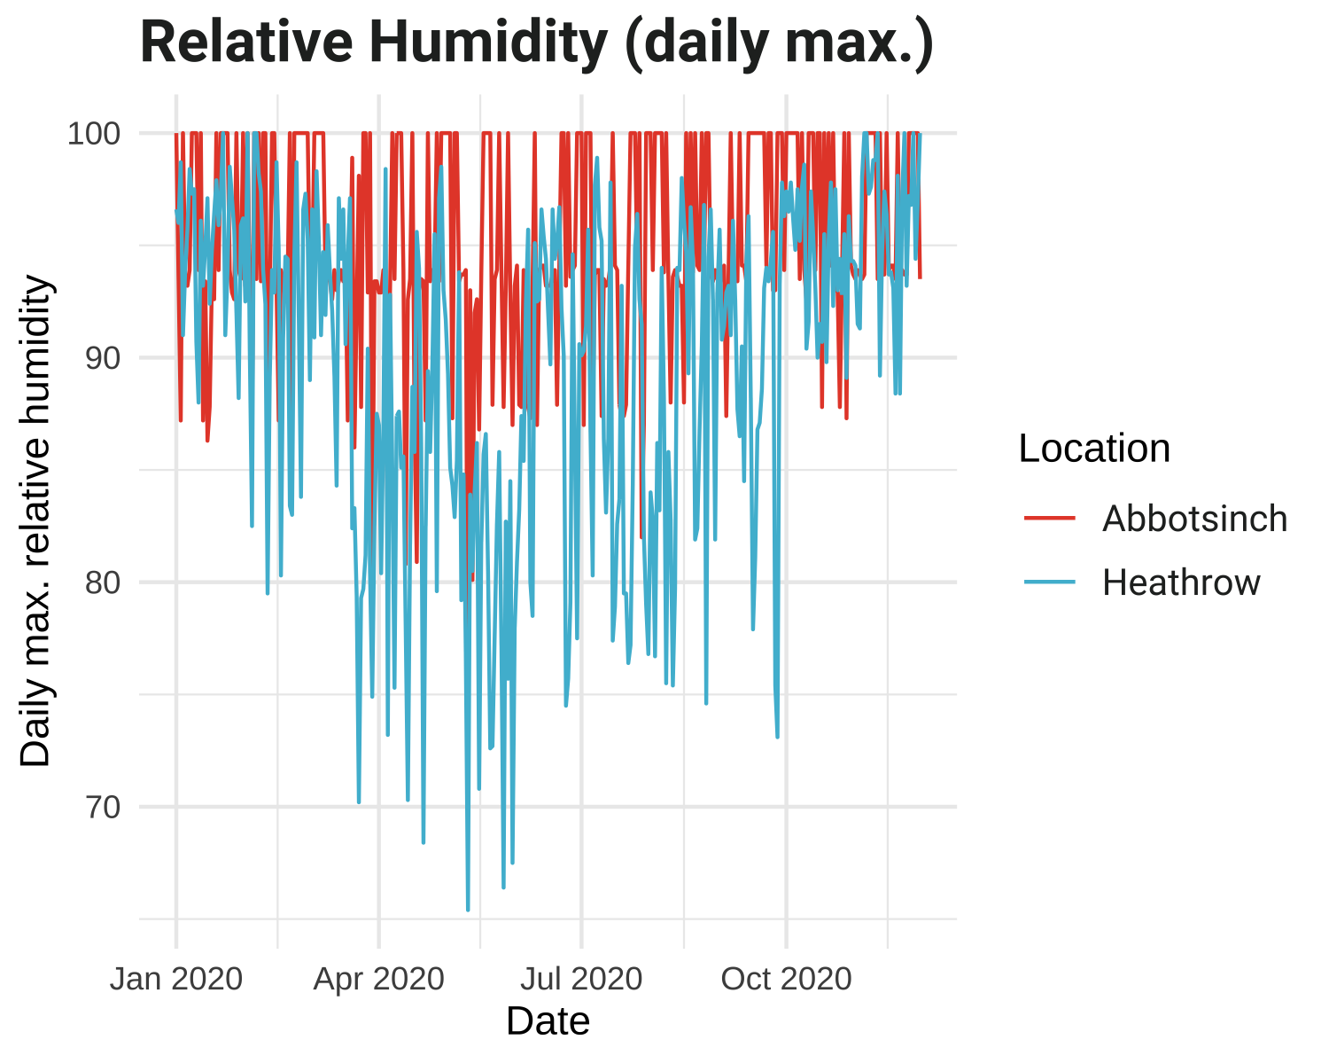 

# Wind Speed

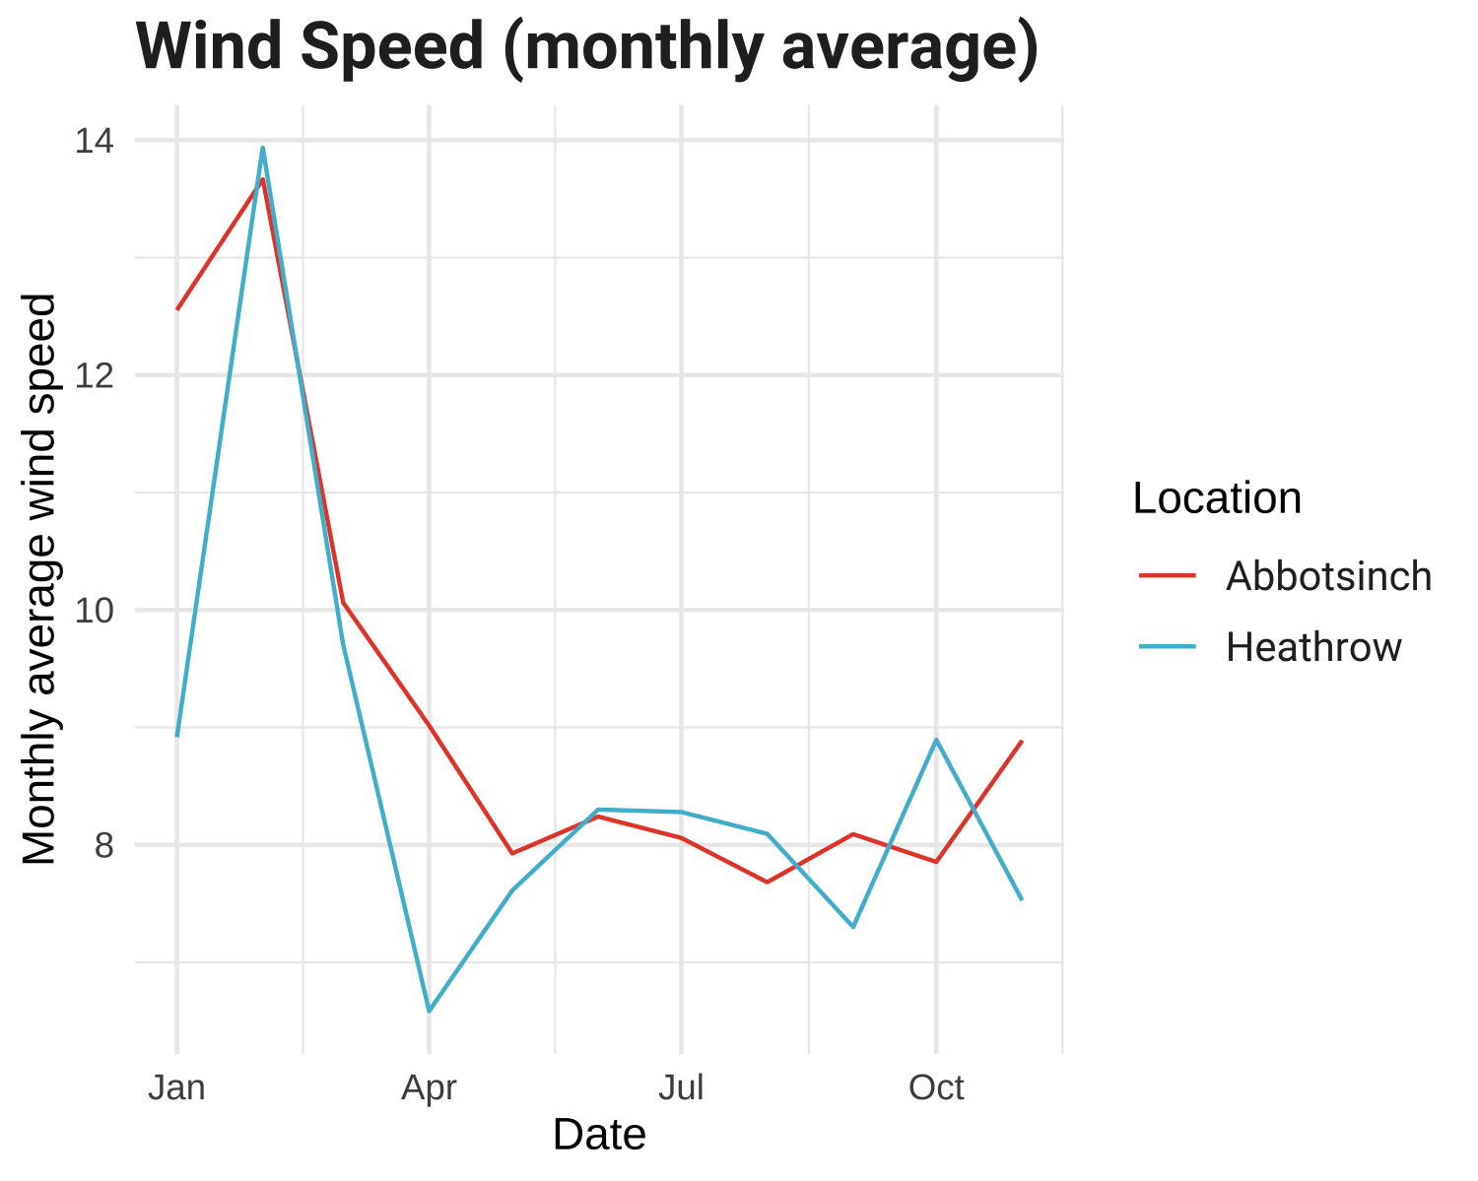 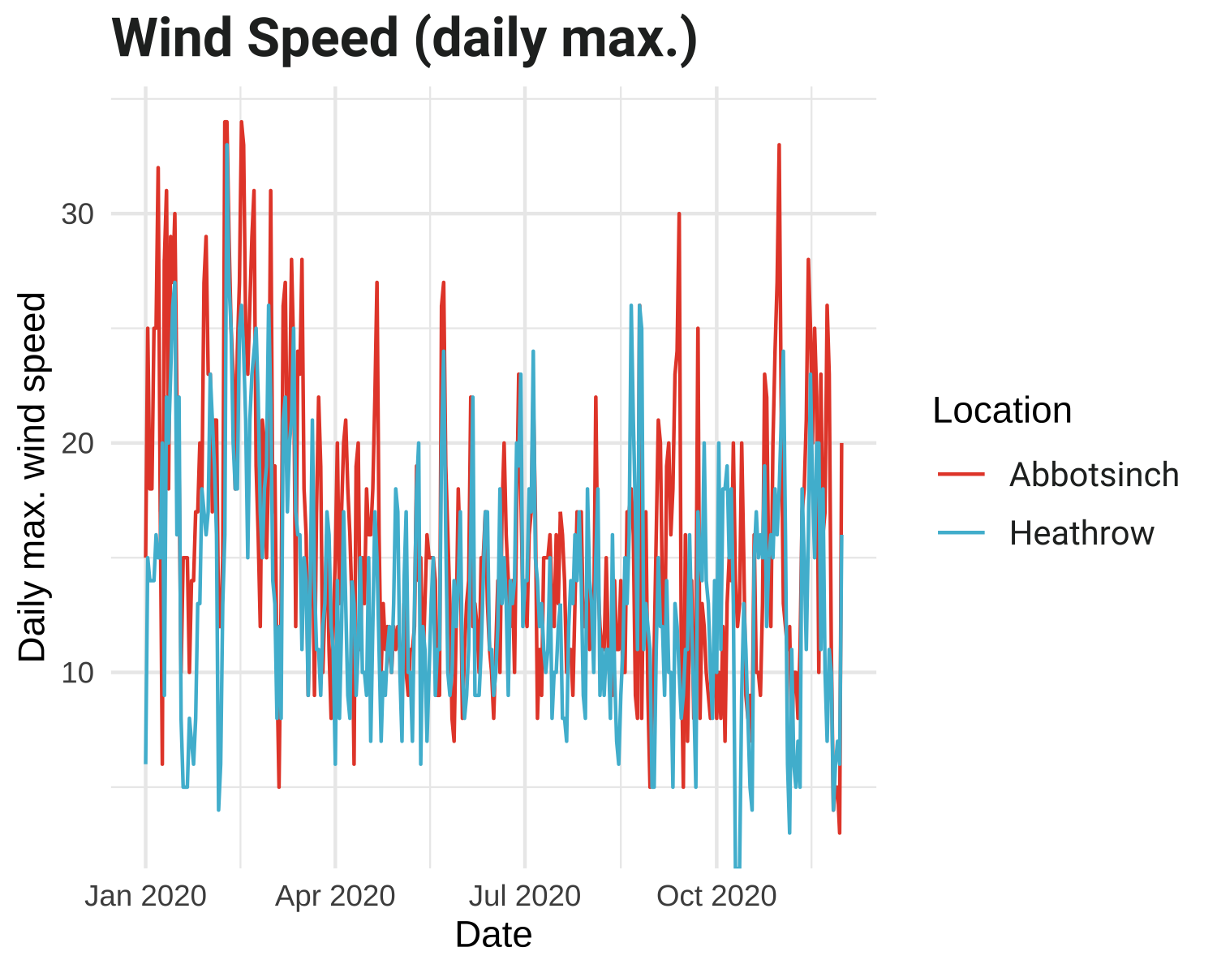 

# Visibility

