

JOSIP JURAJ STROSSMAYER UNIVERSITY OF OSIJEK

BLUSA
Smart Parking Management System
Using ESP32-S3, NFC Authentication and Wi-Fi Monitoring

Carlota Moreno Tirado

Embedded Systems

2026/2027

Table of contents
1. Introduction 3
2. System Overview 5
3. Hardware Components 9
4. Software Development 15
5. System Implementation 15
6. Testing and Results 15

1. Introduction
1.1. Project Objectives
The main objective of this project is to design and implement a functional prototype of a smart parking system called BLUSA Smart Parking System. The system will automatically control vehicle entry and exit using motorized barriers, NFC authentication, and ultrasonic sensors. In addition, BLUSA will allow real-time monitoring of parking occupancy and the number of available parking spaces through Wi-Fi communication.
To achieve this objective, the following specific objectives have been established:
- Implement NFC authentication: Use a PN532 NFC reader to identify users through NFC cards and allow entry only to authorized users.
- Develop an automatic barrier system: Use two servo motors to independently control the opening and closing of the entrance and exit barriers.
- Detect vehicles using ultrasonic sensors: Integrate four HC-SR04 ultrasonic sensors, two at each access point. The first sensor will detect an approaching vehicle, while the second will confirm that the vehicle has passed through the barrier.
- Monitor parking occupancy: Automatically register vehicle entries and exits to calculate the number of available parking spaces and prevent new vehicles from entering when BLUSA is full.
- Display system information: Use an LCD or OLED display to show relevant information, such as access authorization, barrier status, and available parking spaces.
- Implement Wi-Fi communication: Use the integrated Wi-Fi connectivity of the ESP32-S3 to allow remote monitoring of BLUSA and its occupancy status without requiring an additional Wi-Fi module.
- Provide audio notifications: Use a buzzer to generate audible signals indicating authorized or denied access and other relevant events.
- Apply microcontroller programming techniques: Program the ESP32-S3 to control the electronic components, manage sensor readings, implement communication protocols, and coordinate the different operations of BLUSA.
- Test and validate the prototype: Verify the correct operation of the sensors, barriers, NFC authentication, and communication systems, ensuring that vehicle entries and exits are properly recorded.
1.2. Project Scope
The scope of this project includes the design, development, assembly, and testing of a small-scale prototype of an automated parking access management system called BLUSA Smart Parking System.
BLUSA will use a LOLIN S3 development board based on the ESP32-S3 microcontroller as its main control unit. The parking facility will have two independent access points: one for vehicle entry and another for vehicle exit. Each access point will be equipped with a barrier operated by a servo motor and two HC-SR04 ultrasonic sensors.
At the entrance, the first ultrasonic sensor will detect an approaching vehicle. The driver will then identify themselves using an NFC card, which will be read by the PN532 module. The microcontroller will check whether the card is authorized and whether parking spaces are available before allowing the barrier to open. The second sensor, positioned after the barrier, will confirm that the vehicle has passed through.
At the exit, BLUSA will operate automatically without requiring an NFC card. The first sensor will detect a vehicle approaching from inside the parking facility and activate the opening of the barrier. The second sensor, located after the exit barrier, will confirm that the vehicle has left the parking facility.
Using the information provided by the sensors, the ESP32-S3 will maintain a record of the number of vehicles inside BLUSA. Each confirmed entry will increase the vehicle counter by one, while each confirmed exit will decrease it by one. This will allow the system to calculate the number of available parking spaces based on the maximum parking capacity.
An LCD or OLED display will show information about the system status, access authorizations, and parking availability. In addition, a buzzer will generate audible notifications for specific events. Thanks to the integrated Wi-Fi connectivity of the ESP32-S3, parking occupancy information will be accessible remotely without requiring an external communication module.
The operation of BLUSA will be divided into two main processes:
Vehicle Entry Process:
- A vehicle approaches the entrance and is detected by the first ultrasonic sensor.
- The driver presents an NFC card to the PN532 reader.
- The ESP32-S3 checks whether the card is authorized and whether parking spaces are available.
- If both conditions are satisfied, the servo motor opens the entrance barrier.
- The vehicle passes through the barrier and is detected by the second ultrasonic sensor.
- Once the vehicle has completely passed through, the barrier closes automatically.
- BLUSA increases the number of vehicles inside the parking facility by one and updates the available parking spaces.
- The updated information is displayed on the screen and made available through the Wi-Fi connection.
If the NFC card is not authorized or BLUSA has reached its maximum capacity, access will be denied and the entrance barrier will remain closed.
Vehicle Exit Process:
- A vehicle approaches the exit and is detected by the third ultrasonic sensor.
- The ESP32-S3 activates the corresponding servo motor and automatically opens the exit barrier.
- The vehicle passes through the barrier and is detected by the fourth ultrasonic sensor.
- Once the vehicle has completely passed through, the barrier closes automatically.
- BLUSA decreases the number of vehicles inside the parking facility by one and updates the available parking spaces.
- The updated information is displayed on the screen and made available through the Wi-Fi connection.
When BLUSA reaches its maximum capacity, the system will prevent new vehicles from entering until another vehicle leaves. However, the exit barrier will continue to operate normally.
To avoid counting errors, BLUSA will include control logic to register only one entry or exit for each barrier opening and closing cycle. Furthermore, the barriers will close only when the sensors indicate that the passage area is clear.
The project is intended as an educational prototype rather than a commercial parking management system. Therefore, it will focus on demonstrating the main electronic and programming functions without developing a complete real-world parking infrastructure.
Advanced features such as payment processing, license plate recognition, and integration with commercial parking management platforms are not included in the scope of this project.
The final result will be a functional prototype of BLUSA Smart Parking System, capable of automatically managing vehicle access, recording vehicle movements, and providing updated information about parking availability.
To facilitate access to the source code and technical documentation, BLUSA will have a GitHub repository containing the ESP32-S3 programming files, system configurations, and other resources related to the development and implementation of the prototype.
GitHub Repository: https://github.com/carlotamorenouclm/Blusa-Smart-Parking-System

2. System Overview
2.1. General Description of the Smart Parking System
BLUSA Smart Parking System is organized as a centralized embedded system in which a single microcontroller coordinates vehicle detection, access authorization, barrier movement, and parking occupancy management.
The system is designed to operate automatically based on the information received from its input devices. Each detected event is processed by the controller, which determines the corresponding action according to the current system conditions.
Although the entrance and exit operate independently, both share the same occupancy counter. This allows the system to manage parking availability consistently and prevent new entries when the maximum capacity is reached.
In addition to controlling physical access, BLUSA provides local and remote information about the parking facility. The combination of automatic control and wireless monitoring allows the system to operate with minimal manual intervention.
2.2. System Architecture
The architecture of BLUSA is based on the interaction between three main functional groups: input devices, the central processing unit, and output devices.
Input devices collect information from the parking environment and users. These include the ultrasonic sensors, which provide distance measurements, and the NFC reader, which obtains identification data from the cards.
The central processing unit is the ESP32-S3 microcontroller, responsible for interpreting input signals and executing the control logic. It manages the authorization process, evaluates vehicle detection sequences, updates the occupancy counter, and coordinates communication between the different components.
Output devices execute the actions determined by the microcontroller. The servo motors control the barriers, while the display and buzzer provide visual and audible feedback. The integrated Wi-Fi connectivity enables the exchange of parking information with a remote monitoring interface.
The general organization of these elements is illustrated in Figure 1.
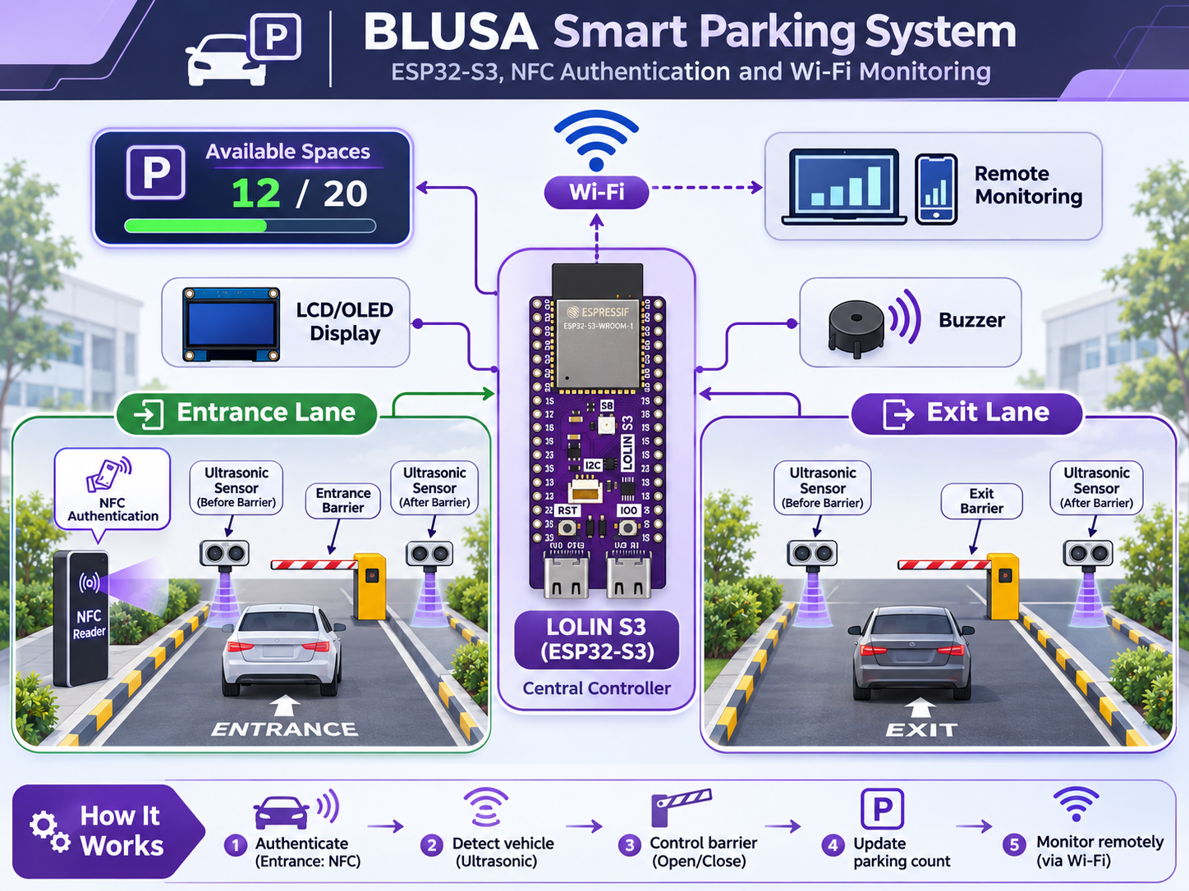
Figure 1. General architecture of the BLUSA Smart Parking System.
The communication between components will be implemented using the interfaces available on the ESP32-S3. Digital input and output pins will be used for vehicle detection and barrier control, while the NFC reader and display will communicate through suitable serial protocols, depending on their final configuration.
The software will coordinate the different functions through independent control processes for the entrance, exit, and monitoring system. These processes will share the same occupancy information to maintain consistency.
2.3. System Operation
The operation of BLUSA is based on a sequence of events and conditions managed by the ESP32-S3.
Instead of activating the barriers continuously, the system responds to specific events, such as vehicle detection, successful authentication, or confirmation that a vehicle has completed its movement.
To organize these operations, the software will use different operating states, allowing each access point to follow a controlled sequence.
2.3.1. Vehicle Entry Process
The entrance control logic will be organized into the following states:
- Idle: The entrance remains closed while the system monitors the approach sensor.
- Authentication: When a vehicle is detected, the controller waits for an NFC card and checks its authorization.
- Access Evaluation: The system verifies that the card is valid and that parking capacity is available.
- Barrier Opening: The entrance servo motor moves the barrier to the open position.
- Vehicle Passage: The system monitors the ultrasonic sensors to identify the vehicle's movement through the entrance.
- Barrier Closing: Once the passage is confirmed and the detection area is clear, the barrier returns to its closed position.
- Occupancy Update: The completed entry is registered, and the system returns to its initial state.
If authentication fails or no spaces are available, the system will return to the idle state without opening the barrier.
This state-based structure will prevent repeated commands and help ensure that each completed entry is registered only once.
2.3.2. Vehicle Exit Process
The exit control follows a similar state-based structure, although it does not include an authentication stage.
The main states are:
- Idle: The exit barrier remains closed until a vehicle is detected.
- Vehicle Detection: The approach sensor identifies a vehicle waiting to leave.
- Barrier Opening: The controller activates the exit servo motor.
- Vehicle Passage: The sensors monitor the movement of the vehicle through the exit.
- Barrier Closing: The barrier closes after the passage has been confirmed and the detection area is clear.
- Occupancy Update: The completed exit is registered, and the controller returns to the initial state.
The entrance and exit will be managed independently, allowing both processes to respond to vehicle movements without interfering with each other.
2.3.3. Parking Occupancy Management
The parking occupancy management system is based on a counter that stores the number of vehicles currently inside BLUSA.
The number of available spaces is calculated as:
Available Spaces = Maximum Capacity − Occupied Spaces
The counter is modified only after a valid vehicle movement has been confirmed. This prevents changes in occupancy caused by vehicles that approach a barrier but do not complete the entry or exit process.
To improve reliability, the software will apply the following control conditions:
- Only one vehicle movement can be registered during each completed access cycle.
- The occupied spaces counter cannot exceed the maximum parking capacity.
- The occupied spaces counter cannot be lower than zero.
- The entrance is disabled when the maximum capacity is reached.
- The exit remains operational regardless of the current occupancy level.
For example, if BLUSA is configured with a maximum capacity of 10 vehicles and the current occupancy is 7, the system will indicate that 3 spaces are available.
The updated occupancy value will be shared with the display and the Wi-Fi monitoring interface.
The software will also need to manage the initialization of the counter when the microcontroller starts. A suitable storage or initialization method will be selected during implementation to ensure that the system begins operating with a valid occupancy value.

3. Hardware Components
The BLUSA Smart Parking System combines different electronic components to perform vehicle detection, access control, barrier movement, and wireless monitoring.
The hardware is based on the LOLIN S3 development board, which communicates with sensors and peripheral devices through its digital interfaces. The selection of components is based on their compatibility with the ESP32-S3, their ease of integration, and their suitability for a small-scale prototype.
This section describes the technical characteristics and functions of the main components used in the project.
3.1. LOLIN S3 Development Board (ESP32-S3)
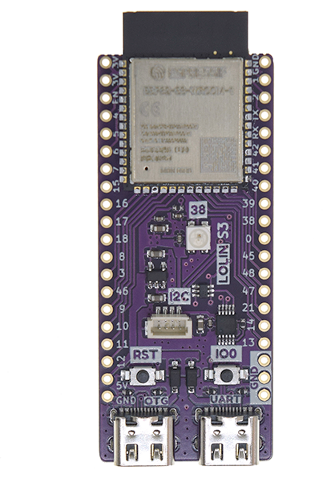
The LOLIN S3 is the main development board used in BLUSA. It is based on the ESP32-S3 microcontroller developed by Espressif Systems and provides the processing capabilities required to control the parking system.
The ESP32-S3 is a 32-bit microcontroller with a dual-core Xtensa LX7 processor, capable of operating at frequencies up to 240 MHz. It includes wireless connectivity and several communication interfaces, making it suitable for embedded systems and Internet of Things (IoT) applications.
The LOLIN S3 development board includes the following main features:
- ESP32-S3-WROOM-1 microcontroller module.
- Dual-core 32-bit processor operating at up to 240 MHz.
- 16 MB Flash memory and 8 MB PSRAM.
- Integrated 2.4 GHz Wi-Fi and Bluetooth Low Energy connectivity.
- Multiple General-Purpose Input/Output (GPIO) pins.
- Support for communication interfaces such as I2C, SPI, and UART.
- PWM capabilities for controlling actuators.
- Two USB-C connectors for programming, debugging, and communication.
One of the main advantages of this board is its ability to integrate sensor measurements, actuator control, and wireless communication without requiring a separate communication microcontroller.
In BLUSA, the ESP32-S3 will process signals from the ultrasonic sensors and NFC reader, generate control signals for the servo motors, update the occupancy information, and manage the display, buzzer, and Wi-Fi interface.
An important electrical characteristic is that the ESP32-S3 GPIO pins operate at 3.3 V. Therefore, components that generate 5 V signals must be connected using appropriate voltage adaptation circuits.

3.2. NFC Reader (PN532) and NFC Cards
Near Field Communication (NFC) is a short-range wireless technology that allows data to be exchanged between compatible devices.
BLUSA will use a PN532 NFC reader to recognize identification cards and determine whether a user is authorized to access the parking facility.
The PN532 is a contactless communication controller that supports communication at 13.56 MHz and is compatible with several NFC and RFID standards.
Its main characteristics include:
- Operating frequency of 13.56 MHz.
- Support for compatible NFC cards and tags.
- Short-range contactless communication.
- Communication interfaces including I2C, SPI, and UART, depending on the module configuration.
- Compatibility with microcontroller-based applications.
The reader will obtain the Unique Identifier (UID) of each presented card. This identifier will be compared with a list of authorized identifiers stored in the system.
For the prototype, UID-based authentication provides a simple method for demonstrating electronic access control. However, it should not be considered a secure authentication mechanism for a commercial parking facility, since some types of NFC identifiers can be copied or emulated.
The PN532 module will communicate with the ESP32-S3 using a compatible serial communication interface. The exact interface and electrical connections will be selected according to the version of the reader used.
The project will use NFC cards already available for testing the authentication system.
3.3. Ultrasonic Sensors (HC-SR04)
Ultrasonic sensors are used to measure the distance between a sensor and an object without physical contact.
BLUSA will use four HC-SR04 ultrasonic sensors to monitor the movement of vehicles through the entrance and exit areas.
The HC-SR04 operates by transmitting ultrasonic waves and measuring the time required for the reflected signal to return to the receiver.
Each sensor has four connections:
- VCC: Power supply.
- TRIG: Input used to initiate an ultrasonic measurement.
- ECHO: Output signal representing the duration of the reflected ultrasonic pulse.
- GND: Ground connection.
The main technical characteristics of the HC-SR04 are:
- Operating voltage: 5 V DC.
- Ultrasonic frequency: 40 kHz.
- Typical measurement range: 2–400 cm.
- Approximate measurement accuracy: 3 mm under suitable conditions.
- Non-contact distance measurement.
The distance to an object is calculated from the travel time of the ultrasonic signal:
Distance = (Speed of Sound × Echo Time) / 2
The division by two is necessary because the ultrasonic wave travels from the sensor to the object and then returns to the receiver.
In BLUSA, the sensors will be distributed as follows:
- Sensor 1: Vehicle detection before the entrance barrier.
- Sensor 2: Vehicle passage detection after the entrance barrier.
- Sensor 3: Vehicle detection before the exit barrier.
- Sensor 4: Vehicle passage detection after the exit barrier.
The sensor readings will be processed by the ESP32-S3 to identify vehicle presence and changes in distance.
Because the HC-SR04 normally operates at 5 V and its ECHO output can reach 5 V, voltage dividers or suitable logic-level converters will be required to protect the 3.3 V inputs of the ESP32-S3.
3.4. Servo Motors for the Automatic Barriers
A servo motor is an electromechanical actuator that allows controlled angular movement.
Unlike a conventional DC motor, a positional servo motor can move to a specified angular position, making it suitable for applications requiring controlled rotation.
BLUSA will use two servo motors, one for each barrier.
The main characteristics of a typical hobby servo motor include:
- Controlled angular positioning.
- PWM-type control signal.
- Three electrical connections: power supply, ground, and control signal.
- Compact size suitable for small-scale prototypes.
- Ability to maintain a commanded position within its mechanical limitations.
The servo motors will be controlled by signals generated by the ESP32-S3. Two angular positions will be defined: one corresponding to the closed barrier and another corresponding to the open barrier.
The actual movement angles will depend on the mechanical design of the prototype and the characteristics of the selected motors.
The servo motors will require an appropriate external power supply to avoid excessive current consumption from the development board.
Both servo motors and the ESP32-S3 will share a common ground reference to ensure reliable control signals.
The selected motors must provide sufficient torque to move the lightweight barriers used in the prototype.
3.5. LCD/OLED Display
A display will be incorporated into BLUSA to provide visual information about the parking system.
Two possible alternatives are a Liquid Crystal Display (LCD) and an Organic Light-Emitting Diode (OLED) display.
An LCD uses liquid crystals to represent characters or images, while an OLED display uses light-emitting pixels and does not require a separate backlight.
For a compact embedded system, a small OLED display is a suitable option because of its size, readability, and relatively simple integration.
The display will be used to present information such as:
- Current number of available parking spaces.
- Parking occupancy status.
- Access authorization messages.
- Barrier operating status.
- System notifications.
A display supporting I2C communication would be particularly convenient, as this interface requires only two signal lines: Serial Data (SDA) and Serial Clock (SCL).
The final display model will be selected according to its electrical compatibility with the ESP32-S3 and its suitability for the prototype.
3.6. Integrated Wi-Fi Connectivity
Wireless communication is an important feature of BLUSA, allowing system information to be accessed without a direct physical connection to the microcontroller.
The ESP32-S3 includes integrated 2.4 GHz Wi-Fi connectivity, eliminating the need for an additional Wi-Fi module.
This capability allows the controller to connect to a compatible wireless network and exchange information with other devices.
For BLUSA, Wi-Fi will be used to provide access to parking occupancy information through a remote monitoring interface.
A possible implementation is a simple web interface hosted by the ESP32-S3, allowing a smartphone or computer to access the current parking status.
The main information available through this interface may include:
- Total parking capacity.
- Number of occupied parking spaces.
- Number of available parking spaces.
- Entrance and exit barrier status.
The final communication method and interface design will be defined during software development.
3.7. Buzzer and Additional Electronic Components
A buzzer is an electronic component capable of producing audible signals when activated electrically.
BLUSA will include a buzzer to provide acoustic feedback during specific operations.
Different sound patterns can be programmed to identify particular events, such as:
- A short beep for authorized NFC access.
- Two short beeps for denied access.
- Three short beeps when the parking facility is full.
- Intermittent beeps for system errors or warnings.
A buzzer compatible with the ESP32-S3 control voltage will be selected. If the chosen device requires more current or a higher voltage than a GPIO pin can safely provide, an appropriate transistor driver will be used.
In addition to the main electronic modules, the prototype will require several supporting components, including:
- Breadboard or prototyping board.
- Jumper wires for electrical connections.
- Resistors for voltage adaptation and other circuits.
- Connectors and power distribution wiring.
- Mechanical supports for the barriers and sensors.
These components will allow the different devices to be connected and assembled into a functional prototype.
3.8. Power Supply and Electrical Connections
A reliable power supply is necessary to ensure the correct operation of the electronic components.
BLUSA will use devices with different electrical requirements. The ESP32-S3 operates with 3.3 V GPIO logic, while the HC-SR04 sensors and many hobby servo motors typically require a 5 V supply.
The power distribution system must therefore provide suitable voltage levels for each component.
The LOLIN S3 can be powered through its USB-C connection, while the servo motors will use an external regulated power supply appropriate for their voltage and current requirements.
The main electrical considerations are:
- Providing the correct operating voltage to each component.
- Preventing excessive current consumption from the development board.
- Connecting all relevant ground terminals to a common reference.
- Adapting 5 V sensor outputs to the 3.3 V logic level of the ESP32-S3.
- Checking the compatibility of the NFC reader, display, and buzzer with the selected supply voltages.
- Using suitable wiring and connections to reduce electrical interference and unstable operation.
The servo motors may generate temporary current peaks during movement. For this reason, their power requirements must be considered separately from those of low-power sensors and communication devices.
The complete wiring diagram, GPIO assignments, and power distribution will be presented in Section 5.1, Circuit Diagram and Wiring, once the final hardware configuration has been established.
Proper power management and electrical compatibility are essential to ensure that BLUSA operates reliably and that its electronic components are protected from incorrect voltage levels.

4. Software Development
4.1. Programming Environment
4.2. ESP32-S3 Programming and Peripheral Control
4.3. NFC Authentication
4.4. Vehicle Detection and Parking Space Management
4.5. Automatic Barrier Control
4.6. Wi-Fi Communication and Remote Monitoring
4.7. Display and Audio Notifications

5. System Implementation
5.1. Circuit Diagram and Wiring
5.2. System Flowchart
5.3. Hardware Assembly
5.4. Integration of Hardware and Software

6. Testing and Results

