**Report Introduction to Data Science – Assignment 4**

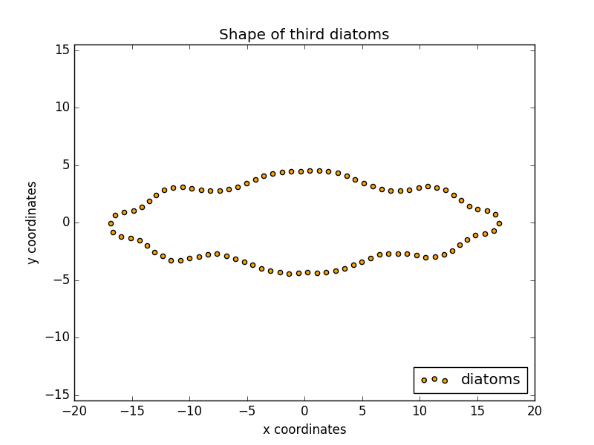**Exercise 1**

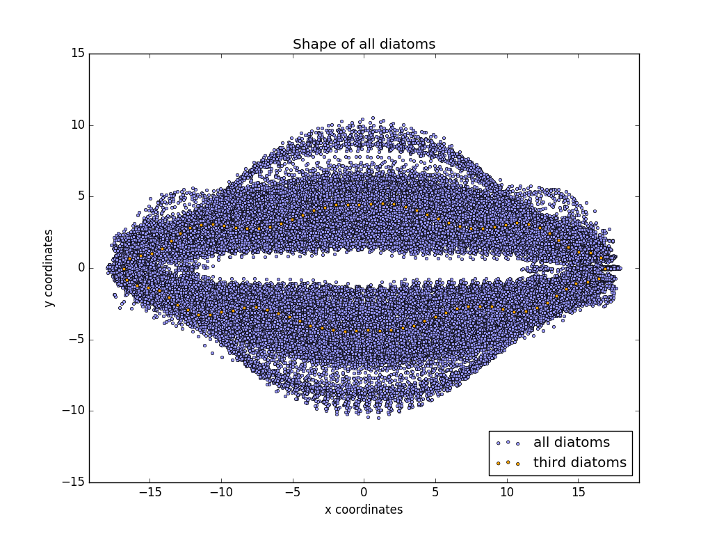

Can you see a pattern? Short description

**Exercise 2**

**Exercise 3**

**Exercise 4**