Home Work 2  
May the 19th 2017  
Group 7: Nynne Nymann, Peter Horskjær, Charlotta Porcelli, Max Tomlinson & Ke Zhai

**Question 1: Dicer dissected  
The human DICER1 gene encodes an important ribonuclease, involved in miRNA and siRNA processing. Several mRNAs representing this gene have been mapped to the human genome (March 2006 assembly). We will look closer at one of them with the accession number AK002007.**

To answer these following questions, we looked up the gene on UCSC genome browser and selected the human genome with the March 2006 assembly (NCBI36/hg18). Choosing full human mRNA track for DICER1 from GenBank gave us the opportunity to investigate the AK002007 mRNA sample. Note that our gene of interest is located on the reverse strand.

**a) What are the first five genomic nucleotides from the first exon of this transcript?**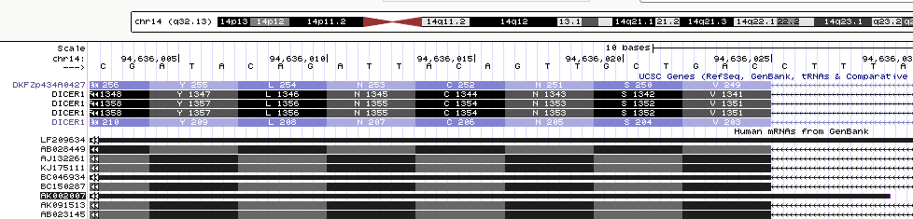Examination of the first exon in AK002007 reveals the first five nucleotides to be: AAAGG

**b) Look at the raw mRNA sequence of AK002007, from the database it actually comes from. What are the first five nucleotides?**



Thus, the first five nucleotides in the raw mRNA sequence of AK002007 is: GAAGC

**c) How do you explain the discrepancy (maximum 5 lines)?**

First seven nucleotides on the mRNA sequence are not mapped to the genome. The discrepancy could be explained by the fact that cDNA is used during the gene sequencing which a lot of factors involved. These include adaptors, primers and linkers which are attached to the sequence during the process. Thus, this means both ends of the mRNA cannot be linked to the genome.