Maxquant exercise (processing of proteomics data with R)
This exercise is based on the data and data analysis published in Hubner et al.
Intro:
MaxQuant is a freely available program (http://www.maxquant.org/) that can analyse the output from Thermo Scientific LC-MSMS systems¹. The program is quite user friendly, but requires a powerful computer to analyse large datasets. This is not possible in this exercise, so we will focus on the output from Maxquant and how this can be used for further analysis.
Very briefly the Maxquant program requires that you:
- provide a set of RAW files (spectra output from the mass spec system, one from each LC run, typically 300-500 MB each)
- provide a FASTA protein database to search against.
- specify the enzyme used to digest proteins and if the peptides were chemically modified.
- specify if SILAC labeling were used and how the different samples should be compared.
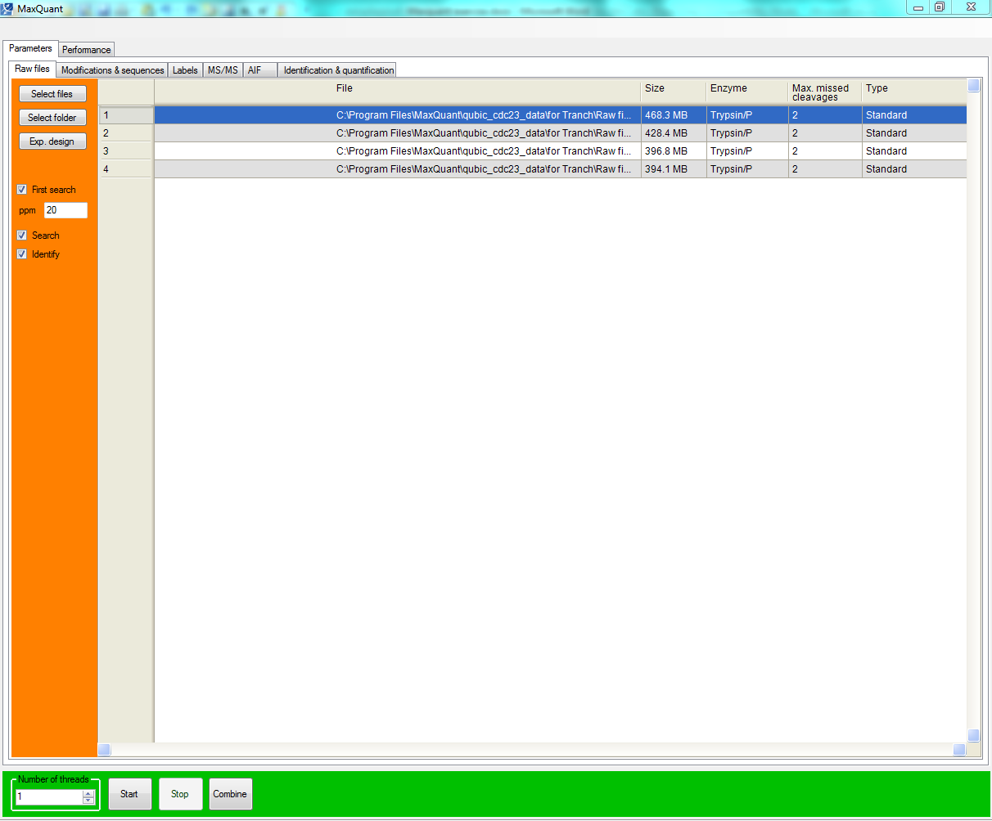
The program will then analyse the spectra and compare against the peptides present in the provided FASTA sequence file and produce a number of output files. The most relevant of these is a file called ProteinGroups.txt, which contain quantifications and identifications matched to proteins.
Aims:
- Familiar with the MaxQuant proteingroups output
- Able to analyse the output from a SILAC experiment using R
Exercise:
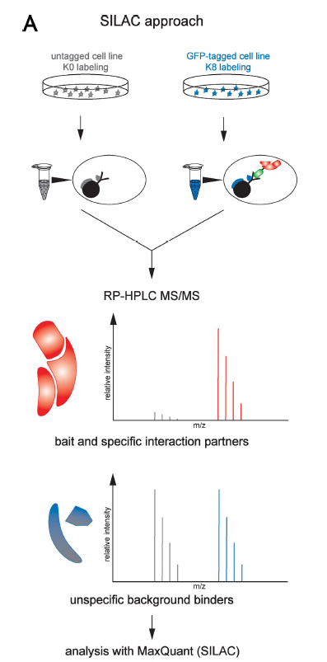
One of the applications for quantitative proteomics is to identify protein-protein interactions. The advantage of the quantitative set-up is that it allows the specific interactors to be identified from background binders.
Figur 1: shows a SILAC based and a label-free strategy for analyzing pull down experiments. The figure is taken from Hubner er al.², and we will in this exercise take a look at some of the data from this publication.
Find the provided ProteinGroups_CDC23_silac file on the course homepage and download it to a specified location on your harddisk. This is the MaxQuant output from the analysis of a SILAC labeled CDC23 pulldown and followed by LC-MSMS analysis. The file contains the information from two experiments (CDCL and CDCH). In both experiments the CDC23 beads were compared with control beads using SILAC labeling.
Open the file in Excel and browse the content.
Our aim is to find the proteins which were bound specifically to the CDC23 bait. The provided code can be pasted into R. You should modify the code r to answer the questions.
- Try to load the ProteinGroups file in R.
setwd(choose.dir()) #Find the folder containing the file
proteins <- read.csv(' CDC23_proteingroups_silac.txt', header = T, stringsAsFactors=F, sep='\t')
- Next we want to filter the proteins that are present in the protein groups file. To remove proteins that are marked as contaminants with a “+” in the Contaminants column.
filteredproteins <- proteins[proteins$Contaminant != "+", ]
- Try doing the same for the Proteins marked with ”+” in the Reverse column.

- Can you remember why some proteins are marked with Reverse?
- Also to make sure that only proteins identified with 3 peptides or more are used in the analysis (“Peptides..seq.” column):
filteredproteins <- filteredproteins[which(filteredproteins$Peptides..seq.>2), ]
- Try also making sure that we are only looking at proteins that have at least two unique peptide (“Unique.Peptides..seq.” column)

- Now we are ready to take a look at the data. The columns, that are named Ratio.H.L.Normalized.CDCH and Ratio.H.L.Normalized.CDCL are the ones that contain the SILAC ratios.
- Try to plot histograms for SILAC ratios obtained the two experiments. It is a good idea to logtransform the ratios. (Hint: use the hist function for plotting histograms)

- Try to plot the logtransformed SILAC ratios from the two experiments in a XY plot.
- What do you think of the correlation between the experiments?
- To retrieve the genenames (Gene.Names) of the proteins that have significant (less than 10^-4) outlier ratios in the H experiment:
filteredproteins$Gene.Names[filteredproteins$Ratio.H.L.Significance.A..CDCH < 0.0001 & !is.na(filteredproteins$Ratio.H.L.Significance.A..CDCH)]

- Now try to find the proteins that have significant (less than 10^-4) outlier ratios in the H experiment in both experiments. How many proteins are interacting with CDC23 by these criteria?
- Can you find other evidence that these protein interact. (Hint use http://string-db.org/newstring_cgi/show_input_page.pl?input_page_type=multiple_identifiers)
1 Cox, J. & Mann, M. MaxQuant enables high peptide identification rates, individualized p.p.b.-range mass accuracies and proteome-wide protein quantification. Nat Biotechnol 26, 1367-1372, doi:10.1038/nbt.1511 (2008).
2 Hubner, N. C. et al. Quantitative proteomics combined with BAC TransgeneOmics reveals in vivo protein interactions. J Cell Biol 189, 739-754, doi:10.1083/jcb.200911091 (2010).

