Global AI Community
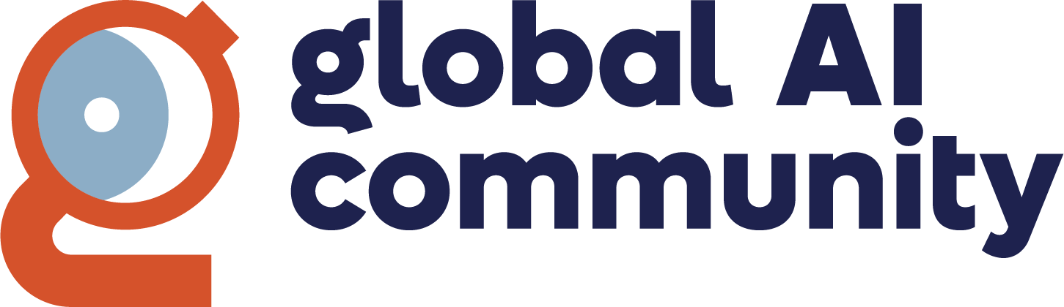

About the Global AI Community
The Global AI Community is an international non-profit organization with the goal of helping people learn about artificial intelligence (AI) by connecting local communities around the world. Its mission is to promote, educate, and advance a diverse AI community through outreach activities, education, conferences, events, and social gatherings. The community enables passionate AI developers to share knowledge through events and meetups, offering resources such as sponsored Meetup Pro accounts, event content, Azure passes, and support for booking Microsoft venues. It works closely with Microsoft product teams to share educational content about new Azure AI products.
All details are available on the official website: Global AI Community | Connect, Learn & Build with AI Developers Worldwide - Global AI Community.

The Global AI Community in Numbers
Number of Global AI Community members: 138,904 members
Number of global events: 4,652 (since 2018)
Number of local chapters: 140 groups in 33 countries

The Global AI Community in Italy
In Italy, the Global AI Community has 2 official chapters: Lecce and Milan.

Global AI Community Lecce
The Global AI Lecce community is the official chapter of the Global AI Community located in Lecce, Italy. This community brings together enthusiasts, professionals, and researchers in the field of artificial intelligence, with the aim of exchanging ideas, building relationships, and collaborating on the latest innovations in the sector. Whether you are an expert or a beginner, you will find a space to stay updated on new trends, participate in workshops, and listen to the most authoritative voices in the field. The first event was held in Lecce on September 5th.
Organizer: Fabrizio Benvenuto
Number of members: 49
Events organized: 2

Global AI Community Milan
Organizers: Daniele Grandini, Francesco Molfese, Matteo Conti
Number of members: 174
Events organized: 6
Description: The Milan chapter is a reference point for AI enthusiasts in the Lombardy region. It brings together professionals, students, and researchers to share knowledge, experiences, and opportunities in the field of AI. The meetings offer opportunities for networking, training, and collaboration on innovative projects.

