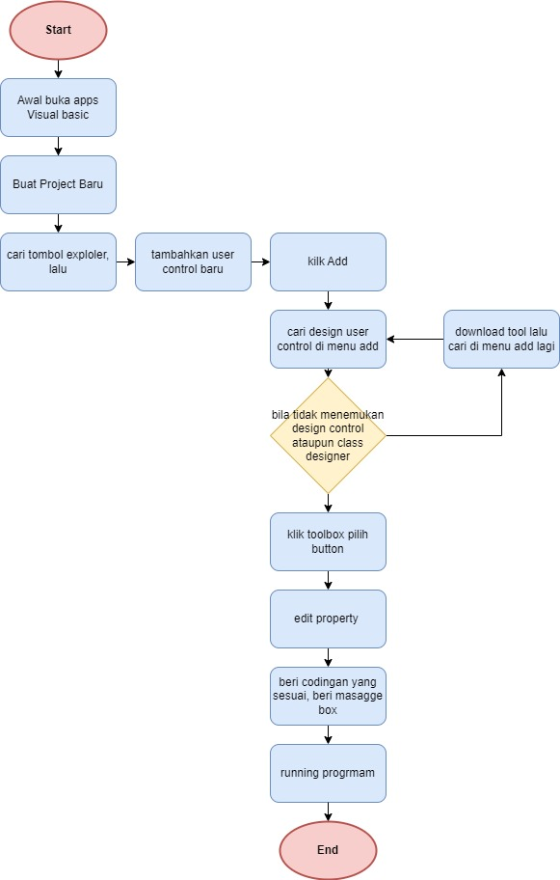
KK – ALPRO FLOWCHART – CARLO IMANUEL – 322310001

