# Chapter 4: Design

## 4.1 Introduction

The first time interviewing the user, a simple user interface was agreed upon where he could see all the records easy to pick up and self-explanatory. The only person that requires access to it is himself so only him will be using this program. A few wire frames will be presented showing the design of the application.

## 4.2 Wireframes

Initial design of the user interface he wanted the list of artist and be able to search for them. This will be the artists view where the user will look at all the items that belongs to an artist their ID, name. other details. After one of the interviews the user said that the only one with access to this software is going to be him as he is the person that closes up the process of the distribution

## Figure 4.2.1 Initial Design

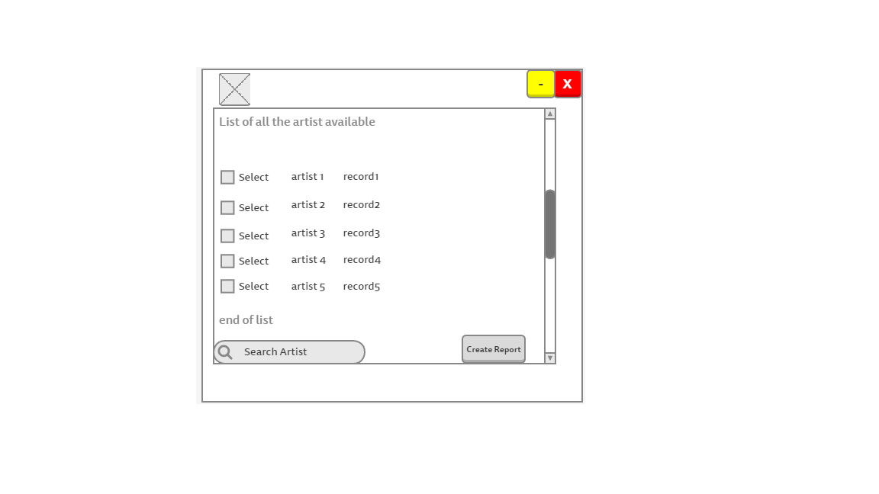

The song’s view will be also similar to the artist’s view as the principle is the same show the information about the songs so they can be edit or be added if there are new songs functionality will be added so totals are calculated by the program.

As an extra feature a query result box was added so the user can see after doing an action the program will provide a visible output telling the user about the action that just took place. For example if user deletes a record the box will display record deleted.

## Figure 4.2.2 Second Design

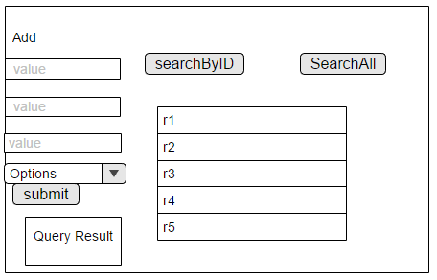

## 4.3 Database Design – Class Diagram

The database diagram was created with the purpose of allowing the creation of a conceptual model of the system, to ensure that all the key areas are identified and added to the system. Another reason is that it reduces the possibility of making errors and saves time as all the troubleshooting and planning is taken care prior the build of the system. The following diagram (figure 4.3.1) was created using StarUML.

## Figure 4.3.1

