# Introduction

Economic sanctions are widely used in foreign policy. In some cases, politicians impose sanctions simply to retaliate or signal disagreements, as in Turkey’s blockade against Armenia since the Nagorno-Karabakh conflict or the United States’ 1951 *Trade Agreements Act* that put the Soviet bloc outside of its Reciprocal Trade Program (Schelling 1958: 489-490). In other cases, politicians use sanctions to gain influence not through outright imposition, but through threats to impose them unless targets meet their demands. When the U.S. threatened Russia with sanctions unless it stopped supporting separatists in Ukraine in 2014, it sought to influence Russian policy by making it potentially too costly. If the economic cost of a potential sanction is perceived to entail high political cost on the leadership, the target leader will have an incentive to avoid it by conceding (Hirschman 1945: 17).

How much a sanction’s economic costs translate into political costs is a function of a target’s domestic political institutions. Since a democratic society suffering under sanctions is in a better position to punish its leader or remove her or him from office, previous research suggests that sanctions in general “work” better against democracies (Brooks 2002: 1; Marinov 2005: 572-573; Lektzian and Souva 2007: 849). If that is correct, then politicians’ sanction practices are puzzling: almost all active U.S. sanctions target autocratic regimes.[[1]](#footnote-1) If these targets are less likely to concede, sanctions might not be the best available investment of time and resources for politicians to achieve their foreign policy goals.

I argue that the solution to this puzzle lies in the fact that not all autocracies are equally resilient to sanctions threats. Specifically, personalist” regimes are resilient, and other non-democratic regimes under military or single-party rules respond to sanctions threats in ways that are more similar to their democratic counterparts. In other words, institutionalized autocracies produce constituencies that can pressure leaders to avoid economic hardship. Because a target can always avoid sanctions imposition by conceding to sender’s demand, studying sanctions threats also alleviate the challenge of selection effect. To paraphrase Schelling, as sanctions can be “most purposive and most successful when it is threatened and not used” (2008, 10), we might never observe the sanctions responsible for a target’s change in policy (Bueno de Mesquita and Smith 2012: 174; Noorudin 2002: 60; Smith 1995: 241) if we only study sanction impositions.

Drawing on a dataset of all threatened sanctions from 1945 to 2005,[[2]](#footnote-2) I develop a “domestic audience” account to explain personalist targets’ resistance to sanctions threats. After taking potential confounding factors into consideration, targets are less likely to make policy concessions at threat stage compared to other regime types. The higher a target’s personalism score, the less likely it will concede. The results also hold when modeling target regime type in three categories: personalist, non-personalist, and democratic targets. While other scholars find sanction imposition to be more destabilizing on personalist targets (Escribà-Folch and Wright 2010: 334), this paper demonstrates empirically that the effectiveness of sanctions at imposition stage might not translate into useful threats: since personalist leaders has a smaller domestic audience size, they face little domestic punishment for policy failures, they can afford to stand firm against a sender which may or may not have the resolve to carry out its threat. Even if sanction imposition can increase their risks of being violently removed from power, this does not affect their threat stage calculus because the probability of successful elite coordination to is extremely low while the risk of being forcibly removed from office given a successful coordination is already high for these leaders. Moreover, the domestic political structure in personalist states also tends to select individuals who took “great risks to pursue power and were also lucky enough to survive” (Weeks 2014: 31). Even when facing foreign threats with potentially dire consequence, these leaders are expected to be risk-acceptant and demonstrate high resilience. With respect to foreign policy, this implies that personalist leaders can be relatively immune at threat stage. Therefore, using sanctions threats to leverage personalist targets could be a waste of time even if the same policy might work on democratic and non-personalist autocracies.

# Searching for A Sanction Effect

Situated between “words and war” (Marinov 2005: 565), sanctions are popular among politicians as they allow senders to coerce targets without resorting to military force. While the sanctions literature is extensive, one challenge for policy-makers is the multiple dimensionalities of sanction’s effectiveness. Some focus on sanctions’ merits as an alternative to use of force (Pape 1997: 90), others identify “circumstances in which economic sanctions can succeed” (Hufbauer et al 1990: 1), still others evaluate sanctions’ intended and unintended consequences, such as target regime change (Marinov 2005: 572-573) or human rights oppression following imposition (Drury and Peksen 2014: 463). In this article, I focus on the effect of “threatened” sanctions on a target’s policy behavior and bring clarity to the puzzle: what contributes to a target’s resistance against sanctions threats?[[3]](#footnote-3) Are there systematic factors that allowed Russia to stand firm against sanctions threat in 2014, but not Guatemala in 1987? This setting allows me to address the common use of sanctions as a tool of foreign policy “compellence.”

Although the idea of explaining target resistance is not new, previous research tends to distinguish regime type only in “democratic” and “autocratic” black boxes, hence leaving the institutional variations among non-democracies unaddressed. In more recent studies, researchers show that not all autocracies are alike in their foreign policy behavior (for example, Weeks 2008: 44-49; Weiss 2014: 16-27). Especially important was Escribà-Folch and Wright’s (2010: 348-350) finding that once sanctions are imposed, leaders of personalist autocracies are more likely to be removed from power compared to leaders of other non-democracies.

The result that autocratic targets respond to sanction’s destabilization differently due to their institutional variations invites further empirical inquiry: if autocratic regimes behave differently at sanction’s *imposition stage* as a result of their domestic political institutional variation, it is possible that such institutional variation also plays a role in autocratic leaders decision-making process when they are threatened with economic sanctions (i.e. at *threat stage*). Since strategic interaction is involved, there are reasons why the results in the two stages can be different, and addressing this would contribute to our understanding of the finding of Escribà-Folch and Wright (2010) – even if personalist institutions are more vulnerable to sanctions, they insulate leaders from responsibilities of failures and selecting a particular class of leaders who are less predictable and careless about the final outcome.

# Domestic Audience, Trade Dependence, and Target Resistance to Sanctions threats

I argue that the effectiveness of a sanctions threat is largely determined by two main factors: the size of a target’s domestic audience and its trade dependence on the sender. First, when a target leader is held responsible by a large domestic political audience, her or his preferences are constrained by the audience’s own political preferences.[[4]](#footnote-4) Since sanctions are likely to cause economic damage to the general population, only leaders with a small domestic audience can isolate themselves from public pressure and stand firm against a sender’s demands. The logic here can be traced back to the selectorate theory (Bueno de Mesquita 2003; Peceny and Butler 2005: 570-575): a leader ensures her or his political survival by answering to the group that keeps her or him in power (the *winning coalition*). The implicit assumption here that the public is in general unwilling to stand the pain of sanctions is supported by empirical studies of sanction’s destabilization such as Marinov (2005: 572-573) and Escribà-Folch & Wright (2010: 348-350).[[5]](#footnote-5) While it is possible that hostilities might help prop up target regimes in sanction impositions or use of force,[[6]](#footnote-6) such situations seem to be rare and unlikely to introduce systematic bias.

The literature on authoritarian regimes agrees that personalist dictators have the smallest domestic audience, whereas single-party and military regimes contain domestic audiences smaller than, but nonetheless similar to, those of democracies. In a personalist autocracy, the government is dominated by “a single individual” rather than by a military organization or a hegemonic party (Geddes 1999: 130). As a result, compared to a leader of a non-personalist autocracy, a personalist leader has more freedom in pursuing foreign policy goals at her or his will. A personalist leader is also more likely to be adventurous and revisionist in her or his foreign policy position because, as elaborated by Weeks (2014: 29-30), personalist leaders have greater discretion over the distribution of “potential spoils” from their policies. Even in the wake of a foreign policy failure, personalist leaders could face only little political punishment: because their regimes are weakly institutionalized, the probability of successful coordination among political elites to remove a personalist leader from power is very low, and scholars find makes personalist leaders comparatively invulnerable to negative foreign policy consequence such as war outcomes (Croco and Weeks 2016: 594-602).

One potential counter-argument is that even if elite coordination against personalist leaders is unlikely to succeed, it still has a deterrent effect on the leadership because of its extremely high risk: once a personalist leader is removed from power, she or he is much more likely to be removed irregularly and violently compared to leaders in other autocracies (Escribà-Folch and Wright 2010: 348-350). However, research on leaders and international conflict suggests that such risk provides little deterrent to personalist leaders, as their risk of being forcibly removed from office is already high (Chiozza and Goemans 2011: 28). Under sanctions threats, this allows a personalist leader to stand firm regardless of the potential costs to the country. An illustrative example is Saddam Hussein’s reaction to the sanctions imposed by the UN Security Council. Although Iraq’s total import and exports decreased by a stunning 38.5 billion from 1980 to 1996 (Brooks 2002: 1) and the population’s suffering was beyond description, he was in no way constrained by domestic population or elites and there were no visible domestic political consequences for the economic loss caused by his policy.

In addition to giving its leader a higher share of the spoils after a success and shielding her or him from negative political consequence after a failure, personalist institutions also introduce non-rational sources of sanctions resistance as the selection of leadership under such a regime favors leaders with a particular “tyrannical” personality colored by international ambition (Week 2014: 29-31), supremacy (Rosen 2005: 135-136), and self-image (Glad 2002: 3). Moreover, the general argument that career paths of political leaders tend to select individuals with “positive illusions” (Johnson 2004: 24) and overconfidence (Taylor and Brown 1988: 199) into high office can makes an even stronger case for personalist leaders, as they need to take “great risks to pursue power and were also lucky enough to survive” (Weeks 2014: 31). In sum, even when facing sanctions threat with potentially costly consequence, personalist leaders are more likely to stand firm compared to leaders of other regimes.

The domestic audience account presented above also draws insight from the literature on autocratic regimes and use of force. For instance, previous research found that among non-democratic leaders, personalist dictators are the most likely to initiate disputes with democratic states (Reiter and Stam 2003: 333). Military operations are much more costly than economic sanctions and one would expect leaders to be more cautious in their decisions to initiate them. Despite losing a higher proportion of the wars they start, “personalist bosses” are still more risk-acceptant compared to leaders in other regimes who must avoid risky military ventures in order to stay in power. As a result, they “initiate conflict more frequently, lose a higher proportion of the wars they start, and yet survive in office at a remarkable rate in the wake of defeat” (Weeks 2014: 7) compared to democracies and other types of autocracies.

Three examples are used to illustrate how domestic audience size is able to explain threat stage outcomes for three sanctions threats issued by the United States: (a) its failed sanctions threat against Panama (personalist) in 1987, (b) its successful threat against Japan (democratic) in 1994, and (c) its successful sanctions threat against Guatemala (non-personalist autocracy) in 1993.

(a) The U.S.’s sanctions threat against Panama started on August 8, 1987, when Rep. Mel Levine introduced H.R.3214 in the House against Panamanian military commander Manuel Noriega’s regime. The Noriega regime was a military-personalist autocracy with a personalist index of 1. Consistent with domestic audience theory, the institutional selection of leadership under personalist rule selected a brutal and recalcitrant dictator, and the small domestic audience size gave Noriega little reason to cave in. Noriega rose to power “through a long and calculated career of corruption, deceit, and betrayal” (Witt 1990: ii) and was involved in human rights abuses, narcotics trafficking and money laundering (Sullivan and Rivas 2008: 26-27). Despite Panama’s close economic relationship with the U.S., which included foreign aid, a bilateral investment treaty in 1982, and its access to U.S. markets from the Caribbean Basin Initiative (CBI) in 1984, dependence failed to make a difference in Noriega’s firm position against U.S. threat. After the imposition of unsuccessful sanctions for two years, George H. W. Bush ordered U.S. military intervention, known as Operation Just Cause, and removed Noriega from power by force.[[7]](#footnote-7)

(b) In the U.S.-Japan example, sanctions threat was issued by U.S. Trade Representative Mickey Kantor in October 1993 conditioned on Japan’s opening of its construction market to foreign competition.[[8]](#footnote-8) Prior to this episode, both Reagan and Bush administration had sought to open Japan’s twenty-billion market of construction services and the issue has been a “lingering irritant in U.S.-Japanese trade relations.”[[9]](#footnote-9) As U.S.’s key democratic allies, Japan has had deep economic ties with the United States. Although initially reluctant to open the market under U.S. pressure, the Japanese government under Prime Minister Morihiro Hosokawa conceded in January 1994, three months after the sanctions threat and a month before a scheduled meeting between Clinton and Hosokawa.

(c) The U.S. sanctions threat against Guatemala in May 1993 was a response to President Jorge Serrano Elias’s *self-coup* when he dissolved Congress and Supreme Court and imposed press censorship. At that time, Guatemala has been under an indirect military rule for 7 years based on Geddes’s classification. With a relatively larger domestic audience size compared to personalist regimes and a close economic relationship with the U.S., domestic audience theory predicts that Guatemala’s leaders are more likely to concede as they are more vulnerable to pressures from the general population. This was indeed the case: while other Latin American states also moved fast to address this issue multilaterally, scholars find that the most powerful factor explaining the outcome was the U.S.’s threat to withdraw Guatemala’s trade benefits under the General System of Preferences (Brett 2008: 45). This potentially devastating cost led the business community to use their influence with their allies within the military and join other civil society groups to successfully pressured Serrano from power.[[10]](#footnote-10)

Based on this preceding discussions and examples, I test the following two hypotheses:

*Hypothesis 1a*: when sender-target trade dependence is low, personalist targets are as likely as to make policy concessions compared to democracies and other autocracies when threatened with economic sanctions.

*Hypothesis 1b*: when sender-target trade dependence is high, personalist targets are, on average, less likely to make policy concessions compared to democracies and other autocracies when threatened with economic sanctions.

While the main theoretical focus is the domestic political institution of the target regime, including target dependence is helpful in setting a scope condition of when personalist targets are expected to behave in a systematically different way compared to other types of targets. Cases in which a target is threatened by a sender with which it had little or no trade at all might be less relevant to the mechanisms proposed here – since senders in these cases cannot inflict costly economic consequence on the general population through cutting down trade, the size of domestic audience in democracies, personalist regimes, and other autocracies does not generate useful predictions on how targets respond compared to high-trade-dependence scenarios.

# Research Design

An empirical test of the hypotheses requires data on past sanction episodes, target regime type, economic sanctions threats, and outcomes at threat stage. The Threat and Imposition of Sanctions (TIES) dataset developed by Morgan, Bapat, Krustev, and Kobayashi (2014) provides this. I use TIES’s data on sanction episodes from 1945 to 2005 and merge it with Barbara Geddes, Joseph Wright, and Erica Frantz’s data on autocratic regimes (GWF), which contains country-year information of every country’s regime type in a given year from 1946 to 2010 in independent countries with more than one million inhabitants (Geddes et al 2014: 317). The visualization of the distribution of target regimes types over years is shown in Figure 1.

In TIES, a sanction is defined as “actions that one or more countries take to limit or end their economic relations with a target country in an effort to persuade that country to change one or more of its policies.” Coders code a sanction episode as begun “when the sender either makes a threat about the possibility of sanctions or imposes sanctions with no previous threat.” Since the theoretical focus here is to explain targets’ responses to sanctions threats, cases in which sanctions are imposed without being threatened are dropped. In TIES, sanctions threats also vary by the specificity, types and, actor. Some are verbal statements by government officials or draft legislation. Others are passages of conditional laws stipulating that sanctions will be imposed if certain target behaviors are not changed. While in some cases primary senders are international organizations in the TIES dataset, this paper limits its cases to those both the senders and targets are sovereign states in order to take sender-target trade dependence into consideration.

**Figure 1: Target Regime Type and Sanctions threats, 1945-2005**

../_repository/Rplot01_3.pdf

*Dependent Variable*

The dependent variable is *threat outcome* measured in whether a target state makes policy concession to a sender state given the sender’s sanctions threat. The variable *concession to threat* is a categorical variable recoded from the variable *final outcome* from the TIES dataset, which records not only whether the threat was successful, but also whether the sender imposed sanctions if its target refuses to alter its foreign policy behavior. Since this research focuses on the coercive effect of sanctions threats, I set my focus on the first category: “target concession at threat stage”.

While it is also possible to look at the relationship between target regime type and sanctions imposition, it is worth noting that a target’s resistance to sanctions threat and a sender’s imposition of economic sanctions are not always expected to be complimentary. If target concedes to sanctions threat, it is clear that sanction will not be imposed. If the target refuses to concede, however, sanction imposition does not always follow. First, a sender might have bluffed and actually did not have enough economic or political capital to impose what was being threatened. It is also possible that a sender decides to back down after updating its beliefs about its target’s resolve and its own chance of success based on their interactions at threat stage even if it was capable of imposing economic sanctions. A change of situation such as domestic political atmosphere might also influence a sender’s resolve. Hence, although the domestic audience theory predicts that sanctions threats targeting personalist leaders with high trade dependence are unlikely to succeed, it is unclear whether senders targeting personalists are also systematically more resolved to carry out the imposition compared to senders targeting other types of targets.

*Independent Variables*

The main independent variable of interest is *personalist index.* This variablemeasures the level of “personalism” of a country and was developed by Weeks (2014: 47-48) from Geddes’s (2003: 225-232) raw data.[[11]](#footnote-11) *Personalist index* is a continuous variable with a lower bound of 0 and an upper bound of 1. The value 0 indicates a regime of a given year showed no personalist characteristics and value 1 indicates that a regime was fully personalist according to Geddes’s definition. Since a continuous index does not force any regime to be strictly personalist or non-personalist, one can avoid losing potentially important information when drawing categorical cut points. Moreover, the index allows us to estimate not only the categorical effect of being a personalist target compared to being a non-personalist target but also the effect of an incremental increase of “personalism” of a target has on the probability of its concession to sanctions threat.

As an additional robustness check, the trichotomous variable *target regime type* was also used to evaluate the same hypotheses. *Target regime type* can take the value of either “democracy,” “non-personalist autocracy,” or “personalist autocracy” for robustness check. While Geddes’s original coding scheme allows an autocratic regime to be in multiple categories at the same time,[[12]](#footnote-12) I only focus on the personalist/non-personalist distinction among autocracies. Thus, regimes meeting the personalist requirements are viewed as “Personalist” regardless of their possible hybridity. Those meeting only other autocratic categories are coded as “Non-personalist Autocracies” and are primarily single-party and military regimes, whereas the rest are “Democracies.”

Since the explanatory power of the domestic audience account depends on how well a target leader can isolate herself or himself from a population that might suffer under economic sanction, I use *target trade dependence* to capture the economic costs that a threatened sanction can inflicton the target population if it is actually imposed. If a target does not trade with its sender at all, it is more reasonable to assume that the coercive power of the sender’s sanctions threat is not based on the theoretical mechanism discussed in previous sections. On the other hand, in a situation where a target is threatened by its major trade partner with economic sanctions, the assumption that if imposed, economic sanctions can really *hurt* the leader given a larger domestic audience size, is more reasonable. In other words, although *target trade dependence* is not a part of the domestic audience theory, it is included in my models because the theory only predicts autocratic regime type to have an effect when target trade dependence on the sender is high.

To measure target trade dependence, I rely on the Barbieri’s (1996: 36) concept of trade share, which is built on Hirschman's original concept of “trade index.”[[13]](#footnote-13) While the primary trade data used in this article is from the Correlates of War, I also use the International Trade Statistics Database of the United Nations (UN Comtrade) as a robustness check. UN Comtrade arguably has the trade data with the best quality. However, trade data prior to 1960 are not available. Neither does UN Comtrade have trade information of non-UN members such as Taiwan. To address this issue, I conduct the same analysis on two versions the UN Comtrade and provide all statistical results in the next section.[[14]](#footnote-14)

*Control Variables*

*Economic conditions of sender and target* – the size of the economies of both the sender and target might be related to their behaviors in a sanction episode. For instance, a sender with a large domestic economy might be in a better position to actually impose economic sanctions if the target chooses to stand firm, therefore projecting a higher credibility when it issues a threat. To mitigate this concern, I include the GDP of the target and sender in the model (*t gdp* and *s gdp*).

*CINC Score* – in the sanction literature, a sender’s power relative to its target is seen as an important factor in the outcome (Bapat et al 2013: 8), so I include the difference in the national material capabilities between sender and target operationalized by the ratio (*cinc ratio*) of sender-target CINC score (Singer et al 1987). Each sanction episode also has a different level of geopolitical relevance which can be revealed by the geographical information between sender and target. For instance, a threat made by a neighboring state might be more politically salient and consequential compared to a threat made by a state that is far away. I seek to capture such nuance using the distance between the capital cities of the sender and the target developed by Kristian Gleditsch.

*The United States and the Cold War* – in TIES, more than half of the sanctions threats are issued by one single actor: The United States. There are reasons to believe that the U.S. as a sender might systematically choose different types of targets or lead to a particular type of sanction outcome, if not both. To take this into account, I use a binary variable (*sender usa*) to indicate whether it was the United States that issued the sanctions threat in an episode. Another factor to consider is whether an episode occurred during or after the Cold War. Since the Cold War era is characterized by a particular global distribution of power, the essence of sanctions threats might be different during and post-Cold War. Indeed, scholars have found that the end of the Cold War has “increased governments’ willingness to impose sanctions (Martin 2000: 17). Thus, I control for whether the episode started during or after the Cold War period (*post coldwar*).

*Issue type, Sanction type, and Institution –* To avoid treating all sanctions threats as the same, I differentiate them in terms of issue areas, mentions of the use of specific policy tools, and the involvement of international organizations. For issue areas, I differentiate cases where a sanctions threat is security-related (*is security*), trade-related (*is econ*), or human-rights related (*is hrts*). In the sanctions literature, it has been well-established that some types of sanctions, especially financial and targeted sanctions, are different from others in terms of effectiveness.[[15]](#footnote-15) Following the operationalization summarized by Bapat et al. (2013: 8-9), I code a sanction episode as *financial* if the threatened sanction included aid terminations or asset freezes; and as *targeted* if the sender’s intention includes targeting the regime leadership, business interests, or the military. While scholarly assessments of multilateral sanction’s effectiveness are mixed (see Drezner 2001), I use the binary variable (institution) to record whether an international institution is involved during threat stage.

*Past success and multiple sanctions* – as in any generalized linear models, the statistical model here requires the Independent and identically distributed assumption (IID) to be at least conditionally satisfied.[[16]](#footnote-16) Although it is extremely difficult to categorically ensure that IID is met, I control 2 variables in order to alleviate such concern. First, from the target’s point of view, sender’s success in previous sanction episodes against other targets (or the same target) might establish a reputation and influence its decision of whether to concede. Therefore, I use a binary variable *past success* to indicate whether the outcome of the sender’s previous threat was successful at threat stage or not.

Another spill-over effect that a sanction episode might create can occur when a target found itself simultaneously in more than one episode. If a target was already under sanction by another sender while a new sanctions threat was issued against it, the target might have already been weakened by the sanction imposition and decide to cave in to a threat that it might have otherwise stood firm against. In some situations, scholars such as Early and Spice (2015: 347-348) find multiple sanction episodes to be an important factor in explaining target behavior. To account for this potential effect, I generate a binary variable *multiple* that takes the value of 1 if the sanctions threat was issued on a target prior to the “end date” of the previous sanction imposition.

*Sender regime –* finally, drawing from the audience cost literature, a sender’s domestic political institution might signal important information about whether a threat is credible. Through the same logic of domestic audience presented earlier, since democracies have a larger domestic political audience, a given leader might find herself more vulnerable to the public’s *ex-post* punishment if she bluffed and hurt the country’s reputation. I use the same Geddes (1999, 2003) trichotomy for the sender to account for this potential effect.

# Findings and discussion

Are personalist autocracies more resistant to sanctions threat after taking potential confounding factors into account and under a high trade-dependence setting? I use multinomial logistic regression as the estimation procedure and present the results in Table 1. To ensure that the results are not artifacts of how trade level is measured or how missing data are handled, five models with different operationalizations of *target trade dependence* a provided. Since the substantive effect size is harder to be interpreted from the coefficient table of generalized linear regressions with interaction terms, I also report the results visually based on predicted probability in Figure 2.

|  |  |  |  |  |  |
| --- | --- | --- | --- | --- | --- |
| **Table 1: Coefficients Table for 5 Models with different Trade Data and Trade Dependence Operationalization with Personalist Index** | | | | | |
| **Multinomial Outcome = Concession**  **(base outcome: Non-concession at threat stage)** | **Model (1):** | **Model (2) :** | **Model (3) :** | **Model (4) :** | **Model (5) :** |
| **COW Trade** | **UN Comtrade** | **Alternative COW** | **Alternative UN** | **UN Imputed** |
| Trade | 1.404 | 0.681 | 0.141 | 0.561 | 0.972 |
|  | (1.171) | (1.064) | (0.667) | (0.920) | (0.766) |
| (Personalist index) x Trade | -5.314 | -5.821 | -2.330 | -4.718 | -3.528 |
|  | (5.198) | (7.229) | (2.061) | (5.102) | (3.122) |
| Personalist index | 0.287 | -0.0276 | 0.163 | -0.108 | 0.270 |
|  | (0.976) | (1.549) | (0.808) | (1.348) | (0.996) |
| Target GDP | 3.10e-14 | 4.05e-14 | 3.87e-14 | 4.11e-14 | 3.94e-14 |
|  | (6.16e-14) | (6.68e-14) | (6.15e-14) | (6.69e-14) | (6.16e-14) |
| Sender GDP | -7.78e-14 | -4.18e-14 | -7.31e-14 | -3.96e-14 | -8.42e-14 |
|  | (8.14e-14) | (9.94e-14) | (8.12e-14) | (9.97e-14) | (8.16e-14) |
| Financial sanction | 0.269 | -0.0513 | 0.191 | -0.0675 | 0.184 |
|  | (0.359) | (0.424) | (0.355) | (0.424) | (0.358) |
| Targeted sanction | 0.259 | 0.249 | 0.263 | 0.252 | 0.274 |
|  | (0.311) | (0.361) | (0.311) | (0.361) | (0.311) |
| Capital distance | 0.0000298 | 0.0000201 | 0.0000139 | 0.0000181 | 0.0000310 |
|  | (0.0000365) | (0.0000435) | (0.0000358) | (0.0000422) | (0.0000363) |
| Issue type = Security | -0.786 | -1.037\* | -0.808 | -1.030\* | -0.780 |
|  | (0.430) | (0.492) | (0.428) | (0.492) | (0.430) |
| Issue type - Economics | -0.880 | -0.693 | -0.883 | -0.700 | -0.825 |
|  | (0.563) | (0.629) | (0.566) | (0.628) | (0.563) |
| Issue type = Human Rights | -0.760 | -0.718 | -0.717 | -0.705 | -0.760\* |
|  | (0.389) | (0.446) | (0.387) | (0.445) | (0.387) |
| National Material Capabilities Ratio | 0.00212\* | 0.00387\* | 0.00230\* | 0.00412\*\* | 0.00245\* |
|  | (0.00107) | (0.00153) | (0.00111) | (0.00159) | (0.00110) |
| Post-Cold War threat | -0.0415 | -0.0910 | -0.0816 | -0.104 | -0.0433 |
|  | (0.377) | (0.430) | (0.374) | (0.430) | (0.375) |
| Sender = USA | 0.411 | 0.268 | 0.615 | 0.262 | 0.514 |
|  | (0.715) | (0.886) | (0.707) | (0.878) | (0.709) |
| Multilateral Institution involved | 0.857\* | 1.112\* | 0.814\* | 1.107\* | 0.842\* |
|  | (0.402) | (0.464) | (0.399) | (0.464) | (0.399) |
| Sender = Other Autocracy | -0.653 | -1.116 | -0.733 | -1.119 | -0.746 |
|  | (0.589) | (0.752) | (0.586) | (0.753) | (0.586) |
| Sender = Personalist | 0.766 | 0.547 | 0.743 | 0.545 | 0.568 |
|  | (0.808) | (0.864) | (0.808) | (0.864) | (0.776) |
| Sender's last threat led to target concession | 1.177\*\*\* | 1.062\*\* | 1.175\*\*\* | 1.082\*\* | 1.178\*\*\* |
|  | (0.289) | (0.329) | (0.289) | (0.329) | (0.289) |
| Multiple episodes at the same time | -0.314 | -0.480 | -0.293 | -0.483 | -0.332 |
|  | (0.311) | (0.345) | (0.310) | (0.345) | (0.309) |
| \_cons | -0.680 | -0.602 | -0.523 | -0.594 | -0.685 |
|  | (0.608) | (0.694) | (0.597) | (0.688) | (0.602) |
| **Multinomial Outcome = Imposition**  **(base outcome: Non-concession at threat stage)** | **Model (1):** | **Model (2) :** | **Model (3) :** | **Model (4) :** | **Model (5) :** |
| **COW Trade** | **UN Comtrade** | **Alternative COW** | **Alternative UN** | **UN Imputed** |
| Trade | -0.459 | -0.253 | -0.249 | -0.275 | -0.0556 |
|  | (0.995) | (0.854) | (0.601) | (0.756) | (0.656) |
| (Personalist index) x Trade | 0.245 | 0.175 | -0.274 | -0.913 | -1.905 |
|  | (3.805) | (4.791) | (1.123) | (2.913) | (2.444) |
| Personalist index | -0.336 | -0.699 | -0.149 | -0.437 | 0.199 |
|  | (0.804) | (1.190) | (0.641) | (0.990) | (0.811) |
| Target GDP | 1.53e-14 | 1.21e-14 | 1.73e-14 | 1.42e-14 | 2.29e-14 |
|  | (5.65e-14) | (5.85e-14) | (5.64e-14) | (5.86e-14) | (5.63e-14) |
| Sender GDP | -4.90e-14 | -3.78e-14 | -4.99e-14 | -3.58e-14 | -5.05e-14 |
|  | (6.89e-14) | (8.03e-14) | (6.85e-14) | (8.07e-14) | (6.86e-14) |
| Financial sanction | 0.371 | 0.316 | 0.395 | 0.286 | 0.370 |
|  | (0.307) | (0.356) | (0.305) | (0.357) | (0.307) |
| Targeted sanction | 0.334 | 0.334 | 0.338 | 0.334 | 0.361 |
|  | (0.263) | (0.294) | (0.263) | (0.294) | (0.263) |
| Capital distance | -0.0000343 | -0.0000293 | -0.0000335 | -0.0000318 | -0.0000282 |
|  | (0.0000311) | (0.0000355) | (0.0000308) | (0.0000348) | (0.0000311) |
| Issue type = Security | 0.347 | 0.00764 | 0.364 | 0.0168 | 0.377 |
|  | (0.347) | (0.383) | (0.345) | (0.383) | (0.346) |
| Issue type - Economics | 0.0193 | -0.160 | -0.00178 | -0.171 | -0.00698 |
|  | (0.434) | (0.518) | (0.435) | (0.516) | (0.433) |
| Issue type = Human Rights | -0.445 | -0.342 | -0.429 | -0.334 | -0.439 |
|  | (0.347) | (0.385) | (0.345) | (0.385) | (0.343) |
| National Material Capabilities Ratio | 0.00218\* | 0.00394\* | 0.00236\* | 0.00419\*\* | 0.00251\* |
|  | (0.00107) | (0.00153) | (0.00111) | (0.00159) | (0.00110) |
| Post-Cold War threat | -0.225 | -0.265 | -0.223 | -0.282 | -0.237 |
|  | (0.323) | (0.354) | (0.320) | (0.354) | (0.319) |
| Sender = USA | 0.382 | 0.0401 | 0.347 | 0.0492 | 0.329 |
|  | (0.601) | (0.703) | (0.594) | (0.697) | (0.591) |
| Multilateral Institution involved | 0.343 | 0.233 | 0.300 | 0.229 | 0.307 |
|  | (0.347) | (0.404) | (0.342) | (0.405) | (0.342) |
| Sender = Other Autocracy | -1.336\*\* | -1.409\* | -1.395\*\* | -1.417\* | -1.396\*\* |
|  | (0.491) | (0.555) | (0.488) | (0.555) | (0.486) |
| Sender = Personalist | -0.125 | -0.649 | -0.117 | -0.648 | -0.345 |
|  | (0.740) | (0.782) | (0.739) | (0.782) | (0.701) |
| Sender's last threat led to target concession | -0.0291 | -0.0933 | -0.0158 | -0.106 | 0.00837 |
|  | (0.289) | (0.320) | (0.289) | (0.320) | (0.288) |
| Multiple episodes at the same time | -0.0674 | -0.198 | -0.0556 | -0.192 | -0.0895 |
|  | (0.257) | (0.276) | (0.256) | (0.276) | (0.255) |
| \_cons | 0.440 | 0.628 | 0.406 | 0.635 | 0.345 |
|  | (0.493) | (0.546) | (0.487) | (0.542) | (0.489) |
| N | 521 | 430 | 522 | 431 | 527 |
| Standard errors in parentheses | |  |  |  |  |
| ="\* p<0.05 | \*\* p<0.01 | \*\*\* p<0.001" |  |  |  |

**Figure 2 – Predicted Probability of Target Concession When Personalism Index Varies from 0 to 1**



**COW Trade UN Comtrade**

(Trade dependence set at two standard deviations above the mean)

As shown in Figure 2 above, when trade dependence is high, as target’s personalist index gradually move from 0 to 1, the predicted probability of target concession at threat stage decreases from 0.3 to somewhere close to 0. In fact, from the point where personalist index is higher than 0.5, the predictive probability of target concession at threat stage is no longer statistically different from 0. The limit of this finding is that while the predicted probability decreases more than 60%, the confidence intervals overlap at the 95% level. As the first cut at the data, however, Figure 1 presents that under high trade dependence, targets are expected to be more resistant against sanctions threat when they are more “personalist” and provide initial support for the hypothesis.

To further evaluate the relationship between target regime type and sanctions threat, I conduct the same statistical analyses but use the trichotomous “target regime type” as my main independent variable. While Table 2 presents the coefficients of each variable in the five different models, I compare the predicted probabilities of threat stage concession of each regime type in Figure 2 and the marginal effects of regime types in Figure 3.

|  |  |  |  |  |  |
| --- | --- | --- | --- | --- | --- |
| **Table 2: Coefficients Table for Models with different Trade Data & Dependence Operationalization** | | | | | |
| **Multinomial Outcome = Concession**  **(base outcome: Non-concession at threat stage)** | **Model (1):** | **Model (2) :** | **Model (3) :** | **Model (4) :** | **Model (5) :** |
| **COW Trade** | **UN Comtrade** | **Alternative COW** | **Alternative UN** | **UN Imputed** |
| Trade | -5.066 | -3.802 | -3.836 | -3.449 | -3.605 |
| (3.736) | (3.767) | (2.102) | (2.652) | (2.361) |
| (Target = Democracy) x Trade | 7.227 | 4.383 | 3.993 | 3.783 | 4.823 |
| (3.922) | (3.858) | (2.243) | (2.787) | (2.486) |
| (Target = Other Autocracy) x Trade | 7.077 | 5.188 | 4.116 | 4.832 | 4.053 |
| (4.123) | (3.988) | (2.334) | (2.955) | (2.677) |
| Target = Democracy | -1.096 | -0.698 | -0.930 | -0.646 | -1.031 |
| (0.629) | (0.709) | (0.546) | (0.642) | (0.585) |
| Target = Other Autocracy | -1.306 | -1.182 | -1.041 | -1.186 | -1.017 |
| (0.725) | (0.798) | (0.595) | (0.738) | (0.647) |
| Target GDP | 3.11e-14 | 3.46e-14 | 4.73e-14 | 3.54e-14 | 4.73e-14 |
| (6.44e-14) | (6.85e-14) | (6.40e-14) | (6.86e-14) | (6.41e-14) |
| Sender GDP | -9.61e-14 | -3.97e-14 | -8.87e-14 | -3.50e-14 | -9.81e-14 |
| (8.53e-14) | (1.01e-13) | (8.48e-14) | (1.01e-13) | (8.46e-14) |
| Financial Sanction | 0.0209 | -0.114 | -0.0548 | -0.143 | -0.0858 |
| (0.387) | (0.430) | (0.386) | (0.430) | (0.381) |
| Targeted Sanction | 0.224 | 0.162 | 0.235 | 0.160 | 0.260 |
| (0.323) | (0.366) | (0.323) | (0.366) | (0.321) |
| Capital Distance | 0.0000605 | 0.0000350 | 0.0000311 | 0.0000311 | 0.0000499 |
| (0.0000390) | (0.0000440) | (0.0000379) | (0.0000429) | (0.0000381) |
| Issue type = Security | -0.787 | -1.084\* | -0.804 | -1.076\* | -0.789 |
| (0.443) | (0.505) | (0.441) | (0.504) | (0.441) |
| Issue type = Economic | -0.716 | -0.555 | -0.777 | -0.550 | -0.753 |
| (0.567) | (0.635) | (0.570) | (0.636) | (0.569) |
| Issue type = Human Rights | -0.661 | -0.621 | -0.593 | -0.605 | -0.691 |
|  | (0.402) | (0.457) | (0.400) | (0.456) | (0.398) |
| National Material Capabilities Ratio | 0.00465\*\* | 0.00456\*\* | 0.00487\*\* | 0.00486\*\* | 0.00472\*\* |
|  | (0.00155) | (0.00160) | (0.00161) | (0.00168) | (0.00152) |
| Post-Cold War threat | 0.0180 | -0.0996 | -0.0735 | -0.128 | -0.0226 |
|  | (0.389) | (0.439) | (0.385) | (0.439) | (0.386) |
| Sender = USA | 0.237 | 0.143 | 0.582 | 0.142 | 0.440 |
|  | (0.744) | (0.901) | (0.736) | (0.893) | (0.734) |
| Multilateral Institution involved | 0.823\* | 1.138\* | 0.794 | 1.140\* | 0.779 |
|  | (0.414) | (0.468) | (0.410) | (0.470) | (0.408) |
| Sender = Other Autocracy | -0.870 | -1.075 | -0.943 | -1.088 | -0.981 |
|  | (0.635) | (0.768) | (0.630) | (0.769) | (0.628) |
| Sender = Personalist | 0.758 | 0.598 | 0.740 | 0.582 | 0.553 |
|  | (0.818) | (0.886) | (0.817) | (0.886) | (0.785) |
| Sender's last threat led to target concession | 1.218\*\*\* | 1.085\*\* | 1.210\*\*\* | 1.114\*\*\* | 1.226\*\*\* |
|  | (0.298) | (0.336) | (0.298) | (0.336) | (0.299) |
| Multiple episodes at the same time | -0.285 | -0.462 | -0.236 | -0.466 | -0.296 |
|  | (0.325) | (0.356) | (0.324) | (0.356) | (0.322) |
| \_cons | 0.123 | 0.0281 | 0.190 | 0.0150 | 0.145 |
|  | (0.807) | (0.940) | (0.765) | (0.893) | (0.791) |
|  |  |  |  |  |  |
| **Multinomial Outcome = Imposition**  **(base outcome: Non-concession at threat stage)** | **Model (1):** | **Model (2) :** | **Model (3) :** | **Model (4) :** | **Model (5) :** |
| **COW Trade** | **UN Comtrade** | **Alternative COW** | **Alternative UN** | **UN Imputed** |
| Trade | -0.966 | -2.181 | -0.671 | -1.95 | -2.249 |
|  | (-2.99) | (-3.372) | (-0.918) | (-2.275) | (-2.019) |
| (Target = Democracy) x Trade | 1.005 | 2.147 | 0.445 | 1.868 | 2.245 |
|  | (-3.151) | (-3.427) | (-1.173) | (-2.373) | -2.132 |
| (Target = Other Autocracy) x Trade | 0.9 | 2.078 | 0.863 | 1.843 | (2.703) |
|  | (-3.322) | (-3.537) | (-1.231) | (-2.53) | -2.242 |
| Target = Democracy | 0.301 | 0.449 | 0.304 | 0.479 | 0.0747 |
|  | -0.557 | -0.631 | -0.469 | -0.561 | -0.518 |
| Target = Other Autocracy | -0.101 | -0.015 | -0.181 | 0.00763 | -0.429 |
|  | -0.62 | -0.694 | -0.502 | -0.632 | -0.566 |
| Target GDP | -1.42E-14 | -9.97E-15 | -9.70E-15 | -8.80E-15 | -3.38E-15 |
|  | -5.91E-14 | -6.04E-14 | -5.87E-14 | -6.04E-14 | -5.86E-14 |
| Sender GDP | -7.32E-14 | -4.49E-14 | -7.21E-14 | -4.39E-14 | -6.95E-14 |
|  | -6.98E-14 | -8.07E-14 | -6.93E-14 | -8.11E-14 | -6.98E-14 |
| Financial sanction | 0.322 | 0.304 | 0.337 | 0.276 | 0.311 |
|  | -0.32 | -0.357 | -0.317 | -0.358 | -0.318 |
| Targeted sanction | 0.322 | 0.31 | 0.329 | 0.305 | 0.343 |
|  | -0.268 | -0.298 | -0.267 | -0.298 | -0.267 |
| Capital distance | -0.000025 | -0.0000304 | -0.0000256 | -0.0000313 | -0.0000177 |
|  | -0.0000326 | -0.0000359 | -0.0000319 | -0.0000353 | -0.0000321 |
| Issue type = Security | 0.402 | 0.0388 | 0.398 | 0.0472 | 0.417 |
|  | -0.354 | -0.391 | -0.354 | -0.391 | -0.354 |
| Issue type - Economics | 0.149 | -0.0697 | 0.15 | -0.0531 | 0.175 |
|  | -0.441 | -0.524 | -0.443 | -0.525 | -0.442 |
| Issue type = Human Rights | -0.362 | -0.391 | -0.35 | -0.383 | -0.355 |
|  | -0.353 | -0.391 | -0.351 | -0.391 | -0.349 |
| National Material Capabilities Ratio | 0.00342\* | 0.00379\* | 0.00364\* | 0.00407\* | 0.00391\*\* |
|  | -0.00151 | -0.00157 | -0.00157 | -0.00166 | -0.00149 |
| Post-Cold War threat | -0.132 | -0.211 | -0.149 | -0.222 | -0.186 |
|  | -0.327 | -0.359 | -0.325 | -0.359 | -0.326 |
| Sender = USA | 0.373 | 0.0711 | 0.387 | 0.0693 | 0.333 |
|  | -0.608 | -0.706 | -0.602 | -0.7 | -0.6 |
| Multilateral Institution involved | 0.345 | 0.309 | 0.313 | 0.308 | 0.32 |
|  | -0.354 | -0.408 | -0.348 | -0.409 | -0.349 |
| Sender = Other Autocracy | -1.421\*\* | -1.450\* | -1.491\*\* | -1.460\* | -1.493\*\* |
|  | -0.518 | -0.574 | -0.516 | -0.574 | -0.514 |
| Sender = Personalist | -0.207 | -0.781 | -0.208 | -0.79 | -0.451 |
|  | -0.752 | -0.799 | -0.749 | -0.799 | -0.713 |
| Sender's last threat led to target concession | 0.0336 | -0.156 | 0.0358 | -0.164 | 0.0762 |
|  | -0.294 | -0.323 | -0.294 | -0.324 | -0.293 |
| Multiple episodes at the same time | -0.0774 | -0.266 | -0.0661 | -0.259 | -0.0936 |
|  | -0.264 | -0.285 | -0.265 | -0.284 | -0.263 |

|  |
| --- |
| **Figure 3 – Predicted Probability of Target Concession**  **../_repository/_rplot/bobofish.pdf** |

As shown in the second and the third sections (“Other Autocracies” and “Democracies”) in Figure 2, non-personalist autocratic targets and democratic target display a similar tendency: when a target is highly dependent on a sender in terms of trade, the probability of their concession is between 0.2 to 0.4 and the result is statistically significant at the 95% level. By contrast, a personalist target is expected to be resilient even if it trades intensively with the sender which threatened it with sanctions. For personalist targets, the predicted probability is around 0.15 and not statistically significant at the 95% level. As a robustness check, I have conducted the same statistical analysis with three different data sources on international trade (COW Trade, UN Comtrade, UN Comtrade after multiple Imputation) and the results are the same.

In addition to predicted probabilities, one can also look at the marginal effect of both target regime type and the level of trade dependence on the probability of concession. Using “personalist target” as the base category, Figure 3 shows the marginal effect of target regime type when the target is a democracy (on the left) or other autocracies (on the right) compared to a personalist regime at different levels of trade dependence. As target trade dependence increases, the effect of “democratic target” and “other autocratic target” becomes positive and statistically significant at the 95% level on the probability of target concession compared to the personalist baseline. This result here is consistent with Figure 2.

**Figure 4– Marginal Effect of Target Regime Type (Base category = personalist) When Logged Target Trade Dependence to the sender increases from minimum to maximum**

**../_repository/_graphs/dydx_new.pdf**

Finally, the models also show that material capabilities ratio, issue type and sender’s coercive success from the previous episode have effects on a sender’s probability of conceding at threat stage. For material capabilities, the result is consistent with Morgan and Schwebach (1997: 32) that a sender’s power relative to its target is positively correlated with sanction effectiveness (Bapat et al 2013: 8). For issue type, security issue tends to make targets less likely to concede. Senders who seek to use sanctions threat to contain political influence, change a target’s military behavior, or solve issues such as territorial dispute are less likely to achieve their goals. Finally, a sender’s coercive success in the previous episode is positively associated with the probability of concession. In other words, a sender’s “reputation of success” matters in its target’s calculus over whether to cave in or to fight on. This result is complementary with Peterson’s (2013: 679) study of all U.S.-initiated threats, which finds that targets are less likely to acquiesce when the U.S. recently backed down from a sanctions threat. Together, the results are consistent with Weisiger and Yarhi-Milo’s emphasis on the importance of past behaviors in international crises (2015: 473).

# Conclusion

Overall, the empirical evidence supports my argument that personalist institutions, due to its smaller domestic audience size, can and make concessions less likely at threat stage. Moreover, the results are also consistent with the theoretical precondition: a personalist target is only expected to behave differently compared to targets of other regime types when its trade dependence on the sender is high. Measuring regime type and specifying trade dependence are both methodological challenges not without debates.[[17]](#footnote-17) I use two trade datasets, two measurements of target trade dependence, and two different approaches to operationalizing “personalism,” to run the same analysis and our interested results remain the same. In addition to personalist resilience, the model also suggests that difference in target-sender material capability, the type of issue that is under dispute, and a sender’s past behavior all have implications on a target’s likely response to a sender’s threat.

While previous literature argues that sanction works better against democracies than autocracies, this article provides two refinements. First, not all autocracies are alike and some behave more like democracies than others. If the results here are to be trusted, target resistance is more likely to be observed in personalist leaders than leaders from military or single-party regimes. Second, the article shows the importance of taking “threat stage” into consideration, especially when the goal is to understand a sanction’s coercive effectiveness, not just its material impact on a target society when already imposed. Taken together, empirical evidence from threat stage and imposition stage has a strong implication for policy-makers: that personalist leader’s vulnerability to sanction imposition does not make them less resilient to sanctions threats. In this case, leveraging personalist targets with sanctions threats might not only be a waste of time but can potentially give their leaders an opportunity to look strong against adversaries or even time to erode senders’ domestic political will to actually impose sanctions.

# Reference:

Baldwin DA (1985) *Economic Statecraft.* Princeton: Princeton University Press.

Baldwin DA (1999) The sanctions debate and the logic of choice. *International Security* 24(3):80–107.

Bapat NA, Tobias H, Yoshiharu K, and Morgan TC (2013) Determinants of sanctions effectiveness: sensitivity analysis using new data. *International Interactions* 39(1):79–98.

Bapat NA and Kwon BR (2015) When are sanctions effective? a bargaining and enforcement framework. *International Organization* 69(01):131–162.

Barbieri K (1996) Economic interdependence: a path to peace or a source of interstate conflict? *Journal of Peace Research* 33(1):29–49.

Barbieri K and Keshk O (2012) Correlates of war project trade dataset codebook, version 3.0. online: http://correlatesofwar.org.

Barbieri K and Peters RA II (2003) Measure for mis-measure: a response to Gartzke & Li. *Journal of Peace Research*, 40(6):713–719.

Bolks SM and Al-Sowayel D (2000) How long do economic sanctions last? examining the sanctioning process through duration. *Political Research Quarterly* 53(2):241–265.

Brett RL (2008) *Social Movements, Indigenous Politics and Democratisation in Guatemala, 1985-1996*. Boston: Brill Academic Publishers.

Brooks RA (2002) Sanctions and regime type: what works, and when? *Security Studies* 11(4):1–50.

Bueno de Mesquita B and Smith A (2012) Domestic explanations of international relations. *Annual Review of Political Science*, 15:161–181.

Chiozza G and Goemans HE (2011) *Leaders and International Conflict*. Cambridge: Cambridge University Press.

Colgan JD (2013) *Petro-Aggression: When Oil Causes War*. Cambridge: Cambridge University Press.

Cooper WH (1993) Japan-U.S. trade: the construction services issue. *Congressional Research Service: Report for Congress*: CRS-1993-ECN-0097.

Cortright D and Lopez GA (1997) *Carrots, sticks, and cooperation: economic tools of statecraft*. Joan B. Kroc Institute for International Peace Studies, University of Notre Dame.

Dashti-Gibson J, Davis P, and Radcliff B (1997) On the determinants of the success of economic sanctions: an empirical analysis. *American Journal of Political Science* 41(2):608–618.

Downes AB and Sechser TS (2012) The illusion of democratic credibility. *International Organization* 66(03):457–489.

Doyle MW (1986) Liberalism and world politics. *American Political Science Review* 80(04):1151– 1169.

Drezner DW (1999) *The Sanctions Paradox: Economic Statecraft and International Relations*. Cambridge: Cambridge University Press.

Drezner DW (2000) Bargaining, enforcement, and multilateral sanctions: when is cooperation counterproductive?. *International Organization* 54(1), 73–102.

Drezner, DW (2003) The hidden hand of economic coercion, *International Organization* 57(3):643–659.

Drezner DW (2015) Targeted sanctions in a world of global finance. *International Interactions*, 41(4):755–764.

Drury AC (1998) Revisiting Economic Sanctions Reconsidered. *Journal of Peace Research* 35(4):497– 509.

Drury AC and Peksen D (2014) Women and economic statecraft: the negative impact international economic sanctions visit on women. *European Journal of International Relations* 20(2):463– 490.

Early BR and Spice R (2015) Economic sanctions, international institutions, and sanctions busters: when does institutionalized cooperation help sanctioning efforts?. *Foreign Policy Analysis* 11(3): 339–360.

Escribà-Folch A (2012) Authoritarian responses to foreign pressure spending, repression, and sanctions. *Comparative Political Studies* 45(6):683–713.

Escribà-Folch A and Wright J (2010) Dealing with tyranny: international sanctions and the survival of authoritarian rulers. *International Studies Quarterly* 54(2):335–359.

Fearon JD (1994) Domestic political audiences and the escalation of international disputes. *American Political Science Review* 88(03):577–592.

Galtung J (1967) On the effects of international economic sanctions: with examples from the case of Rhodesia. *World Politics* 19(3):378–416.

Gartzke E and Li Q (2003) Measure for measure: concept operationalization and the trade interdependence–conflict debate. *Journal of Peace Research* 40(5):553–571.

Geddes B (2003) *Paradigms and Sand Castles: Theory Building and Research Design in Comparative Politics (Analytical Perspectives on Politics)*. University of Michigan Press.

Geddes B, Wright J, and Frantz E (2014) Autocratic breakdown and regime transitions: a new dataset. *Perspectives on Politics* 12(02):313–331.

Glad B (2002) Why tyrants go too far: malignant narcissism and absolute power. *Political Psychology* 23(1), 1-37.

Hirschman AO (1945) *National Power and the Structure of Foreign Trade*. University of California Press.

Horowitz M, McDermott R and Stam AC (2005) Leader age, regime type, and violent international relations. *Journal of Conflict Resolution* 49(5):661–685.

Hufbauer GC, Schott JJ, Elliott KA, and Oegg B (2007) *Economic Sanctions Reconsidered*. Washington, DC: Peterson Institute for International Economics.

Jing C, Kaemper WH and Lowenberg AD (2003) Instrument choice and the effectiveness of international sanctions: a simultaneous equations approach. *Journal of Peace Research*, 40(5):519–535.

Johnson DDP (2004) *Overconfidence and War: The Havoc and Glory of Positive Illusions*. Cambridge: Harvard University Press.

Kaempfer WH and Lowenberg AD (2007) The political economy of economic sanctions. In Hartley K and Sandler T (eds), *Handbook of Defense Economics*. Elsevier.

Lai B and Slater D (2006) Institutions of the offensive: domestic sources of dispute initiation in authoritarian regimes, 1950-1992. *American Journal of Political Science* 50(1):113–126.

Lektzian D and Souva M (2007) An institutional theory of sanctions onset and success. *Journal of Conflict Resolution* 51(6):848–871.

Lenway SA (1988) Between war and commerce: economic sanctions as a tool of statecraft. *International Organization* 42(02): 397–426.

Marinov N (2005) Do economic sanctions destabilize country leaders? *American Journal of Political Science* 49(3):564.

Martin, LL (1992) *Coercive Cooperation: Explaining Multilateral Economic Sanctions*. Princeton: Princeton University Press.

Martin LL (2000) *Democratic Commitments*. Princeton: Princeton University Press.

Mearsheimer JJ (1992) Disorder restored. In Allison GT and Gregory FT (eds), *Rethinking America’s Security*. New York: W. W. Norton.

Mertens WG (2000) Economic sanctions in a dictatorship model. Center for Economic Analysis, Department of Economics, University of Colorado at Boulder, pages 1–34.

Miyagawa M (1992) *Do Economic Sanctions Work?* Palgrave Macmillan.

Morgan TC, Bapat NA and Kobayashi Y (2014) Threat and imposition of economic sanctions 1945-2005: updating the ties dataset. *Conflict Management and Peace Science* 31(5).

Morgan TC and Schwebach VL (1997) Fools suffer gladly: the use of economic sanctions in international crises. *International Studies Quarterly* 41(1):27–50.

Nooruddin I (2002) Modeling selection bias in studies of sanctions efficacy. *International Interactions* 28(1):59–75.

Pape RA (1997) Why economic sanctions do not work. *International Security* 22(2):90–136.

Peceny M, Beer CC and Sanchez-Terry S (2002) Dictatorial peace? *American Political Science Review* 96(01):15–26.

Peceny M and Butler CK (2004) The conflict behavior of authoritarian regimes. *International Politics* 41(4):565–581.

Peterson TM (2013) Sending a message: the reputation effect of US sanctions threat behavior. *International Studies Quarterly* 57(4):672–682.

Reiter D and Stam AC (2003) Identifying the culprit: democracy, dictatorship, and dispute initiation. *American Political Science Review* 97(2), 333–337.

Rosen SP (2005) *War and Human Nature*. Princeton: Princeton University Press.

Russett B (1994) *Grasping the Democratic Peace: Principles for a Post-Cold War World*. Princeton University press.

Schelling TC (1958) *International Economics*. Boston: Allyn and Bacon.

Schelling TC (2008) *Arms and Influence: With a New Preface and Afterword*. New Haven: Yale University Press.

Schultz KA (1999) Do democratic institutions constrain or inform? contrasting two institutional perspectives on democracy and war. *International Organization* 53(02):233–266.

Singer JD, Bremer S and Stuckey J (1972) Capability distribution, uncertainty, and major power war, 1820-1965. in Russett B (eds) *Peace, War, and Numbers*. Beverly Hills: Sage, 19-48.

Smith A (1995) The success and use of economic sanctions. *International Interactions* 21(3):229–245.

Sullivan MP and Rivas J (2008) Panama: political and economic conditions and U.S. relations. *CRS Report for Congress:* Order Code: RL30981.

Taylor SE and Brown JD (1988) Illusion and well-being: a social psychological perspective on mental health. *Psychological Bulletin* 103(2):193-210.

Tomz M (2007) Domestic audience costs in international relations: an experimental approach. *International Organization* 61(04):821–840.

van Bergeijk PA (1994) *Economic Diplomacy, Trade, and Commercial Policy: Positive and Negative Sanctions in a New World Order*. Aldershot, UK: Edward Elgar.

Weeks JL (2008) Autocratic audience costs: regime type and signaling resolve. *International Organization*, 62(01):35–64.

Weeks, JL (2014) *Dictators at War and Peace*. Ithaca, NY: Cornell University Press.

Weisiger A and Yarhi-Milo K (2015) Revisiting reputation: how past actions matter in international politics. *International Organization* 69(02):473–495.

Weiss JC (2014) *Powerful Patriots: Nationalist Protest in China’s Foreign Relations*. Oxford University Press.

Whang T, Elena VM and Kuberski DW (2013) Coercion, information, and the success of sanctions threats. *American Journal of Political Science* 57(1):65–81.

Witt KB (1990) *Economic Sanctions Against Panama*. U.S. Army War College Individual Study Project.

Wood, RM (2008) A hand upon the throat of the nation: economic sanctions and state repression, 1976-2001. *International Studies Quarterly* 52(3):489–513.

Wright J (2008) Do authoritarian institutions constrain? how legislatures affect economic growth and investment. *American Journal of Political Science* 52(2):322–343.

# Appendix: (The following materials are designed to accompany the article “Sanction-Proof? Explaining Autocratic Resistance to Sanctions threats”)

|  |  |
| --- | --- |
| Final Outcomes in TIES Dataset | |
| *Threat Stage* | |
| Concession at threat stage | Complete acquiescence by target  Partial acquiescence by target |
| Non-concession at threat stage | Stalemate  Negotiated settlement  Capitulation by the sender |
| *Imposition Stage* | |
| Imposition | Complete acquiescence by target  Partial acquiescence by target  Stalemate  Negotiated settlement  Capitulation by the sender |

For COW Trade (1) and UN Comtrade (2), target trade dependency is operationalized in the way below.

Alternative COW (3) and Alternative UN (4), I only look at the proportion of target’s export to sender to the target’s total export volume in a given year.

**Appendix Figure 1 – Predicted Probability of Target Concession when CINC Ratio between Sender and Target Varies from the 1st percentile to the 95th percentile.**

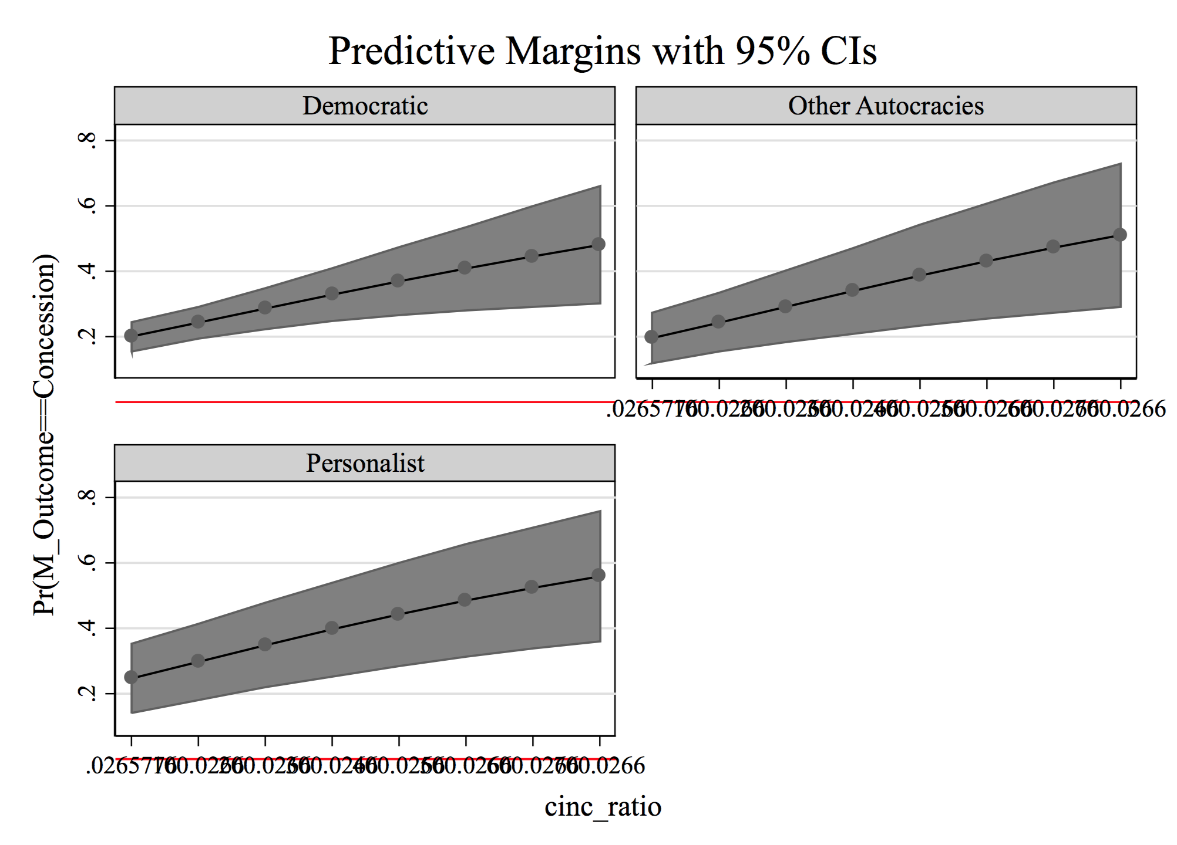

**Appendix Figure 2 – Predicted Probability of Target Concession Across Issue Types**

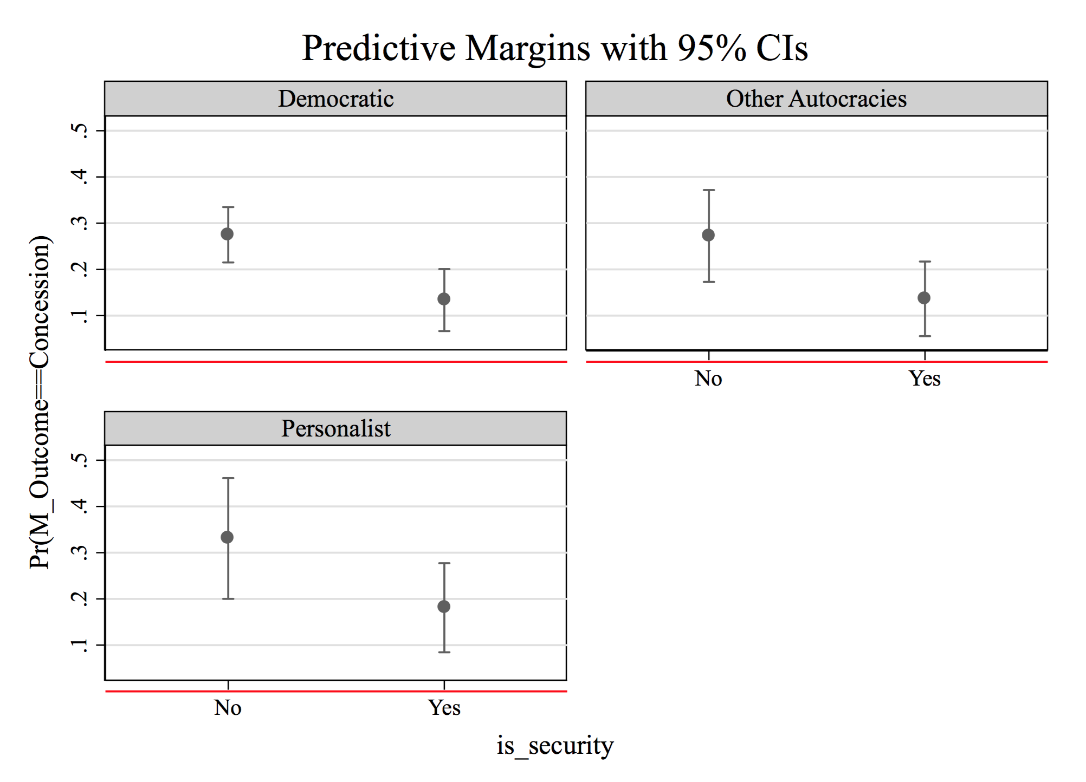

**Appendix Figure 3 – Predicted Probability of Target Concession when Sender’s Last Sanctions threat Resulted in Target Capitulation Varies from 0 to 1**

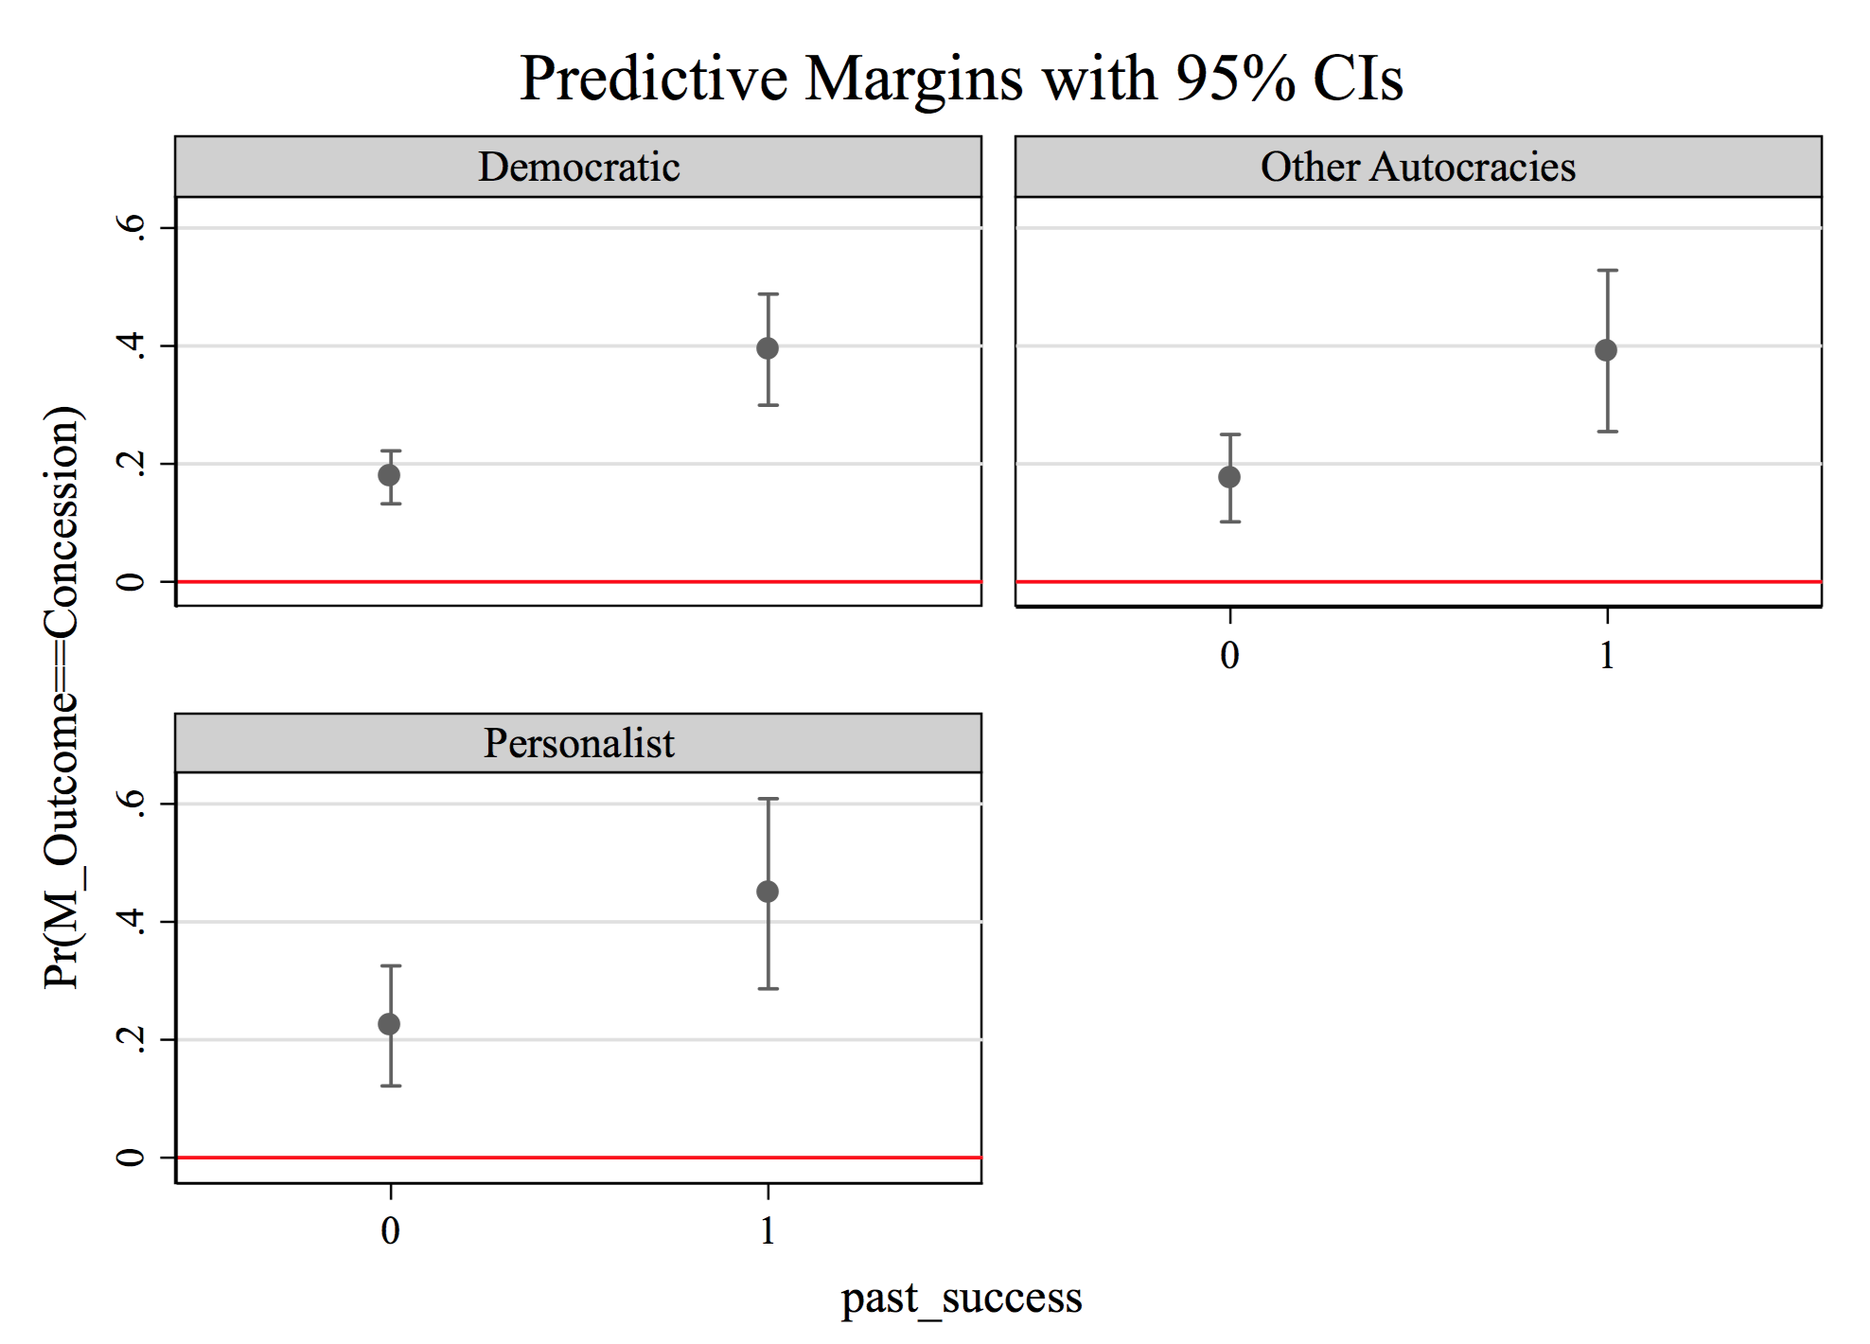

**Appendix Figure 4. Marginal Effects of all Covariates with Respect to   
Probability of Target Concession at Threat Stage**

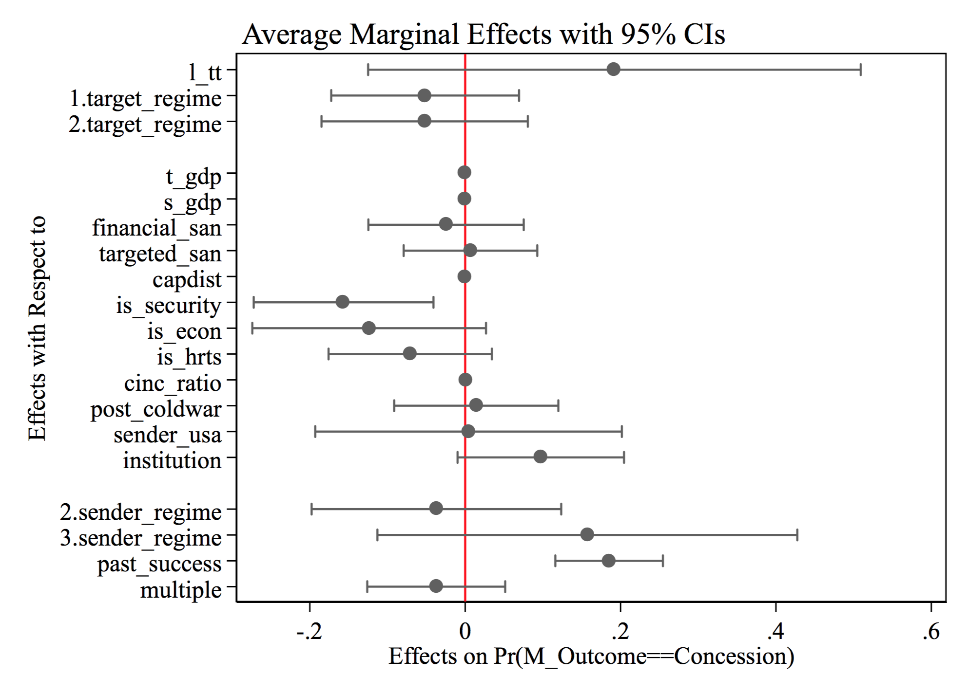

1. Here, I am referring to active U.S. sanction impositions. For how many sanctions threats are issued globally against different types of regimes, see Figure 1. [↑](#footnote-ref-1)
2. This is a time frame that data on sanctions threats and autocratic regime types are both available. The Threat and Imposition of Sanctions (TIES) dataset covers all sanction episodes from 1945 to 2005. The GWF Autocratic Regimes dataset has country years from 1962 to 2010. [↑](#footnote-ref-2)
3. [↑](#footnote-ref-3)
4. Due to the assumption that all leaders seek to stay in power. [↑](#footnote-ref-4)
5. Readers might suspect that domestic audience is less relevant in a study of “sanctions threats” since the public cannot punish its leader for economic damage that has not yet occurred. It is, however, target leaders’ expectation of the damage of a threatened sanction and the public’s potential reaction to it that matters more in this context. On the other hand, only focusing on the relationship between domestic audience size and “sanction imposition” might lead one to miss out the most effective threats that target acquiesced to before imposition (see for example Drezner 2003: 644). [↑](#footnote-ref-5)
6. Pape (1997), for instance, argue that sanctions against Saddam Hussein helped support his unpopular regime and that the effort of the U.N. Peacekeeping force in capturing Somalia’s warlord Mohamed Farrah Aidid had similar effects on his domestic support. [↑](#footnote-ref-6)
7. See Sullivan and Rivas (2008). [↑](#footnote-ref-7)
8. “U.S. Drops Its Threat of Sanctions on Japan,” *The New York Times*. January 20, 1994, [↑](#footnote-ref-8)
9. Cooper, William H. (1993) “Japan-U.S. Trade: The Construction Services Issue,” *Congressional Research Service: Report for Congress*. CRS-1993-ECN-0097. [↑](#footnote-ref-9)
10. New York Times, *3 June 1993*. [↑](#footnote-ref-10)
11. In the coding process of GWF data, coders are instructed to ask several dichotomous questions about the basic characteristics of a particular regime (e.g. Afghanistan 1973-78, Albania 1946-91). Each autocratic regime type has its own set of questions. For instance, there are 12 questions for Personalism, 15 for single-party regimes, and 12 for military regimes. If the number of “yes” appears in more than half of the “personalist” questions for a regime, the coder would code the country as “personalist” within that period. For further reference, all the questions are listed in the Appendix. [↑](#footnote-ref-11)
12. For instance, hybrid cases such as personalist-military and personalist-single party regimes exist in the original dataset. [↑](#footnote-ref-12)
13. According to Barbieri, “trade share measures the proportion of dyadic trade over total trade, both import and export flows, for each state with its trading partners” (36). To calculate the trade dependence of target “i” on sender “j,” I divide the two countries’ bilateral trade flows by the total trade volume of the target. The variable “target trade share” is generated using the Bilateral Trade (v3.0) dataset from the Correlates of War project (Barbieri & Keshk 2012), which contains all the dyadic trade and national trade data from 1870 to 2009. As a robustness check, I also use another conceptualization of target trade share that only takes the proportion of a target’s export to its sender to the target’s national export, but our interested results remain unchanged. [↑](#footnote-ref-13)
14. In addition to the original version of UN Comtrade data, I created a new version that uses (1) the target trade volume from the COW dataset and (2) target GDP from World Bank to impute the missing values in UN Comtrade. As shown in the Appendix, while COW trade data yields the strongest result, results from both versions of UN Comtrade data are statistically significant and substantively consistent with the theory. In the core model presented in the later section, I use the logged version of target trade dependence using the COW data. [↑](#footnote-ref-14)
15. See Dashti-Gibson et al. 1997, Morgan and Schwebach 1997, Cortright and Lopez 1998, Hufbauer et al. 2007, and Drezner 2015 [↑](#footnote-ref-15)
16. That is, after taking all independent variables into account, the outcome of each sanction episode should be independent of another. [↑](#footnote-ref-16)
17. See Gartzke and Li (2003) and Barbieri and Peters (2003). [↑](#footnote-ref-17)