Margin Requirements
The initial leverage ratio of the account can be adjusted to different levels pre-defined by IEXS Prosper Securities and the client (e.g. 1:50 or 1:20 etc.).
Due to specific trading conditions, certain products may have higher margin requirements.
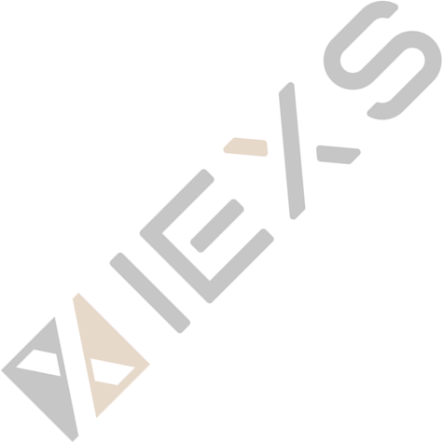
Leverage Adjustment Explanation
Automatic Leverage Adjustment Notice according to IEXS Risk Control Requirements: Your leverage will be automatically decreased under the following circumstances. When the equity of your individual trading account reaches or exceeds the specified equity range，IEXS reserves the right to automatically adjust the leverage of the trading account. Capital transfers or account profits will both impact the account’s equity.
Take a standard account A for example, account A initial equity of $10,000 and leverage of 1:800，When the account’s equity reaches or exceeds $50,000 due to profits or fund transfers, according to the IEXS requirements, the equity of the trading account is greater than $50,000, its trading account leverage is maximum 1:500. Therefore，IEXS will adjust the leverage of account A to 1:500, and the decrease in leverage will increase the required margin for positions. Please be aware of the risks associated with this adjustment. Please refer to the chart below for trading account equity and leverage.

Account Type |  | Standard Account | DMA Account
Instrument Type | Account Equity | Leverage Available | Leverage Available
Shares | ≥0 | 1:10 | 1:10
Indices | ≥0 | 1:20 | 1:20
Oil | ≥0 | 1:100 | 1:100
Sliver | ≥0 | 1:100 | 1:100
Gold | ＜1000 | 1:25  1:50  1:100  1:250  1:400  1:500  1:1000 | 1:25  1:50  1:100  1:200  1:500
 | ≥1000 | 1:25  1:50  1:100  1:250  1:400  1:500 | 1:25  1:50  1:100  1:200  1:250
 | ≥2000 | 1:25  1:50  1:100  1:250  1:400 | 1:25  1:50  1:100  1:200
 | ≥50000 | 1:25  1:50  1:100  1:250 | 1:25  1:50  1:100
 | ≥100000 | 1:25  1:50  1:100 | 1:25  1:50  1:100
 | ≥150000 | 1:25  1:50 | 1:25  1:50
 | ≥2000000 | 1:25 | 1:25
Forex | ＜1000 | 1:50  1:100  1:200  1:500  1:800  1:1000  1:2000 | 1:50  1:100  1:200  1:400  1:1000
 | ≥1000 | 1:50  1:100  1:200  1:500  1:800  1:1000 | 1:50  1:100  1:200  1:400  1:500
 | ≥2000 | 1:50  1:100  1:200  1:500  1:800 | 1:50  1:100  1:200  1:400
 | ≥50000 | 1:50  1:100  1:200  1:500 | 1:50  1:100  1:200
 | ≥100000 | 1:50  1:100  1:200 | 1:50  1:100  1:200
 | ≥150000 | 1:50  1:100 | 1:50  1:100
 | ≥200000 | 1:50 | 1:50
Note: The leverage for certain Special index and stock products may differ from the leverage Shown in the chart. For specific details, Please refer to: https://iexs.comy/indices- shares-specification/

Minimum Margin Requirement
The minimum margin required to open a position depends on the desired leverage，instrument and current market prices. Notification emails will be sent when the available margin in the trading account falls below the 150% threshold.

Margin Call and Margin Cut Policy
Margin call (Use of leverage > 100%) - means when a client does not have enough margin to adjust their position unilaterally. The client may only execute trades to reduce exposure，by closing or hedging the existing net positions. Despite the margin call level being reached, the positions will not be closed automatically. The automated system will not execute all placed bid/offer orders that can increase the exposure.

Risk Disclosure
Trading on margin carries a high level of risk , and may not be suitable for all investors. It is highly recommended to maintain the Use of Leverage at normal levels. The client must always keep in mind that leverage increases potential 1oss, as well as potential profit and invested funds can quickly suffer losses in situations where the market prices exhibit strong volatility，potentially creating an adverse environment for the highly leveraged participant. The client shall be solely responsible for maintaining sufficient margin in relation to the existing positions.

High Risk Investment Warning: CFDs are complex instruments and come with a high risk of losing money rapidly due to leverage. 68% of retail investor accounts lose money when trading CFDs with this provider. You should consider whether you understand how CFDs work and whether you can afford to take the high risk of losing your money. For more information please refer to IEXS’s Risk Disclosure.

- VIEXS (UK) Professional Clients Only – Vision Integrated Exchange LTD is regulated by the Financial Conduct Authority (FCA) reference number 923324. Jurisdiction of incorporation at United Kingdom and the registered office address is 3 Beeston Place, London, UK, SW1W 0JJ.
- IEXS MARKETS PTY LTD (AUS) is authorized and regulated by Australian Securities and Investments Commission(ASIC), License Number: 541328.
- IEXS LLC (SV) Registered office address at First St Vincent Bank Ltd Building, James Street, Kingstown, St. Vincent and the Grenadines, and the regulatory number is 282 LLC 2020.
- IEXS GROUP LTD ( BVI ) According to BVI Business Companies Act , Intershore Chambers, Road Town, Tortola, British Virgin Islands.
- IEXS GLOBAL LTD (BAH) is authorized and regulated by the Securities Commission of the Bahamas (SCB), with regulatory Number: SIA-F257.

Legal: IEXS LLC is incorporated in St. Vincent & the Grenadines as a Limited Liability Company with the registration number 282 LLC 2020. The objects of the Company are all subject matters not forbidden by Limited Liability Companies Act, Chapter 151 of the Revised Law of Saint Vincent and the Grenadines,2009, in particular but not exclusively all commercial, financial, lending, borrowing, trading, service activities and the participation in other enterprises as well as to provide brokerage, training and managed account services in currencies, commodities, indexes, CFDs and leveraged financial instruments.

Disclaimer: The content of this page is for information purposes only and it is not intended as a recommendation or advice. Any indication of past performance or simulated past performance included in advertisements published by IEXS is not a reliable indicator of future results. The customer carries the sole responsibility for all the businesses or investments that are carried out at IEXS.

IEXS LLC does not provide services to residents of the United States, Iran, North Korea, Cuba, Iraq, Syria, Taiwan China and Canada. The information on this site is not directed at residents in any country or jurisdiction where such distribution or use would be contrary to local law or regulation.

