High Risk Investment
Forex margin trading involves substantial risks. Forex margin trading exposes participants to risks including, but not limited to, changes in political conditions, economic factors, acts of nature and other factors, all of which may substantially affect the price or availability of one or more foreign currencies.
Speculative trading is a challenging prospect, even to those with market experience and an understanding of the risks involved. Only funds that a person would allocate to high-risk investments (i.e., funds that if lost would not affect the person's standard of living or financial well-being) should be used in trading.
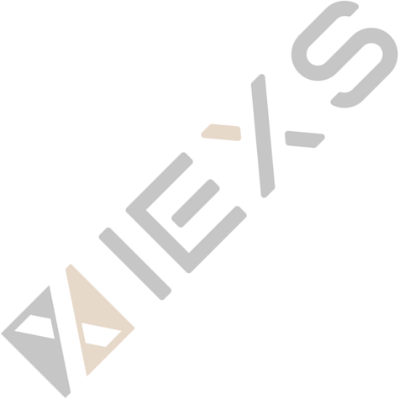
In cases where a Client has used only conservative forms of investment in the past, forex trading might not be appropriate for the Client. A Client must understand that a total loss of all funds deposited can occur, should the market go against the Client's position(s).
Other risks
IEXS does not and cannot guarantee the initial capital of the Clients' portfolio or its value at any time or any money invested in any financial instrument.
The Client should unreservedly acknowledge and accept that the client runs a great risk of incurring losses and damages as a result of the purchase and/or sale of any Financial Instrument and accepts and declares that they are willing to undertake this risk.
Clients should not engage in any investment directly or indirectly in Financial Instruments unless they know and understand the risks involved for each one of the Financial Instruments.
Web Trading Risks
There are certain risks due to the nature of internet-based trading. These may include but not be limited to, the failure of hardware, software, and Internet connection. Since IEXS does not control internet providers, their equipment and technology, internet connection speed or reliability, configuration of your equipment or reliability of its connection, we cannot be responsible for communication failures, distortions or delays when trading via the Internet.
Software risks
Metatrader 4 trading software uses a sophisticated order entry mechanism and order tracking system. IEXS does its best to fill your trade at the price requested. Internet trading, regardless of how convenient or efficient does not necessarily reduce risks associated with currency trading. All quotes and trades are subject to the terms and conditions of the Client Agreement.

Leverage Adjustment Explanation
Automatic Leverage Adjustment Notice according to IEXS Risk Control Requirements: Your leverage will be automatically decreased under the following circumstances. When the equity of your individual trading account reaches or exceeds the specified equity range, IEXS reserves the right to automatically adjust the leverage of the trading account. Capital transfers or account profits will both impact the accounts equity. Please refer to the chart below for trading account equity and leverage.
Account Type |  | Standard Account | DMA Account
Instrument Type | Account Equity | Leverage Available | Leverage Available
Shares/Crypto Currency | ≥200 | 1:10 | 1:10
Indices | ≥200 | 1:20 | 1:20
Oil | ≥200 | 1:100 | 1:100
Sliver | ≥200 | 1:100 | 1:100
Gold | ＜1000 | 1:25  1:50  1:100  1:250  1:400  1:1000 | 1:25  1:50  1:100  1:200  1:500
 | ≥1000 | 1:25  1:50  1:100  1:250  1:400  1:500 | 1:25  1:50  1:100  1:200  1:250
 | ≥2000 | 1:25  1:50  1:100  1:250  1:400 | 1:25  1:50  1:100  1:200
 | ≥50000 | 1:25  1:50  1:100  1:250 | 1:25  1:50  1:100
 | ≥100000 | 1:25  1:50  1:100 | 1:25  1:50  1:100
 | ≥150000 | 1:25  1:50 | 1:25  1:50
 | ≥2000000 | 1:25 | 1:25
Forex | ＜1000 | 1:50  1:100  1:200  1:500  1:800  1:2000 | 1:50  1:100  1:200  1:400  1:1000
 | ≥1000 | 1:50  1:100  1:200  1:500  1:800  1:1000 | 1:50  1:100  1:200  1:400  1:500
 | ≥2000 | 1:50  1:100  1:200  1:500  1:800 | 1:50  1:100  1:200  1:400
 | ≥50000 | 1:50  1:100  1:200  1:500 | 1:50  1:100  1:200
 | ≥100000 | 1:50  1:100  1:200 | 1:50  1:100  1:200
 | ≥150000 | 1:50  1:100 | 1:50  1:100
 | ≥200000 | 1:50 | 1:50

High Risk Investment Warning: CFDs are complex instruments and come with a high risk of losing money rapidly due to leverage. 68% of retail investor accounts lose money when trading CFDs with this provider. You should consider whether you understand how CFDs work and whether you can afford to take the high risk of losing your money. For more information please refer to IEXS’s Risk Disclosure.

- VIEXS (UK) Professional Clients Only – Vision Integrated Exchange LTD is regulated by the Financial Conduct Authority (FCA) reference number 923324. Jurisdiction of incorporation at United Kingdom and the registered office address is 3 Beeston Place, London, UK, SW1W 0JJ.
- IEXS GLOBAL PTY LTD (AUS) is authorized and regulated by Australian Securities and Investments Commission(ASIC), License Number: 001301063.
- IEXS LLC (SV) Registered office address at First St Vincent Bank Ltd Building, James Street, Kingstown, St. Vincent and the Grenadines, and the regulatory number is 282 LLC 2020.
- IEXS GROUP LTD (BVI) According to BVI Business Companies Act, Intershore Chambers, Road Town, Tortola, British Virgin Islands.
- IEXS GLOBAL LTD (BAH) is authorized and regulated by the Securities Commission of the Bahamas (SCB), with regulatory Number: SIA-F257.

Legal: IEXS LLC is incorporated in St. Vincent & the Grenadines as a Limited Liability Company with the registration number 282 LLC 2020. The objects of the Company are all subject matters not forbidden by Limited Liability Companies Act, Chapter 151 of the Revised Law of Saint Vincent and the Grenadines,2009, in particular but not exclusively all commercial, financial, lending, borrowing, trading, service activities and the participation in other enterprises as well as to provide brokerage, training and managed account services in currencies, commodities, indexes, CFDs and leveraged financial instruments.

Disclaimer: The content of this page is for information purposes only and it is not intended as a recommendation or advice. Any indication of past performance or simulated past performance included in advertisements published by IEXS is not a reliable indicator of future results. The customer carries the sole responsibility for all the businesses or investments that are carried out at IEXS.

IEXS LLC does not provide services to residents of the United States, Iran, North Korea, Cuba, Iraq, Syria, Taiwan China and Canada. The information on this site is not directed at residents in any country or jurisdiction where such distribution or use would be contrary to local law or regulation.

