INDIVIDUAL PROGRESS REPORT
Week 2: Data Gathering and Data Cleaning / Data Processing
Group Topic | Boardie Analytics: A Big Data Approach to Student Boarding House Discovery and Geofenced Presence Pattern Analysis
Student Name | Francis Anthony S. Garbosa
Lab No. | Week 2
Git Repo / Colab Link | https://github.com/carlpoot/Week-2---Biggs-Data

Objectives
The primary goal for this week was to generate a substantial volume of data for the Boardie Analytics project to demonstrate the early stages of handling big data. Specific requirements included compiling over 500,000 total records across multiple files, ensuring ethical data use, and performing data cleaning, variable creation, and visualization.
Tasks Completed
Reviewed the updated project scope to define three necessary data categories: student search logs, boarding house listings, and consent-driven geofenced event logs.
Built a simulation-based pilot dataset tailored to the project's specific methodology.
Successfully generated a total of 643,700 raw records across several CSV files, surpassing the 500,000-row minimum requirement.
Intentionally introduced realistic flaws into the raw data—such as missing fields, duplicates, inconsistent formatting, and non-consented records—to create a robust, documented cleaning process.
Executed data cleaning procedures that involved eliminating duplicates, standardizing text, handling missing values, capping extreme values, and extracting time and day features from timestamps.
Calculated the distance to campus for housing listings using geographic coordinates and classified listings into practical tiers (e.g., budget-near-campus, student-standard, high-amenity).
Ensured data privacy by stripping out non-consented geofence records and converting participant IDs into anonymous hashed codes.
Produced four visualizations mapping search behavior patterns by hour, price distributions, campus occupancy statuses, and geofenced events by day period.
Documented the workflow in a notebook format and created a Python script version to streamline rerunning the code and uploading to GitHub.
Tasks to be Completed
Expand the dataset by adding new contextual metrics, such as area-density or owner-related details, pending group approval.
Conduct deeper exploratory data analysis to initiate the project's actual classification and pattern analysis phases.
Refine the data simulation algorithms, or substitute portions of the mock data with approved real or semi-real data if acquired by the team.
Design presentation-ready tables and potentially build a dashboard for the upcoming project review.
Dataset Summary
Dataset | Raw Rows | Clean Rows
Boarding house listings | 20,500 | 20,000
Student search logs | 422,000 | 420,000
Geofence events | 201,200 | 199,801
Combined total | 643,700 | 639,801
The cleaned dataset remained above the required threshold and preserved enough detail for later classification and pattern analysis.
Results and Analysis
The cleaning pipeline drastically reduced missing data while enriching the tables with new analytical variables, including campus proximity, day parts, search hour, and offer categories. Initial reviews suggest this synthesized data will support both key research objectives. First, housing can now be meaningfully categorized by cost, amenities, and availability. Second, search and geofencing logs can reveal time-based demand and location trends without compromising privacy.
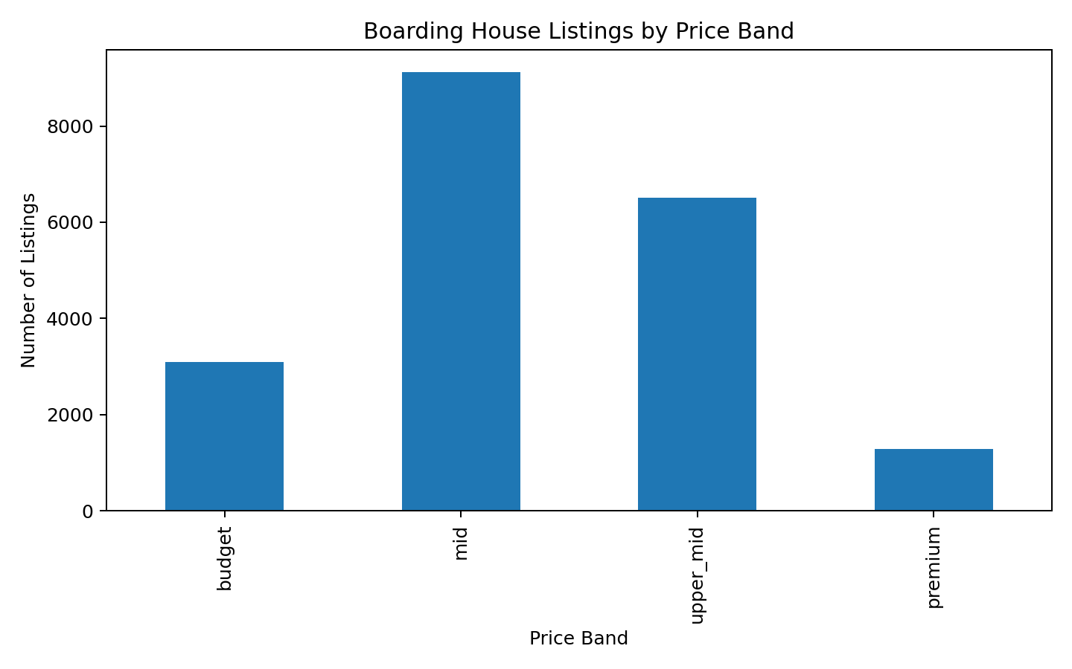
Figure 1. Boarding house listings by price band
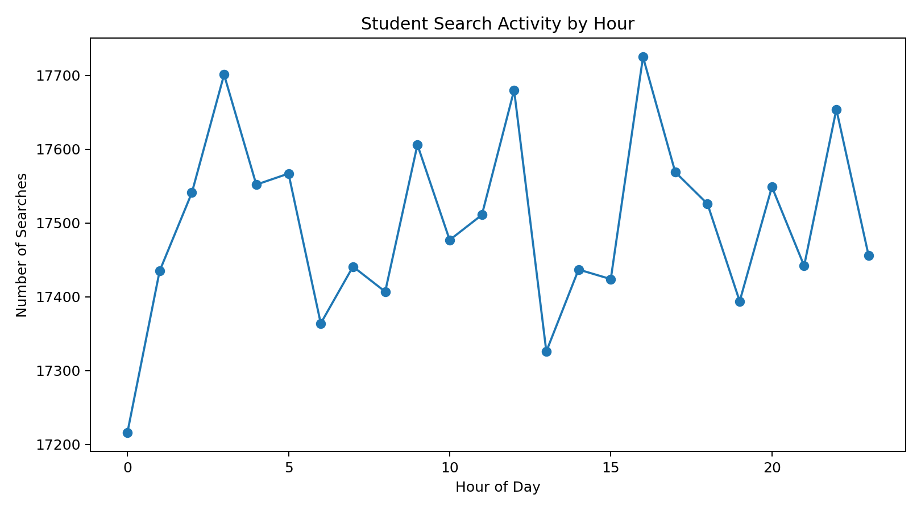
Figure 2. Student search activity by hour

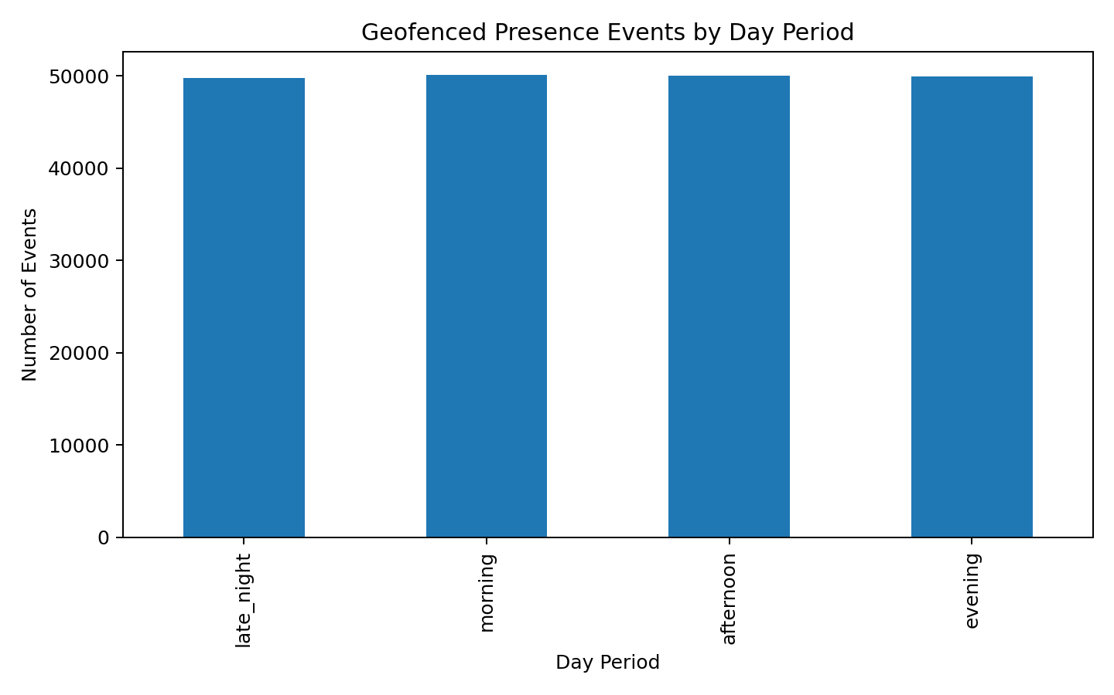
Figure 3. Geofenced presence events by day period

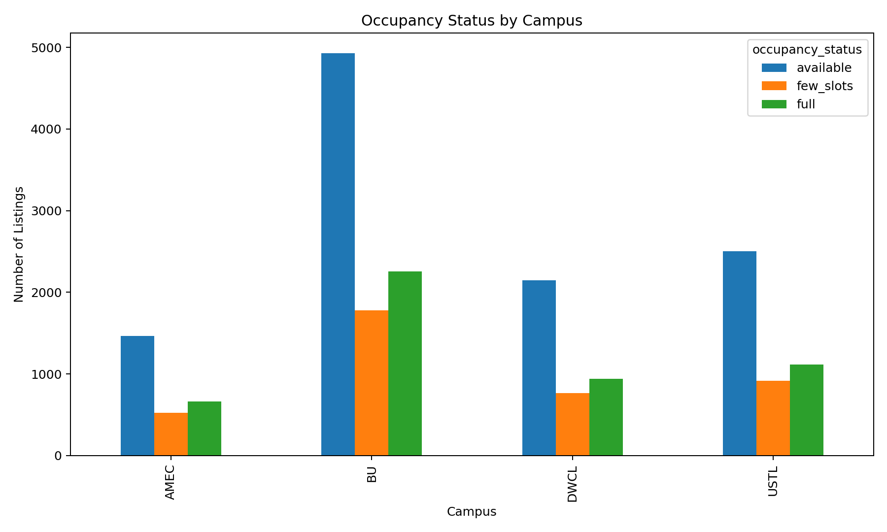
Figure 4. Occupancy status by campus

Challenges and Solutions
Challenge | Solution
The project lacked an approved real-world dataset because it is still in the proposal phase. | Built a simulated, ethically compliant pilot dataset aligned with the new methodology.
Manually gathering over 500,000 rows of data in a single week was unfeasible. | Designed a system to procedurally generate diverse files with realistic searches, listings, and events that easily exceeded the target volume.
Raw data flaws (duplicates, formatting issues, missing values) threatened future analysis quality. | Developed a reusable Python data cleaning script, allowing for continuous improvements and easy iterations
Handling geofence data introduced privacy concerns. | Restricted data inclusion to consent-provided records only and anonymized real participant IDs using hash codes.

Conclusion
This week's objectives were successfully achieved by compiling a massive, ethically sourced pilot dataset primed for the Boardie Analytics project. This workflow demonstrated how to effectively aggregate raw data from multiple sources and transform it into a usable, visualizable format using reproducible Python scripts. The resulting cleaned dataset establishes a strong foundation for the next stages of project development.

