INDIVIDUAL PROGRESS REPORT
Week 2: Data Gathering and Data Cleaning / Data Processing
Group Topic | Boardie Analytics: A Big Data Approach to Student Boarding House Discovery and Geofenced Presence Pattern Analysis
Student Name | Joseph Odilon P. Dating Jr.
Lab No. | Week 2
Git Repo / Colab Link | https://github.com/carlpoot/Week-2---Biggs-Data

Objectives
The main objective for this week’s task is to generate a large-scale dataset for the Boardie Analytics project and demonstrate the early stage of big data handling. The assignment involved ensuring ethical data usage, structuring the dataset into multiple files totaling more than 500,000 entries, performing data cleaning, creating analytical variables, and producing visual representations of the data.
Tasks Completed
Reviewed the updated scope of the Boardie Analytics project and determined the three required datasets: boarding house listings, student search records, and consent-based geofenced presence logs.
Developed a simulation-based pilot dataset aligned with the project’s methodology. The dataset was distributed across several CSV files, reaching a total of 643,700 raw entries, exceeding the required 500,000 rows.
Produced realistic raw data containing intentional issues such as missing values, duplicate entries, inconsistent formatting, and non-consented records to make the cleaning process meaningful and traceable.
Processed and cleaned the dataset by removing duplicates, standardizing text formats, filling missing values, trimming out-of-range data, generating day-period variables, and converting timestamps into usable time-based features.
Computed the distance to campus for boarding house listings using geographic coordinates and categorized the listings into groups such as budget-near-campus, student-standard, high-amenity, and mixed-value.
Implemented privacy measures on geofence data by filtering out non-consented records and anonymizing participant IDs using hashed values before saving the cleaned dataset.
Created four visual outputs summarizing price distribution, hourly search behavior, geofenced activity by day period, and campus occupancy status.
Saved the work in a notebook format and also converted it into a Python script for easier execution and uploading to GitHub.

Tasks to be Completed
Enhance the cleaned dataset by adding more contextual variables if the group decides to include owner-related or area-density attributes.
Conduct more in-depth exploratory data analysis and initiate classification and pattern recognition processes.
Improve the simulation process or replace portions of the dataset with approved real or semi-real data if available.
Prepare presentation-ready tables and potentially develop a dashboard for the next project update.

Dataset Summary
Dataset | Raw Rows | Clean Rows
Boarding house listings | 20,500 | 20,000
Student search logs | 422,000 | 420,000
Geofence events | 201,200 | 199,801
Combined total | 643,700 | 639,801
The cleaned dataset remained above the required threshold and preserved enough detail for later classification and pattern analysis.
Results and Analysis
The preprocessing stage produced three cleaned datasets: boarding house listings, student search logs, and geofencing records. After removing duplicates and filtering out non-consented entries, the final dataset consisted of 639,801 records. Missing values were significantly reduced, and the dataset was enriched with analytical features such as campus proximity, day classification, time segments, search hour, amenity count, and listing categories.
Initial analysis suggests that the generated dataset is adequate for both aspects of the study. First, housing listings can be grouped into meaningful categories based on price, availability, and amenities. Second, search and geofencing data can be used to examine time-based trends, supporting demand analysis and movement pattern identification while maintaining user privacy.
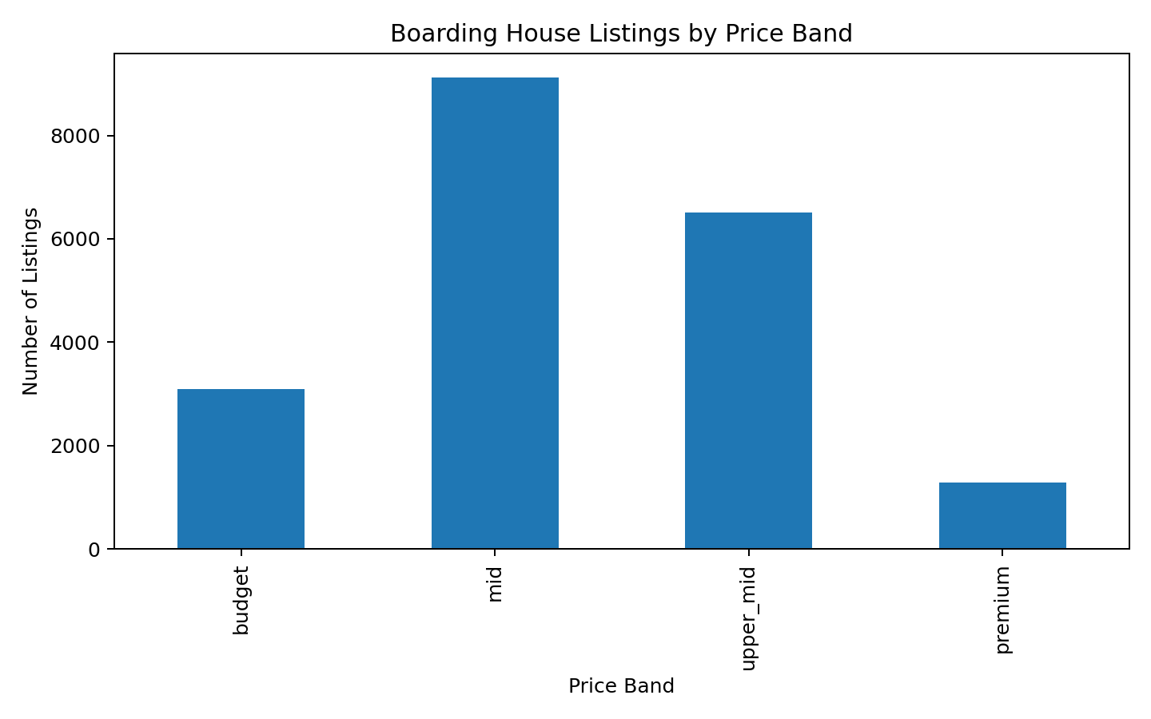
Figure 1. Boarding house listings by price band
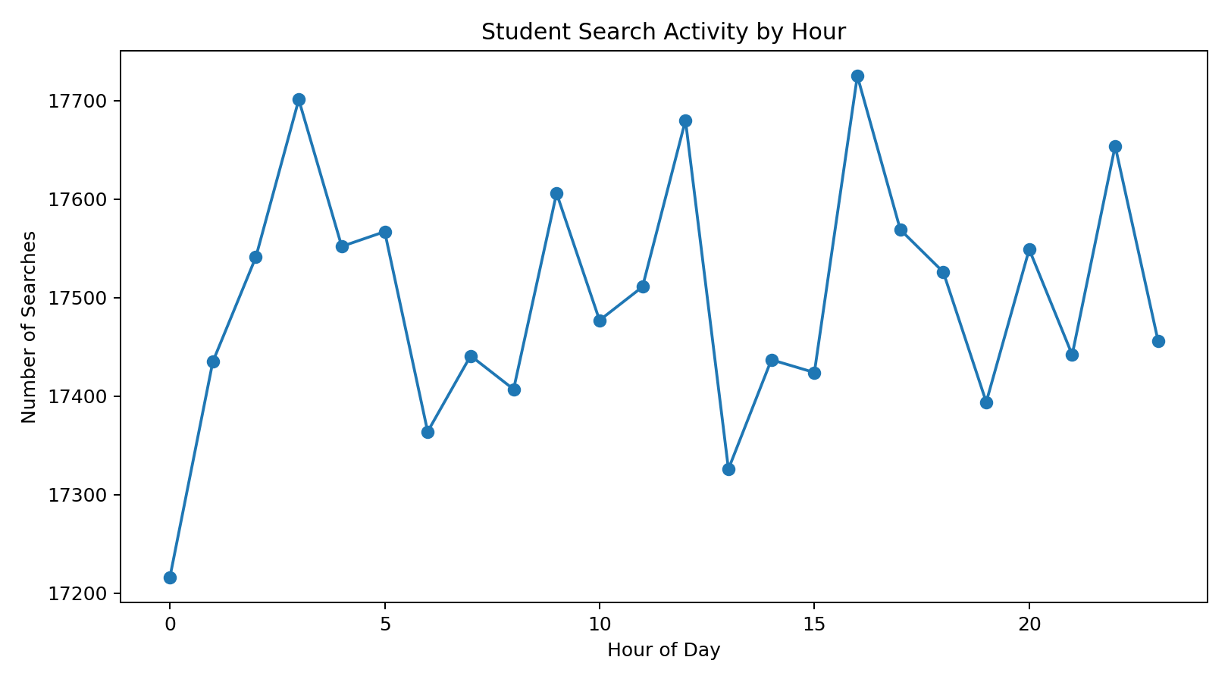
Figure 2. Student search activity by hour

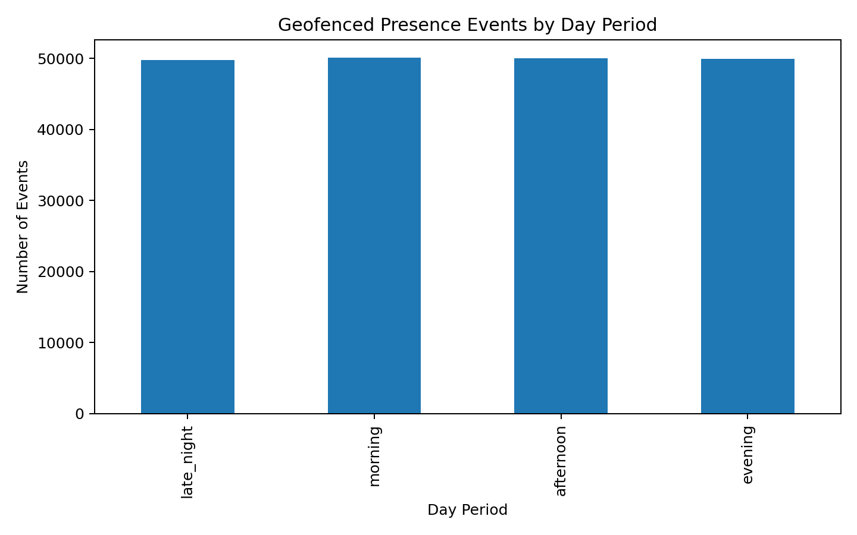
Figure 3. Geofenced presence events by day period

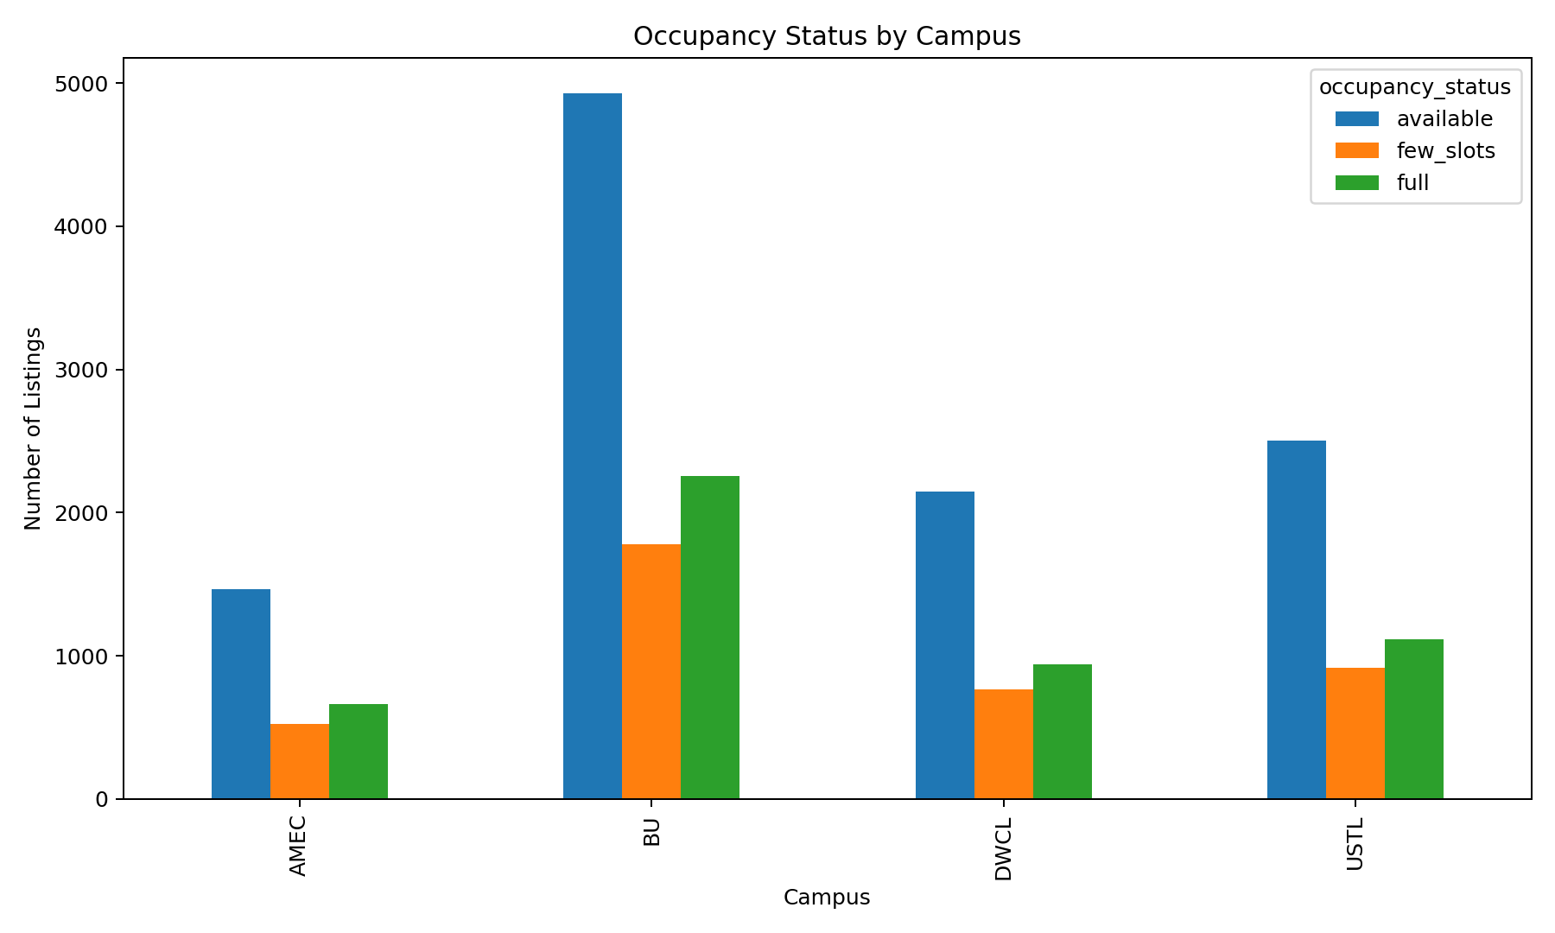
Figure 4. Occupancy status by campus

Challenges and Solutions
Challenge | Solution
The project is still under proposal, so there is no finalized real-world dataset available. | A simulated pilot dataset was developed based on the updated project variables while ensuring ethical standards and methodology are followed.
Gathering more than 500,000 data entries manually within a short time frame is challenging. | The dataset was generated across multiple files, designed to simulate realistic listings, searches, and geofencing events with a total count exceeding the requirement.
Issues in raw data such as duplicates, missing values, and inconsistent formatting may impact future analysis. | A data cleaning script was implemented using Python to allow efficient processing and future refinements.
Geofence-related data may pose privacy risks. | Only records with proper consent were included, and participant identifiers were anonymized through hashing instead of using actual IDs.

Conclusion
The goals for this week have been effectively achieved, as a substantial pilot dataset was developed while maintaining ethical standards, making it ready for analysis in the Boardie Analytics project. This task highlighted the process of collecting raw information from multiple sources and converting it into a well-structured format that can be analyzed and visualized using Python tools. Overall, this output provides a reliable baseline for the succeeding stages of the project’s progress.z

