INDIVIDUAL PROGRESS REPORT
Week 2: Data Gathering and Data Cleaning / Data Processing
Group Topic | Boardie Analytics: A Big Data Approach to Student Boarding House Discovery and Geofenced Presence Pattern Analysis
Student Name | Carl Nathan S. Poot
Lab No. | Week 2
Git Repo / Colab Link | https://github.com/carlpoot/Week-2---Biggs-Data

Objectives
The goal of the task assigned for the week is to develop a large volume of data for the Boardie Analytics project and to illustrate the initial phase of working with big data. The assignment required creating an ethical use of data for the project, organizing the data into several files with over 500,000 total entries, cleaning the data, developing analytical variables from the data, and visualizing the data.
Tasks Completed
Reviewed the revised Boardie Analytics project scope and identified the three data groups needed for the study: boarding house listings, student search logs, and consent-based geofenced presence event logs.
Prepared a simulation-assisted pilot dataset aligned with the project methodology. The dataset was split into multiple CSV files and reached 643,700 raw rows in total, which satisfies the minimum requirement of 500,000 rows.
Generated realistic raw records with deliberate issues such as missing values, duplicates, inconsistent text formatting, and non-consented noise records so that the cleaning workflow would be meaningful and documented.
Cleaned the raw files by removing duplicate records, standardizing text values, filling missing numerical and categorical values, clipping out-of-range values, deriving day-period variables, and converting timestamps into analyzable time features.
Calculated distance-to-campus values for boarding house listings through latitude and longitude fields and grouped housing records into practical categories such as budget-near-campus, student-standard, high-amenity, and mixed-value.
Applied a privacy-conscious step to the geofence data by removing non-consented records and anonymizing participant identifiers into hashed codes before saving the cleaned file.
Created four visualizations from the cleaned dataset to summarize price distribution, search behavior by hour, geofenced event patterns by day period, and occupancy status by campus.
Saved the code in notebook form and also prepared a Python script version for easier rerunning and GitHub upload.

Tasks to be Completed
Extend the cleaned dataset with additional contextual variables if the group decides to add owner-side or area-density features.
Perform deeper exploratory data analysis and begin the actual classification and pattern analysis phase.
Refine the simulation logic or replace parts of the pilot dataset with approved real or semi-real data if the group secures one.
Prepare presentation-ready tables and possibly a dashboard for the next project update.

Dataset Summary
Dataset | Raw Rows | Clean Rows
Boarding house listings | 20,500 | 20,000
Student search logs | 422,000 | 420,000
Geofence events | 201,200 | 199,801
Combined total | 643,700 | 639,801
The cleaned dataset remained above the required threshold and preserved enough detail for later classification and pattern analysis.
Results and Analysis
The preprocessing pipeline resulted in three sets of cleaned data: boarding house offers, student searches, and geofencing events. Following duplication elimination and non-consent data removal, the final set of cleaned data consisted of 639,801 observations. The missingness in the data was drastically minimized, while the cleaned data tables were augmented with analytical variables like proximity to campus, day type, day part, search hour, amenity number, and offer category.
Preliminary analyses indicate that the synthesized data is sufficient for both analytical aspects of the research project. First, housing data may be categorized into meaningful groups relevant to students according to their cost, availability, and amenities. Second, the search and geofencing logs may be utilized to analyze time trends that could eventually serve demand analysis and location pattern generation without exposing sensitive information.
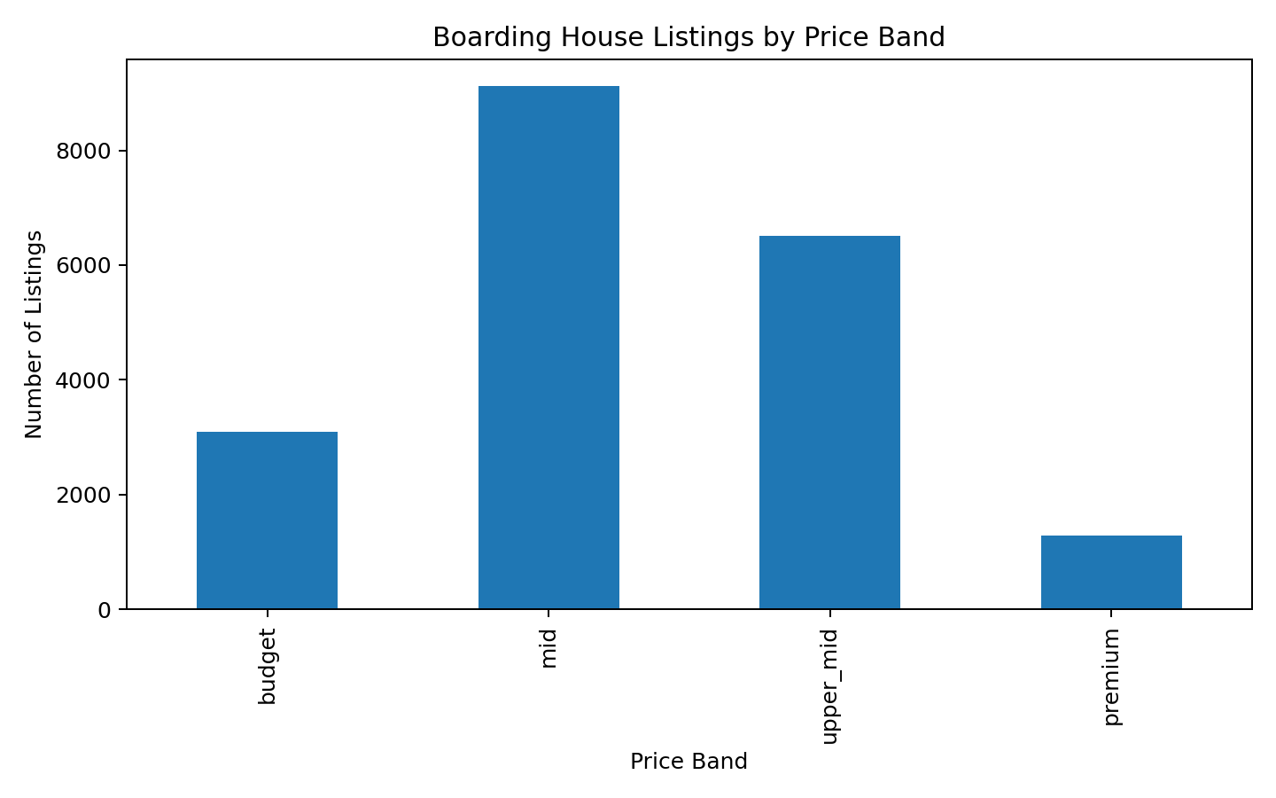
Figure 1. Boarding house listings by price band
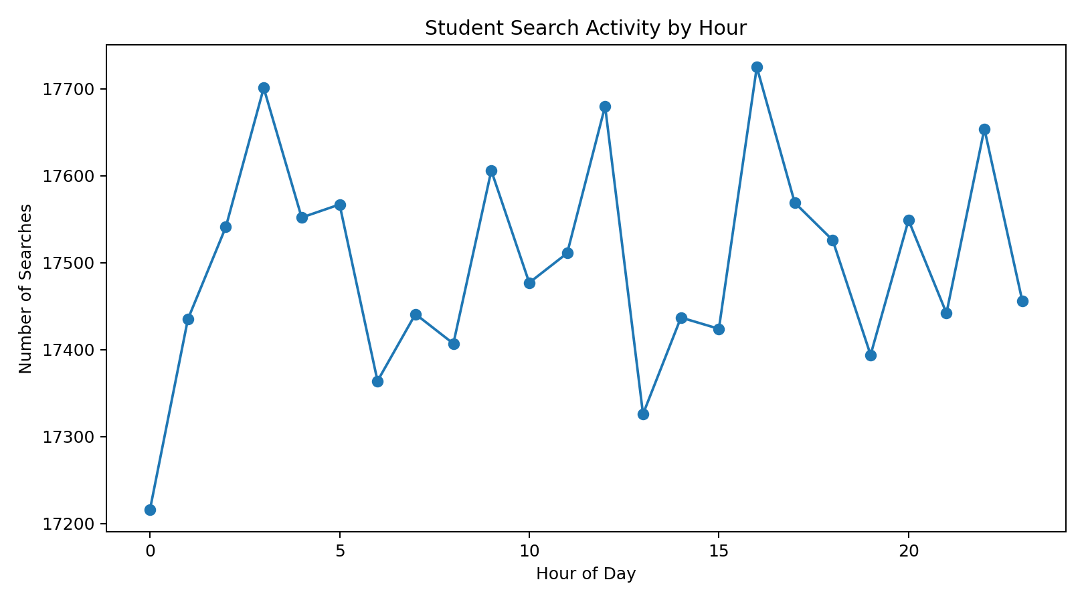
Figure 2. Student search activity by hour

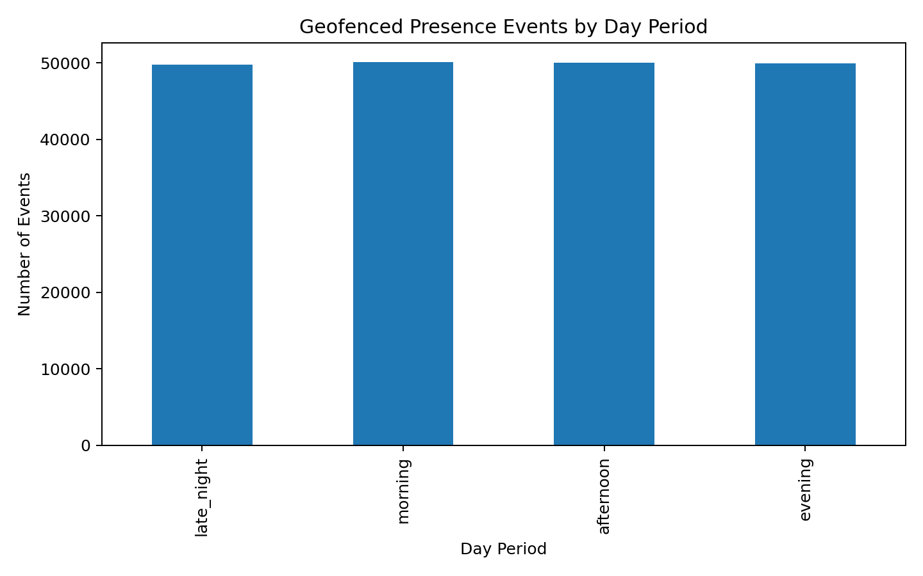
Figure 3. Geofenced presence events by day period

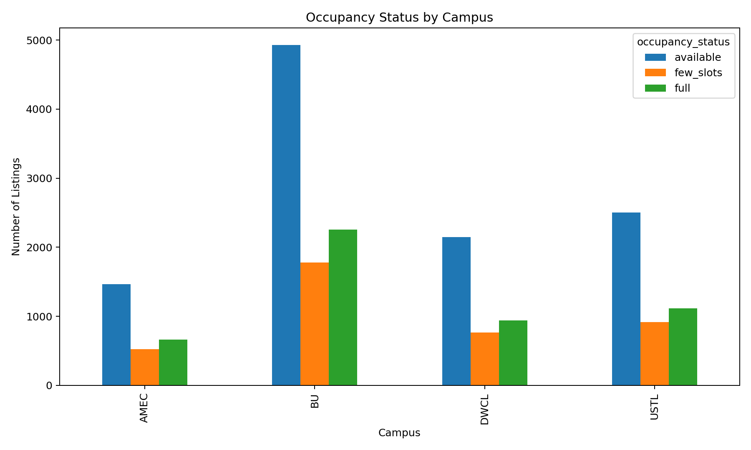
Figure 4. Occupancy status by campus

Challenges and Solutions
Challenge | Solution
The project topic is still in the proposal stage, so there is no approved real-world dataset yet. | A simulated pilot set was created to align with the new project variables while adhering to ethics and new methodology.
The task requires more than 500,000 rows, which is difficult to gather manually in one week. | The dataset has been created in various files and was designed to create realistic lists, searches, and geofenced events with more total numbers than needed.
Raw data quality issues such as duplicates, missing values, and inconsistent formatting can affect later analysis. | The dataset cleaning script was developed using Python so that future improvements and iterations can be done.
Geofence-related data may raise privacy concerns. | The records in the dataset have only been included if consent was provided, and the participant ID hashes have been used instead of real IDs.

Conclusion
The objectives that were set for the current week have been accomplished, as we have been able to compile a large pilot dataset that is ethical and ready to be analyzed for the Boardie Analytics project. This process showed us how to collect raw data from various sources and present it in a form that can be used and visualized in a reproducible manner through the use of Python. This will serve as an ideal starting point for further development of our project.

