INDIVIDUAL PROGRESS REPORT
Week 3
Group Topic | Boardie Analytics: A Big Data Approach to Student Boarding House Discovery and Geofenced Presence Pattern Analysis
Student Name | Carl Nathan S. Poot
Lab No. | Week 3
Git Repo / Colab Link | ;…
Objectives
The objective of this week, our aim is to further develop the Boardie Analytics project through the selection of an appropriate machine learning algorithm that can be implemented in code and fine-tuned for improvement. As we are currently working with data labeled as categories of a price band, our choice of model falls under classification. Our model will help classify whether a listing is from the budget, mid-range, upper mid, or premium range.
Tasks Completed
- Reviewed the Week 2 processed dataset and identified price_band as the target variable for the Week 3 classification task.
- Selected Classification as the appropriate algorithm type because the output is a categorical label rather than a continuous numerical value.
- Prepared the modeling dataset by selecting relevant numerical and categorical features such as neighbourhood, property type, room type, accommodates, bedrooms, beds, amenities count, availability, number of reviews, review score, superhost status, and instant bookable status.
- Created a preprocessing pipeline that fills missing numerical values using the median and fills missing categorical values using the most frequent value.
- Applied one-hot encoding to categorical variables so they could be used by the machine learning model.
- Split the dataset into training and testing subsets using an 80 percent training and 20 percent testing setup.
- Implemented a Decision Tree Classifier as the baseline model for comparison.
- Implemented a Random Forest Classifier as the main classification model because it combines multiple decision trees and reduces overfitting compared with a single tree.
- Fine-tuned the Random Forest model using GridSearchCV with different values for number of trees, maximum depth, and minimum samples per leaf.
- Generated model outputs including a results text file, confusion matrix figure, and feature importance figure for documentation and GitHub submission.
- Prepared the Week 3 code notebook, Python script, README file, and individual progress report for manual upload to GitHub.
Tasks to be Completed
- Replace the demonstration processed file with the final processed Week 2 dataset if the group decides to use the larger version for final checking.
- Run the notebook again after the final GitHub upload to confirm that all file paths work properly.
- Compare the Random Forest model with other possible algorithms such as Logistic Regression or Gradient Boosted Trees if the instructor requires more model comparisons.
- Improve the class balance if some categories have fewer records than others, especially the Budget and Premium classes.
- Prepare a short presentation explanation showing why classification and Random Forest are appropriate for the Boardie Analytics dataset.

Model Summary
Item | Description
Algorithm Type | Classification
Target Variable | price_band
Predicted Classes | Budget, Mid-range, Upper-mid, Premium
Baseline Model | Decision Tree Classifier
Main Model | Random Forest Classifier
Fine-Tuning Method | GridSearchCV
Train-Test Split | 80 percent training, 20 percent testing
Evaluation Metrics | Accuracy, precision, recall, F1-score, confusion matrix
Results and Analysis
As per the results obtained from the initial implementation of the model, classification is appropriate for use on the Boardie Analytics continuation assignment due to the possibility of arranging the data into various listing prices. Initially, a Decision Tree Classifier model was chosen, and the main model used was a Random Forest Classifier. The better performance obtained using the Random Forest Classifier during the pilot phase is attributed to the combination of many decision trees and predictions done collectively.
From the pilot execution of this task that was provided in the Week 3 dataset file set, the Decision Tree baseline model was capable of attaining an accuracy rate of 0.6700 and the fine-tuned Random Forest model attained an accuracy rate of 0.7400. The optimal Random Forest parameters obtained through the tuning process were max_depth at 6, min_samples_leaf at 1 and n_estimators at 50.
The confusion matrix depicts the distribution of the classifications in each of the price ranges. The majority of the correct classifications were recorded among the Mid-range and Upper mid groups since these categories contained more data than the other two. The feature importance graph also gives insight into the most influential variables in theRandom Forest model output.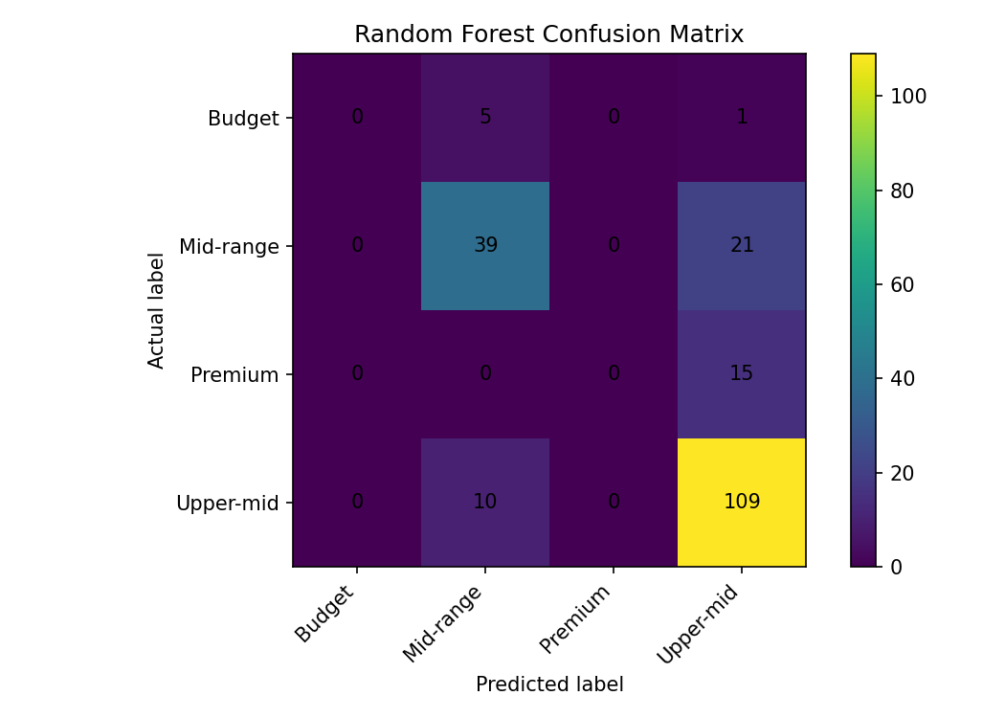
Figure 1. Random Forest confusion matrix
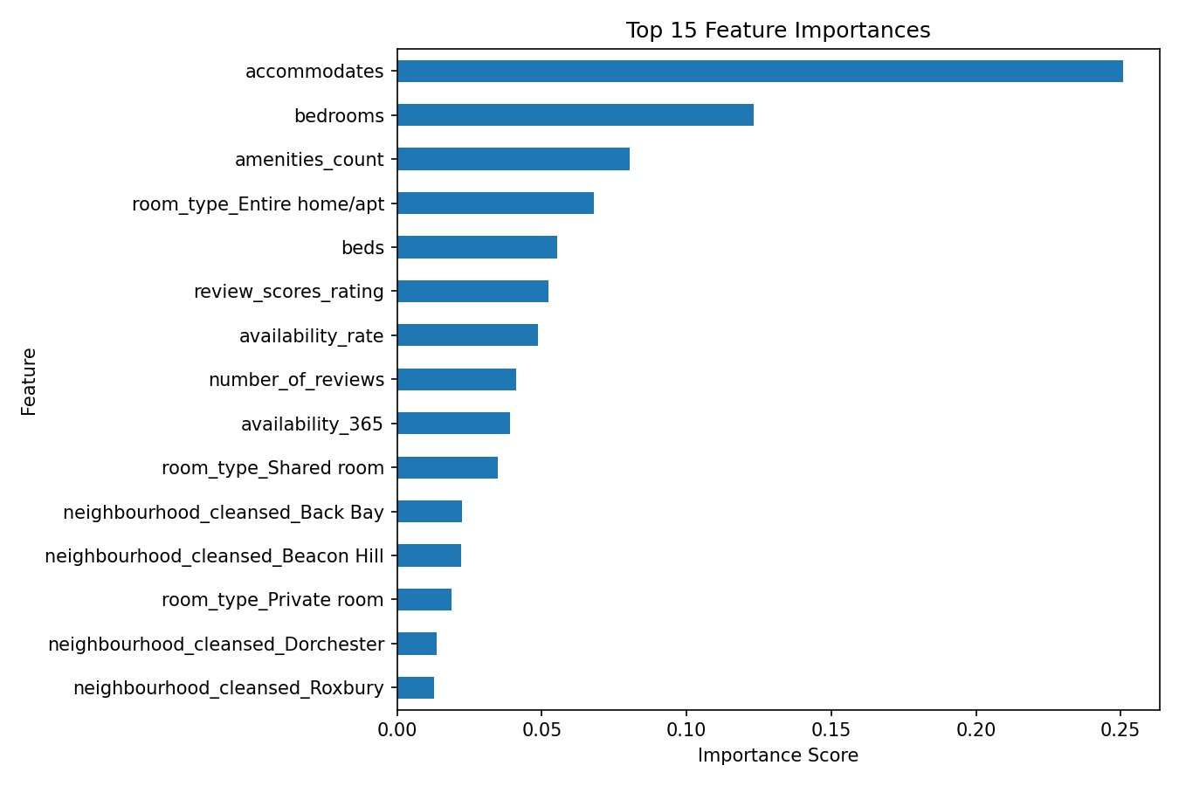
Figure 2. Top 15 feature importances from the Random Forest model
Challenges and Solutions
Challenge | Solution
The Week 3 task required choosing whether to use prediction, clustering, or classification. | The target variable was reviewed, and classification was selected because price_band is categorical.
The dataset contains both numerical and categorical variables. | A preprocessing pipeline was created to handle missing values and encode categorical values before model training.
A single decision tree may overfit or depend too much on one tree structure. | Random Forest was selected as the main model because it combines several decision trees and improves stability.
Some categories may have fewer records than the others. | The report notes class balance as an area for improvement, and future work can include adding more records or applying balancing techniques.
The GitHub repository will be created and uploaded manually. | The report uses a temporary placeholder for the GitHub link so it can be replaced after upload.
Conclusion
The goals of Week 3 were achieved by choosing Classification as the suitable algorithm type, developing a baseline model using the Decision Tree and also developing a model using the Random Forest Classifier and optimizing the hyperparameters via the GridSearchCV technique. This project made us associate our cleaned dataset from Week 2 with a real machine learning process. Our developed notebook, Python code, Readme file, model results, and visualization output are now ready to be uploaded to our Github repository.

