INDIVIDUAL PROGRESS REPORT
Week 3
Group Topic | Boardie Analytics: A Big Data Approach to Student Boarding House Discovery and Geofenced Presence Pattern Analysis
Student Name | Joseph Odilon P. Dating Jr.
Lab No. | Week 3
Git Repo / Colab Link | ;…
Objectives
The objective for this week is to continue the development of the Boardie Analytics project by selecting a suitable machine learning algorithm that can be coded and optimized for better performance. Since the dataset currently contains labeled categories based on price ranges, the selected approach belongs to classification. The model is intended to classify whether a listing belongs to the budget, mid-range, upper-mid, or premium category.
Tasks Completed
- Reviewed the processed dataset from Week 2 and identified price_band as the target variable for the Week 3 classification activity.
- Chose Classification as the suitable algorithm type because the output consists of categorical labels instead of continuous numerical values.
- Prepared the dataset for modeling by selecting important numerical and categorical features including neighbourhood, property type, room type, accommodates, bedrooms, beds, amenities count, availability, review count, review score, superhost status, and instant bookable status.
- Developed a preprocessing pipeline that replaces missing numerical values using the median and missing categorical values using the most frequent entry.
- Applied one-hot encoding to categorical variables to make them compatible with machine learning models.
- Divided the dataset into training and testing sets using an 80 percent training and 20 percent testing ratio.
- Implemented a Decision Tree Classifier as the baseline model for evaluation and comparison.
- Implemented a Random Forest Classifier as the primary model since it combines multiple decision trees and minimizes overfitting compared to a single tree.
- Optimized the Random Forest model using GridSearchCV by testing different values for the number of trees, maximum depth, and minimum samples per leaf.
- Produced model outputs such as a results text file, confusion matrix visualization, and feature importance chart for documentation and GitHub submission.
- Prepared the Week 3 notebook, Python script, README file, and individual progress report for manual GitHub upload.
Tasks to be Completed
- Replace the sample processed dataset with the finalized Week 2 processed dataset if the group decides to use the larger version for final validation.
- Re-run the notebook after the final GitHub upload to ensure all file paths function correctly.
- Compare the Random Forest model with additional algorithms such as Logistic Regression or Gradient Boosted Trees if further comparison is required by the instructor.
- Improve class balance if certain categories contain fewer records, particularly the Budget and Premium classes.
- Prepare a brief presentation explaining why Classification and Random Forest are appropriate for the Boardie Analytics dataset.

Model Summary
Item | Description
Algorithm Type | Classification
Target Variable | price_band
Predicted Classes | Budget, Mid-range, Upper-mid, Premium
Baseline Model | Decision Tree Classifier
Main Model | Random Forest Classifier
Fine-Tuning Method | GridSearchCV
Train-Test Split | 80 percent training, 20 percent testing
Evaluation Metrics | Accuracy, precision, recall, F1-score, confusion matrix
Results and Analysis
Based on the initial implementation results, classification was identified as an appropriate method for the Boardie Analytics continuation assignment because the dataset can be categorized into different listing price ranges. A Decision Tree Classifier was first implemented as the baseline model, while the Random Forest Classifier served as the primary model. The improved performance of the Random Forest model during the pilot phase can be attributed to its ability to combine several decision trees and generate predictions collectively.
From the pilot execution using the provided Week 3 dataset, the Decision Tree baseline model achieved an accuracy score of 0.6700, while the fine-tuned Random Forest model reached an accuracy score of 0.7400. The optimal parameters identified during tuning were a max_depth of 6, min_samples_leaf of 1, and n_estimators of 50.
The confusion matrix illustrates how classifications were distributed across the different price ranges. Most correct classifications were observed within the Mid-range and Upper-mid categories because these groups contained more records compared to the other classes. Additionally, the feature importance graph provides insight into which variables had the greatest influence on the Random Forest model predictions.
.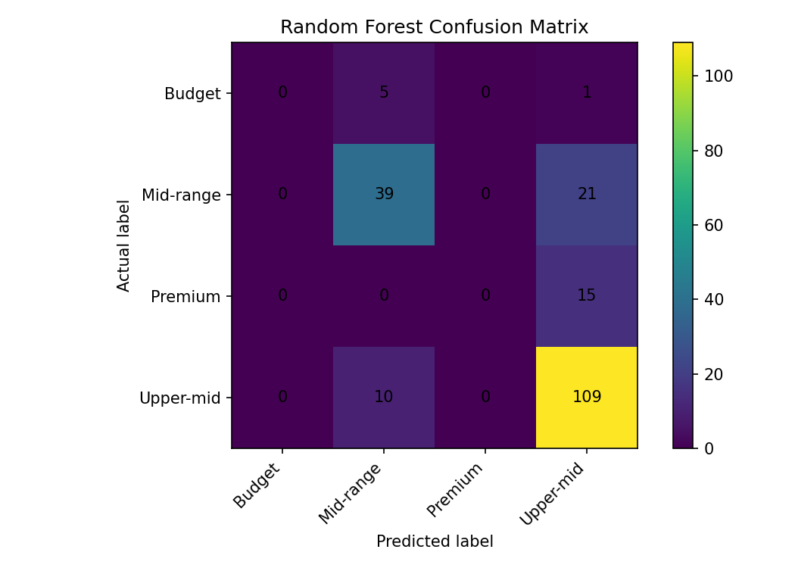
Figure 1. Random Forest confusion matrix
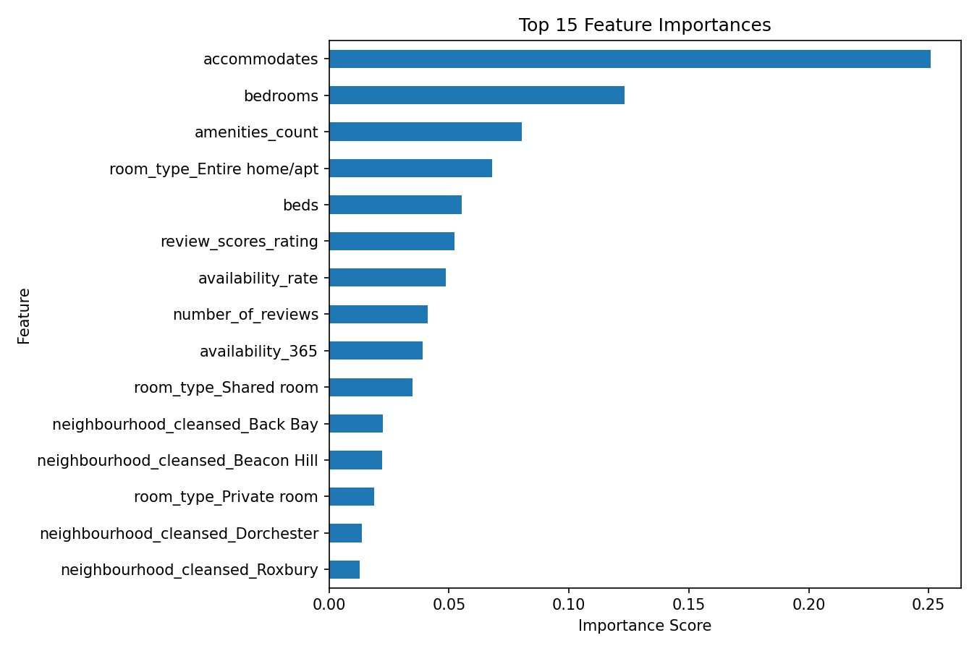
Figure 2. Top 15 feature importances from the Random Forest model

Challenges and Solutions
Challenge | Solution
It was initially unclear whether the Week 3 activity should use prediction, clustering, or classification techniques. | After evaluating the target variable, classification was identified as the most suitable approach since price_band represents categorical data.
The dataset consisted of a mix of numerical and categorical attributes, making preprocessing more complex. | A preprocessing pipeline was implemented to manage missing data and convert categorical variables into encoded values before model training.
Using only a single decision tree could lead to overfitting and unstable predictions. | The Random Forest algorithm was chosen as the primary model because it combines multiple decision trees to produce more reliable and stable results.
Certain categories contained significantly fewer records than others, which may affect model performance. | Class balancing was identified as a possible improvement area, and future enhancements may involve adding more samples or applying balancing methods.
The GitHub repository and project files still need to be uploaded manually. | A temporary placeholder link was included in the report and can later be replaced once the repository upload is completed.
Conclusion
The objectives for Week 3 were successfully accomplished by selecting Classification as the appropriate algorithm type, creating a baseline model using the Decision Tree Classifier, and developing a Random Forest Classifier model optimized through the GridSearchCV method. This activity allowed us to connect the cleaned dataset from Week 2 with an actual machine learning workflow. The completed notebook, Python script, README file, model results, and visualization outputs are now prepared for upload to the GitHub repository.

