INDIVIDUAL PROGRESS REPORT - Week 3
Group Topic | Boardie Analytics: A Big Data Approach to Student Boarding House Discovery and Geofenced Presence Pattern Analysis
Student Name | Francis Anthony S. Garbosa
Lab No. | Week 3
Git Repo / Colab Link | https://github.com/carlpoot/week-3-biggs-data

Objectives
This week's primary goal is to advance the Boardie Analytics project by identifying, programming, and optimizing a suitable machine learning algorithm. Since our dataset involves categorical price bands, we are employing a classification model to categorize listings into budget, mid-range, upper-mid, or premium tiers.

Project Progress
Based on the overarching goals, the workflow was structured into three main phases:
- Choosing an algorithm to use (Prediction, Clustering, or Classification): Analyzed the dataset and determined that Classification is the best fit, as our target variable (price_band) requires categorical labeling rather than continuous prediction.
- Implementation of Algorithm in code: Built a preprocessing pipeline to handle missing values and applied one-hot encoding. Divided the data into 80% training and 20% testing sets. Developed a Decision Tree Classifier as a baseline, then deployed a Random Forest Classifier as the primary model to mitigate overfitting and improve stability.
- Fine-Tuning the Algorithm: Utilized GridSearchCV to optimize the Random Forest hyperparameters (tuning the number of estimators, maximum depth, and minimum samples per leaf). Produced evaluation outputs, including feature importance charts and a confusion matrix.

Tasks to be Completed
- Update the repository with the final Week 2 dataset if the group opts for the larger version.
- Re-validate all file paths in the notebook post-GitHub upload.
- Compare the Random Forest performance with Gradient Boosted Trees or Logistic Regression if further validation is needed.
- Address class imbalances (specifically for Budget and Premium classes) in future iterations.
- Create a brief presentation justifying the choice of Random Forest classification for this project.

Model Summary
Item | Description
Algorithm Type | Classification
Target Variable | price_band
Predicted Classes | Budget, Mid-range, Upper-mid, Premium
Baseline Model | Decision Tree Classifier
Main Model | Random Forest Classifier
Fine-Tuning Method | GridSearchCV
Train-Test Split | 80% training, 20% testing
Evaluation Metrics | Accuracy, precision, recall, F1-score, confusion matrix

Results and Analysis
The classification approach successfully segmented the Boardie Analytics data into pricing tiers. Our initial Decision Tree baseline achieved an accuracy of 67.0%. By implementing the Random Forest Classifier, we improved the accuracy to 74.0% due to the model's collective decision-making ensemble process. GridSearchCV identified the optimal parameters as: max_depth = 6, min_samples_leaf = 1, and n_estimators = 50.
The confusion matrix illustrates the distribution of predictions, showing higher accuracy for Mid-range and Upper-mid categories due to their larger representation in the dataset.
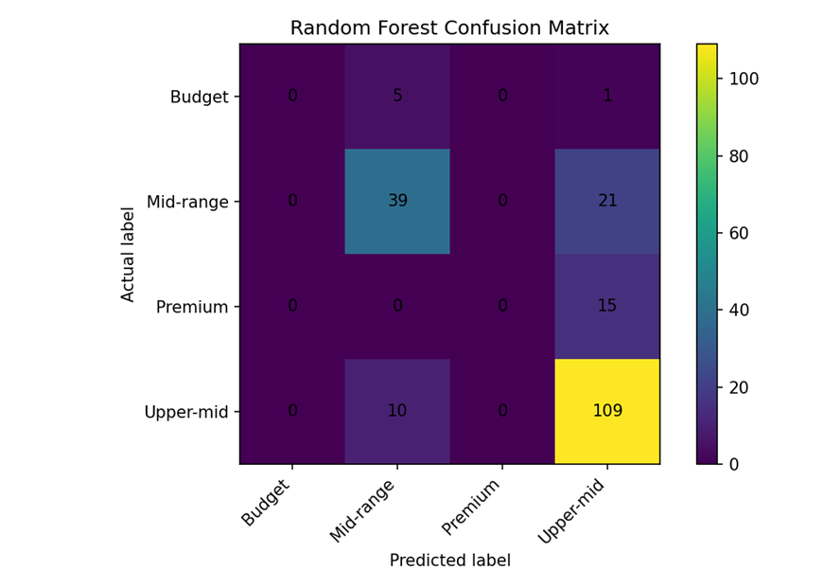

Figure 1: Random Forest confusion matrix
Additionally, the feature importance graph highlights which variables had the most significant impact on the Random Forest predictions.

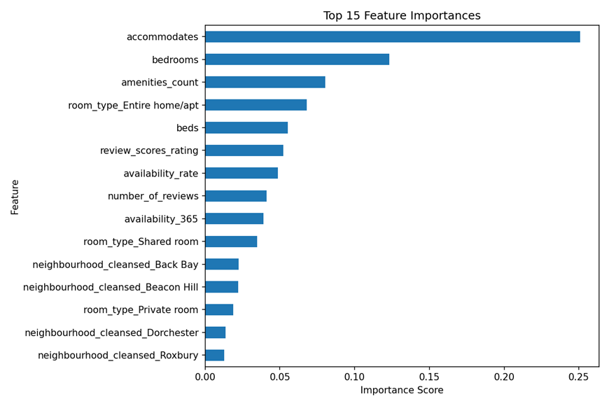

Figure 2: Top 15 feature importances

Challenges and Solutions
Challenge | Solution
Selecting between prediction, clustering, or classification. | Chose classification due to the categorical nature of the price_band target.
Handling mixed data types (numerical and categorical). | Implemented a preprocessing pipeline with median/mode imputation and one-hot encoding.
Risk of overfitting with a single decision tree. | Adopted a Random Forest model to enhance stability and generalizability.
Imbalanced category records (Budget vs Mid-range). | Documented the imbalance for future correction via resampling or additional data gathering.
Manual GitHub repository setup pending. | Used a placeholder link in the report pending final code upload.

Conclusion
We successfully met Week 3's milestones by framing the problem as a Classification task, establishing a Decision Tree baseline, and ultimately optimizing a Random Forest model using GridSearchCV. This phase effectively transitioned our cleaned Week 2 dataset into a functional machine learning pipeline. All associated files, including notebooks, Python scripts, and documentation, are finalized and ready for GitHub deployment.

