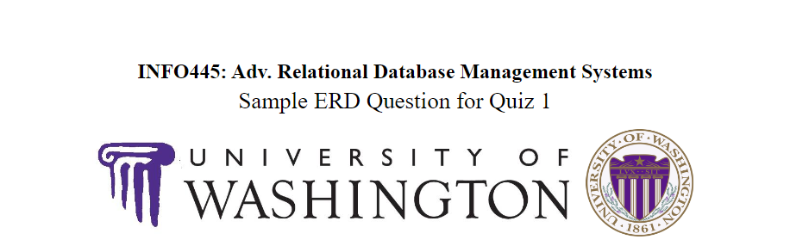

The Main Office handles administrative tasks for the School of Music including handling room usage and security. They are looking for a new system to replace a paper file system for their key and equipment rentals and purchases. The following have been determined through primary interviews with the staff members.

1. Practice room keys cost $10 to purchase. The locks are switched each year and new keys must be purchased by all students each year. (FacStaff receive for free.)
2. Room keys (Medeco system, mainly) have a varying deposit system depending on the person’s standing with the school of music. (detailed below.)
3. Most key rentals must be validated by a relevant FacStaff.
4. Equipment for projection and recording can be rented for free, due back within a few business days.
5. Medeco keys are serialized, but piano keys and mailbox keys (common checkouts) are not currently.
6. A TA who needs a key for personal use pays the undergraduate rate, not the TA rate.
7. We need ID’s from students, but take other forms of ID from non-students.

The main office has had multiple office break-ins in recent months and requires a fast way to determine who has access to rooms. They require serialized look ups of who a piece of equipment is checked out to. The main goal of the system is to rein in rentals, and better handle key reposition duties.

|  |  |  |  |  |  |  |  |
| --- | --- | --- | --- | --- | --- | --- | --- |
| Sample users | Practice room | 1st Medeco key | 2nd Medeco key | 3rd Medeco key | Nth Medeco key | Mailbox key | Piano key |
| Undergraduate | 10 | 50 | 20 | 20 | 20 | N/A | 0 |
| TA | 10 | 25 | 10 | 5 | 0 | 0 | 0 |
| Faculty | 0 | 0 | 0 | 0 | 0 | 0 | 0 |
| Staff | 10 | 0 | 0 | 0 | 0 | 0 | 0 |

There are additional steps that may be taken in this case study that are not as good for quiz material.

* We are cash only. After cash is given, it is collected and cash from each person is assigned to a cash transmittal, which is a bundle that becomes a back deposit. We are required to track the transmittal numbers associated with the money from a rental.
* We return deposits to people based on how many keys they still have, not on how much they paid for a key. For example: A person rents key A for 50. They then rent key B for 20. Then, they return key A and receive 20 dollars back from their deposit. We require the system to report how much of a deposit the user should receive from this key return. These reimbursements are not tracked in the transmittal list currently, but that might be a good way to look towards tracking them.