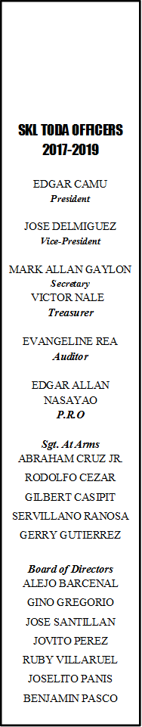

SKL TODA OFFICERS

2021-2023

EDGAR CAMU

***President***

JOSE DELMIGUEZ

***Vice-President***

MARK ALLAN GAYLON

***Secretary***

VICTOR NALE

***Treasurer***

EVANGELINE REA

***Auditor***

EDGAR ALLAN NASAYAO

***P.R.O***

***Sgt. At Arms***

ABRAHAM CRUZ JR.

RODOLFO CEZAR

GILBERT CASIPIT

SERVILLANO RANOSA

GERRY GUTIERREZ

***Board of Directors***

JOSELITO PANIS

ALEJO BARCENAL

GINO GREGORIO

JOSE SANTILLAN

JOVITO PEREZ

RUBY VILLARUEL

BENJAMIN PASCO

SKL TODA INC.

SitioKubuhanLanggam&Rustan St. Joseph 9&10 Toda Inc.

**SEC Reg. No.: CN200809756**

**APPLICATION FORM PARA SA DRIVER**

Pangalan: _____________________________________________Kasarian:_______

Tirahan: ___________________________________________________Edad:_____

Contact No.:________________ Precint No.:________Kapanganakan:___________

Driver’s License No.:_____________________________ Expiration Date:_________

Pangalan ng Operator: _____________________________ Body No. ng unit:______

Uri ng motor: ____________________ Franchise No.:________________________

Coding ng Motor:_______________________ Year Model ng Motor:____________

Ang nasabing mga impormasyon ay wasto at totoo

Lagda ng Driver Lagda ng Operator

Kasunduan ng magkabilang panig (Gumamit ng ekstrang papel kung kinakailangan)

Boundary

Oras ng Pagbiyahe

Oras ng garahe

Karagdagang oras ng pagbiyahe

Coding

Incentive ng Driver

Iba pang mga service

Kalinisan ng Tricycle

Maintenance ng Tricycle

Iba pang mga Kasunduan

Ang magkabilang panig ay sumasang-ayon sa mga kasunduan.

Lagda ng Driver Lagda ng Operator

Inaprubahan ni: _________________

**Presidente**