002133899

**Program Structures & Algorithms**

**Fall 2021**

**Assignment No. N3**

* **Task**

|  |  |  |
| --- | --- | --- |
| Number of Nodes | Number of pairs | estimated |
| 5 | 8 | 4 |
| 10 | 17 | 11 |
| 20 | 34 | 30 |
| 40 | 75 | 73 |
| 80 | 194 | 175 |
| 160 | 450 | 406 |
| 320 | 1023 | 922 |
| 640 | 2260 | 2067 |
| 1280 | 5207 | 4578 |
| 2560 | 11186 | 10045 |
| 5120 | 21355 | 21864 |
| 10240 | 49847 | 47278 |
| 20480 | 107574 | 101654 |
| 40960 | 230107 | 217504 |
| 81920 | 480067 | 463400 |

* **Relationship Conclusion:**

**Total pairs = sites * ln(sites)/2**

* **Evidence to support the conclusion:**

First, I calculated the ratio of the pair numbers of different sites and find that the ratio is continuously rising so I estimated that the growth is not linear. After I calculated the relationship between sites and pair numbers I found that the ratio is rising slowly from 1.6 to 5.86. So I guess that the relationship must contain a log method. After having tired different sets, I find n*ln(n)/2 will fit the situation of large sites numbers, So that’s how I came out my result.

1. **Output (Snapshot of Code output in the terminal)**

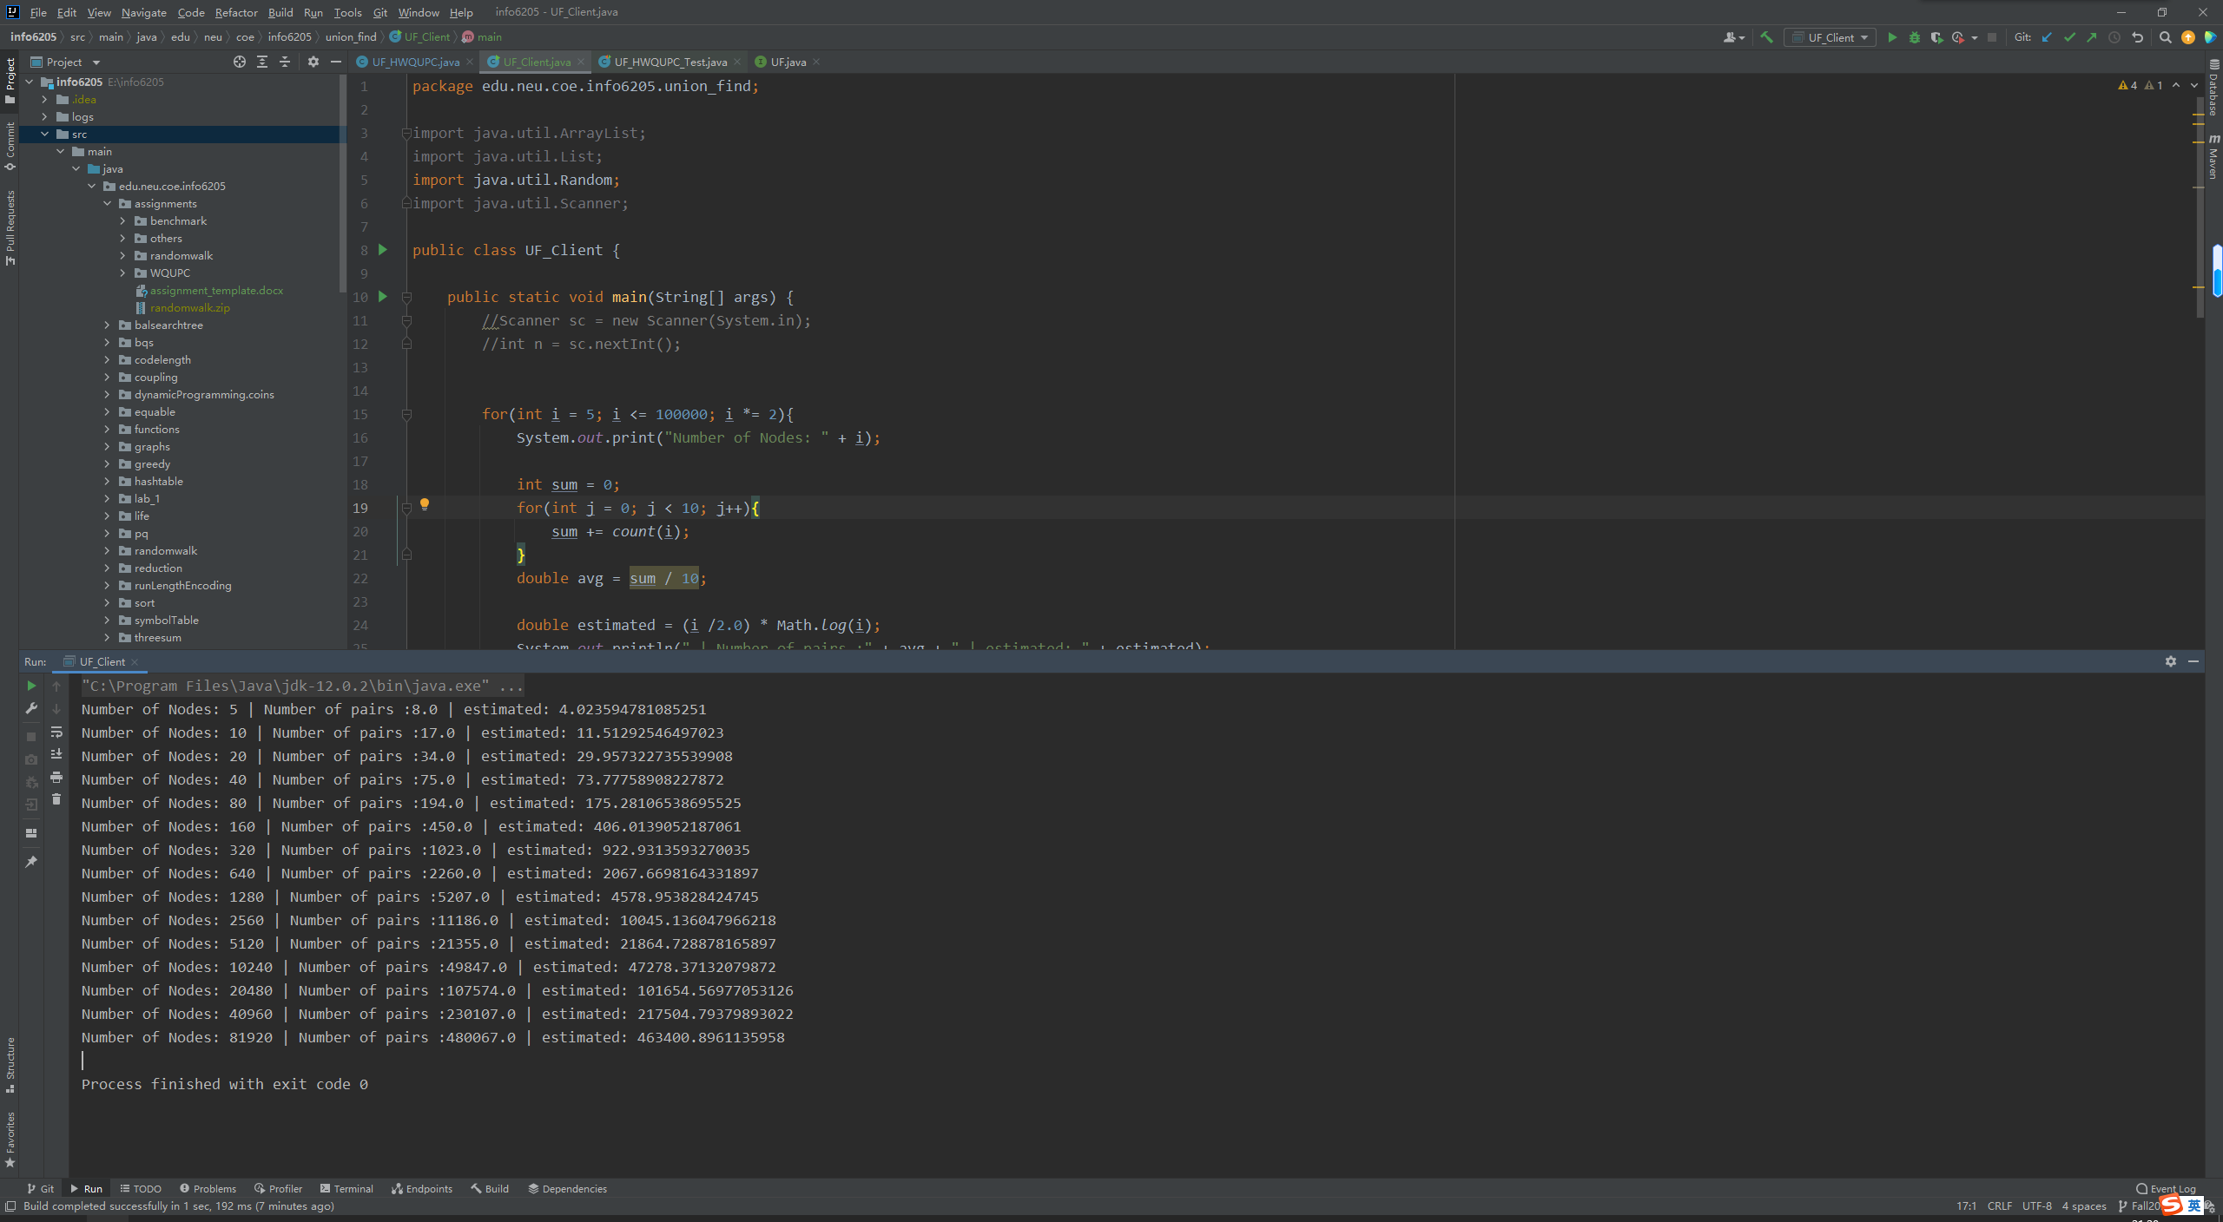

1. **Graphical Representation(Observations from experiments should be tabulated and analyzed by plotting graphs(usually in excel) to arrive on the relationship conclusion)**

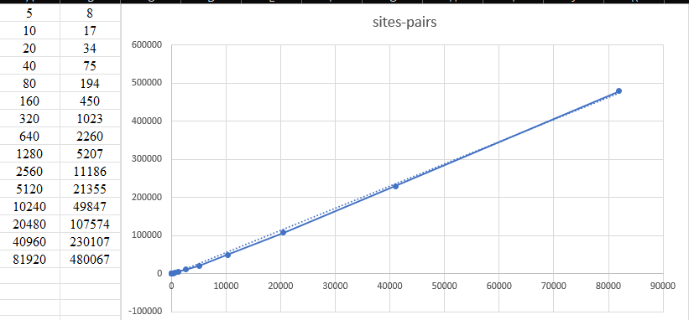

* **Unit tests result:(Snapshot of successful unit test run)**

