002133899

**Program Structures & Algorithms**

**Fall 2021**

**Assignment No. 2**

**Random order**

|  |  |  |  |
| --- | --- | --- | --- |
| **Array length** | **Run time** | **Mean lap time** | **ratio** |
| **400** | **10+100** | **0.58** |  |
| **800** | **10+100** | **1.23** | **2.12** |
| **1600** | **10+100** | **3.67** | **2.98** |
| **3200** | **10+100** | **13.77** | **3.75** |
| **6400** | **10+100** | **53.22** | **3.86** |
| **12800** | **10+100** | **214.59** | **4.03** |

**Relationship Conclusion: O(n) ≈ n²**

**Ordered order**

|  |  |  |  |
| --- | --- | --- | --- |
| **Array length** | **Run time** | **Mean lap time** | **ratio** |
| **400** | **10+100** | **0.63** |  |
| **800** | **10+100** | **0.32** | **0.50** |
| **1600** | **10+100** | **0.35** | **1.09** |
| **3200** | **10+100** | **0.3** | **0.86** |
| **6400** | **10+100** | **0.35** | **1.17** |
| **12800** | **10+100** | **0.42** | **1.2** |

**Relationship Conclusion: O(n) ≈ n**

**Partially ordered order**

|  |  |  |  |
| --- | --- | --- | --- |
| **Array length** | **Run time** | **Mean lap time** | **ratio** |
| **400** | **10+100** | **0.69** |  |
| **800** | **10+100** | **0.96** | **1.39** |
| **1600** | **10+100** | **2.78** | **2.89** |
| **3200** | **10+100** | **10.41** | **3.74** |
| **6400** | **10+100** | **40.01** | **3.84** |
| **12800** | **10+100** | **161.17** | **4.02** |

**Relationship Conclusion: O(n) ≈ n²**

**Reverse order**

|  |  |  |  |
| --- | --- | --- | --- |
| **Array length** | **Run time** | **Mean lap time** | **ratio** |
| **400** | **10+100** | **0.86** |  |
| **800** | **10+100** | **2.04** | **2.37** |
| **1600** | **10+100** | **7.06** | **3.46** |
| **3200** | **10+100** | **27.13** | **3.84** |
| **6400** | **10+100** | **107.4** | **3.95** |
| **12800** | **10+100** | **427.66** | **3.98** |

**Relationship Conclusion: O(n) ≈ n²**

* **Evidence to support the conclusion:**

1. **Output**

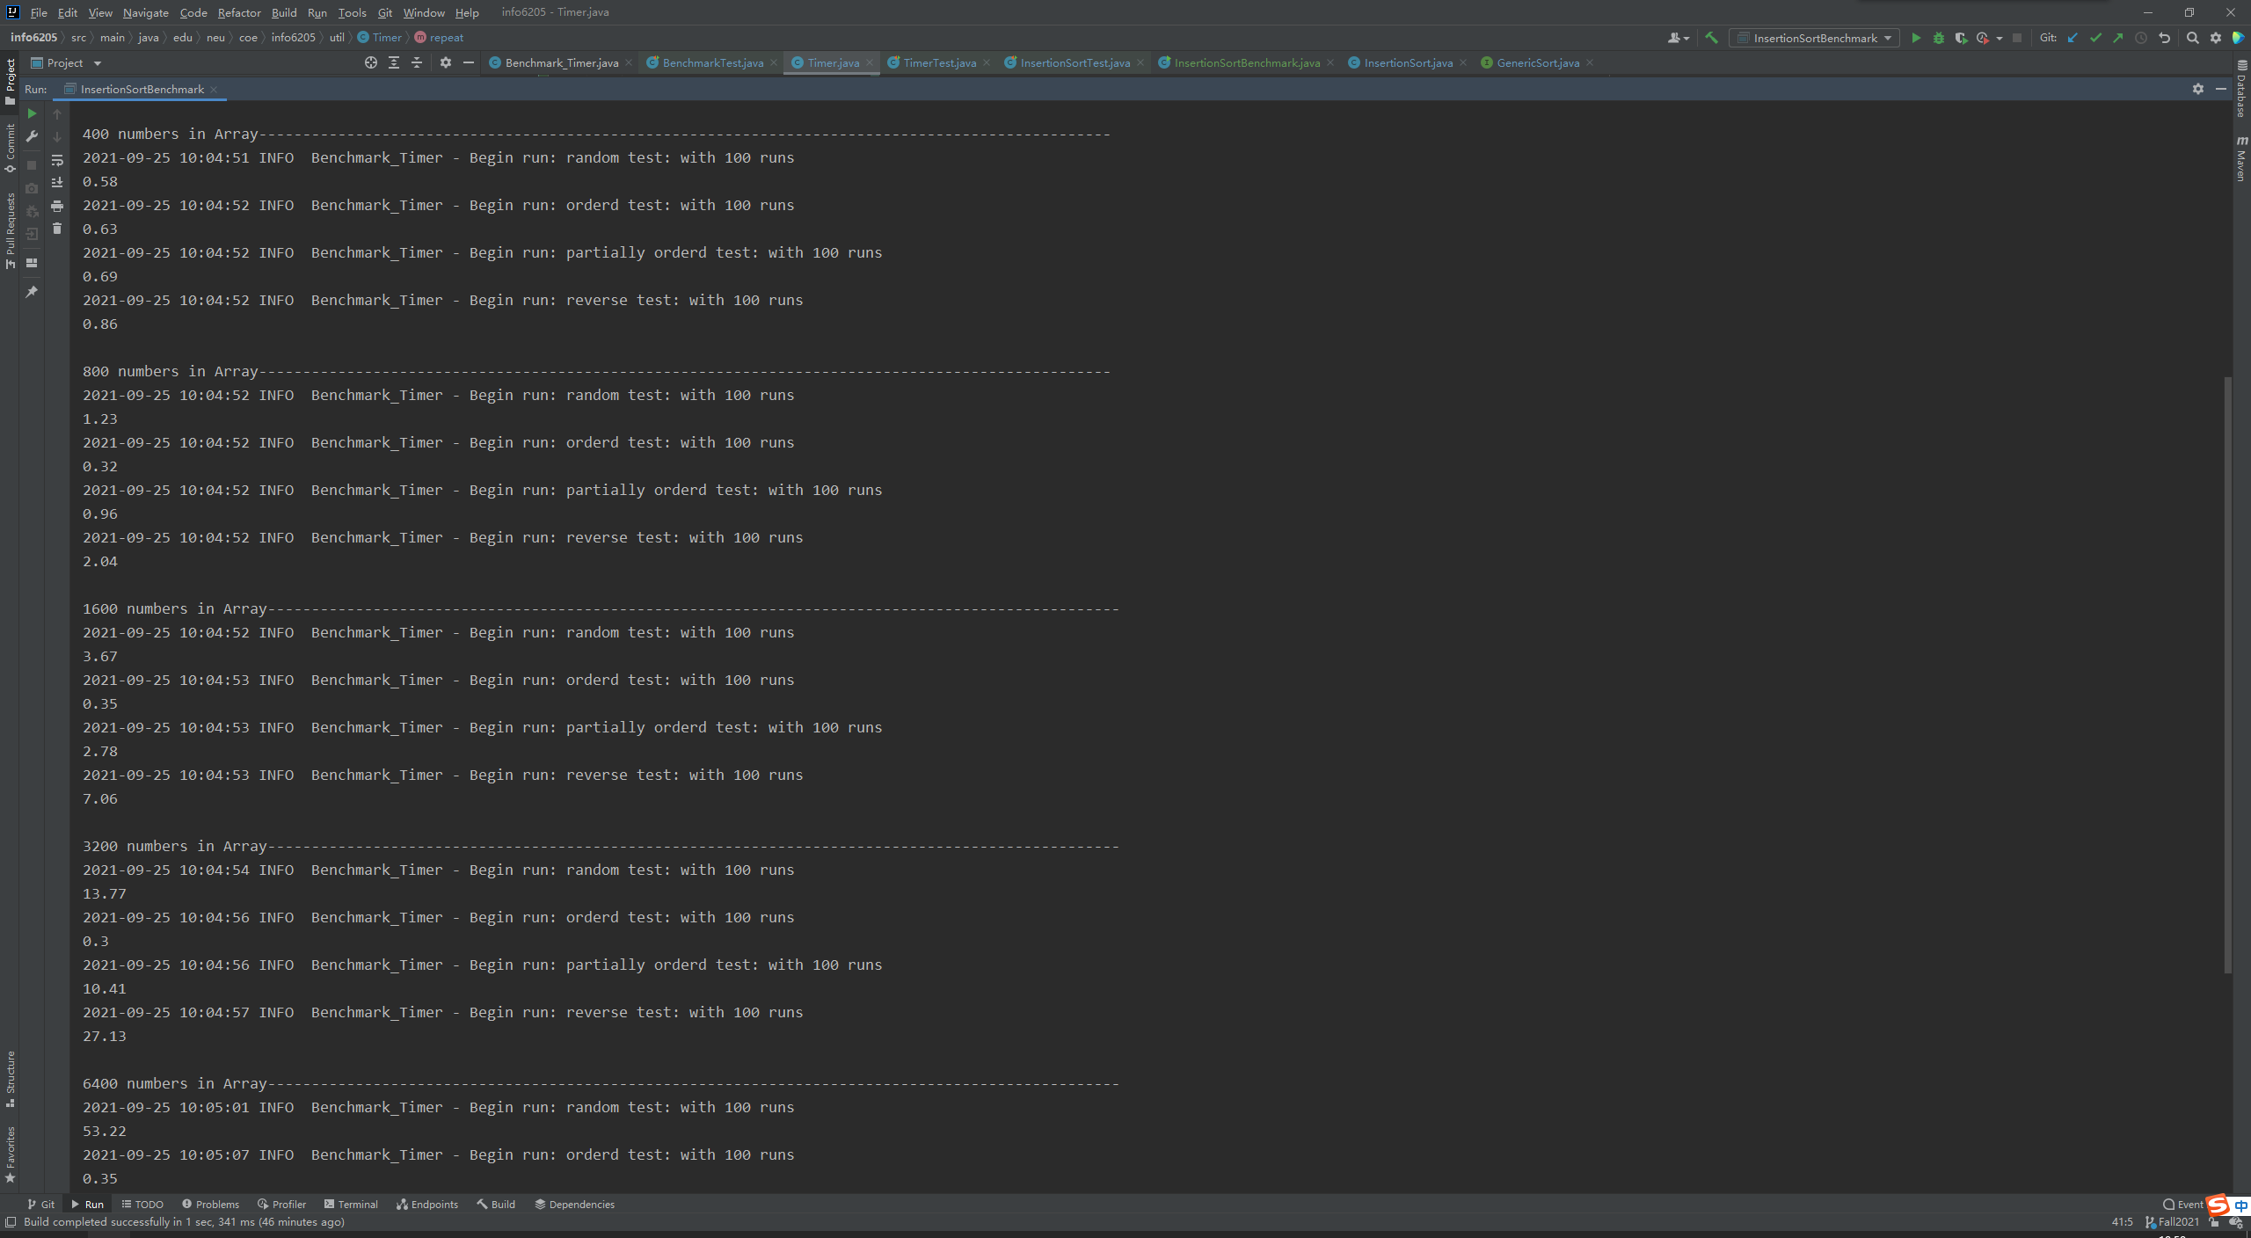

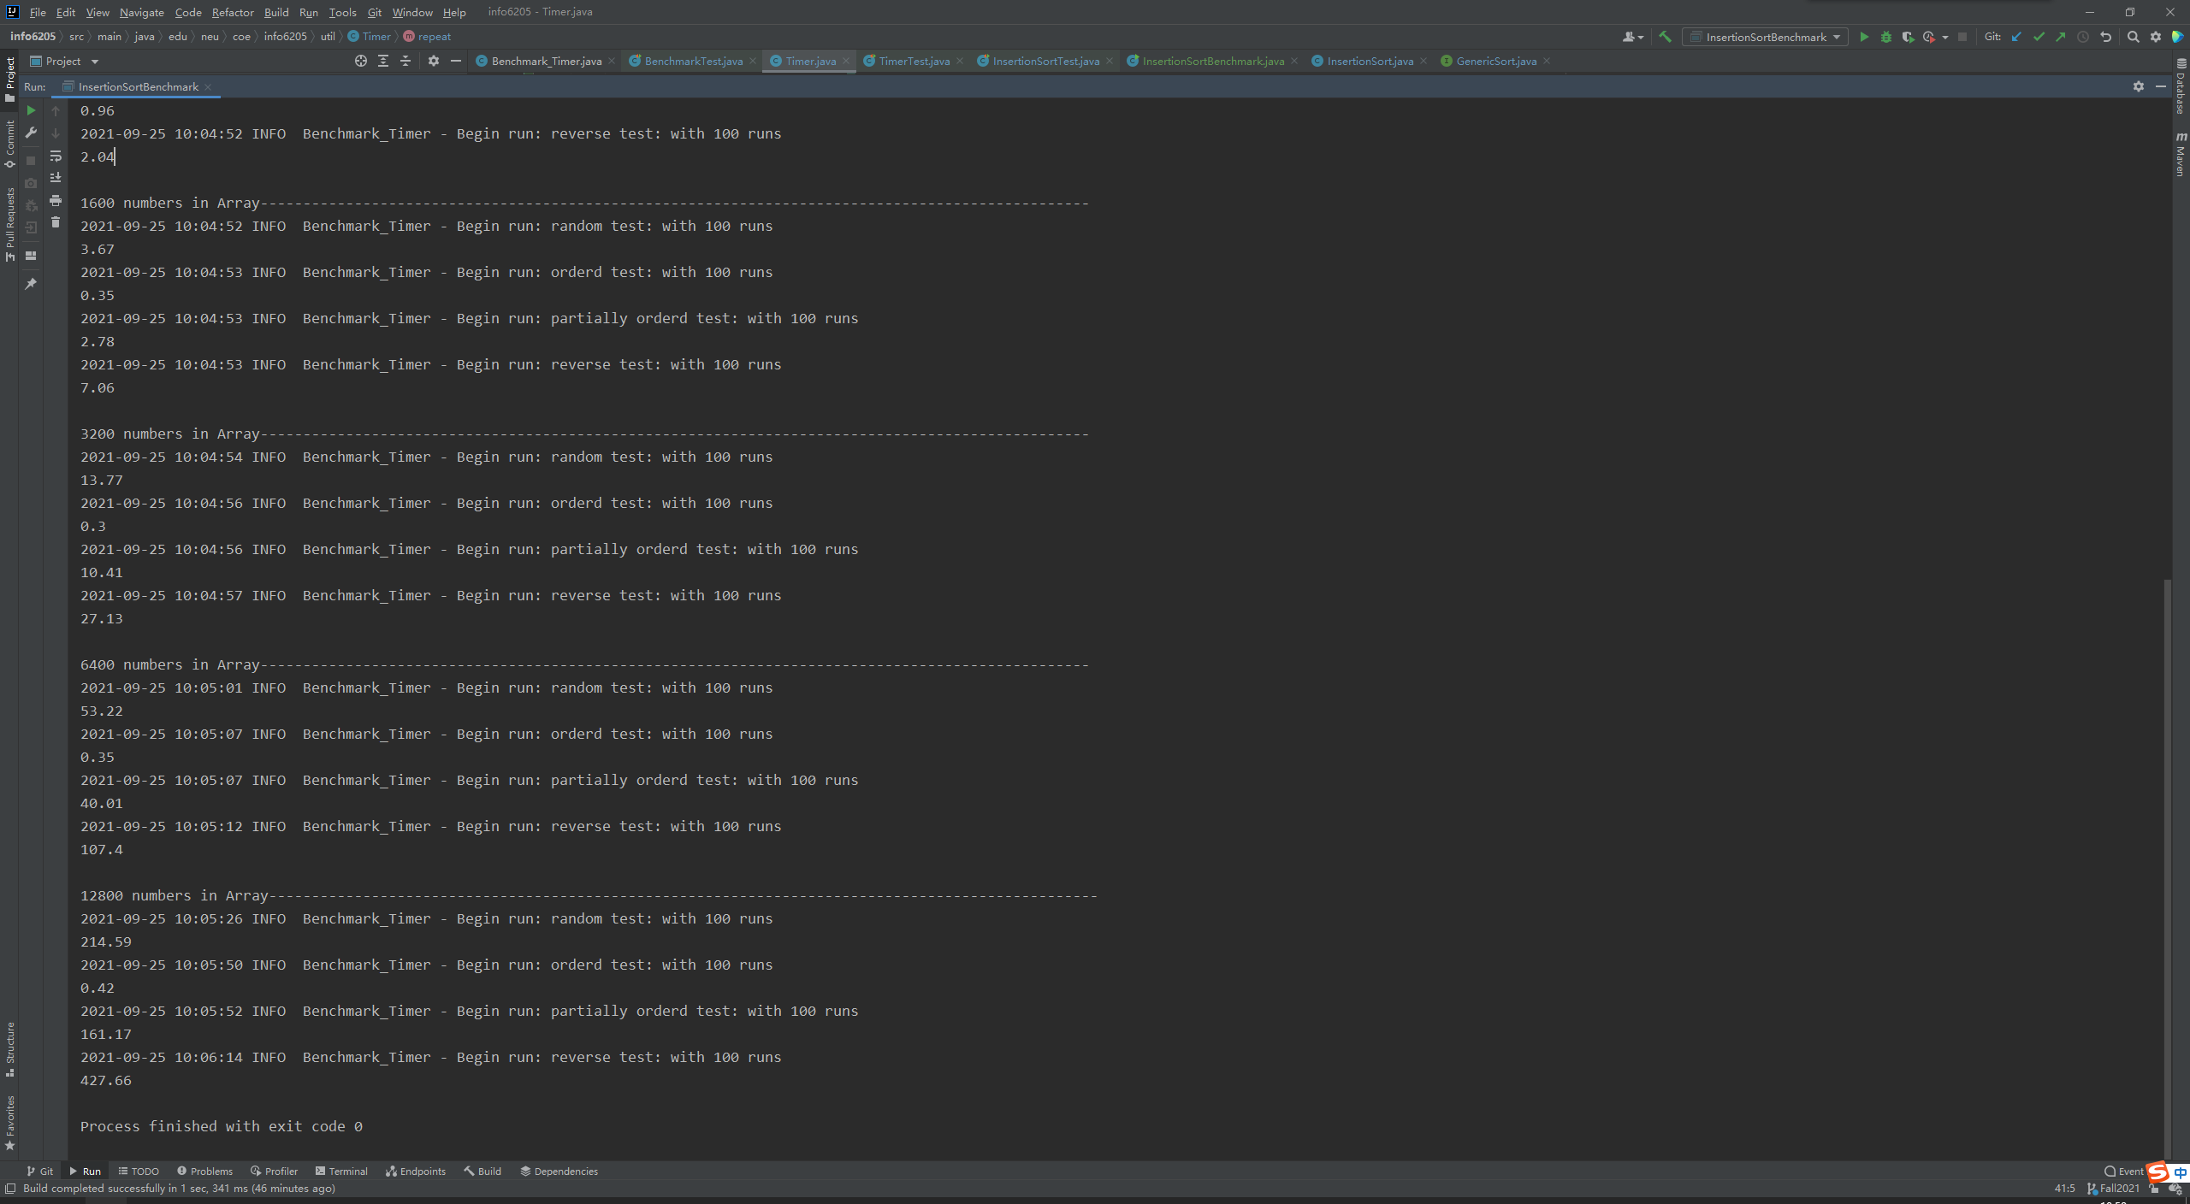

1. **Graphical Representation**

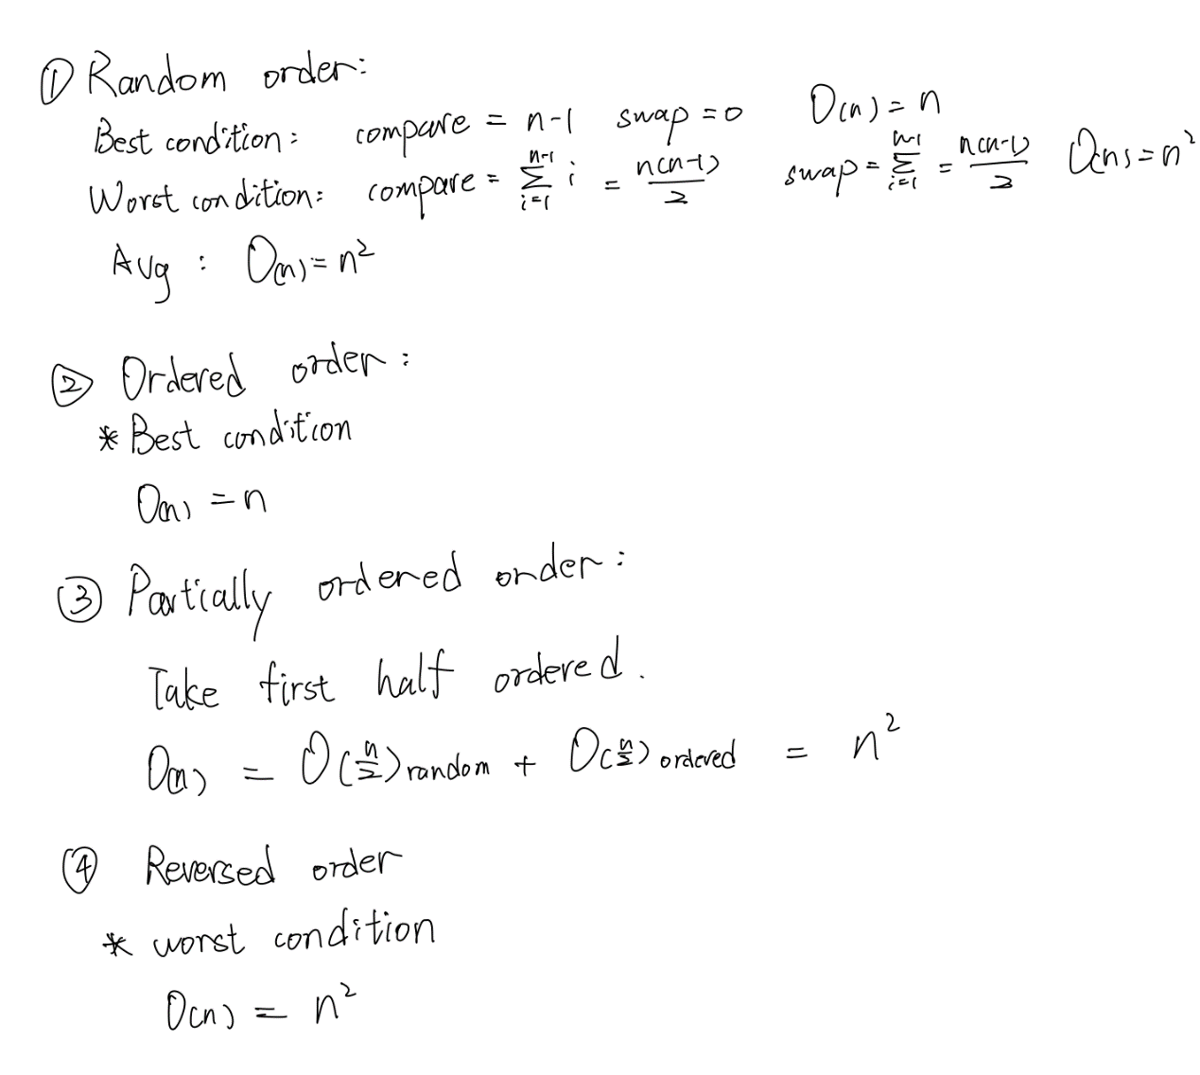

**Unit tests result:**