短信云控制台

<https://console.cloud.tencent.com/cam/capi>

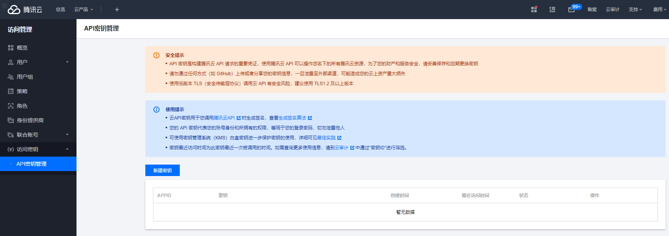

<https://console.cloud.tencent.com/smsv2/csms-sign/create>

<https://console.cloud.tencent.com/smsv2/app-manage/detail/1400525419>

短信模板

https://console.cloud.tencent.com/smsv2/csms-template