Problem 1

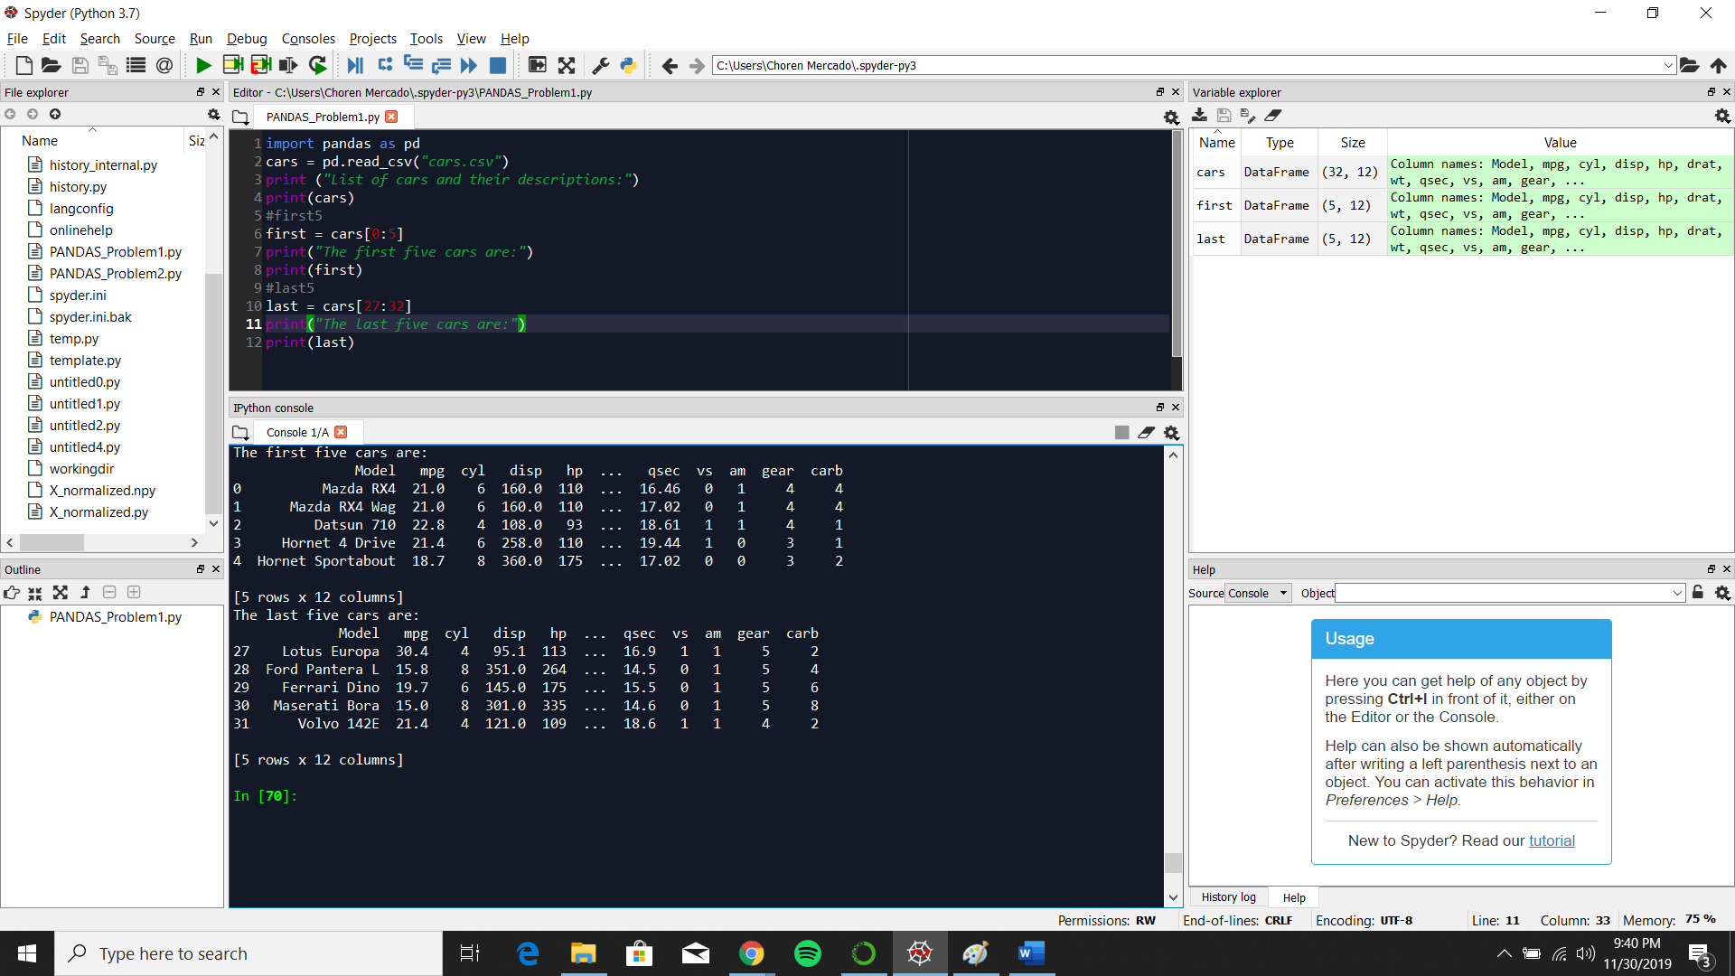b.)

The first five cars are:

Model mpg cyl disp hp ... qsec vs am gear carb

0 Mazda RX4 21.0 6 160.0 110 ... 16.46 0 1 4 4

1 Mazda RX4 Wag 21.0 6 160.0 110 ... 17.02 0 1 4 4

2 Datsun 710 22.8 4 108.0 93 ... 18.61 1 1 4 1

3 Hornet 4 Drive 21.4 6 258.0 110 ... 19.44 1 0 3 1

4 Hornet Sportabout 18.7 8 360.0 175 ... 17.02 0 0 3 2

[5 rows x 12 columns]

The last five cars are:

Model mpg cyl disp hp ... qsec vs am gear carb

27 Lotus Europa 30.4 4 95.1 113 ... 16.9 1 1 5 2

28 Ford Pantera L 15.8 8 351.0 264 ... 14.5 0 1 5 4

29 Ferrari Dino 19.7 6 145.0 175 ... 15.5 0 1 5 6

30 Maserati Bora 15.0 8 301.0 335 ... 14.6 0 1 5 8

31 Volvo 142E 21.4 4 121.0 109 ... 18.6 1 1 4 2

[5 rows x 12 columns]

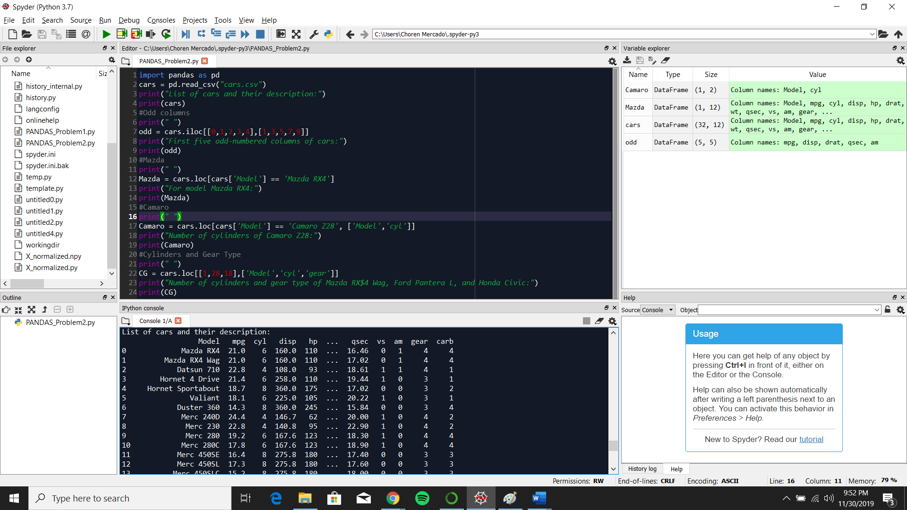Problem 2

First five odd-numbered columns of cars:

mpg disp drat qsec am

0 21.0 160.0 3.90 16.46 1

1 21.0 160.0 3.90 17.02 1

2 22.8 108.0 3.85 18.61 1

3 21.4 258.0 3.08 19.44 0

4 18.7 360.0 3.15 17.02 0

For model Mazda RX4:

Model mpg cyl disp hp drat wt qsec vs am gear carb

0 Mazda RX4 21.0 6 160.0 110 3.9 2.62 16.46 0 1 4 4

1. Answer: 8

Number of cylinders of Camaro Z28:

Model cyl

23 Camaro Z28 8

1. Answer: For Masda: 6 cylinders and 4 gear. For Ford: 8 cylinders and 5 gears. For Civic: 4 cylinders and 5 gears

Number of cylinders and gear type of Mazda RX$4 Wag, Ford Pantera L, and Honda Civic:

Model cyl gear

1 Mazda RX4 Wag 6 4

28 Ford Pantera L 8 5

18 Honda Civic 4 4