CP2406 Programming 3 Assignment 1
By: Chen Runting
Problem Specification:
The problem provided is to design and create a functional vehicle traffic simulator, which can use at least cars, motorcycles and buses. The simulator can record the countdown time of traffic lights, calculate whether it can pass the traffic lights through speed, and display the current speed and distance.
Problem Decomposition:
We need to know some information to make the simulator accurate. We will come back to analyze which aspects are necessary.
- Road:Vehicles drive on the road, so the road is an entity for us, and we should study it. For roads, we will divide them into straight roads and intersections. Each intersection is assumed to have traffic lights.
-Road ID:This ID is the information used to mark each road and facilitate road identification.
-Location ID:Used to know where the current vehicle is
-Destination ID:It is used to know the destination of the vehicle and to know where to pass during driving.
-Intersection ID:It is used to understand the traffic lights corresponding to the current intersection.
-Direction:It is convenient to better locate the vehicle on the simulator.

- Car:The vehicle ontology will also affect the value of some data. We can learn a lot of information from the vehicle.
-Speed:The vehicle speed will calculate whether the vehicle can pass the traffic lights at the corresponding intersection within the specified time
-Length:The length of the vehicle will affect the distance between the vehicle and the traffic lights. Determining the distance can make the calculation more accurate.
Locating point:Different vehicle types use different positioning points. Tires can be used to locate the distance. Four wheeled vehicles are positioned with four wheels, and motorcycles are positioned with two wheels.
-Direction of motion:The distance between the vehicle and the traffic lights can be better judged by the moving direction.

- Traffic Lights:Traffic lights mainly have two aspects: one is the different meanings corresponding to different colors, and the other is the color duration of traffic lights.
-Traffic light color:The simulator will simulate the color conversion of traffic lights, and the color will be converted for a period of time to achieve the real effect.
-Traffic light duration:The duration of traffic lights at different intersections can be different. Vehicles are controlled by the time of traffic lights.

UML Class Diagram

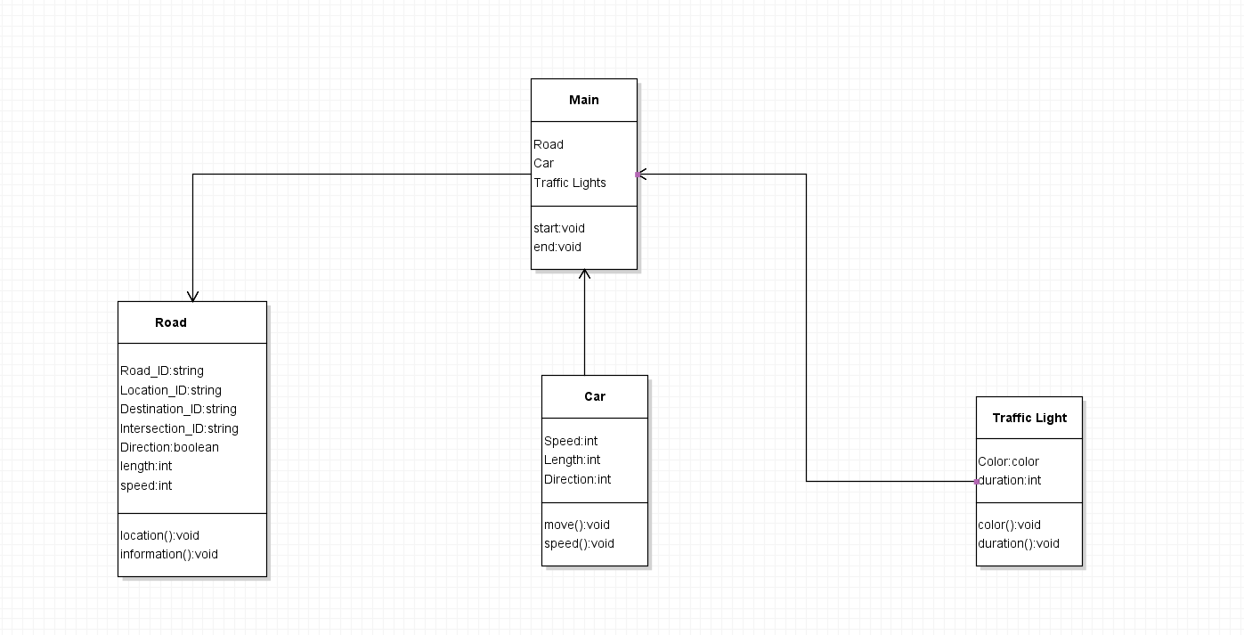
User Stories
- Person 1:
Name: | Aaron
Age: | 22
Purpose: | The user contacted our team and said he was willing to participate in our test. He will buy a standard car to participate in our test.
Priority Level: | High
Test: | The user will provide us with the model he intends to buy and some specific information about the vehicle, such as the length and speed of the vehicle.

- Person 2:
Name: | Alden
Age: | 25
Purpose: | Users have asked our team for help. He hopes to use the simulation system to know whether he will timeout when passing the traffic lights.
Priority Level: | Medium
Test: | We will ask him to use the average speed and measure the time required to pass the traffic lights in a certain distance.

- Person 3:
Name: | Humphrey
Age: | 28
Purpose: | Users immigrated from China to Singapore, but due to different countries, the driving direction of the road is also different, so they asked our team for help to quickly adapt to the driving direction of the road.
Priority Level: | Medium
Test: | The simulator will display different road directions according to different countries.

- Person 4:
Name: | Johnny
Age: | 30
Purpose: | The user is the boss of an automobile enterprise. He hopes to design a car. When the vehicle runs on a specific road, the speed of the vehicle can reach the level he wants.
Priority Level: | Medium
Test: | Our team will make this plan based on the speed he needs, and the simulator will show the speed of the vehicle.

