DEEPLRN – S40
Kaggle Competition: Mallorn Astronomical Challenge
Baradas, Ko, Lim, Salvador March 10, 2026

Preface
The model used to identify tidal disruption events (TDEs) based on real observations was not our own original creation, but it is rather developed by individuals with backgrounds in physics and computer science. The model was developed by the users maymeridian and maiadox. This document was written after obtaining new results in using the same model and is mainly an analysis on the methods used and results obtained.

Model Performance
The current cross-validated performance of the model is a mean F1 score of ~0.7359, which is stored in models/latest_score.txt. This value represents the average F1 score computed across stratified cross-validation folds during training, as implemented in src/machine/model_factory.py. Importantly, this is not a leaderboard test score but rather an internal validation metric calculated on the labeled training data. But plugging in the generated submission file into Kaggle yielded a public score of 0.7043 and private score of 0.7424, highlighting its accuracy and effectiveness of identifying TDEs.
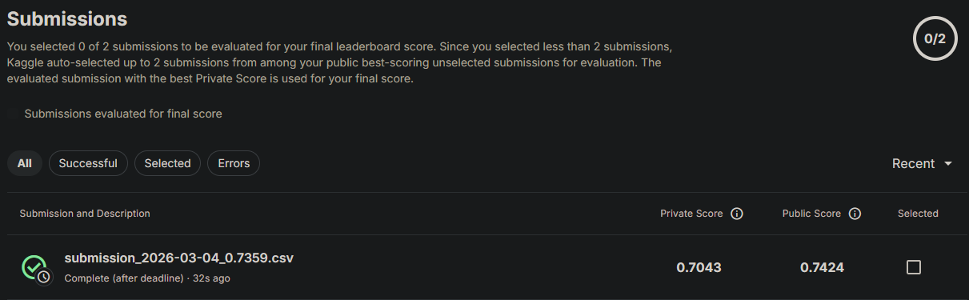
Figure 1: Final Kaggle scores using the submission spreadsheet.
The decision threshold used for converting predicted probabilities into binary classifications is approximately 0.388, stored in models/threshold.txt. Instead of using a fixed default threshold of 0.5, the training pipeline performs a per-fold threshold search to maximize the F1 score. The final inference-time threshold is computed as the average of the optimal thresholds found in each fold.
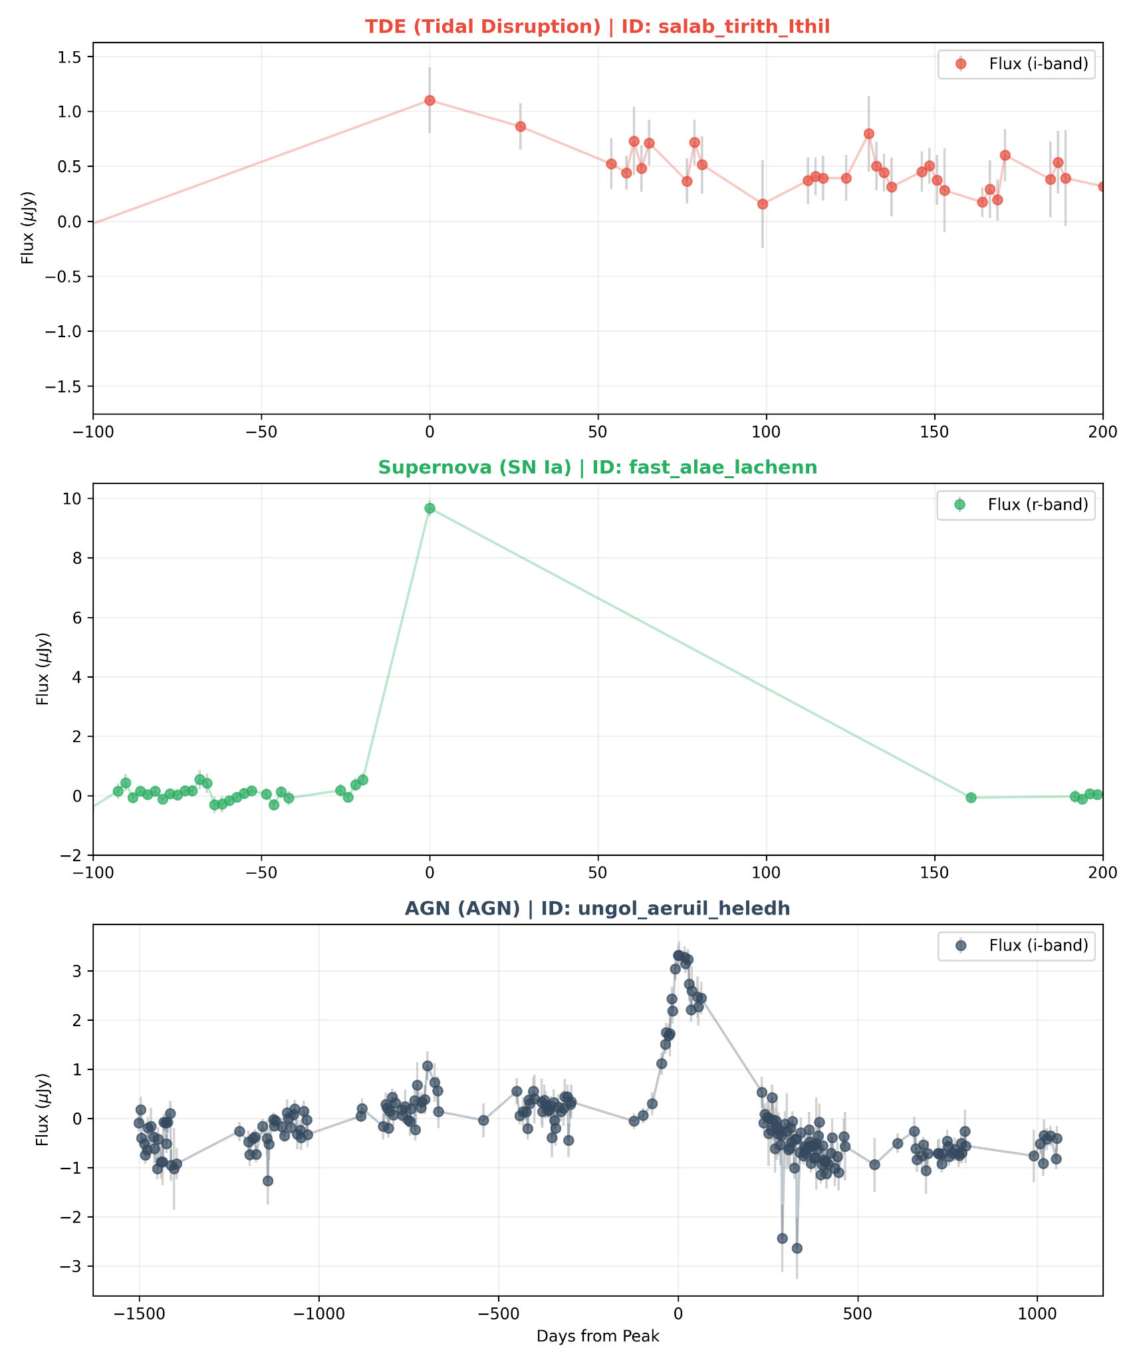
Figure 2: Representative TDE / Supernova / AGN comparison used visually to sanity-check model behavior.

Methodology
The overall modeling strategy follows a feature-based classification paradigm using a physics-guided hybrid ensemble. Instead of directly modeling raw time-series data with deep sequence architectures, the pipeline extracts domain-informed features for each object. These include Gaussian Process–based interpolations, analytic physics-motivated fits, and derived color or thermodynamic metrics. The resulting structured feature vectors are then passed into an ensemble classifier composed primarily of CatBoost models, supplemented by neural and distance-based learners.
Feature extraction begins by concatenating raw split files located in datasets/split_* into unified curve files under datasets/combined_curves/*. These curves are processed using a two-dimensional Gaussian Process interpolation procedure and analytic fits. The computed features are cached in datasets/processed_data/processed_*. The relevant logic for this stage can be found in src/io_handler/io_handler.py and src/machine/features.py. Caching ensures computational efficiency, as Gaussian Process fitting is resource-intensive.
The core model architecture is implemented through an EnsembleClassifier in src/machine/model_factory.py. The ensemble consists of multiple specialized learners. A base CatBoost model is trained on the full feature set. Two additional CatBoost models specialize on morphology-only and physics-only feature subsets, respectively. To enhance diversity and capture nonlinear manifolds that tree models might miss, the ensemble also includes a Multi-Layer Perceptron (MLP) and a K-Nearest Neighbors (KNN) classifier as support learners.
Final prediction probabilities are computed via a weighted average of all component outputs. The weighting scheme assigns 48% to the base CatBoost model, 16% each to the morphology and physics specialists, and 10% each to the MLP and KNN models. These weights were determined empirically to optimize cross-validated F1.
Training and validation follow a stratified 5-fold cross-validation procedure, incorporating dynamic class weighting to address class imbalance. For each fold, the pipeline searches over thresholds in the range 0.20 to 0.78 (step size 0.02) to maximize F1. The reported score in latest_score.txt is the mean of the best F1 scores achieved per fold. After cross-validation, the final model is retrained on the full dataset with calibrated class weights, and the average fold threshold is saved for use during inference.
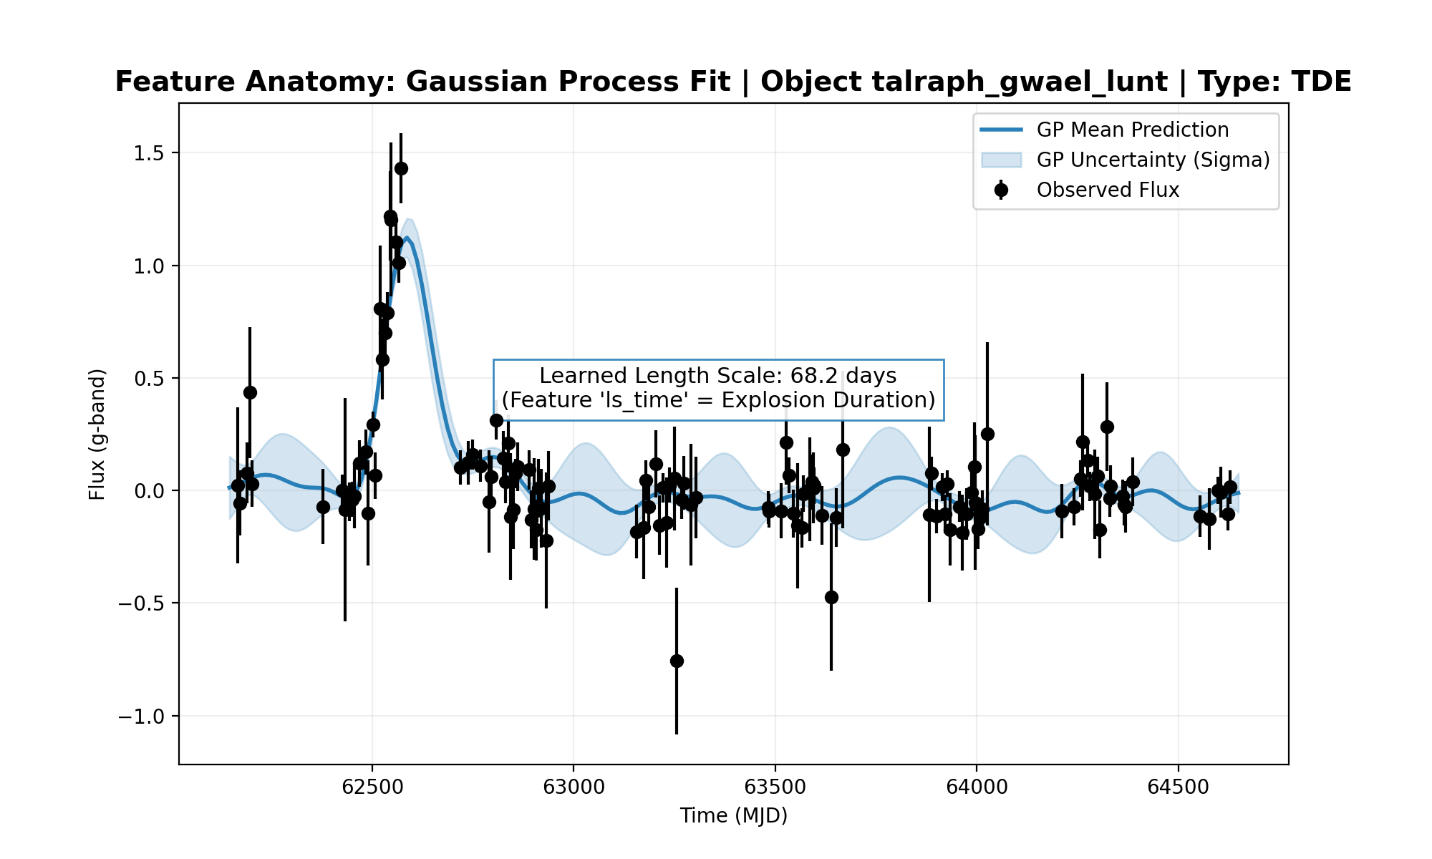
Figure 3: Gaussian Process anatomy example — shows learned length scale and GP uncertainty used during feature extraction (feature “ls_time”).
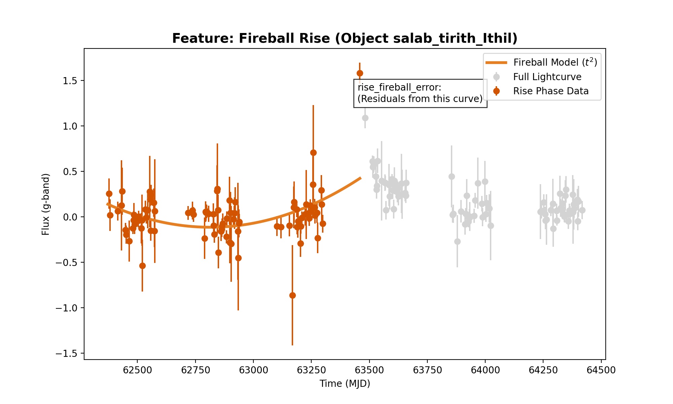
Figure 4: Fireball (t^2) rise anatomy used to compute “rise_fireball_error”.
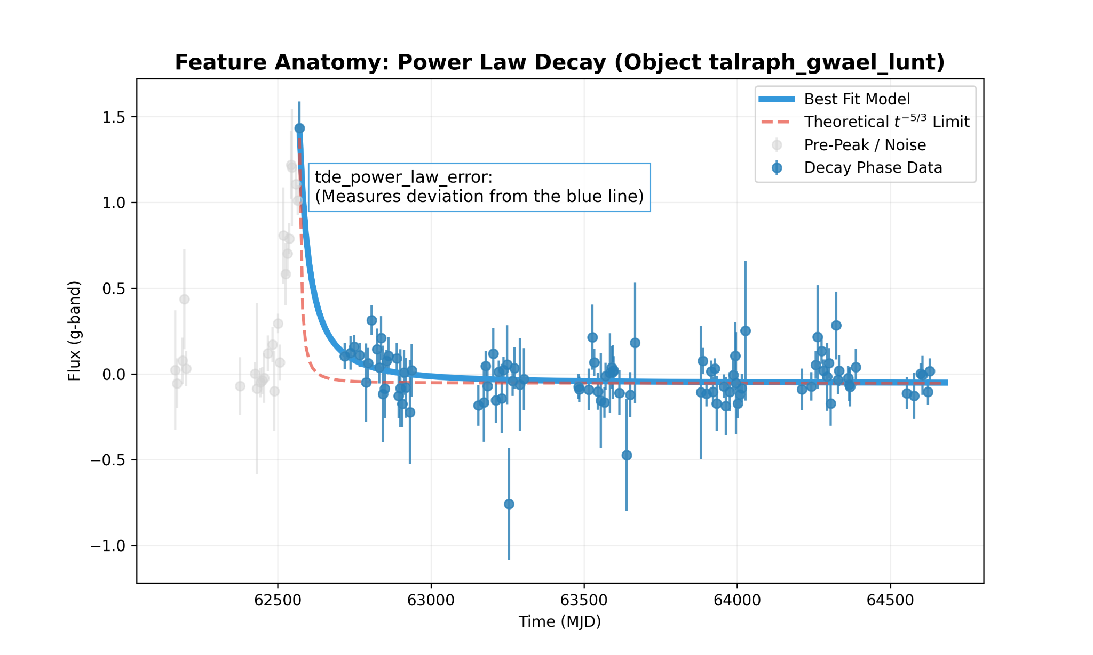
Figure 5: Power-law decay anatomy illustrating “tde_power_law_error” (fit vs theoretical t ^{-5/3}).

Ablation Studies
Threshold optimization plays a significant role in performance. If per-fold threshold tuning is removed and a fixed threshold of 0.5 is used instead, the F1 score typically declines. This degradation is expected due to class imbalance, where the positive class (e.g., TDE-like events) benefits from a tuned balance between precision and recall.
The ensemble weighting scheme (48/16/16/10/10) was also validated through ablation. Running a base-only CatBoost model often preserves strong precision but may reduce generalization, particularly for atypical positive examples. Removing the MLP and KNN support models tends to reduce recall, as these learners help capture minority-class examples that occupy specific regions of feature space. Equal-weight averaging across all components is generally less stable than the tuned weighting strategy. The final weighting search procedure is implemented in src/machine/experiments.py.
Feature subset ablations further demonstrate the value of domain knowledge. Dropping physics-derived features, such as power-law fits or template chi-square statistics, reduces performance because these encode signals closely tied to TDE physical behavior. Similarly, removing morphology features such as rise and decay times leads to measurable degradation in F1, underscoring the importance of time-structure information for classification.
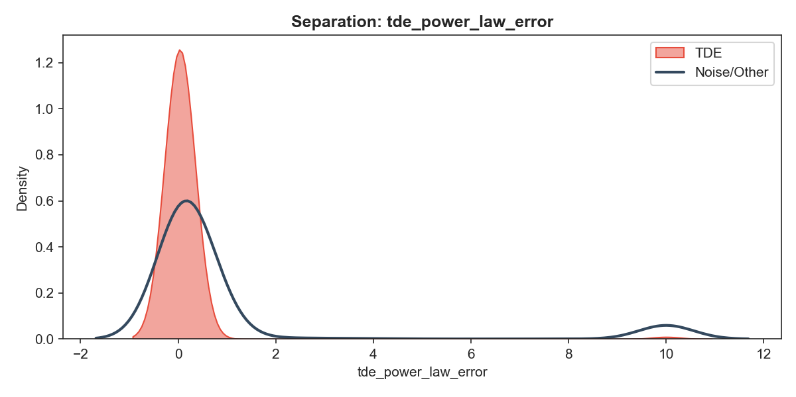
Figure 6: Example feature distribution (power-law error) showing separation between labeled TDEs and other objects; removing this feature reduces discriminative power.

Analysis and Practical Notes
The stored latest_score.txt value reflects cross-validated F1 computed on labeled training data sourced from datasets/log_data/train_log.csv. It is a within-dataset validation metric and does not represent an out-of-sample test accuracy unless evaluated against a separate labeled holdout set.
During training, correctness is determined by comparing binary predictions (probability greater than or equal to the chosen threshold) against the true labels in train_log.csv. Precision, recall, and F1 are computed for validation folds. When generating predictions for the competition test set, no ground-truth labels are available, so performance metrics cannot be computed for that dataset.
To improve reproducibility, the pipeline uses a fixed random seed defined in MODEL_CONFIG['random_seed'] within src/config.py. Hyperparameters are chosen to encourage deterministic behavior where possible. Nevertheless, minor variations may arise due to Gaussian Process numerical optimization or platform-specific floating-point behavior.
Intermediate artifacts such as datasets/combined_curves/* and datasets/processed_data/* function as runtime caches. If removed, the pipeline will rebuild them automatically, although Gaussian Process fitting can be computationally expensive. Generated plots are stored in plots/, while archival visuals reside in graphs/.

GitHub Repository
https://github.com/CarlKo-DLSU/DEEPLRN_Kaggle_MALLORN.git

