Whisper Generated Guide

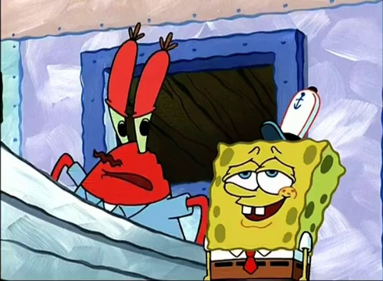

Not that sandwich boy, the curvy, koo-ney, old in the sandwich.



Hey, that's my driving teacher, Mrs. Puff!



Mrs. Puff?



Oh, she's married.

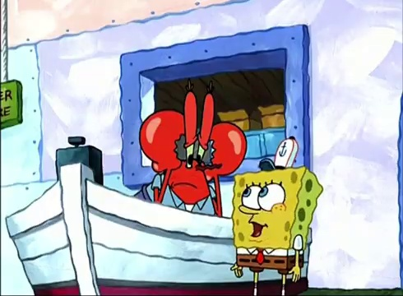

All no, Mr. Crab, she's single.

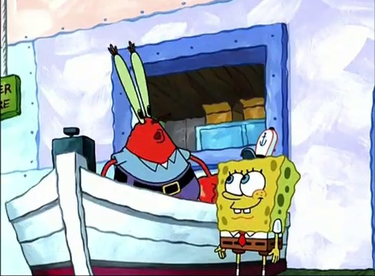

Then what happened to Mr. Puff?

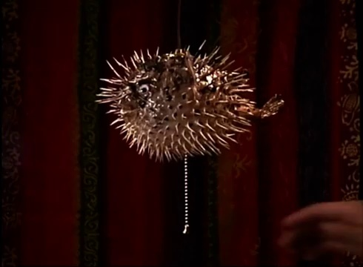

She doesn't like to talk about it.