Lab4.R

carlychang

2025-01-16

x <- 1:50  
plot(x,sin(x))

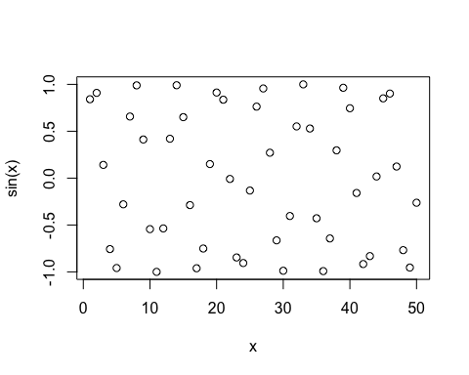

#make this nicer  
plot(x,sin(x),col="blue",type="l",lwd=3)

