## Time Allowed: 3 Hours

# Reinforcement Learning Assignment

## Module 3 & 4

**Task 1:** You are expected to make an automatic path finder program (agent) using the fastest RL algorithm in a grid world of (5 X 5) that has 4 cells i.e. [(2,2), (2,3)] and [(3,2), (3,3)] as obstacle through which the agent cannot go through. The starting point for the agent is (5,1) and the goal is (1,5). If the agent enters the cell (2,5) it is game over. For your reference partial code for this task is available in the file named “Q_Learning_Question.py”.

*Hint:* Places where you have to write the code are denoted by blanks “_________”.

**Expected Result:** The agent has to navigate to the goal while maximizing the score / rewards and print it in the console.

**Task 2:** You have been given the complete script for solving the famous cliff example where an agent has to figure out a way to go across a cliff. You have to execute the same example using SARSA algorithm. For your reference entire code for Q – Learning is available in the file named “Q_Learning_Cliff.py”.

Bonus: Can you implement SARSA that takes the same optimal route as Q – Learning?

**Expected Result:** The output of the algorithm should be solving the cliff problem using SARSA algorithm.

*Hint:* The difference between Q – Learning and SARSA has been explained using a flow chart as mentioned below.

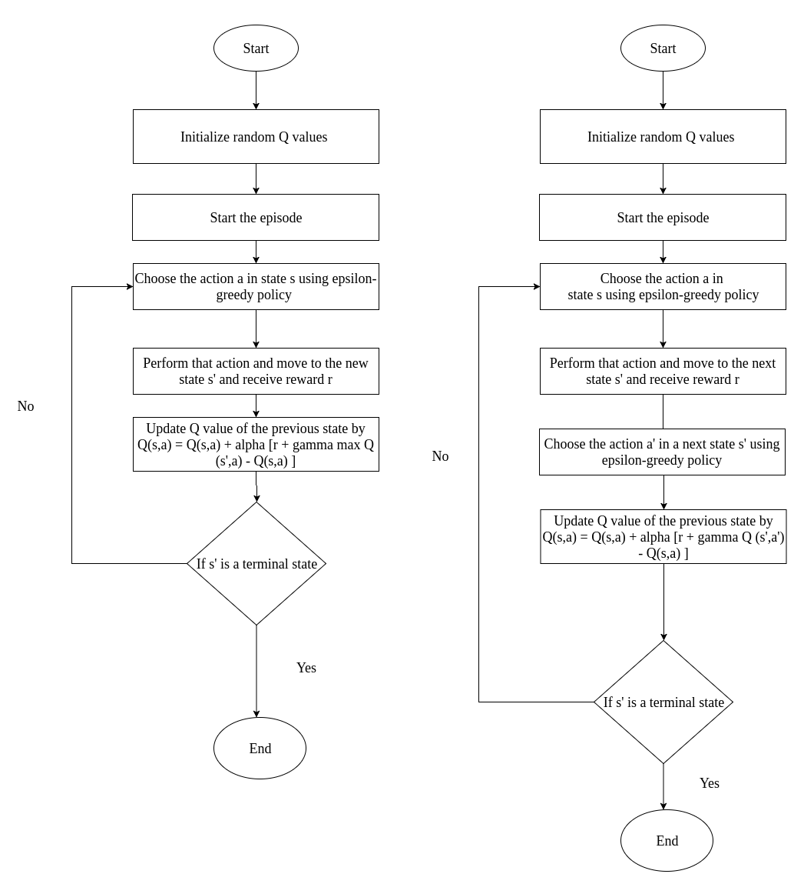

Q - Learning

SARSA