**Procedure to Recreate Data: Constant Value Rate Constants**

Procedure: The following procedure details how we attempted to recreate the raw data seen in the paper (Z. Hong, K. Lam, R. Sur, S. Wang, D. Davidson, R. Hanson, Proceedings of the Combustion Institute 34 (2013) 565-571.) In this approach we will use the exact values of the rate constants presented in the supplementary material.

1. In order to obtain the raw data presented in the paper an online graph reader was used and the following three plots were graph-read to acquire data from the images presented in the paper
   1. Fig. 1 top (H2O ppm profile)
   2. Fig. 1 bottom (OH ppm profile)

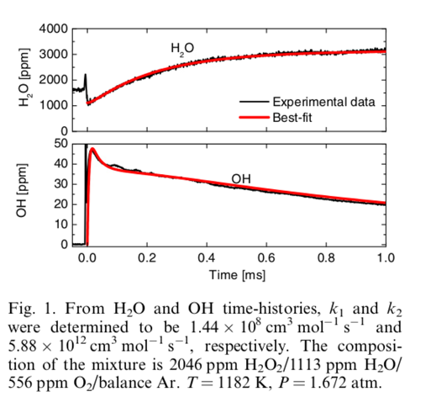

* 1. Fig. 2 Laser Absorbance

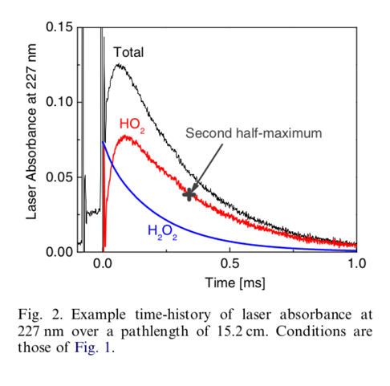

1. Downloaded the mechanism presented in the paper (Reference 14)
   1. Converted the mechanism file to a cti file in order to be able to run simulations using Cantera
2. Downloaded the supplementary material presented in the paper
   1. Located the conditions at which the raw data were determined
   2. 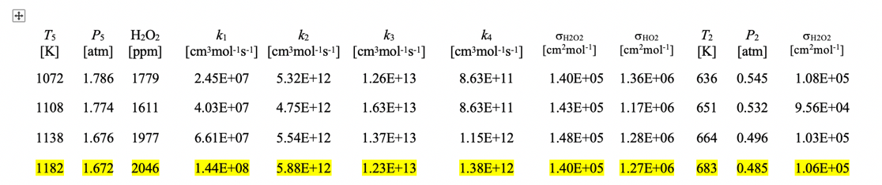
3. Updated the key reactions in the cti file to have the same rate constants as that of those presented in the supplementary material (k1,k2,k3,k4), as seen above
   1. This was done by setting the A factor for a given reaction equal to the rate constant, and setting other parameters equal to zero (For Example: A1 = k1, n1=0, Ea1=0)
   2. Screen grabs from the cti file can be seen below

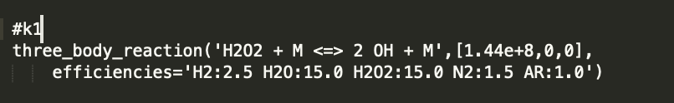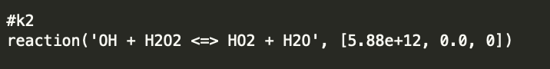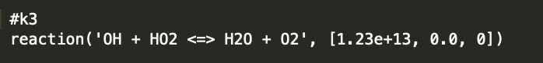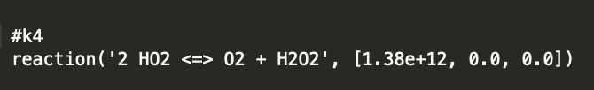

1. Updated the absorption coefficients for H2O2 and HO2 internally in our code in order to match that of those in the supplementary material ($σ_{H_{2}O_{2}}, σ_{HO_{2}}$)
2. Ran a constant pressure shock tube simulation with Cantera using the modified cti file and given pressure, temperature, and initial mixture composition presented in the paper
   1. P = 1.672 atm
   2. T = 1182 K
   3. X =2046 ppm H2O2/1113 ppm H2O/556 ppm O2/balance Ar
3. Plotted the results

Plots Of The Results Can Be Seen Below:

Results for OH Profile





Results for H2O Profile





Results For Absorbance 227 nm Profile



