**Procedure to Recreate Data: Half Temperature Dependent**

Procedure: The following procedure details how we attempted to recreate the raw data seen in the paper (Z. Hong, K. Lam, R. Sur, S. Wang, D. Davidson, R. Hanson, Proceedings of the Combustion Institute 34 (2013) 565-571.) In this approach we will use the two constant values presented in the supplementary material k3 and k4 and derive values for A1 and A2 in order to make the rate constant expression match the value presented the supplemental material for k1 and k2 at 1182 K.

1. In order to obtain the raw data presented in the paper an online graph reader was used and the following three plots were graph-read to acquire data from the images presented in the paper
   1. Fig. 1 top (H2O ppm profile)
   2. Fig. 1 bottom (OH ppm profile)

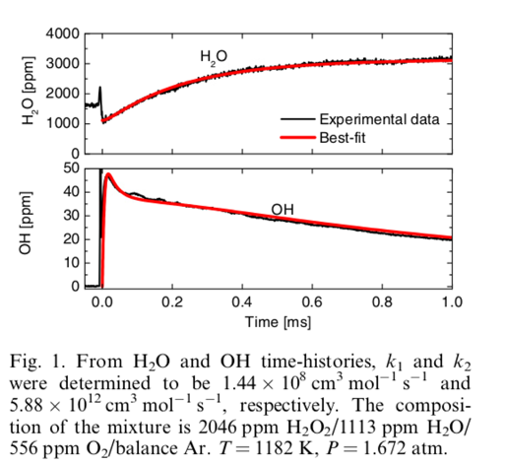

* 1. Fig. 2 Laser Absorbance

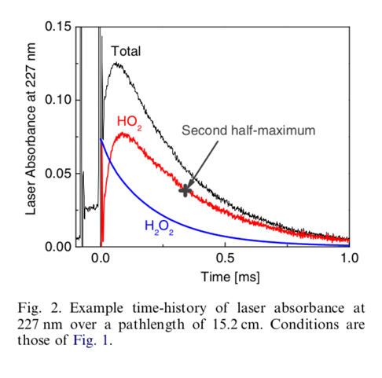

1. Downloaded the mechanism presented in the paper (Reference 14)
   1. Converted the mechanism file to a cti file in order to be able to run simulations using Cantera
2. Downloaded the supplementary material presented in the paper
   1. Located the conditions at which the raw data was determined
   2. 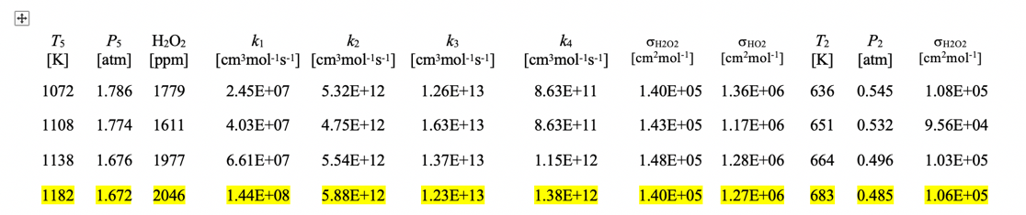
3. Updated the key reactions in the cti file
   1. Updated (k3,k4) with the values presented in the supplementary material
      1. k3 = 1.23 X 1013
      2. k4 = 1.38 X 1012
   2. Screen grabs from the cti file can be seen below

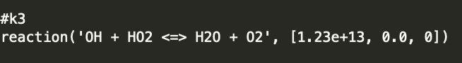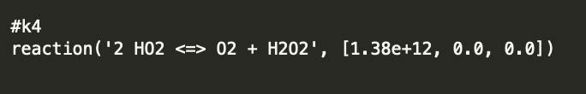

* 1. Updated (k1,k2), in order to equal the value seen above at the temperature presented in the supplementary material (1182 K)
     1. This was accomplished by starting with the original expression for a reaction in the cti file by solving for an A factor(s) for k1 and k2 that forced the rate constant expression to equal the values presented in the supplementary material at 1182 K
        1. Note For k1: because this reaction was presented as a falloff reaction in the cti file, we checked that we were safely in the low pressure limit for this experiment and then represented the reaction as a three body reaction
           1. max error of .3% given this assumption
        2. Then we were able to adjust a single A factor (as described above) until the rate constant matched k1(T,P), as presented in the supplementary material at 1182 K
     2. Screen grabs from the cti file can be seen below

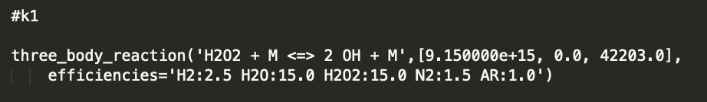

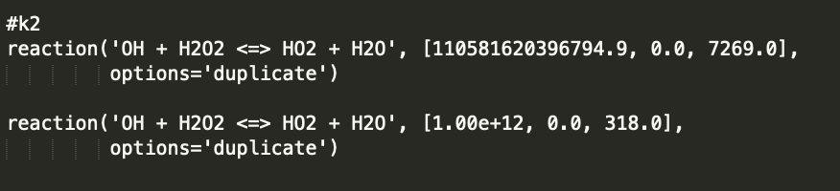

1. Updated the absorption coefficients for H2O2 and HO2 internally in our code in order to match that of those in the supplementary material ($σ_{H_{2}O_{2}}, σ_{HO_{2}}$)
2. Ran a constant pressure shock tube simulation with Cantera using the modified cti file and the pressure, temperature, and initial mixture composition presented in the paper
   1. P = 1.672 atm
   2. T = 1182 K
   3. X =2046 ppm H2O2/1113 ppm H2O/556 ppm O2/balance Ar
3. Plotted the results

Plots Of The Results Can Be Seen Below:

Results for OH Profile



Results for H2O Profile



Results For Absorbance 227 nm Profile

