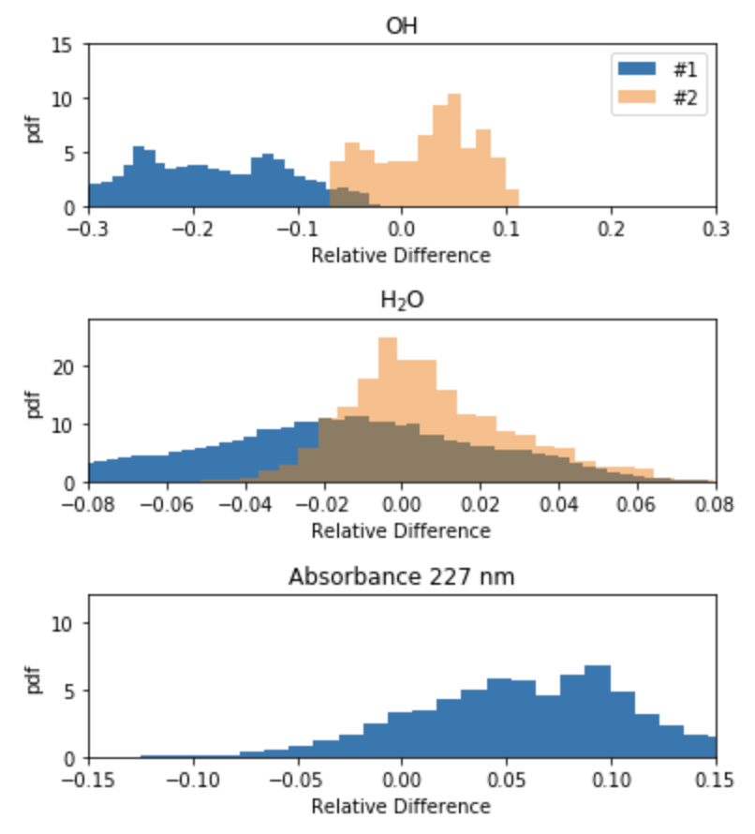

Figure a: MSI interpretation of data Figure 1b: Hong interpretation of data

For figure 1a, 2a and 3a the instances plotted in blue, labeled number one, show some representation of the relative difference between the raw Hong experimental data (graciously given to us by the authors, but not presented in the paper) for the Hong et al. [3] experiments and our optimized model. The instances plotted in orange, labeled number two, express the relative difference between any Hong et al. H2O2 decomposition experiment [1,2] included in our model that we had access to raw experimental data for and our optimized model predictions.

For figures 1b,2b,3b the instances plotted in blue, labeled number one, show some representation of the relative difference between the raw Hong experimental data for the Hong et al. [3] experiments and the original model they present in their paper, with the addition of the fitted rate constants also presented in the paper. The instances plotted in orange, labeled number two, express the relative difference between any Hong et al. H2O2 decomposition experiment [1-2] included in our model that we had access to raw experimental data for and the original model presented in the paper, with the addition of the fitted rate constants also presented in the paper.

In the Figure 1 these relative differences are plotted as probabilities. We can compare how the MSI optimized model performs in relation to how the Hong model performs. One can note that the MSI model seems to be relatively consistent with the raw data where it is available for [3], however our model seems to systematically over predict the OH data. While the MSI model predicts the H2O and Absorbance with higher accuracy, as indicated by the normally distributed smaller relative differences. One can also note that in Figure 1a, for the instance shown in orange (labeled number two) the MSI model does a better job at predicting the raw OH data for experiments [1,2] than for the raw data for experiment [3]. If one examines Figure 1b it can be noted that the Hong model systematically underpredicts OH values for [3], to a greater degree than the MSI model. One can also note it systematically over predicts the absorbance profiles for [3] as compared to the MSI model. It seems to perform similarly to that of MSI for H2O, though still with a slight under prediction. These under and over predictions possibly may be attributed to systematic errors in the interpretations of the original data. One can also note that by including the raw Hong data as targets from [3] MSI seems to systematically over predict OH for [1] and [2].



Figure 2a: MSI interpretation of data Figure 2b: Hong interpretation of data



Figure 3a: Hong interpretation of data Figure 3b: MSI interpretation of data

In Figure 2 the relative differences are plotted verses time and in Figure 3 they are plotted verses temperature. Figure 2a and 2b which show the relative difference verses time seem to show a similar trend as described above. Figure 3a and 3b seem to show how the MSI model is more consists with the raw data over a larger temperature range than that of the Hong model with the fitted rate constants. On average our model is able to systematically predict the real raw data over a wide range of temperatures.

[1]  Z. Hong, R. D. Cook, D. F. Davidson, R. K. Hanson, A shock tube study of OH+H2O2=H2O+HO2 and HO2+M=2OH+M using laser absorption of H2O and OH, J. Phys. Chem. A 114 (2010) 5718–5727.

[2]  Z. Hong, A. Farooq, E. A. Barbour, D. F. Davidson, R. K. Hanson, Hydrogen peroxide decomposition rate: a shock tube study using tunable laser absorption of H2O near 2.5 micrometers., J.Phys. Chem. A 113 (2009) 12919–12925.

[3]  Z. Hong,  K.-Y. Lam,  R. Sur, S. Wang,  D. F. Davidson, R. K.Hanson,  On the rate constants of OH+HO2and HO2+HO2:A comprehensive study of H2O2 thermal decomposition using multi-species laser absorption, Proc. Combust. Inst. 34 (2013) 565–571.