Diet breadth and quality is declining for many predatory fish in the warming Northeast US Continental Shelf

Nathan T. Hermann^{1*}, Andrew J. Allyn², Carly S. Lovas², Mark J. Wuenschel³, Brian E. Smith³, Katherine E. Mills², Nathan B. Furey¹

¹University of New Hampshire, Department of Biological Sciences, Durham, NH, USA
²Gulf of Maine Research Institute, Portland, ME, USA
³National Marine Fisheries Service, Woods Hole, MA, USA

*Corresponding Author: Email: Nathan.Hermann@unh.edu; Phone: (563) 543-9451

Running Title: Diet quality declines for US fish predators

Manuscript Prepared for Submission to Global Change Biology
Author Contributions Statement: Nathan T. Hermann: Formal Analysis (lead), Methodology (lead), Writing – Original Draft Preparation (lead), Writing – Review and Editing (lead). Andrew J. Allyn: Methodology (supporting), Writing – Review and Editing (equal). Carly S. Lovas: Methodology (supporting), Writing – Review and Editing (equal). Mark J. Wuenschel: Conceptualization (supporting), Writing – Review and Editing (equal). Brian E. Smith: Data Curation (lead), Writing – Review and Editing (equal). Katherine E. Mills: Conceptualization (co-lead), Funding Acquisition (co-lead), Methodology (supporting), Project Administration (co-lead), Writing – Review and Editing (equal). Nathan B. Furey: Conceptualization (co-lead), Funding Acquisition (co-lead), Methodology (supporting), Project Administration (co-lead), Supervision (lead), Writing – Review and Editing (equal).
Funding: The project has been supported by NSF Award #2023536 awarded to Nathan Furey and Katherine Mills.

Submission Questions
What scientific question is addressed in this manuscript?: First, we address whether marine predators on the Northeast US Continental Shelf have shown signs of diet change with ocean warming. We further evaluate the extent, patterns, and drivers of change for the community and across major predator species.
What is/are the key finding(s) that answer this question?: Guild diet compositions show compression over time despite stability in species assignments. More specifically, we found that key diet metrics shifted over time which cumulatively suggests diet quality is declining, especially among benthic predators.
What are the novel results, ideas, or methods presented in your work?: Multivariate guild analysis showed continuous compression in diets over multiple decades. Among predators, we observed species-specific responses with a general decline in diet quality. To further assess changes in diet quality of individual predators, we incorporated a new integrative database of energy content.
Describe how your paper fits within the scope of GCB; what biological AND global change aspects does it address?: This paper investigates the biotic pressures consumers face in the rapidly warming the Northeast US Continental Shelf. The response of predator diets in this community may offer insights or warnings into climate change effects on trophic interactions globally.
What are the three most recently published papers that are relevant to this manuscript (include DOIs)?:
Lindmark, M., Karlsson, M., & Gårdmark, A. (2023). Larger but younger fish when growth outpaces mortality in heated ecosystem. eLife, 12, e82996. https://doi.org/10.7554/eLife.82996
Mills, K. E., Kemberling, A., Kerr, L. A., Lucey, S. M., McBride, R. S., Nye, J. A., Pershing, A. J., Barajas, M., & Lovas, C. S. (2024). Multispecies population-scale emergence of climate change signals in an ocean warming hotspot. ICES Journal of Marine Science, 81(2), 375–389. https://doi.org/10.1093/icesjms/fsad208
Wilkes, L. N., Barner, A. K., Keyes, A. A., Morton, D., Byrnes, J. E. K., & Dee, L. E. (2024). Quantifying co-extinctions and ecosystem service vulnerability in coastal ecosystems experiencing climate warming. Global Change Biology, 30(7), e17422. https://doi.org/10.1111/gcb.17422
Conflict of Interest: The authors do not have any conflicts of interest to disclose.
Artificial Intelligence Generated Content: No Artificial Intelligence Generated Content (AIGC) tools were used to generate content for any portion of this manuscript.
Data Availability Statement: Data for these analyses are hosted by the Northeast Fisheries Science Center. Code for analyses can be accessed at the following public repository: [GitHub link, once finalized]. Raw data from the Food Habits Database is available from the Northeast Fisheries Science Center: https://www.fisheries.noaa.gov/inport/item/8083. Energy contents data is available from the National Science Foundation’s Biological and Chemical Oceanography Data Management Office: https://www.bco-dmo.org/dataset/948253.

Acknowledgements
We acknowledge the importance of all employees, past and present, of the Northeast Fisheries Science Center that completed annual trawl surveys collecting data that made this research possible. We further acknowledge the National Science Foundation for providing funding to KEM and NBF, grant #2023536. Easton White and Rebecca Rowe have provided input on methodology as members of NTH’s dissertation committee at the University of New Hampshire.
Abstract: Marine organisms face strong pressures from climate change that require responses for continued survival. For many fish, these responses include range shifts to maintain preferred water temperatures, but species-specific shifts create potential to disrupt trophic linkages. With data collected from the Northeast Fisheries Science Center’s Spring and Fall Bottom Trawl Surveys, we conducted a retrospective analysis of feeding in the Northeast US Continental Shelf Large Marine Ecosystem fish community (n = 41 predator species, n = 369,540 individual diets) from 1973 to 2019 to determine potential shifts in diet in an ecosystem experiencing rapid warming. We first used clustering techniques to assign predators to feeding guilds in past (1973-1997) and recent (1998-2019) time periods, along with non-metric multidimensional scaling to compare guilds over time, to identify changes in diet and community structure. Community analysis revealed a high degree of consistency in consumption patterns as predators largely maintained guild assignments (>87%), but declining inter-guild dispersion (p = 0.010) suggested that predator diet composition is compressing. Individual predators similarly compressed their diets, with 83.0% of predators experiencing reduced diet breadths. Additional metrics indicated declining diet quality across the community, including declines in relative consumption (79.6% of predators), relative energy consumption (66.1%), and absolute energy consumption (54.2%), but without evidence of shifts to prey of different energy densities. Among feeding guilds, those that are benthic predators experienced more rapid declines in diet quality than other predator guilds. Our results suggest that diet quality for a broad community of predators has declined over the past ~50 years, with implications for energetics given the apparent lack of feeding adaptations to climate change. Simplified diets and reduced feeding opportunities have implications across individuals, populations, and communities that need to be considered in fisheries management..
Keywords: trophic interactions, feeding guild, climate change, marine, fish ecology, range shift, adaptation, foraging

Introduction
As species experience the pressures of ocean warming due to climate change, they are forced to move or adapt to maintain connection with hospitable conditions or resources (Nogués-Bravo et al. 2018). In marine environments, movement-based responses by many species are observed as biomasses or abundances shifting poleward (Mills et al., 2024; Nye et al., 2009) and to deeper waters (Dulvy et al., 2008). However, the rate and direction of species range shifts is highly variable (Carroll et al., 2024; Mills et al., 2024; Pinsky et al., 2020). Further, movement patterns can be more complex than a simple latitudinal shift as they follow variable landscapes (Campana et al., 2020). For some species, moving at the pace of climate change is not possible (Burrows et al., 2011) due to landscape features (Dias et al., 2013; Fuller et al., 2015) or biological limitations (Bashevkin et al., 2020). In these instances, species may exhibit adaptive responses to confront local climate changes. Such adaptations can include regional residencies timed to changing temperatures (Langan et al., 2021), locally adapted life histories including younger age at maturity and narrower diet breadth (McMahan et al., 2020), targeting alternative prey with novel foraging behaviors (Dyck & Romberg, 2007), and transgenerational plasticity in reproductive, dietary, and behavioral traits (Donelson et al., 2018). Species that do not move or adapt can experience reduced productivity (e.g., growth, condition, fecundity, and survival), potentially leading to local declines in abundance and even extirpation (Jonsson & Ebenman, 2001).
Climate change poses a risk to foraging opportunities through spatial mismatch between consumers and their food (Carroll et al., 2024), uncoupling interspecific interactions (Thorne & Nye, 2021; Wilkes et al., 2024; Winder & Schindler, 2004). In response, a predators can express changes in their prey, foraging success, or risk of local extirpation (Wilkes et al., 2024). Generalist diets can confer resilience to predators and their communities (Closs et al., 1999; Gerking, 1994). Prey-switching or increasing diet generalization may then improve success in changing environments (Higginson & Ruxton, 2015; Moorhouse‐Gann et al., 2020), observed for several fish feeding guilds (Smith & Smith, 2020). Independent of the generalist-specialist continuum, predator species can be classified into these feeding guilds by the prey types they consume.
Feeding guilds classify predators by their most common prey types. Feeding guilds and degrees of generalization change ontogenetically for many predators (Garrison & Link, 2000a) but are relatively stable over time on local scales (Garrison and Link 2000b). Stable foraging enables predators to acquire suitable energy for growth and reproduction (Lindmark et al., 2023) rather than incurring energetic costs or risks of switching (Gauzens et al., 2024; Moorhouse‐Gann et al., 2020). Predators, therefore, attempt to balance stability or optimal foraging decisions with adaptations to changing environmental conditions in order to maintain productivity and condition (Gauzens et al., 2024). As foraging is central to the success and survival of fish consumers (Hjort, 1914), studying diets and the multispecies interactions within communities is essential to fully understanding climate impacts and vulnerabilities. Therefore, it is important to identify foraging changes across individual predator species, guilds, and their communities to determine how ecological systems respond to climate impacts..
The Northeast US Continental Shelf Large Marine Ecosystem (NEUS) is highly productive (Field et al., 1998), but is experiencing rapid climate change, with sea surface temperatures warming 2.5-times faster than those of global oceans (0.38°C·decade⁻¹ vs 0.15°C·decade⁻¹; Mills et al. 2024). Subregions within the NEUS have shown changes in community composition in recent years (Langan et al., 2021; Lucey & Nye, 2010). Species range shifts spanning the region erode historic linkages and generate new interactions within the marine community (Mills et al., 2024; Nye et al., 2009; Pinsky et al., 2013). Further, the suitable habitat area for some species or assemblages have declined within subregions of the area, resulting in contractions of space use within the subregion (Kleisner et al., 2016). As both increasing localized population biomass densities (Kleisner et al., 2016) and varying positions of prey species (Ganley et al., 2022) are happening within assemblages and trophic interactions, there is potential for foraging connections to be disrupted (Thorne & Nye, 2021).
Our objectives were to assess changes to the trophic structure of the fish community within the NEUS and characterize species-specific foraging responses over >45 years using a long-term dataset of predator stomach contents. Specifically, we defined feeding guilds in past (1973 – 1997) and recent (1998 – 2019) time periods to determine whether common fish predators are maintaining community trophic roles. Further, we examined community-wide shifts within and among guilds using multivariate techniques. We characterized predator species using metrics of both observed diet conditions—feeding frequency, breadth, and magnitude—as well as diet energetics—absolute energy, energy density, and relative energy. Cumulatively, these metrics were used to assess diet quality, which we hypothesized to decline over time for many predators. Lastly, the rate of responses by each predator for each diet metric was compared to species-specific attributes describing movement, climate adaptability, distribution, reproduction, and observed population changes.

Methods
Stomach contents used in all analyses were obtained as part of the Northeast Fisheries Science Center’s (NEFSC) Spring and Fall Bottom Trawl Surveys. The Fall survey began in 1963 and both it and the Spring survey have occurred since 1968 across the eastern US continental shelf from Cape Hatteras, North Carolina to the Scotian Shelf, off the coast of Nova Scotia (Figure 1; Link and Almeida 2000). The stratified random sampling design of the survey included strata from both inshore and offshore regions; however, only consistently sampled strata are included in this study eliminating both inshore strata and those on the Canadian side of the Hague Line. Since 1973, stomach contents from predators have been systematically collected to identify trophic linkages within the fish community, with a total of 369,540 diets collected from 41 predator species between 1973-2019 (Table 1). The number of diets is highly variable across species (median = 6773; range = 1 – 49137; Supplemental 1.S1) with silver hake (n = 48054) and spiny dogfish (n = 49137) having the most diets examined while Atlantic sharpnose shark (n = 1) and tautog (n = 2) having the least (Supplemental 1.S1). Although variation partly reflects the abundance and accessibility of the fish species, it is also driven by NEFSC prioritization of species for diet collection to capture commercially- and ecologically-important species over time (see Smith and Link 2010). When a species was prioritized in a survey, individuals were sampled randomly from length bins across the range of sizes caught (e.g., one diet per 10 cm). Bin width was consistent across surveys but varied between species reflecting possible sizes (i.e., larger fishes had wider bins). The individual weight of sampled fish was recorded starting in 1992.
The collected diets were analyzed in a laboratory in all cases before 1981 and processed at sea in most cases since 1981, with occasional stomachs preserved at sea for subsequent laboratory analysis for quality assurance (Link & Almeida, 2000; Smith & Link, 2010b). For each stomach sample, either the total weight or the volume was measured directly from which the other was estimated by a 1.1:1 weight:volume ratio (Link & Almeida, 2000). Empty stomachs were also recorded. The individual components of stomach contents were identified to the finest taxonomic resolution possible by visual inspection and measured for the proportion of total weight and volume of stomach contents. Across all diets, a total of 1101 unique prey items were identified; fish were regularly identified to higher taxonomic resolution than invertebrates, especially following the shift to inspections at sea in 1981. To both standardize across time periods and better represent the important prey items, identified contents were re-classified following the system used by Garrison and Link (2000a). Specifically, this system largely classified invertebrates at family or order, whereas fish were classified at family, genus, or even species, reflecting their perceived importance as prey as well as the confidence of identification. The result was 52 taxonomically diverse prey categories (Table 2).

Defining guild structure for predator size categories
First, we compared predator fish feeding guild structure between two time periods. The first time period (1973-1997) mirrors Garrison and Link (2000a) that provided an initial assessment of feeding guilds in the NEUS, with the second period being 1998-2019to extend analyses to more current conditions. Each species was first separated into size categories that reflect the growth trajectory of the predator and potential ontogenetic shifts in diet (Table 1). We then treated each of the individual size categories of each species as a distinct predator type, including only those which had >20 diets in both time periods for analyses (n predators = 89; n species = 34). Though the number of diets required to reflect dietary variation varies according to the diversity and richness of a predator’s diet (Supplemental 1.S2), the standard threshold of 20 diets per time period was used to mirror that used by Garrison and Link (Garrison & Link, 2000a) in their initial assessment.
For each of the 52 prey categories, a simple proportion of total diet mass that it contributed to each predator was calculated for each time period. The proportion was calculated across all surveys within the time period and did not incorporate tow-to-tow variation in predator abundance. Grouping prey types into categories lessened the influence of rare prey, and none were removed from analysis as all but Engraulidae during the early time period were present in 1% of stomachs for at least one predator species (0.3% of Large Spiny Dogfish). A full matrix of dietary overlap was then created using Schoener’s Overlap (Schoener, 1970) calculated as:
(Eq. 3.1) $S_{a}=1-0.5*∑\left|p_{1,j}-p_{2,j}\right|$
where $p_{1}$ and $p_{2}$ represent the proportions of the $j$th diet item in predators $1$ and $2$, respectively, within the same time period. Schoener’s overlap values range from 0-1, with 0 indicating the predators have completely distinct diets and 1 indicating perfect overlap. A permutation procedure was employed to identify a significant level of overlap. A matrix of proportions of each prey item (n rows = 52) for each predator (n columns = 89) was generated for each time period. Diet matrices were permuted 250 times while retaining all zeroes in place, and a null overlap matrix was calculated from each permutation. Significant overlap was then identified as values within the original overlap matrix greater than 95% of all off-diagonal values estimated from the 250 permuted overlap matrices. This metric was used to group dietary guilds in a quantitative way, but is considered conservative due to the retention of zeroes (Garrison & Link, 2000a; Jaksić & Medel, 1990).
For each time period, we used the overlap matrix to assign predators to guilds. The overlap matrix was organized using hierarchical agglomerative clustering using the group average metric and visualized with a dendrogram leveraging the function hclust from the package pvclust (Suzuki et al., 2019) in R (R Core Team, 2024, v4.1.2). After performing clustering for each of the two time periods, a tanglegram was created as a visual of the two dendrograms connecting predator positions within each period using the package dendextend (Galili, 2015). The tanglegram was summarized by calculating the correlation of cophenetic distances for the two dendrograms and the level of entanglement between species-size class positions within the dendrograms; both metrics were calculated using dendextend (Galili, 2015) in R (R Core Team, 2024, v4.1.2). Cophenetic distance is the height on the dendrogram at which two predator species-size classes first diverge, i.e., the average intergroup dissimilarity. Entanglement is calculated as the sum of the absolute difference between the position of the same species-size class on the two dendrograms, e.g., one in the first position and the fifth position has a difference of four. These differences are raised to a power of 1.5 to emphasize large shifts in position and the sum was normalized by the maximum entanglement, resulting in values between zero and one.

Multivariate analysis of guild interrelatedness over time
To analyze relative diet changes through time as well as within and among guilds, the annual diet composition for all predators (i.e., species-size classes) belonging to the same guild were summarized. The predators were grouped into feeding guilds from clustering based on diets collected during the historic time period, 1973-1997, and assumed constant assignments over the entire time period. The annual proportion of the total diet mass for each diet category was calculated for each guild weighted by the abundance of predators within the guild captured in each tow. The distance between whole guild annual diet compositions was calculated for each pairwise comparison (e.g., 1973 Piscivores vs. 1997 Benthivores) using Bray-Curtis dissimilarity given the high frequency of zeroes within the compositional data (43.5%) and non-normality of prey abundances. Non-metric Multidimensional Scaling (NMDS) using the function metaMDS within the vegan package (Oksanen et al., 2019) in R (R Core Team, 2024, v4.1.2) was used to reduce the dimensionality of the matrix to 1-6 axes. A minimum of 250 random starts were tried at each dimension, and the final ordination was selected such that an additional increase in dimension would not reduce stress >5%. No transformations were performed. Patterns in guilds were monitored over time through vector fitting to year for each guild using the function envfit from the vegan package (Oksanen et al., 2019). To identify the interrelatedness of guilds, a centroid position across all five guilds was defined for each year with dispersion being calculated as the mean distance from each guild position to that centroid. Dispersion was then regressed against year with a guild-year interaction term to identify changes over time and account for differences in the relative positions of guilds. Ordinations and vector fits were visualized using ggplot2 and ggpubr packages (Kassambara, 2022; Wickham, 2016) in R (R Core Team, 2024, v4.3.2).

Distinguishing species-specific diet responses and drivers of change
For each species independently, diet contents were summarized across all size classes in three ways: frequency, breadth, and magnitude. General consistency in size distributions was confirmed over time (Supplemental 1.S3). Feeding frequency was evaluated with the percentage of stomachs found to be empty; higher percentages indicate less frequent feeding. Diet breadth was estimated with the Simpson’s Index of Diversity (D):
(Eq. 3.2) $D=1-\sum{p_{j}^{2}}$
where $p_{j}$ is the proportion of the jth diet item in composition of the diet (Simpson, 1949). Scores range from (0-1) with low scores indicating low diet breadth. Feeding magnitude was calculated as relative consumption: the weight of the stomach contents divided by the weight of the fish (g.g⁻¹). This metric was only available after 1992 when the mass of the fish was first recorded. Empty stomachs were removed from this feeding magnitude calculation as they were accounted for in the measure of feeding frequency.
In addition, we used energy density estimates of observed prey items to develop three further metrics: absolute energy consumption, diet energy density, and relative energy consumption. Using a database of collated published estimates of energy density (see Hermann et al. 2025; Hermann 2025) prey items were paired with energy densities within the diet database based on the finest shared taxonomic resolution. Using the available energy density for each prey item consumed, we estimated the energy consumed for each diet. First, the absolute energy consumed was calculated as the product of energy density and weight consumed for each diet item summed over all diet items (kJ). Second, the diet energy density was calculated as the total energy within the diet divided by the total weight consumed (kJ.g⁻¹ diet). Thirdly, relative energy consumption was calculated as the absolute energy consumed divided by the mass of the predator (kJ.g⁻¹ predator). As above, this metric is available from 1992-2019 when the mass of the predator was recorded.
To analyze how these six metrics (percent empty stomachs, diet breadth, relative consumption, absolute energy consumption, diet energy density, and relative energy consumption) varied through time, in Fall and Spring seasons, and among species, we used generalized linear models (GLMs). Relative consumption, which can only be positive but is heavily right-skewed, was fit using a Gamma distribution with a log-link. Proportion of stomachs that were empty, as discrete counts of empty stomachs given a discrete number of stomachs surveyed, was fit using a binomial distribution with a logit-link. Diet breadth using Simpson’s Index of Diversity, as a continuous value bounded (0,1), was fit using a quasibinomial distribution with a logit-link. Absolute energy, which had right-skewed but entirely positive values, was analyzed using a Gamma distribution with a log-link. Energy density was fit using a normal distribution. Lastly, relative energy consumption, which had entirely positive and right-skewed values, was fit using a Gamma distribution with a log-link. Each model included main effects of species, season, and year with the species abundance from the tow added as a weight within the model. Only those species with a robust time series, defined as having ≥ 20 surveys (season – year combinations) with ≥ 20 diets collected mirroring the threshold for clustering, were included in these models (n species = 31). Model output was summarized as the slope for each species in each season (n species-season = 59). Intercepts were ignored from change analyses, but can define interspecific differences in typical foraging patterns, e.g., intermittent, binge-feeding, generalist. Slopes were grouped into five categories ranging from strongly negative to strongly positive. Strong responses were those which changed ≥30%, positively or negatively, from the beginning of the time series to the end. Weak responses were those ≥10% and <30% change over the time series. Finally, all responses that changed <10% were categorized as neutral responses. To determine if observed changes in the percent empty stomachs or relative consumption could be explained by warming waters rather than by changes in food availability or foraging, additional analyses compared the mean response of these metrics to the simulated changes from temperature via gastric evacuation models (see Supplemental 2 for details).
We used six complementary diet metrics for each species-season to perform a more robust assessment of diet quality. For example, intermittent feeding may result in a high percentage of empty stomachs. However, if the intermittent meals are large (i.e., high relative consumption) the resulting diet quality may be similar to that of a predator consuming smaller meals more regularly. We developed a scoring method to summarize across all six metrics and approximate the overall quality of a species’ diet. The score for each metric was given a sign based on the direction of change and value based on the category of the slope coefficient from the fitted GLM. A negative sign was assigned when the direction of change was assumed to result in a worse outcome for consumers (i.e., a negative slope for all metrics besides percent empty stomachs for which a positive slope was considered worse). One point was assigned for weak responses, two points for strong responses, and zero points for a neutral response based on prior categorizations of percent change over time. For example, a 25% increase in diet breadth was scored a +1, 40% increase in empty stomach frequency a -2, and 5% decline in relative energy a 0.
Finally, we used the slopes from the species-season feeding metric GLMs in post-hoc analyses to identify potential correlates with species characteristics. Characteristic definitions were derived from (a) the above analyses—i.e., feeding guilds (Benthivores, Crab eaters, Piscivores, Polychaete/Amphipod eaters, or Shrimp eaters), (b) NEFSC trawl data—i.e., center of biomass shift over time, or (c) expert opinion as collected by Hare et al. (2016)—i.e., climate vulnerability (Table 3). Each characteristic was categorized as either a feature of the species’ potential adaptiveness (guild, temperature sensitivity, and habitat and prey specificity), reproduction (spawning cycle, stock size/status, complexity in reproductive strategy, and population growth rate), distribution (mean and variation of longitude and latitude of the centers of biomass [CoB]), population trends (rate of change in CoB latitude, CoB longitude, seasonal distance between CoB, and biomass), or movement (dispersal, mobility, and mean and variation the seasonal distance between CoB). The degree of influence a characteristic exerted on each of the six diet metrics was compared after fitting each in a single factor model using the dredge function from the package MuMIn (Bartoń, 2020). Characteristics that had highly skewed responses were fitted with a Gamma distribution and log-link (percent emptiness, diet breadth, and absolute energy), with the rest fitted with a Gaussian distribution and identity (relative consumption, diet energy density, and relative energy consumption). Each model was assessed for the strength of influence based on the R² and model weight. Factors were ranked by the cumulative weight of models including the factor, but only using models with a ΔAICc within 4.0 of the top model. Factor categories were then ranked according to the sum of weight across the factors within it and displayed according to the coefficient of determination.

Results

Defining guild structure for predator size categories
Clustering analysis successfully grouped predator classes into five feeding guilds in both historic and recent time periods, with guild assignments during the initial time period (1973-1997) largely mirroring those from Garrison and Link (2000a) to indicate a faithful replication of clustering methods. Minor differences between Garrison and Link (2000a) and ours are likely because we excluded diets collected from inshore or Canadian strata that were not sampled consistently throughout the recent time period. The tanglegram between the two dendrograms (1973-1997 and 1998-2019) showed strong similarities between predator positions (Supplemental 1.S4) with a correlation of 0.67 and entanglement of 0.05. Only 12 predator species-size classes (13.4%) switched feeding guild between the time periods (Figure 2). In each instance of switching guild definitions, primary diet items remained consistent whereas secondary items changed to align more closely with a different guild. For example, both medium and large American plaice switched from being Benthivores to Polychaete/Amphipod eaters as bivalves fell from 6% to 1.5% of their diet and were replaced by polychaetes rising from 2.5% to 4%; yet brittle stars and other echinoderms still made up over 70% of their diet in both time periods.

Multivariate analysis of guild interrelatedness over time
We used NMDS, final ordination of three axes (Stress = 0.169, R² = 0.721; Figure 3), to observe impacts of external and internal factors on diet composition. Guild positions shifted over time along the primary axis (Figure 3a), largely toward a common position in multivariate space along the second and third axes (Figure 3b,c). This pattern of increasing overlap was further observed through a significant decline in inter-guild dispersion over time (p = 0.010). From 1973 to 2019, dispersion—a unitless, mean distance to an annual centroid from guild ordination positions— declined 11.1% (Figure 4). There was no significant difference in this decline among guilds (0.292 < p < 0.981; range 8.2% – 27.8% declines in dispersion).

Distinguishing species-specific diet responses and drivers of change
Across all species, seasons, and years, 40.7% of fish collected in the trawl surveys had empty stomachs (Figure 5a). The percent of stomachs found empty varied greatly among species, ranging from 10% (for smooth dogfish and alewife) to 77.4% (for summer flounder; Supplemental 3). Across species-season, increasing emptiness over time was common (Figure 6a), with 42.3% of species-season groups having a positive slope (n = 25) and 25.4% having strong positive trends (≥30% increase; n = 15; Figure 7) though the most species-seasons had neutral changes (50.8%, n = 30; ≤10% change; Figure 7). Due to laboratory processing of diets possibly returning fewer empty stomachs than processing at sea, analyses on the percent empty stomachs through time were repeated, restricted to the time periods when stomachs were analyzed at sea which varied by species (post-1981 or post-1985; Link and Almeida, 2000). Repeating this analysis resulted in the number of positive slopes by species-seasons over time declining to just 22.0% (n = 13), replaced by more negative changes (30.5%, up from 6.7%) though neutral responses were still dominant in both scenarios (47.4%; Supplemental 1.S6). Winter Flounder, Butterfish, and Scup are examples of species whose trends in percent empty stomachs were affected by the reanalysis, whereas others were very consistent (e.g., Spiny Dogfish, Summer Flounder, or White Hake; Supplemental 1.S5). Under the 1.58°C and 1.67°C temperature rises measured across time periods from tows in the Spring and Fall, respectively (Supplemental 2.S3), the average simulated increase in percent emptiness from temperature alone was 44.6% (from 26.9% to 38.9% emptiness; Supplemental 2.S2). For only 10.1% of species-seasons did the percent of empty stomachs increase by this margin or more over the entire time series (see Supplemental 2.S4). The strongest increases were seen for, in order, haddock and witch flounder both of which more than doubled in their average percent of empty stomachs in both Spring and Fall (1973-2019; Figure 8).
Diet breadth (as measured by Simpson’s Diversity Index) ranged from 0-0.88, with higher values indicating greater diet diversity (Figure 5b). The broadest diets correlated with the fewest empty stomachs (Pearson’s correlation between mean values by species, ρ = -0.79; p < 0.001); most notably, skates (smooth, little, and thorny) having three of the broadest diets and three of the lowest percentages of empty stomachs. Despite diet breadth being low across guilds (0.095 median for all species-seasons, Figure 5b), diversity was notably higher for Crab eater (0.255) and Polychaete/Amphipod eater guilds (0.315; Figure 5b). Across all guilds, the diet breadth for a large majority of species (87%) declined through time (Figure 6b). Moreover, negative responses were primarily strong (66.1% of declines were >30%; Figure 7), with a maximum decline of 91.7% by Atlantic mackerel (Fall) from 0.53 to 0.05 across 41 years (Figure 8; Supplemental 3). Due to high variation in sampling intensity across species (Supplemental 1.S1), 100 random draws of 100 stomachs were used to compare to the full database diversity values and showed high consistency for all species both in relative and absolute diet breadth (Supplemental 1.S7).
Across all species, the range of relative consumption values was 0.000003 g∙g⁻¹ to 0.68 g∙g⁻¹, with the median being 0.008 g∙g⁻¹ (0.8% body mass; Figure 5c). All species showed heavy skew towards lower relative consumption levels, but the hakes (white hake, silver hake, and red hake) showed the highest medians (Supplemental 3). Most species exceeded 10% body mass (0.1 g∙g⁻¹) at least once, with only black sea bass (max = 5.2%), winter flounder (max = 6.4%), and scup (max = 7.3%) never exceeding this mark. The species exceeding 10% body mass most often were benthic monkfish (3.0% of diets) and sea raven (2.0% of diets; Supplemental 3). Although the median relative consumption among Piscivores was not highest of all guilds (1.07% body mass compared to 1.35% body mass from Crab eaters; Figure 5c), they exceeded 10% body mass more consistently than other guilds (1.7% of diets). Relative consumption among species-season were highly skewed toward negative responses over time (Figure 6c) with 74.5% of species-season observations (n = 44) having a negative response (Figure 7). Responses were quite strong, with the strongest being by butterfish, which averaged a decline of 71.5% and 83.4% in relative consumption in the Fall and Spring, respectively (Figure 8; Supplemental 3). Under constant consumption rates but higher temperatures, more rapid digestion was simulated to reduce observed relative consumption by 18.4% (Supplemental 2.S2). Though warming is expected to result in lower relative consumption due to faster gastric evacuation, the simulated reduction was less than the observed decline for 57.6% of species-season (n = 34; see Supplemental 2 for detailed results).
Diet energy estimates ranged from 0.004 kJ to 27,720 kJ across all species, with the median being 10.234 kJ among stomachs with contents (Figure 5d). Over 80% of the highest 1% of diets by energy came from just four species: monkfish (24.6%, which also consumed nine of the ten highest energy diets), spiny dogfish (23.6%), Atlantic cod (22.3%), and white hake (12.1%). All four of these species belong to the Piscivores guild (median = 20.4 kJ); however, the highest median diet energy by a guild was held by Crab eaters (92.0 kJ: Figure 5d). Total energy of diets generally declined over time, with a median of 13% decline (Figure 6d) and the majority (54.2%) of species-seasons experiencing at least a weak decline (Figure 7). Among those exhibiting increased energy consumption, many were species which have low energy diets, such as scup, which experienced an increase of over 750% from 1.07 kJ to 9.17 kJ (Supplemental 3).
The energy densities of prey items consumed by predators (range = 0.137 – 11.1 kJ.g⁻¹; median = 4.61 kJ.g⁻¹; Figure 5e) was similar to those present within the energy density database (range = 0.015 – 17.9 kJ.g⁻¹; median = 4.23 kJ.g⁻¹; Hermann et al. 2025; Hermann 2025). Values were approximately normally distributed with just over two-thirds of diets falling within 1 kJ.g⁻¹ ± the median (4.61 kJ.g⁻¹). Despite this consistency, each guild had a significantly different average energy density with Shrimp eaters and Piscivores having the highest averages (4.43 and 4.34 kJ.g⁻¹, respectively) and Benthivores having the lowest average (3.14 kJ.g⁻¹; Figure 5e). Changes over time were muted (Figure 6e) with most species-seasons exhibiting neutral responses (<10% change; n = 36; 61.0%; Figure 7).
The energy of diets relative to the mass of the predator was found to range from <0.001 kJ.g⁻¹ of body mass to 3.62 kJ.g⁻¹ (Figure 5f). The median across species was 0.037 kJ.g⁻¹, with larger fish tending toward lower relative energy. Inter-guild averages were similar to patterns for energy density with Piscivores and Crab eaters having the highest values (medians = 0.053 and 0.055 kJ.g⁻¹, respectively) whereas Benthivores and Polychaete/Amphipod eaters had the lowest values (medians = 0.018 and 0.017 kJ.g⁻¹, respectively, Figure 5f). Strong declines were observed overall (Figure 6f), with the largest category response being species-seasons exceeding 30% declines (n = 25; 42.3%; Figure 7). Responses in relative energy by species-season predators were largely consistent with those observed for relative consumption (Figure 8).
By scoring species-specific responses across the six diet metrics , we ranked diet quality changes for predators (species-season) (Figure 8). With potential scores ranging from -12 to 12, the observed range skewed negative from -12 (haddock, Spring) to 5 (longhorn sculpin, Spring) and an average of -4, roughly equating to a weak negative response. When combined across both seasons, the three most sensitive species were haddock (-21), red hake (-19) and witch flounder (-17) and the most resistant to change were silver hake (4) and Atlantic herring and longhorn sculpin (each 3). In total, 83.8% of species returned a negative score summing both seasons (n = 26 species), similar to 81.3% of species-seasons separately (n = 48). Responses were, on average, more negative in the fall (-4.13) than in the spring (-3.86), though the difference was not significant (p = 0.800, t = -0.254, df = 57).
Species characteristics included in single-factor GLMs indicated variation in diet metrics could be explained in part by the movement, adaptive, and reproductive capabilities of the species (Figure 9). Adult feeding guild was identified as significant (<4 ΔAICc) in explaining four metrics. For each of those four metrics, it had the highest R² of the evaluated characteristics, and for three metrics it was the highest-ranking factor (Figure 9). For each of the four metrics for which feeding guilds were significantly different (percent empty stomachs, relative consumption, energy density, and relative energy), the polychaete/amphipod guild either declined in quality the most or was statistically indistinguishable from the most decline (Figure 10). The most stable guilds (change closest to 0%) appeared to be the piscivores and crab eaters, each significantly higher than other guilds (i.e., less negative quality change) in three of the four metrics (Figure 10). Notably, crab eaters were the highest in all metrics defining a rate of consumption (i.e., relative consumption, absolute energy, and relative energy consumption) for which all member predator responses were indicative of increasing quality (Figure 10).
Beyond feeding guild, other adaptive capacities, movement capacities, and distribution features—e.g., latitude/longitude, dispersal, and mobility—occasionally contributed to variation in diet quality metrics (Figure 9). Of specific note, increases in absolute energy consumption driven by latitude (more southern and more rapid change) and longitude (more western and more rapid change) were largely due to inordinately high responses from small predators typical of the Mid-Atlantic Bight, i.e., scup and butterfish (Supplemental 3). Reproductive features exhibited mixed responses, but were related to the percentage of empty stomachs and diet breadth responses. Movement capacities overall performed poorly in explaining variation in diet metrics (Figure 9).

Discussion
Overall, our results suggest the diet quality of predators across different guilds has declined from 1973-2019 in the NEUS, a large marine ecosystem of ecological and socio-economic importance (Northeast Fisheries Science Center, 2024a, 2024b). The common pattern observed for predators may be described as having, lower breadth of prey items and smaller relative diet mass, and when paired with prey energetics data (Hermann et al. 2025), smaller amounts of energy consumed in relative and absolute terms. The only metric that may have improved across most predators is that stomachs may be empty less often than in the past, when correcting observations for increases in temperature. Selecting high energy prey may compensate for environmental pressures (Clarke & Johnston, 1999; Wexler et al., 2003), but overall predators in the NEUS do not appear to obtain higher energy density prey despite declining quality in other metrics. A lack of increase in prey energy density is consistent with diet reflecting available prey densities rather than targeted prey selection, as observed in the Baltic Sea (Gauzens et al., 2024). Reduced consumption and energy obtained has important implications to individual predators and their populations, and reduced diet diversity has implications for this LME’s food web.
Dietary changes within and among feeding guilds signaled an overall compression in diets across predators within the NEUS community. The average level of overlap increased, suggesting that within-guild diets became more similar. Further, the dispersion of annual centroids between guilds declined through time, indicating that the diets of different guilds were also becoming more similar. Increasing guild overlap may suggest that predators are becoming more generalized in prey choice as a potential adaptation to trophic change (Closs et al., 1999; Ma & Levin, 2006). However, this guild-based generalism contrasts with species-level observations of reduced dietary breadth. Together, these observations may suggest that predators are experiencing a reduction in the diversity of their prey base, driving the lower diet diversity and weaker partitioning between and within guilds observed. Prey identification procedures within the dataset used have become more macroscopic through time, which could potentially contribute to the lower diversity in diets we observed; however, prey were categorized at levels which should be consistently identifiable and thus this seems unlikely. Rather, reduced diet diversity may result from non-optimal foraging conditions (Gauzens et al., 2024). Potential losses in foraging opportunities may be driven by prey that are either reduced in abundance or spatially disconnected from predators (Carroll et al., 2024; Fortier et al., 1995; Thorne & Nye, 2021). As the NEUS has been characterized as highly generalist (Link, 2002), lost trophic opportunities could concentrate predators around a few resources, increase susceptibility to major population impacts (Perretti et al., 2017; Pershing et al., 2015), and increase food web instability (Closs et al., 1999).
Although feeding guilds are eating more similar prey, predatory fish in the NEUS have largely occupied the same feeding guilds over the past five decades, confirming continued stability revealed by Garrison and Link (2000a) and on Georges Bank (Garrison & Link, 2000b). Stability suggests that guild positions based on prey composition reflect morphology, such as mouth shape enabling certain feeding methods (Karpouzi & Stergiou, 2003). Additionally, major trophic connections may be maintained as assemblages defined by habitat requirements adapt cohesively (Kleisner et al., 2016). The few instances of guild switching we observed were almost entirely driven by less dominant prey components of the diet. The mechanism behind this change in secondary prey composition is unclear, whether it is density-dependent reflecting a change in abundance of the prey (Gauzens et al., 2024) or is true changes in prey selectivity.
Integrating an energy density database (Hermann et al. 2025; Hermann 2025) with diets suggests predators are obtaining less energy than in the past. Diet breadth reductions and guild compression did not result in significant changes in diet energy densities, suggesting that predators are continuing to consume similar prey types rather than switching to higher energy prey under climate pressures. Consuming higher energy density prey could offset reduced consumption (Martins et al., 2004; Wexler et al., 2003), but no such pattern was observed consistently across the NEUS fish predators. Previous research suggests when predators switch between prey of different energy density, their consumptive requirements can change by as much as 40% by mass (Wexler et al., 2003). While we observed relative consumption declining in NEUS predatory fishes, reduced energy obtained has strong implications for fish, their populations, and growth is strongly correlated with mortality (Lorenzen 1996; Gislason et al. 2010) and fecundity (Hixon et al. 2014; Barneche et al. 2018).
The losses in energy consumed observed for most species must be further contextualized by temperature (Lindmark et al., 2023). As warmer waters increase rates of digestion (Elliott, 1972; Jobling, 1981), an equivalent rate of feeding would result in lower diet weights being observed (Eggers, 1979). As digestive and other metabolic losses increase with temperature (Brett, 1964; Clarke & Johnston, 1999), this can serve as one mechanism driving lower realized growth and productivity trends (Brodziak & Link, 2008; Lindmark et al., 2023). However, in situ temperature measurements taken from the surveys do not fully account for the losses in relative consumption (Supplemental 2), indicating that consumption rates are truly declining in the NEUS. Conversely, simulations of rising gastric evacuation rates from warming waters using standard coefficients (Durbin et al., 1983; Stehlik et al., 2021) indicate increases in the frequency of empty stomachs are lower than those expected from rising temperatures alone (Supplemental 2). Thus, predators may be feeding more frequently than historically, but at a rate insufficient to keep pace with warming. Smaller prey are likely more available for frequent feeding, but larger prey take longer to digest. Thus, detailed examinations of the size distributions of prey consumed by NEUS fishes (e.g., Scharf et al. 2000) could help identify the mechanisms behind fewer empty stomachs but with reduced relative consumption and total energy obtained.
The changes in predator diets were most explained by predator feeding guild and habitat rather than by potential adaptations to climate change. Among feeding guilds, Polychaete/Amphipod eaters were most strongly affected with the greatest reductions in relative consumption. Among these predators experiencing the most consistent declines in diet metrics were flatfishes (e.g., witch flounder) and groundfishes (e.g., haddock). However, diet quality is just one measure of potential productivity, and diet quality changes does not appear to directly equate to biomass declines as both the most (haddock) and least sensitive (silver hake) species by dietary change exhibited an increase in biomass over the collection period (NOAA Fisheries, 2024). It is possible that as a species exhibits one climate response, it will limit or enable the strength of or need for alternative responses (e.g., diet breadth enables establishment in novel environments; Monaco et al. 2020). Across species overall, no diet metric responses were associated with alternative adaptations (e.g., range shifts or migration distances). In contrast, the extremes of overall response, silver hake (least sensitive) and haddock (most sensitive), also were extremes in range shifts, with silver hake rapidly shifting and haddock shifting minimally (Mills et al., 2024; Nye et al., 2009). The shifting distributions of silver hake may have been to track suitable prey (i.e., congruous shifts; Carroll et al. 2024), thus explaining the relative diet consistency. Meanwhile, haddock range shifts may be masked by highly variable biomass resulting from environmental and density-dependent factors (Wang et al., 2021). Additionally, silver hake are a broadly distributed species (Lock & Packer, 2004) as opposed to haddock that tend to be more latitudinally-concentrated off of the Northeastern United States (NEFSC 1999). Generally, species in the NEUS region have not been able to track their distribution shifts with rates of warming (Mills et al., 2024) which may explain or exacerbate our similar observation of general failure to track diet quality.
With the current, ongoing, and escalating pressures of climate change, greater attention is needed to quantify how interactions between species will be impacted and the resulting outcomes for particular species and ecosystems. In the NEUS, many species are vulnerable to climate impacts (Hare et al., 2016; Mills et al., 2024; Pershing et al., 2021) as well as to impacts of ongoing stressors such as fishing pressure (Anderson et al., 2008; Barnett et al., 2017; Brodziak & Link, 2008; Mieszkowska et al., 2009; Pershing et al., 2015; Smith et al., 2025; Tu et al., 2018). Combined effects of climate and harvest pressures leave these species vulnerable to ecosystem changes (Hare et al., 2016; Wilkes et al., 2024). Our results indicate that the availability of food resources for some trophic guilds could constrain the productivity of fish stocks in the region (Wilkes et al., 2024) through mortality and fecundity limitations (Carozza et al., 2019; McBride et al., 2015; Mills et al., 2024). These results may place further emphasis on the need to maintain foraging opportunities for predators, by monitoring forage fishes either directly (Adams et al., 2015; Pikitch et al., 2014; Shelton et al., 2014; Siple et al., 2019) or via those foraging upon them (Gaichas et al., 2024), as management considerations complementary to habitat and accountability measures (Fleming et al., 2003; Gehan & Hallowell, 2012).
Our ability to estimate changes in energy consumed relied on using a single average energy density per prey taxa consumed, which may overlook important, but nuanced, patterns that may require further attention in future studies. The energy density of organisms can be highly variable throughout the year, largely due to reproductive efforts (McBride et al., 2015) and individual lifespan (Wuenschel et al., 2006), and it can also vary spatially or among years (Wuenschel et al., 2024). As the prey choices of consumers vary over the course of a year, including the targeting of ephemeral (Furey et al., 2018), high-quality food resources (Johnson et al., 2016; Yang et al., 2010), reducing prey types to a single estimate does not necessarily reflect the energy density of the item being consumed (Martin et al., 2017). Such a simplification of energy estimates for prey is likely to result in conservative estimates of energy loss for predators given the recent observed decline in energy density of prey (Wuenschel et al., 2024). Further, although the temperature effects on increasing gastric evacuation have been considered here, the additional metabolic costs incurred by higher temperatures will further limit energy available for growth without excessive prey (Dieterman et al., 2004). Future work may attempt more precise diet quality changes using explicit comparisons between and within regions as well as between seasons and across years to identify variability in energy density (Wuenschel et al., 2024). The metabolic costs of warming to predators could also be directly paired with modeled bioenergetic requirements to accurately understand consequences for individual species or predator-prey relationships (Brownscombe et al., 2022).

Conclusion
By analyzing the diet contents of marine predatory fishes within the NEUS, we revealed how feeding guilds, predator diets, and the broader community have changed or remained consistent over recent decades. Feeding guild definitions were highly stable over time, indicating tight associations between predators and their primary prey, but these guild assignments are becoming less distinct, revealing a pattern of compression in the prey base. Most species had significantly reduced diet breadths coupled with reduced consumption, resulting in less energy obtained and overall lower quality diets. Sensitive predators of note were those which consumed small, benthic prey such as flatfish and groundfish from the Polychaete/Amphipod eaters feeding guild. Climate change imposes direct pressures on many marine organisms, driving a myriad of responses. Although marine species distribution shifts in response to ocean warming have garnered much attention, our work highlights how warming may also influence the ability of species to maintain energetic needs, as predators showed widespread declines in diet quality despite stable trophic connections. Understanding the collective consequences of climate change on marine species will require continued monitoring to quantify the impacts on predator diets and prey quality, with an aim to integrate these findings into food web ecology research and fisheries management.

Tables

Table 1
Size classes for each predator included within the National Marine Fisheries Service Food Habits Database as part of the Spring-Fall Bottom Trawl Survey. All size ranges are in cm. Species abbreviations are listed for each species. Feeding guilds from clustering analyses are listed below the size ranges for each species-size class in the initial (left) and recent (right) time periods (B = Benthivores, CE = Crab eaters, PAE = Polychaete/Amphipod eaters, P = Piscivores, and SE = Shrimp eaters).
Species | Abbreviation | Small |  | Medium |  |  |  |  | Large |  |  |  | Extra-Large
Acadian Redfish (Sebastes fasciatus) | AcRe | 1-25 |  | 26-50 |  |  |  |  | >50
 |  | SE | SE | SE | SE
Alewife (Alosa pseudoharengus) | Ale | 1-20 |  | 21-30 |  |  |  |  | >30
American Butterfish (Peprilus triacanthus) | AmBu | 1-20 |  | >20
 |  | PAE | SE | PAE |  |  | SE
American Plaice (Hippoglossoides platessoides) | AmPl | 1-20 |  | 21-40 |  |  |  |  | 41-70 |  |  |  | >70
 |  | PAE | PAE | B |  | PAE |  |  | B | PAE
Atlantic Cod (Gadus morhua) | AtCo | 1-20 |  | 21-50 |  |  |  |  | 51-80 |  |  |  | >80
 |  | SE | SE | SE | CE |  |  |  | P |  |  | P | P | P
Atlantic Croaker (Micropogonias undulatus) | AtCr | 1-25 |  | 26-50 |  |  |  |  | >50
Atlantic Herring (Clupea harengus) | AtHe | 1-20 |  | 21-30 |  |  |  |  | >30
 |  | SE | SE | SE |  |  |  | SE | SE |  |  | SE
Atlantic Mackerel (Scomber scombrus) | AtMa | 1-20 |  | 21-35 |  |  |  |  | >35
 |  | SE | SE | SE |  |  |  | SE | SE |  |  | SE
Atlantic Sharpnose Shark (Rhizoprionodon terraenovae) | AtShSh | 1-60 |  |  |  |  |  |  | >60
Black Sea Bass (Centropristis striata) | BlSeBa | 1-25 |  | 26-50 |  |  |  |  | >50
 |  | CE | CE | CE |  |  |  | CE
Bluefish (Pomatomus saltatrix) | Blu | 1-30 |  | 31-70 |  |  |  |  | >70
 |  | P | P | P |  |  |  | P | P |  |  | P
Fawn Cusk-eel (Lepophidium profundorum) | FaCu | 1-60 |  |  |  |  |  |  | >60
 |  | PAE | PAE
Fourspot Flounder (Paralicthys oblongus) | FoFl | 1-20 |  | 21-40 |  |  |  |  | >40
 |  | SE | SE | P |  |  | P |  | P |  |  | P
Monkfish (Lophius americanus) | Goo | 1-60 |  |  |  |  |  |  | >60
 |  | P | P |  |  |  |  |  | P |  |  | P
Gulf Stream Flounder (Citharichthys arctifrons) | GuStFl | 1-20 |  | >20
 |  | PAE | PAE
Haddock (Melanogrammus aeglefinus) | Had | 1-20 |  | 21-50 |  |  |  |  | 51-80 |  |  |  | >80
 |  | PAE | PAE | PAE |  |  | PAE |  | PAE |  |  | PAE
Little Skate (Leucoraja erinacea) | LiSk | 1-30 |  | 31-60 |  |  |  |  | >60
 |  | PAE | PAE | SE | PAE
Longfin Squid (Doryteuthis (Loligo) pealeii) | LoSq | 1-30 |  |  |  |  |  |  | >30
Longhorn Sculpin (Myoxocephalus octodecemspinosus) | LoSc | 1-25 |  | 26-50 |  |  |  |  | >50
 |  | SE | CE | SE |  | CE
Northern Sand Lance (Ammodytes dubius) | NoSaLa | 1-10 |  | 11-25 |  |  |  |  | >25
Northern Shortfin Squid (Illex illecebrocus) | NoShSq | 1-30 |  |  |  |  |  |  | >30
Ocean Pout (Macrozoarces americanus) | OcPo | 1-60 |  |  |  |  |  |  | >60
 |  | B | B |  |  |  |  |  | B |  | B
Pollock (Pollachius virens) | Pol | 1-20 |  | 21-50 |  |  |  |  | 51-80 |  |  |  | >80
 |  | SE | SE | SE |  | SE |  |  | P |  | P |  | P | P
Red Hake (Urophycis chuss) | ReHa | 1-20 |  | 21-40 |  |  |  |  | >40
 |  | SE | SE | SE |  | CE |  |  | P |  | P
Scup (Stenotomus chrysops) | Scu | 1-25 |  | 26-50 |  |  |  |  | >50
 |  | PAE | PAE | PAE |  |  | PAE
Sea Raven (Hemitripterus americanus) | SeRa | 1-25 |  | 26-50 |  |  |  |  | >50
 |  | P | P | P |  |  | P |  | P |  | P
Silver Hake (Merluccius bilinearis) | SiHa | 1-20 |  | 21-40 |  |  |  |  | >40
 |  | SE | SE | P |  |  | P |  | P |  | P
Smooth Dogfish (Mustelus canis) | SmDo | 1-40 |  | 41-60 |  |  |  |  | 61-80 |  |  |  | >80
 |  |  |  | CE |  |  | CE |  | CE |  | CE |  | CE | CE
Smooth Skate (Malacoraja senta) | SmSk | 1-30 |  | 31-60 |  |  |  |  | >60
 |  | SE | SE | SE |  |  | SE
Spiny Dogfish (Squalus acanthias) | SpDo | 1-40 |  | 41-60 |  |  |  |  | 61-80 |  |  |  | >80
 |  | P | SE | P |  |  | P |  | P |  | P |  | P | P
Spotted Hake (Urophycis regia) | SpHa | 1-20 |  | 21-40 |  |  |  |  | >40
 |  | SE | SE | P |  |  | P
Summer Flounder (Paralichthys dentatus) | SuFl | 1-20 |  | 21-40 |  |  |  |  | 41-70 |  |  |  | >70
 |  |  |  | P |  |  | P |  | P |  | P
Tautog (Tautoga onitis) | Tau | 1-25 |  | 26-50 |  |  |  |  | >50
Thorny Skate (Amblyraja radiata) | ThSk | 1-30 |  | 31-60 |  |  |  |  | 61-80 |  |  |  | >80
 |  | PAE | PAE | PAE |  |  | PAE |  | P |  | PAE |  | P | P
Weakfish (Cynoscion regalis) | Wea | 1-25 |  | 26-50 |  |  |  |  | >50
 |  |  |  | P |  |  | P
White Hake (Urophycis tenuis) | WhHa | 1-20 |  | 21-40 |  |  |  |  | >40
 |  | SE | SE | P |  |  | P |  | P |  | P
Windowpane (Scophthalmus aquosus) | Win | 1-20 |  | 21-40 |  |  |  |  | >40
 |  | SE | SE | SE |  |  | SE
Winter Flounder (Pseudopleuronectes americanus) | WinFl | 1-20 |  | 21-40 |  |  |  |  | 41-70 |  |  |  | >70
 |  | PAE | PAE | PAE |  |  | PAE |  | PAE |  | PAE
Winter Skate (Leucoraja ocellata) | WiSk | 1-30 |  | 31-60 |  |  |  |  | 61-80 |  |  |  | >80
 |  | PAE | PAE | PAE |  |  | PAE |  | P |  | P |  | P | P
Witch Flounder (Glyptocephalus cynoglossus) | WitFl | 1-20 |  | 21-40 |  |  |  |  | 41-70 |  |  |  | >70
 |  | SE | PAE | PAE |  |  | PAE |  | PAE |  | PAE
Yellowtail Flounder (Limanda ferruginea) | YeFl | 1-20 |  | 21-40 |  |  |  |  | 41-70 |  |  |  | >70
 |  | PAE | PAE | PAE |  |  | PAE |  | PAE |  | PAE

Table 2
Prey categories and descriptions of the taxa or functional groups included within each. The number of diets which contain, or were found to be Empty and Unobserved, each prey category is shown (N).
Common Name | Scientific Name | Description | N
Atlantic Herring | Clupea harengus | Adult, juvenile, larval, and egg material of Atlantic herring | 1394
Clupeids | Clupeidae | Adult, juvenile, larval, and egg material of the family Clupeidae that is not or could not be identified as Clupea harengus | 1095
American butterfish | Peprilus triacanthus | Adult, juvenile, larval, and egg material of Peprilus triacanthus | 563
Sand lances | Ammodytes spp. | Adult, juvenile, larval, and egg material of the genus Ammodytes, primarily A. dubius and A. americanus | 3344
Fawn cusk-eel | Lepophidium profundorum | Adult, juvenile, larval, and egg material of Lepophidium profundorum | 450
Ocean pout | Macrozoarces americanus | Adult, juvenile, larval, and egg material of Macrozoarces americanus | 422
Silver Hake | Merluccius bilinearis | Adult, juvenile, larval, and egg material of Merluccius bilinearis | 4517
Other hakes | Urophycis spp. | Adult, juvenile, larval, and egg material of the genus Urophycis, primarily U. tenuis, U. chuss, and U. regia | 855
Gadids | Gadiformes | Adult, juvenile, larval, and egg material of the order Gadiformes not previously identified as Silver, Red, White, or Spotted Hake | 1564
Cottids | Cottidae | Adult, juvenile, larval, and egg material of the family Cottidae | 581
Flatfishes | Pleuronectiformes | Adult, juvenile, larval, and egg material of the order Pleuronectiformes | 1552
Skates | Rajiformes | Adult, juvenile, larval, and egg material of the order Rajiformes | 273
Scombrids | Scombridae | Adult, juvenile, larval, and egg material of the family Scombridae | 803
Engraulids | Engraulidae | Adult, juvenile, larval, and egg material of the family Engraulidae | 49
Other fish | Other fish | Adult, juvenile, larval, and egg material of any fish that were identified but do not fit any of the above categories | 12257
Unidentified fish | Unidentified fish | Adult or juvenile material of any fish not identified more accurately | 16296
Fish larvae | Fish larvae | Any material identified as fish larvae not belonging to a category listed above | 446
Fish eggs | Fish eggs | Any material identified as fish eggs not belonging to a category listed above | 204
Longfin squid | Loligo spp. | Any material identified as belonging to the genus Loligo, primarily the Longfin Inshore Squid now known as Doryteuthis pealeii | 2218
Shortfin squid | Illex spp. | Any material identified as belonging to the genus Illex, primarily Illex illecebrosus | 371
Cephalopods | Cephalopoda | Any material identified belonging to the class Cephalopoda but not further identified as Loligo (Doryteuthis) or Illex | 4025
Crangonids | Crangonidae | Any material identified as belonging to the family Crangonidae | 14338
Euphausiids | Euphausiidae | Any material identified as belonging to the family Euphausiidae (including historic labeling Euphausiacea) | 18030
Pandalids | Pandalidae | Any material identified as belonging to the family Pandalidae | 13634
Mysids | Mysidacea | Any material identified as belonging to the taxa Mysidacea | 4516
Crustacean shrimp | Crustacean shrimp | Any material identified as “shrimp-like” but which does not belong to the order Decapoda or material identified as Cumacea or Stomatopoda | 20137
Crustaceans | Crustacea | Any material identified as belonging to the subphylum Crustacea which were not more precisely identified or which belong to taxa that were not categorized elsewhere, e.g., Cirripedia | 7277
Zooplankton | Zooplankton | Functional group of zooplankton including material identified as belonging to planktonic taxa such as Copepoda and Ostracoda as well as life stages not identified by taxa, e.g., megalops or zoea | 4561
Cancer crabs | Cancridae | Any material identified as belonging to the family Cancridae | 11311
Decapod crabs | Decapoda crabs | Any material identified as “crab-like” or belonging to a taxa not within the family Cancridae | 11060
Decapod shrimp | Decapoda shrimp | Any material identified as “shrimp-like” or that are categorized as Penaeidae, Scyllaridae, Palinura, or Homarus americanus | 4158
Hermit crabs | Paguroidea | Any material identified as belonging to the super-family Paguoidea | 3812
Hyperiid amphipods | Hyperiidae | Any material identified as belonging to the family Hyperiidae | 4007
Gammarid amphipods | Gammaridae | Any material identified as belonging to the family Gammaridae | 27775
Amphipods | Amphipoda | Any material identified as belonging to the order Amphipoda which were not further identified as Gammaridae or Hyperiidae | 7091
Isopods | Isopoda | Any material identified as belonging to the order Isopoda | 6491
Bivalves | Bivalvia | Any material identified as belonging to the class Bivalvia | 7964
Gastropods | Gastropoda | Any material identified as belonging to the class Gastropoda | 1835
Mollusks | Mollusca | Any material identified as belonging to the phylum Mollusca which could not be further identified as Cephalopoda, Bivalvia, or Gastropoda | 1951
Echinoderms | Echinodermata | Any material identified as belonging to the phylum Echinodermata which could not be further identified as brittle stars or sea cucumbers Ophiuroidea or Holothuroidea | 2157
Brittle stars | Ophiuroidea | Any material identified as belonging to the class Ophiuroidea | 6752
Sea cucumbers | Holothuroidea | Any material identified as belonging to the class Holothuroidea | 432
Hydrozoans | Hydrozoa | Any material identified as belonging to the class Hydrozoa | 662
Anthozoans | Anthozoa | Any material identified as belonging to the class Anthozoa | 1453
Cnidarians | Cnidaria | Any material identified as belonging to the phylum Cnidaria which could not be further identified as Hydrozoa or Anthozoa | 245
Ctenophores | Ctenophora | Any material identified as belonging to the phylum Ctenophora | 8160
Polychaete worms | Polychaeta | Any material identified as belonging to the class Polychaeta or a family therein | 28691
Worms | Worms | Any material identified as worm-like that is not further identified as Polychaeta or that was categorized as Oligochaeta or Hirudinea | 2160
Other invertebrates | Other invertebrates | Any material identified to be an invertebrate which could not be categorized elsewhere, e.g., Bryozoa or Porifera | 4471
Other | Other | Any material identified as not an invertebrate and which could not be categorized elsewhere, e.g., Cephalochordate | 335
Animal remains | Animal remains | Any material identified as coming from any animal but which could not be further identified; often this material was highly digested | 50419
Miscellaneous | Miscellaneous | Any foreign material not considered to be food | 3554
Empty | Empty | An indication of a stomach which had no contents upon analysis | 150452
Unobserved | Unobserved | An indication of a stomach which was not properly analyzed | 19

Table 3
Factors for fish predators used in post-hoc analyses on drivers of dietary responses. Factor categories are included along with the source for data leading to the value or the value itself.
Factor | Category | Description | Source
Feeding Guild | Adaptive Capacities | Cluster group of adult class based on diet composition | This study
Sensitivity to Temperature | Adaptive Capacities | Uses species distributions as a proxy for sensitivity to temperature | Hare et al. 2016
Habitat Specificity | Adaptive Capacities | A relative scale describing a predators as a habitat generalist or habitat specialist while incorporating information on the type and abundance of key habitats | Hare et al. 2016
Prey Specificity | Adaptive Capacities | A relative scale describing a predator as a prey generalist of a prey specialist | Hare et al. 2016
Spawning Cycle | Reproductive Capacities | A relative scale describing the duration of the spawning cycle | Hare et al. 2016
Stock Size/Status | Reproductive Capacities | A relative scale on the abundance of a species’ stocks | Hare et al. 2016
Complexity in Reproductive Strategy | Reproductive Capacities | A relative scale describing the complexity of a species’ reproductive strategy and dependence of success on environmental conditions | Hare et al. 2016
Population Growth Rate | Reproductive Capacities | A relative scale of the productivity of a species | Hare et al. 2016
Longitude Mean | Distribution Features | Mean longitude position of population center of biomass | Trawl survey
Latitude Mean | Distribution Features | Mean latitude position of population center of biomass | Trawl survey
Latitude Variance | Distribution Features | Variance in annual latitudes of position of population center of biomass | Trawl survey
Longitude Variance | Distribution Features | Variance in annual longitudes of position of population center of biomass | Trawl survey
Rate of Change Latitude | Population Trend | Slope of regression fit to latitude of annual center of biomass position | Trawl survey
Rate of Change Longitude | Population Trend | Slope of regression fit to longitude of annual center of biomass position | Trawl survey
Rate of Change Migration Distance | Population Trend | Slope of regression fit to distance (km) between seasonal centers of biomass | Trawl survey
Rate of Change Biomass | Population Trend | Slope of regression fit to the cumulative biomass caught | Trawl survey
Dispersal of Early Life Stages | Movement Capacities | A relative scale of the ability of a species to colonize new habitats when/if their current habitat is less suitable | Hare et al. 2016
Migration Distance Variance | Movement Capacities | Variance in distance (km) between seasonal centers of biomass | Trawl survey
Migration Distance Mean | Movement Capacities | Mean distance (km) between seasonal centers of biomass | Trawl survey
Adult Mobility | Movement Capacities | A relative scale of the ability of a species to move to a new location if their current location changes and is no longer favorable for growth and/or survival. | Hare et al. 2016

Figure Legends
Figure 1. Map of the starting points for all NEFSC Spring and Fall Bottom Trawl Survey tow starting points used in the present analyses from 1973-2019.
Figure 2. Alluvial plot showing the assignments of species-size classes to feeding guilds in (left) the initial time period, 1973-1997 (Garrison and Link 2000a) and (right) the later time period, 1998-2019. Colors represent the guild assignment in the first time period.
Figure 3. Non-metric multidimensional scaling (NMDS) of guild positions in each year (1973-2019) reduced diet composition to three dimensions. Shown are the first two dimensions (a), first and third dimensions (b), and second and third (c). Guild assignments are defined from analysis during the initial time period (1973-1997). Arrows connect the mean positions of the earliest (arrow butt) and most recent (arrowhead) years from linear predictions of NMDS scores based on guild and year factors. Guilds are labeled as B=Benthivores, C=Crab eaters, P=Piscivores, P/A=Polychaete/Amphipod eaters, and S=Shrimp eaters.
Figure 4. Distance of NMDS ordinated positions for each guild to the annual centroid across all guilds. The mean distance across the five guilds each year is shown in black. Regression models show the significant decline in average distance over time (p = 0.008) consistent across all guilds.
Figure 5. Mean diet metric values for each species included in GLM analyses (n = 31) broken out by the adult feeding guild of that species. Each point represents the mean for a species from a single trawl. A dashed line indicates the median value for all species regardless of guild. Note log-scale in y-axis for (c) relative consumption, (d) absolute energy consumption, and (f) relative energy consumption.
c
Figure 6. Responses over time for each species (colored by guild) and in total (in black) for each of six diet metrics. Each line represents the mean response for that metric from a GLM using an (a) binomial distribution for emptiness stomachs, (b) quasibinomial distribution for diet breadth, (c) gamma distribution for relative consumption, (d) gamma distribution for absolute energy, (e) normal distribution for energy density, and (f) gamma distribution for relative energy. Metrics (a-c) were generated from direct diet observation and (d-f) integrate data on prey energy density. Lines are grouped by survey season (solid line = Spring, dashed line = Fall). For individual species plots, see Supplemental 3.
Figure 7. Summary table for species-season for (a) percent empty stomachs, (b) diet breadth, (c) relative consumption (d) absolute energy, (e) energy density, and (f) relative energy diet metrics. Bar height is equal to the number of species-seasons that exhibited a response over time with Strong Negative (slope ≤ -30%), Weak Negative (-30 < slope ≤ -10%), Neutral (-10% < slope < 10%), Weak Positive (10% ≤ slope < 30%), and Strong Positive (slope ≥ 30%).
Figure 8. Categorized responses in each of the six metrics for all species and seasons included in individual GLM analyses. Cells are color coded according to the response category of the slope over time with Strong Negative (slope ≤ -30%), Weak Negative (-30 < slope ≤ -10%), Neutral (-10% < slope < 10%), Weak Positive (10% ≤ slope < 30%), and Strong Positive (slope ≥ 30%). Species-seasons are ordered by total score (top to bottom:positive to negative) across all metrics with negative responses (except for percent empty stomachs) being given a negative score and the strength of the response determining the magnitude (Strong = 2, Weak = 1, Neutral = 0).
Figure 9. Model rank for each species-season characteristic from post-hoc analysis on each of the observed and estimated diet metrics (column headings: PE = Percent Empty stomachs, DB = Diet Breadth, RC = Relative Consumption, kJ = Absolute Energy Consumption, ED = Energy Density, and RE = Relative Energy Consumption). The lightness of cells indicates the R² of the model for the row’s characteristic and the column’s metric while the hue, blue or red, indicates the sign of the coefficient from the model, positive or negative, respectively. Grey cells are used for categorical variables. Characteristics are ordered from top to bottom by the cumulative weight across models within each category, and categories are ordered by the cumulative weight across all characteristics within that category. Stars indicate models that are within four ΔAICc of the highest weighted model, regardless of likelihood or R².
Figure 10. Response rates by species-seasons in each of the diet metrics measured within the identified feeding guilds. Species were assigned to the feeding guild of their largest size class. Tukey HSD groupings are shown as letters above guilds for metrics with significant feeding guild effects; the strength of significance is indicated with stars (*p < 0.05, **0.01<p<0.05, ***p<0.01). Boxplots mark interquartile ranges (25%, 50%, and 75%) and 97.5% ranges. Each point represents the species-season response with shape indicating season. Shaded regions around the dashed line at 0% defining the boundary between positive and negative slopes categorize responses as neutral (< ±10%; dark grey), weak (≤ ±30%; light grey), or strong (≥ ±30%; white).

Figures

Figure 1
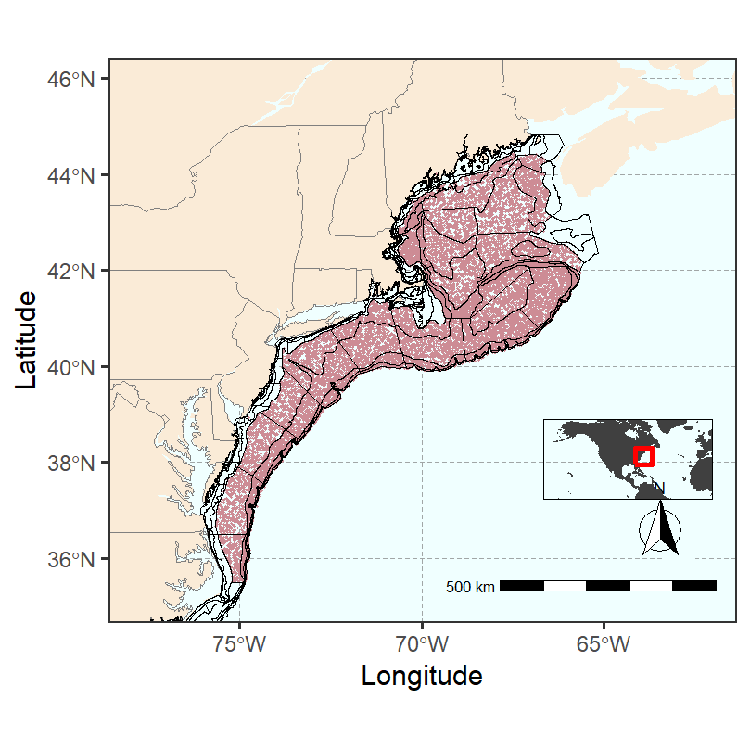

Figure 2
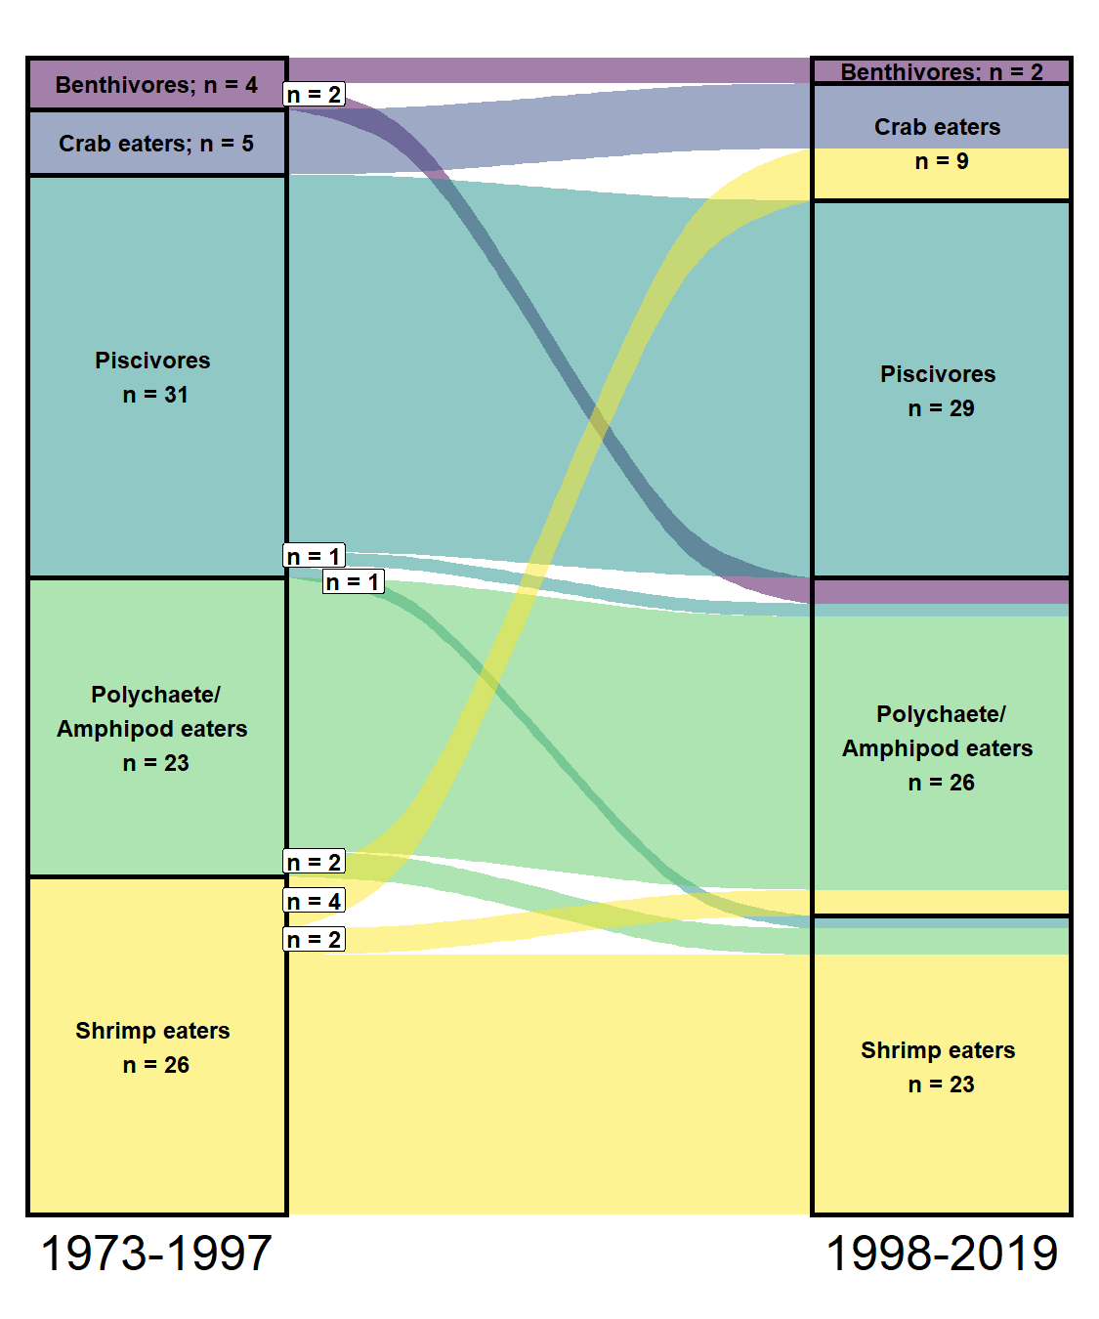

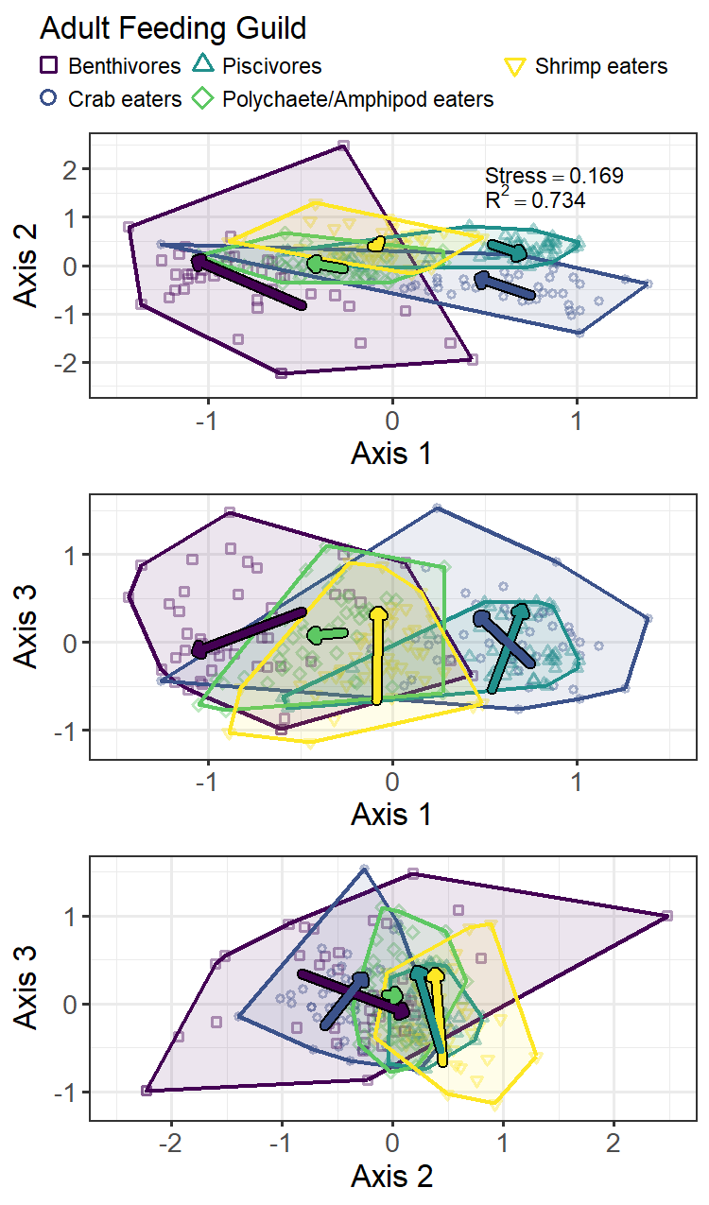

Figure 3
a

b
c

Figure 4
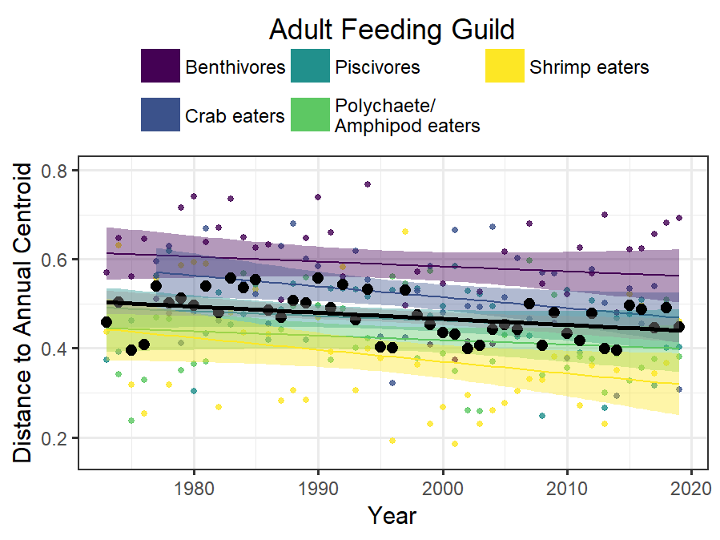

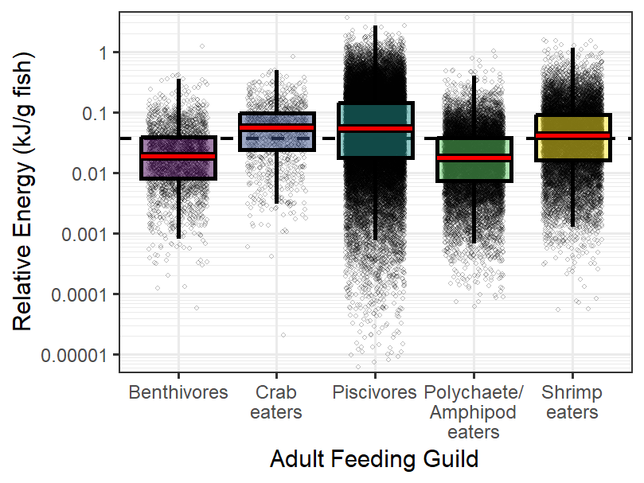
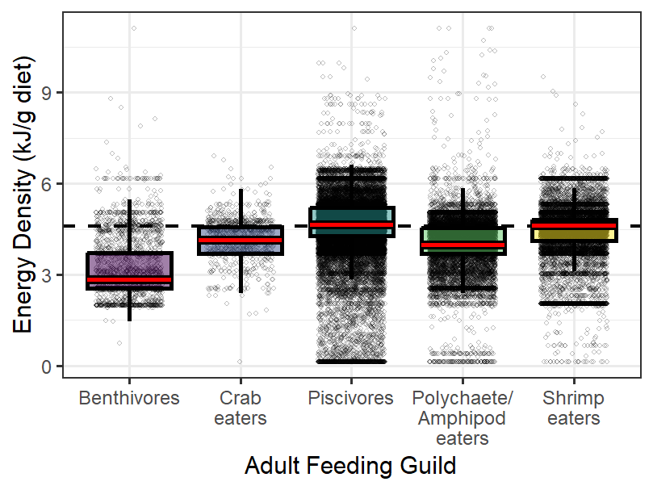
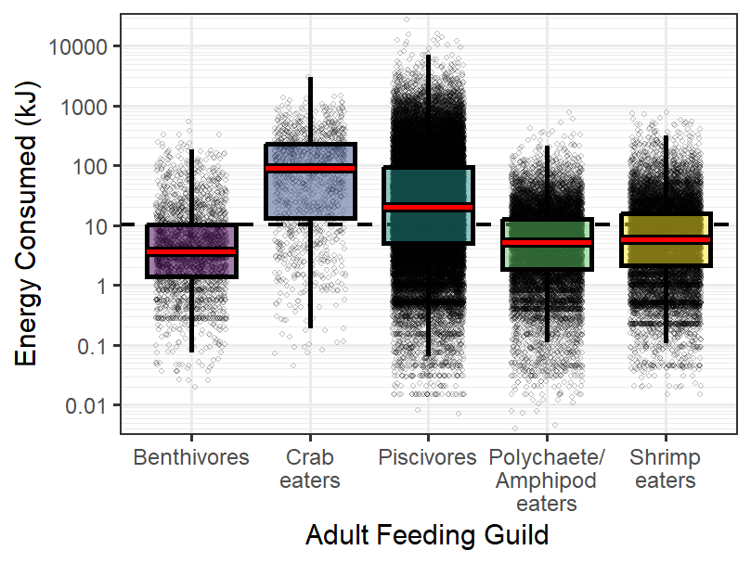
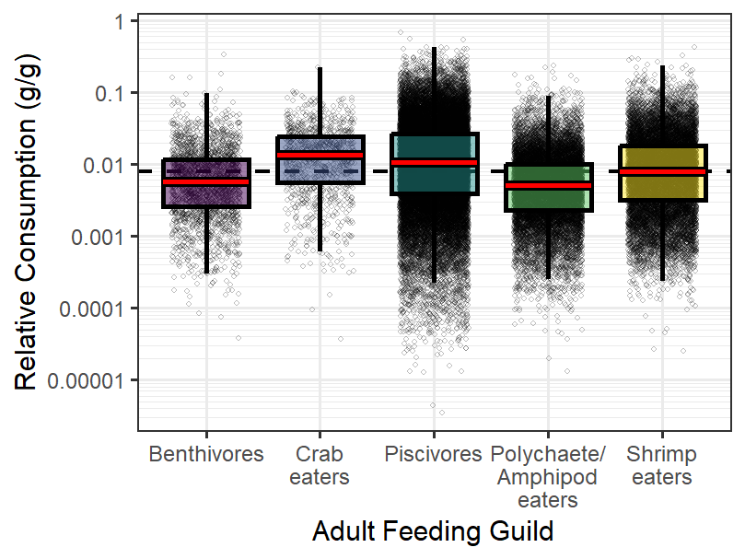
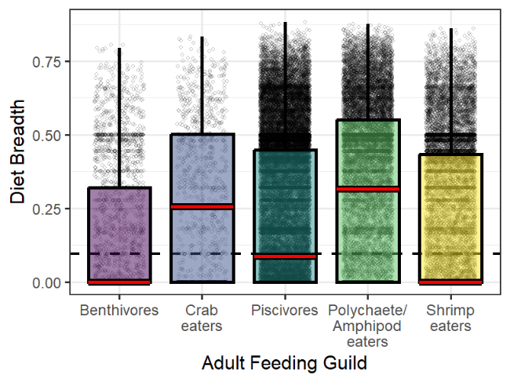
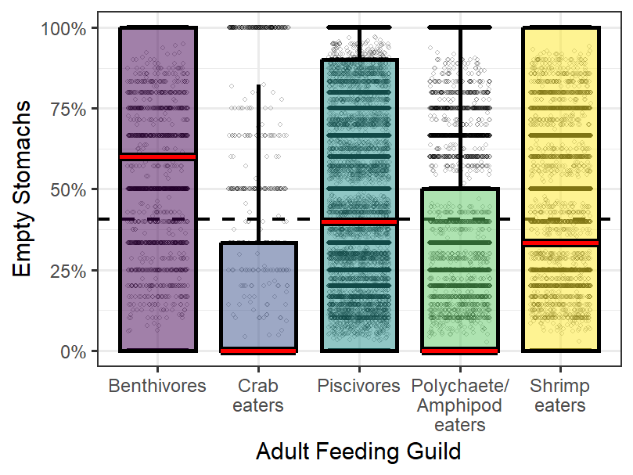
Figure 5
c
f
e
d
b
a
f
e
d

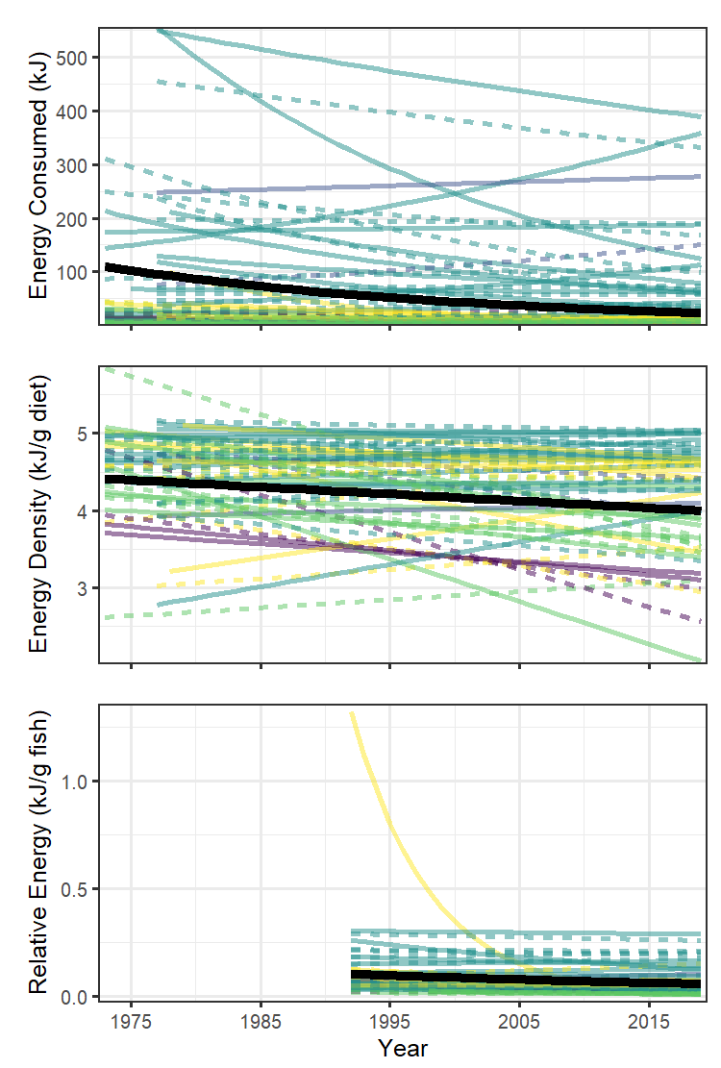
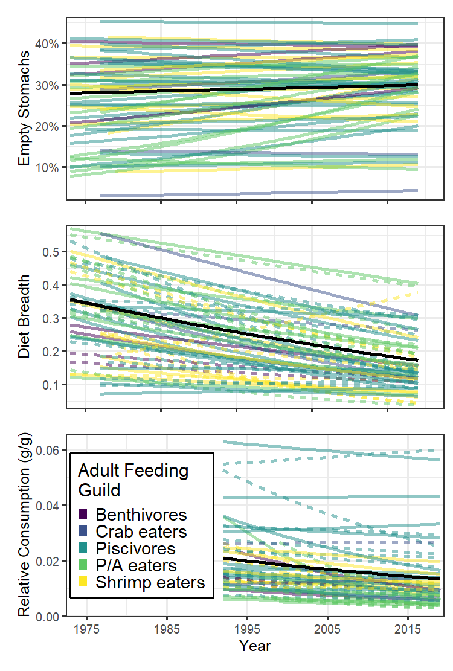
Figure 6
b
c
d
e
f
a

Figure 7
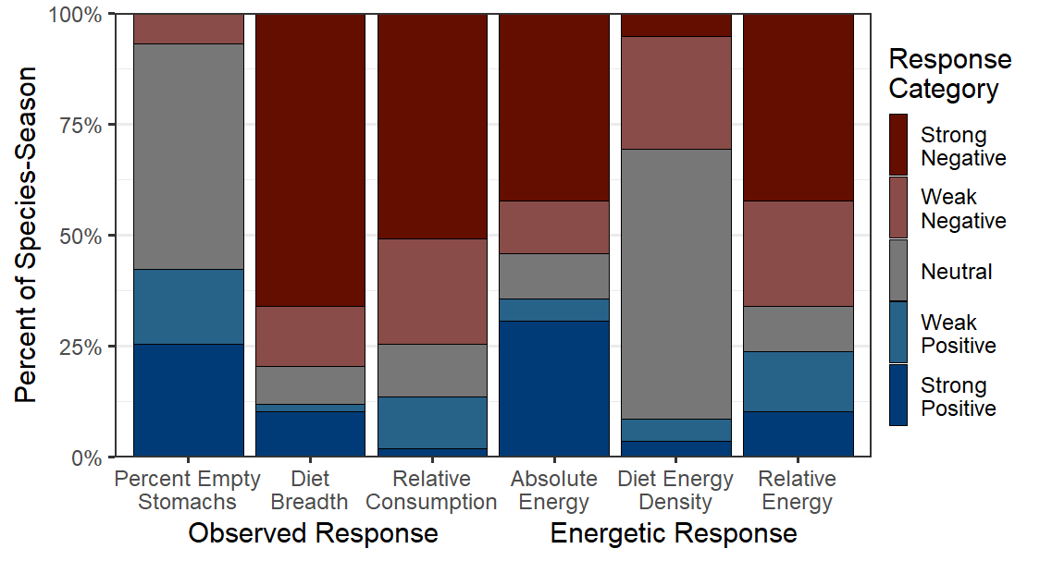

Figure 8
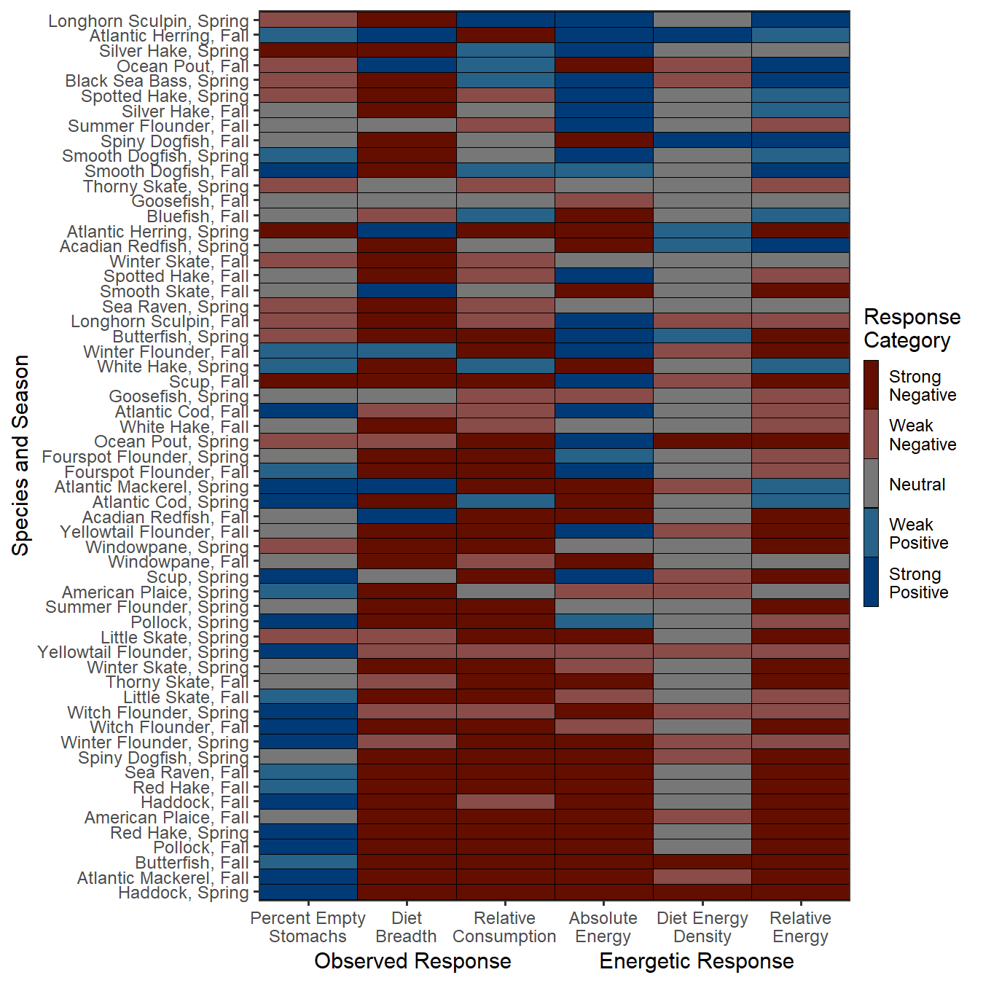

Figure 9
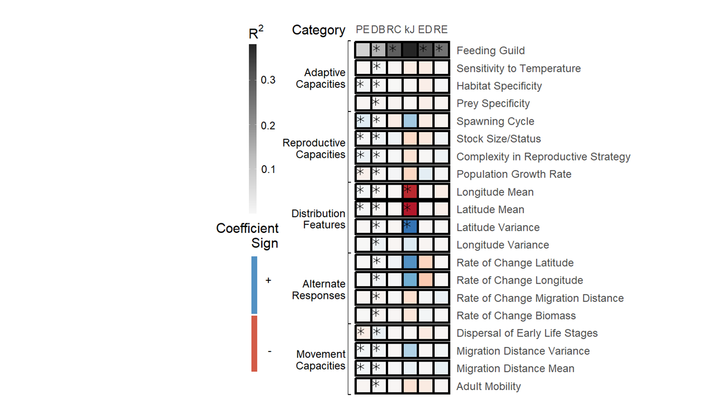

Figure 10
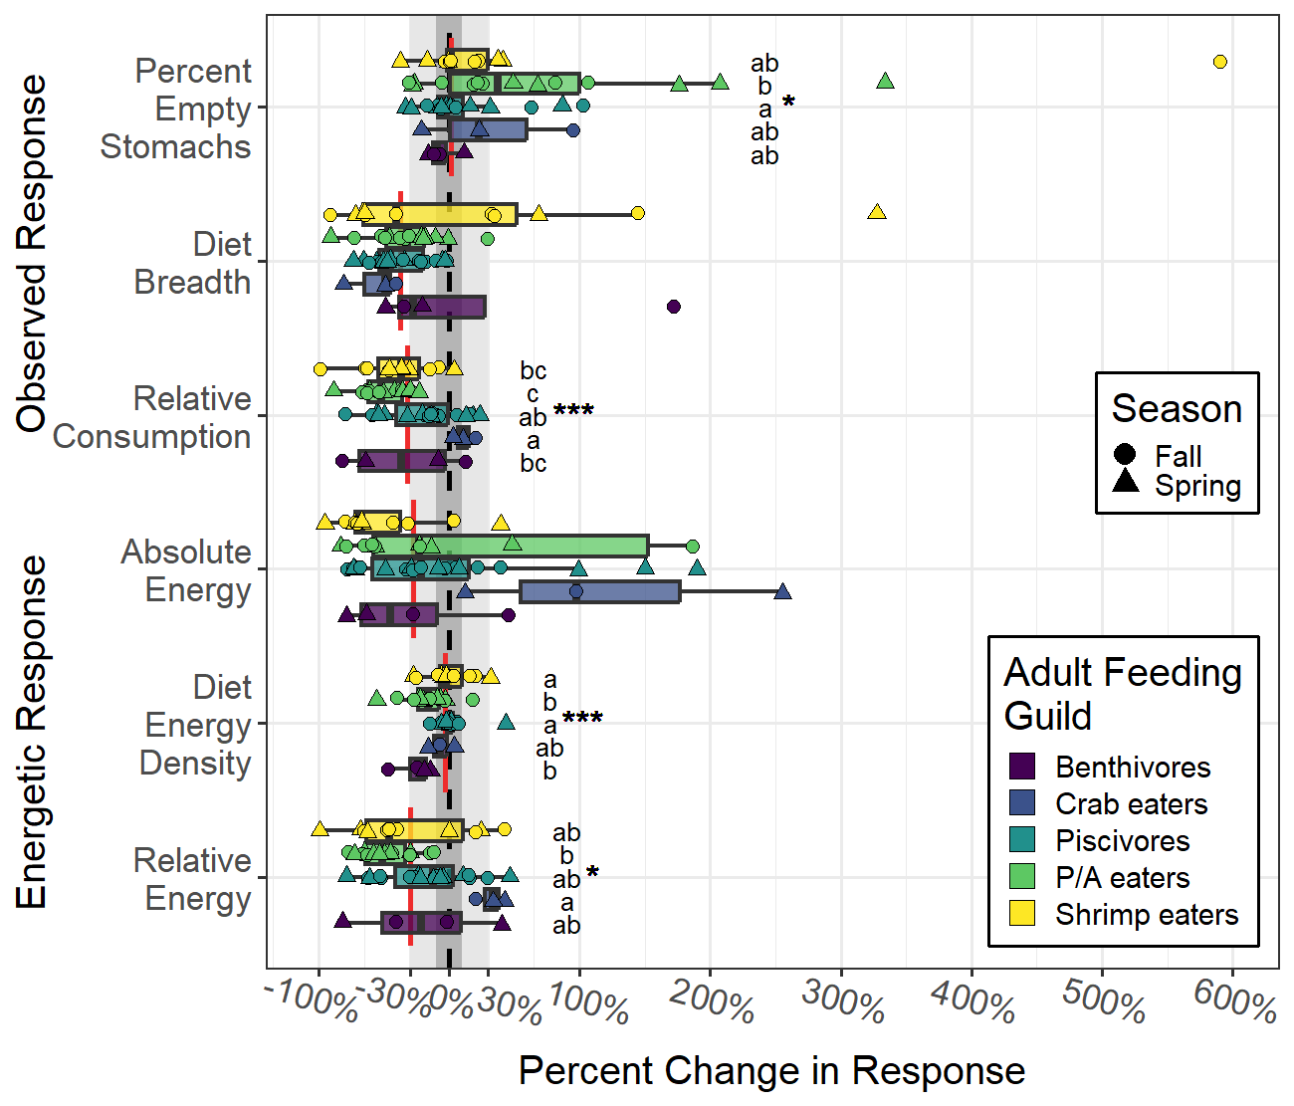

References
Automatic citation updates are disabled. To see the bibliography, click Refresh in the Zotero tab.

