Running Title: Diet quality declines for US fish predators

Diet breadth and quality is declining for many fish predators in the warming Northeast US Continental Shelf

Nathan T. Hermann^{1*}, Andrew J. Allyn², Carly S. Lovas², Mark J. Wuenschel³, Brian E. Smith³, Katherine E. Mills², Nathan B. Furey¹

¹University of New Hampshire, Department of Biological Sciences, Durham, NH, USA
²Gulf of Maine Research Institute, Portland, ME, USA
³National Marine Fisheries Service, Woods Hole, MA, USA

*Corresponding Author: Email: Nathan.Hermann@unh.edu; Phone: (563) 543-9451

Supplemental Figure Legends
Figure S1. Number of diets collected from each predator species and size class over the entire sampling period of the NMFS Annual Spring-Fall Bottom Trawl Survey. Size class definitions (S-Small, M-Medium, L-Large, and XL-Extra Large) reflect species life history and vary by species (see Table 1).
Figure S2. Prey accumulation curve for each of the predators included in the food habits database. Prey are categorized into a maximum of 51 categories (excluding miscellaneous, see Table 2 for details), but the maximum observed for each predator are marked with a black point. Note the high degree of variation in the x-axis reflecting variation in the number of diets collected from each species; the y-axis is fixed across all panels to the max of 51 prey categories.
Figure S3. Size category distribution for each species included in individual analysis for each year. Overlayed in red is the mean length of fishes in each year relative to the highest length across years to standardize across all species.
Figure S4. Tanglegram showing connections between species-size class positions within a dendrogram using diet data collected during (left) 1973-1997 or (right) 1998-2019.
Figure S5. Changes in the percent empty stomachs for each predator included in individual analyses both for the full database (1973-2019) and using only at-sea observations (starting 1981 or 1985, depending on species; Link and Almeida, 2000). Line colors indicate whether the curve was fit to the whole time series (black), just in lab observations (blue), and just at-sea observations (red). Horizontal dashed lines at 1981 and 1985 mark the two years when changes in methodology occurred (Link and Almeida, 2000).
Figure S6. Comparison between the rates of change in percent empty stomachs across all predators when using the total time period (1973-2019) or only the at-sea observation period (starting 1981 or 1985, depending on species; Link and Almeida, 2000). Fewer species increased the frequency of empty stomachs over the shorter time period (22.0%) than over the full time period (42.3%).
Figure S7. Simpson diversity index scores for each predator from 100 random draws of 100 stomachs. Species are sorted left to right by increasing median diversity of the random draws. The mean Simpson diversity score from the full database for each species (red line) follows a similar pattern across species and coincides closely with the median from random draws.

Supplemental Figures

Figure S1
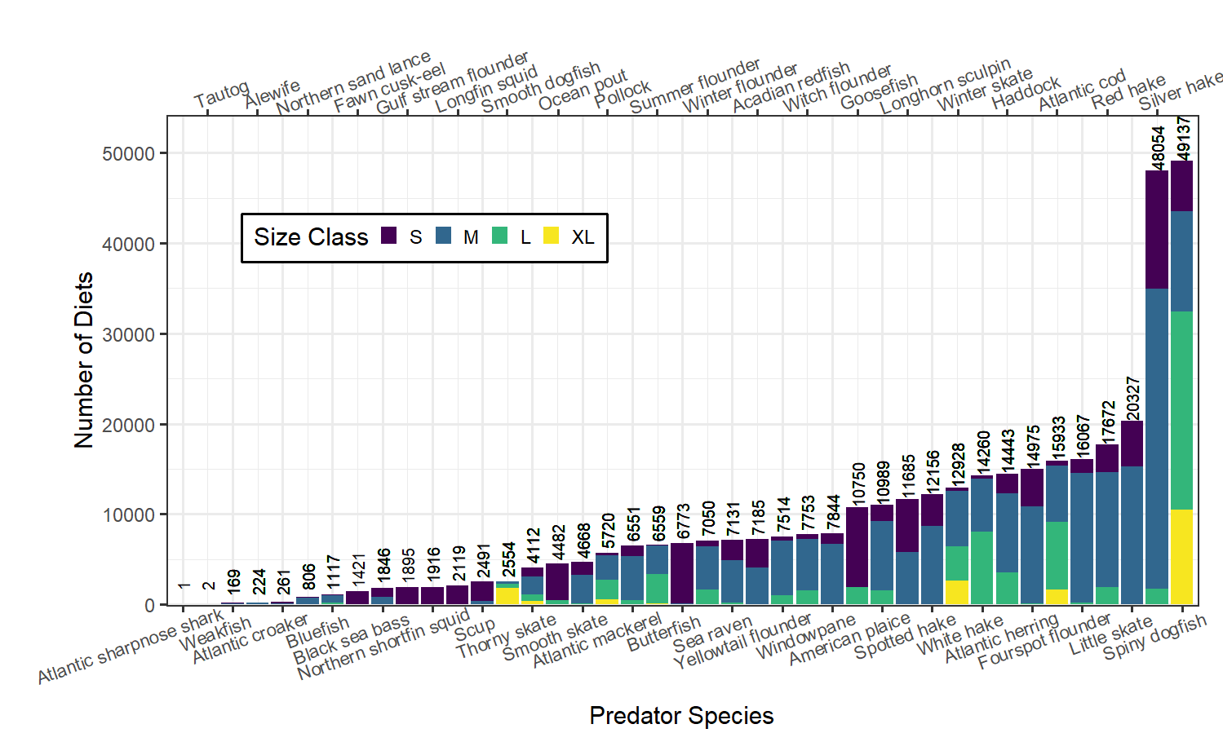

Figure S2
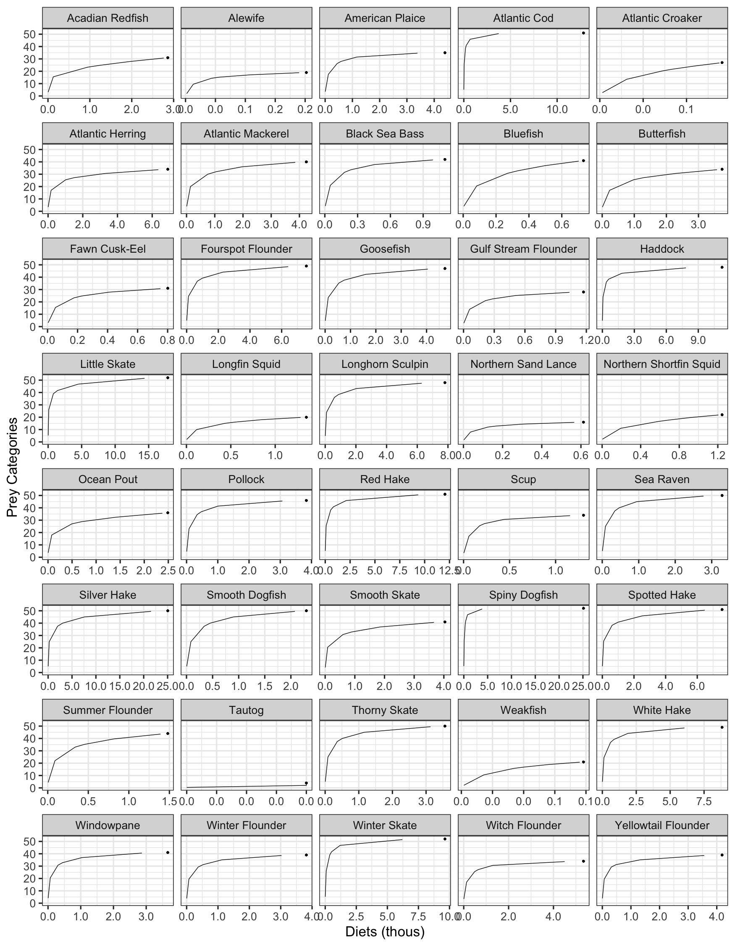

Figure S3
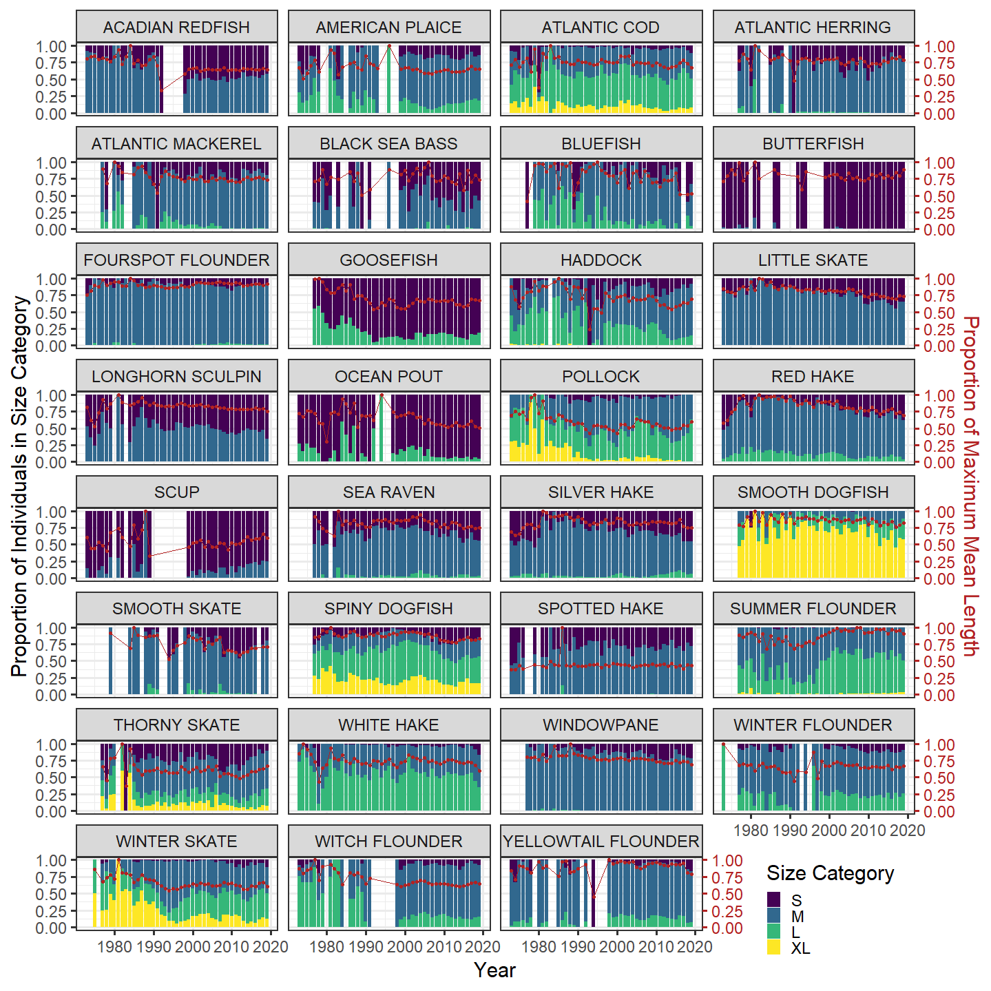

Figure S4
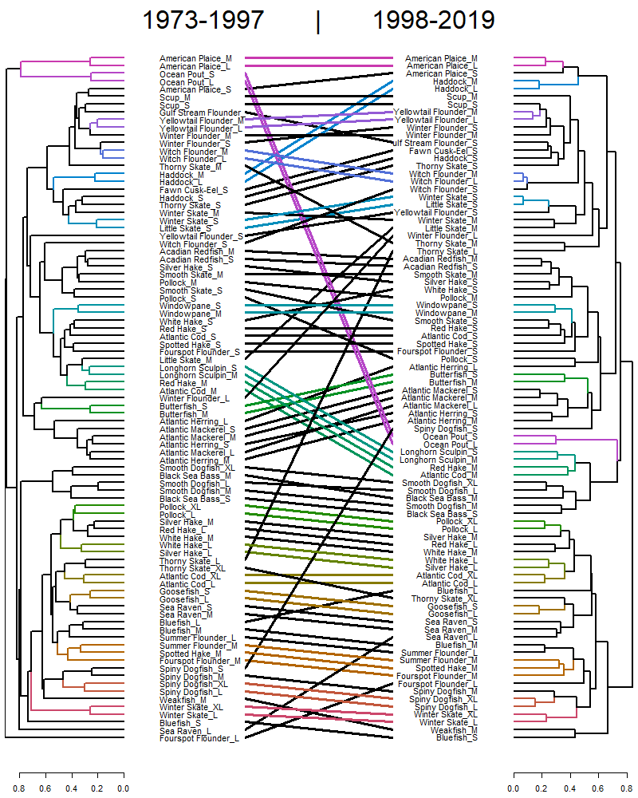

Figure S5
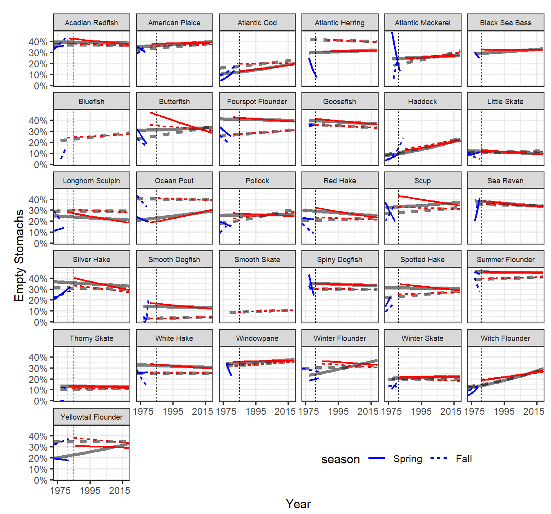

Figure S6
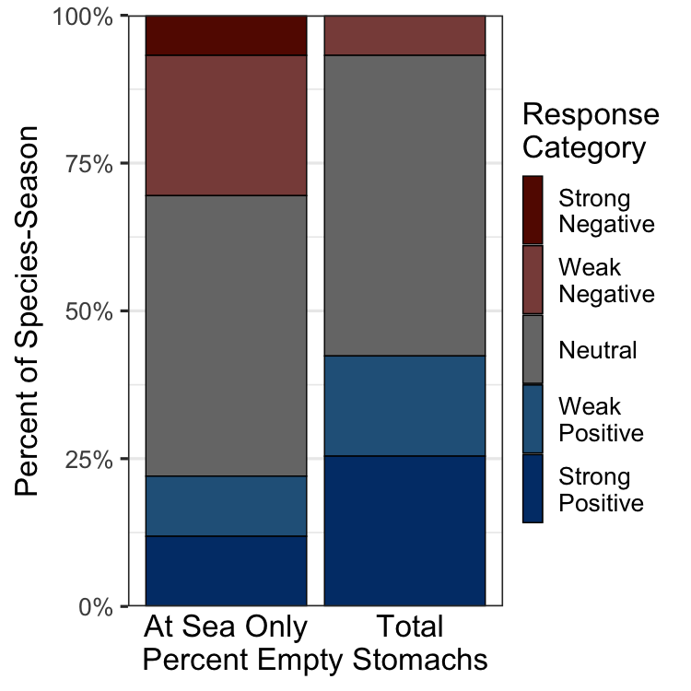

Figure S7
